**The History of DevOps**

Robert Minkler

College of Science & Tech, Bellevue University

CSD 380 DevOps

Professor John Woods

March 23, 2025

**The History of DevOps**

DevOps originated out of the need to streamline development and deployment. Project development cycles took months, if not years, with the original development methodologies. Then, once the entire project is completed, it is turned over to a new team for deployment. These teams would often have competing goals and metrics to measure success. When combined with communication gaps, deployment would frequently fail, requiring a reversal and rework. Development teams are focused on creating new features and expanding capabilities, while operations teams focus on maintaining functioning systems with minimal downtime. The operations team benefits by reducing changes to the system to ensure stability, while development only succeeds when updates are released to the customer. Traditional release cycles spanned from months, quarters, or even years. DevOps attempts to bridge the gap by bringing the entire process under one team and utilizing automation and processes that can reduce release cycles from months to hours or even minutes.

The Agile Manifesto was a catalyst for change when it was released in 2001. The authors wanted to initiate change in the development process, placing individuals over tools and methods, functional software over extensive documentation, customer collaboration over contracts, and responding to changes over strictly adhering to a plan. The older methodologies struggled to integrate customer feedback and adapted slowly as needs changed. Agile was the first glimpse of change in the system and a significant turning point in what would become DevOps.

Lean initiatives are derived from the manufacturing sector. Lean initiatives in the 1980s profoundly impacted manufacturing speed and flexibility. Lean initiatives focus on finding delays and waste and removing them from the process. Before the revolution, manufacturing lead times were six weeks on average, with less than 70% of orders delivered on time. By 2005, the average lead time had been reduced to under three weeks with an on-time delivery rate of 95%. Manufacturers who could not adapt failed as clients sought faster, lower-cost providers. Similarly, in software development, lead times have dropped from years to weeks while the development cost has steadily decreased. With these changes, the cost of failure has shifted from bankruptcy and layoffs to negligible costs to the organization.

DevOps was born from integrating Agile development and Lean initiatives to reduce waste and streamline software development and deployment. The idea of DevOps originated in 2007 but started to grow in 2009. At the Velocity Conference, John Allspaw and Paul Hammond gave a talk entitled “10 Deploys Per Day: Dev and Ops Cooperation at Flickr.” They discussed how the integration of Development and Operations allowed Flickr to deploy code to production several times per day compared to the traditional lead time of months. Later that year, Patrick Debois organized the DevOpsDays conference in Belgium.

As the concept of DevOps began to take hold of the industry, the tools also began to develop and mature. Continuous integration and deployment are cornerstone values of DevOps. As delivery times shrink from years to months, then minutes, the tools to enable automated, rapid testing and deployment became necessary. Rapid deployment of test environments through cloud computing, automated testing to reduce manual workload, and the tools to deploy and revert failed deployments automatically enable such a rapid and safe deployment while maintaining system integrity.

Modern DevOps has become a mainstream philosophy, allowing organizations to be more agile and rapidly respond to changing customer demands. One of the concerns of such a rapid deployment cadence is security, which has given rise to DevSecOps. DevSecOps intends to integrate security testing and validation throughout the DevOps framework. Instead of allowing security to be an afterthought, security practices and procedures are placed throughout the DevSecOps lifecycle to ensure secure systems.

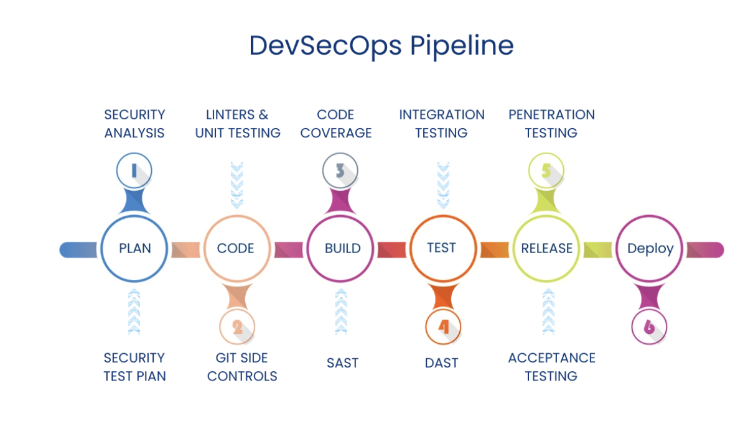

(Kumar, 2024)

Modern DevOps allows for rapid development and deployment of software. It expands beyond just tools and methods. DevOps works best within a strong culture where collaboration, embracing new ideas, allowing failure, and utilizing the right tools combine to create a more efficient and streamlined production environment. Instead of teams with conflicting goals, the entire team works together towards shared goals and success, learning from failure while embracing change. The principles that make DevOps possible allow for greater profit, reduced risk, and improved customer satisfaction while building strong teams that can safely grow and experiment.

**References**

Kim, G., Humble, J., Debois, P., Willis, J., & Forsgren, N. (2021). *The DevOps Handbook, Second Edition: How to Create World-Class Agility, Reliability, & Security in Technology Organizations* (Second Edition). IT Revolution Press.

Kumar, B. (2024, September 25). The history of DevOps: Origins, growth, and Evolution explained. Spoclearn. <https://www.spoclearn.com/blog/history-of-devops-origins-growth-explained/>

Smith, D. (2024, January 25). *The evolution of DevOps*. DevOps.com. <https://devops.com/the-evolution-of-devops/>