Robert Minkler

CSD 380

Module 5.2 Value Stream Map

April 20, 2025

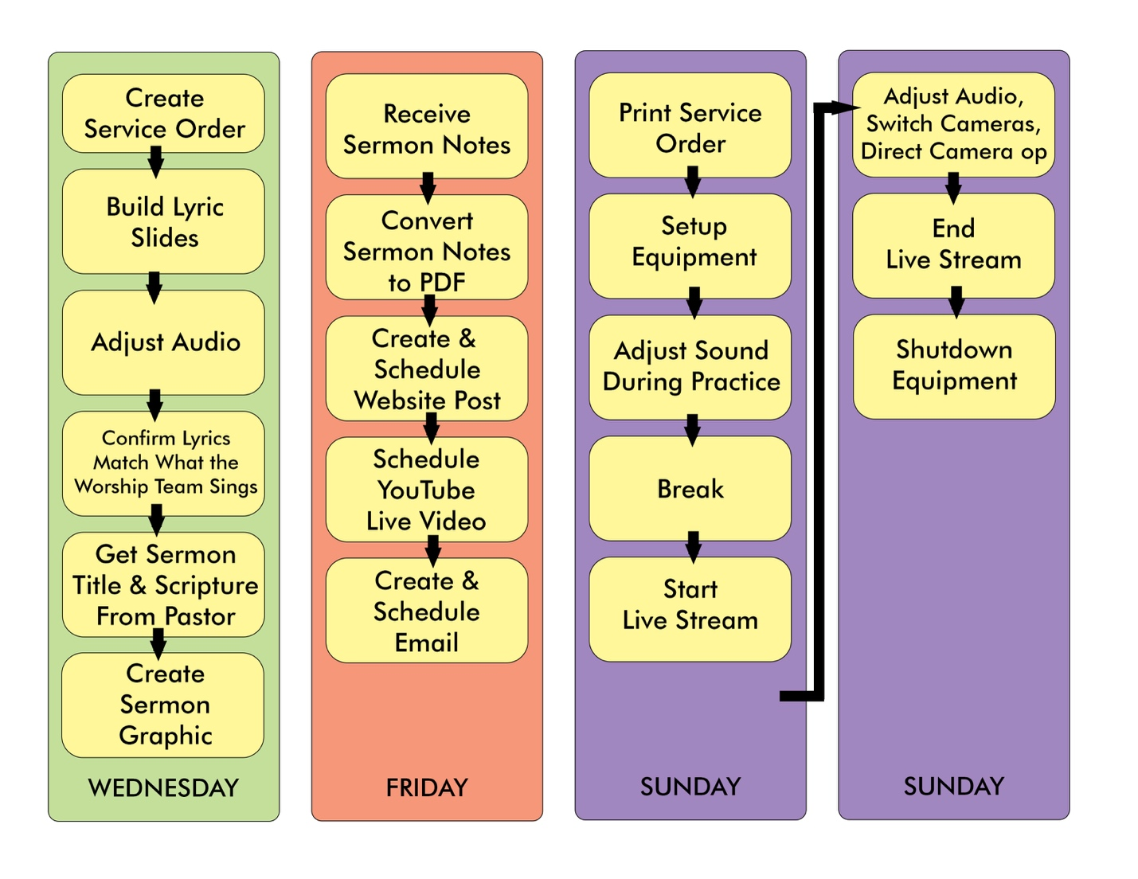

|  |  |
| --- | --- |
| Wednesday | 1 – 1.5 hours |
| Friday | 1 hour |
| Sunday | 4 hours |

This schedule has already been optimized with little room for further optimization.

* Wednesday Tasks run concurrently with Worship Practice.
* Friday tasks depend on receiving sermon notes from a third party and depend on resources from one another. These are done concurrently due to the dependencies, and I shift tasks during load times.
* Sunday tasks run concurrently with morning practice and services.