***ECE-242-SIGNALS AND SYSTEM- MATLAB***

**REPORT FOR->LINEAR CONVOLUTION AND CIRCULAR CONVOLUTION**

**Objective:**

Generation and description on LINEAR CONVOLUTION AND CIRCULAR CONVOLUTION and generation of signal is done using MATLAB.

**Requirement :-**

computer with MATLAB SOFTWARE.

**Theoritical Description :->**

**CONVOLUTION :->**

Convolution is a mathematical way of combing two signals to form a third signal. Convolution is important because it relates the three signals that is the input signal, the output signal, and the impulse response. convolution is a formal mathematical operation just as multiplication, addition, and integration. Addition takes two numbers and produces a third number, while convolution takes two signals and produces a third signal. In linear systems, convolution is used to describe the relationship between three signals of interest: the input signal, the impulse response, and the output signal.

It relates input, output and impulse response of an LTI system as

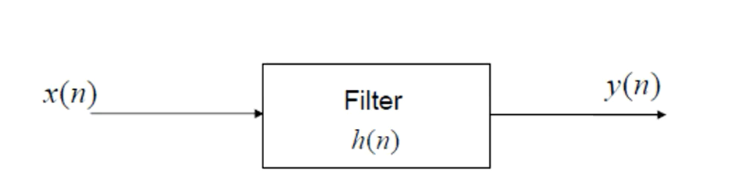

Where

y (t) = output

x (t) = input

h (t) = impulse response

**LINEAR CONVOLUTION:->**

Linear convolution is a mathematical operation done to calculate the output of any Linear-Time Invariant (LTI) system given its input and impulse response. It is applicable for both continuous and discrete-time signals. We can represent Linear Convolution as

**y(n)=x(n)*h(n)**

Here

y(n) is the output

x(n) is the input signal

h(n) is the impulse response

**Result obtained using MATLAB:**

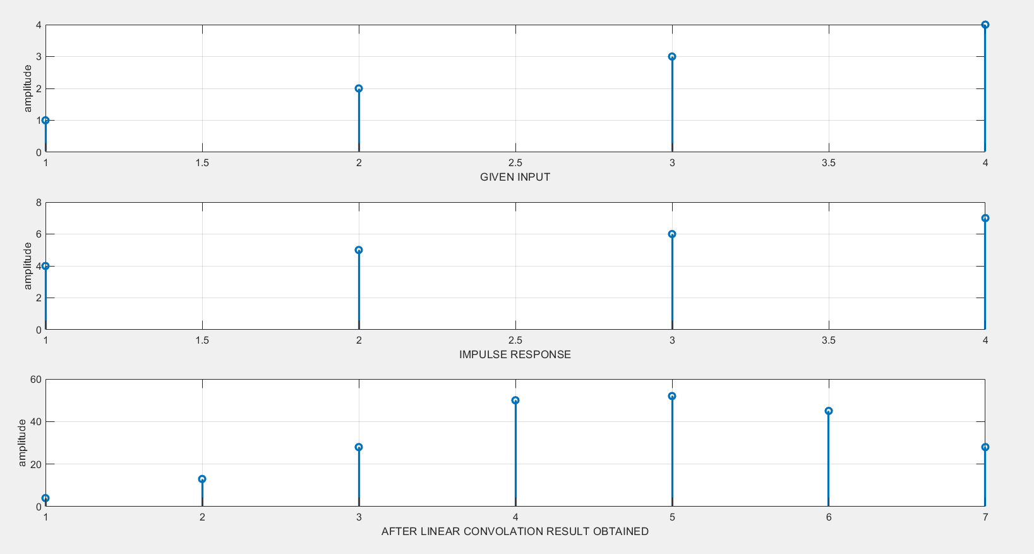

**COCLUSION:**

In linear convolution, both the sequences (input and impulse response) may or may not be of equal sizes.

**CIRCULAR CONVOLUTION:->**

Circular convolution is essentially the same process as linear convolution. in circular convolution, the signals are all periodic. Since the values keep repeating because of the periodicity. Hence, it is known as circular convolution. Circular convolution is also applicable for both continuous and discrete-time signals.

We can represent Circular Convolution as

**y(n)=x(n)⊕h(n)**

**Here**

**y(n) is a output**

**x(n) is a input**

**h(n) is the impulse response**.

**Result obtained using MATLAB:**

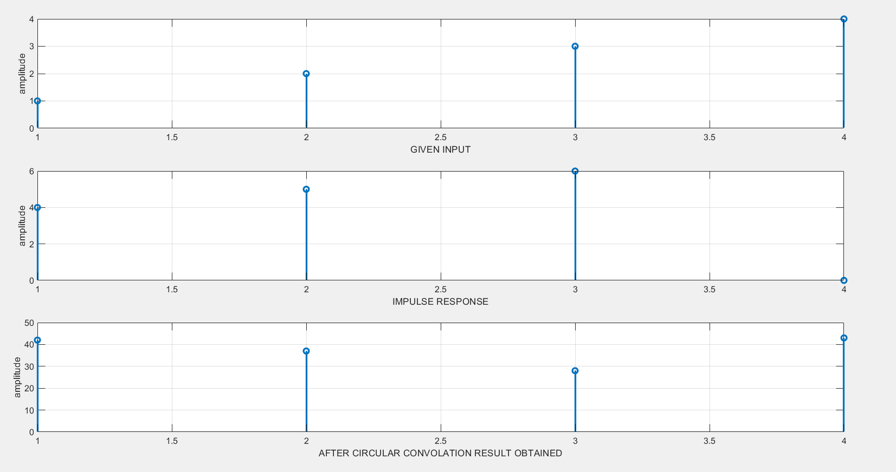

**COCLUSION:**

In circular convolution, both the sequences (input and impulse response) must be of equal sizes. They must have the same number of samples. Thus the output of a circular convolution has the same number of samples as the two inputs as.

NAME:RAHUL KUMAR MISHRA

ROLL NUMBER:19010203