# architecture

Describe here the architecture of the system.

This is the site map.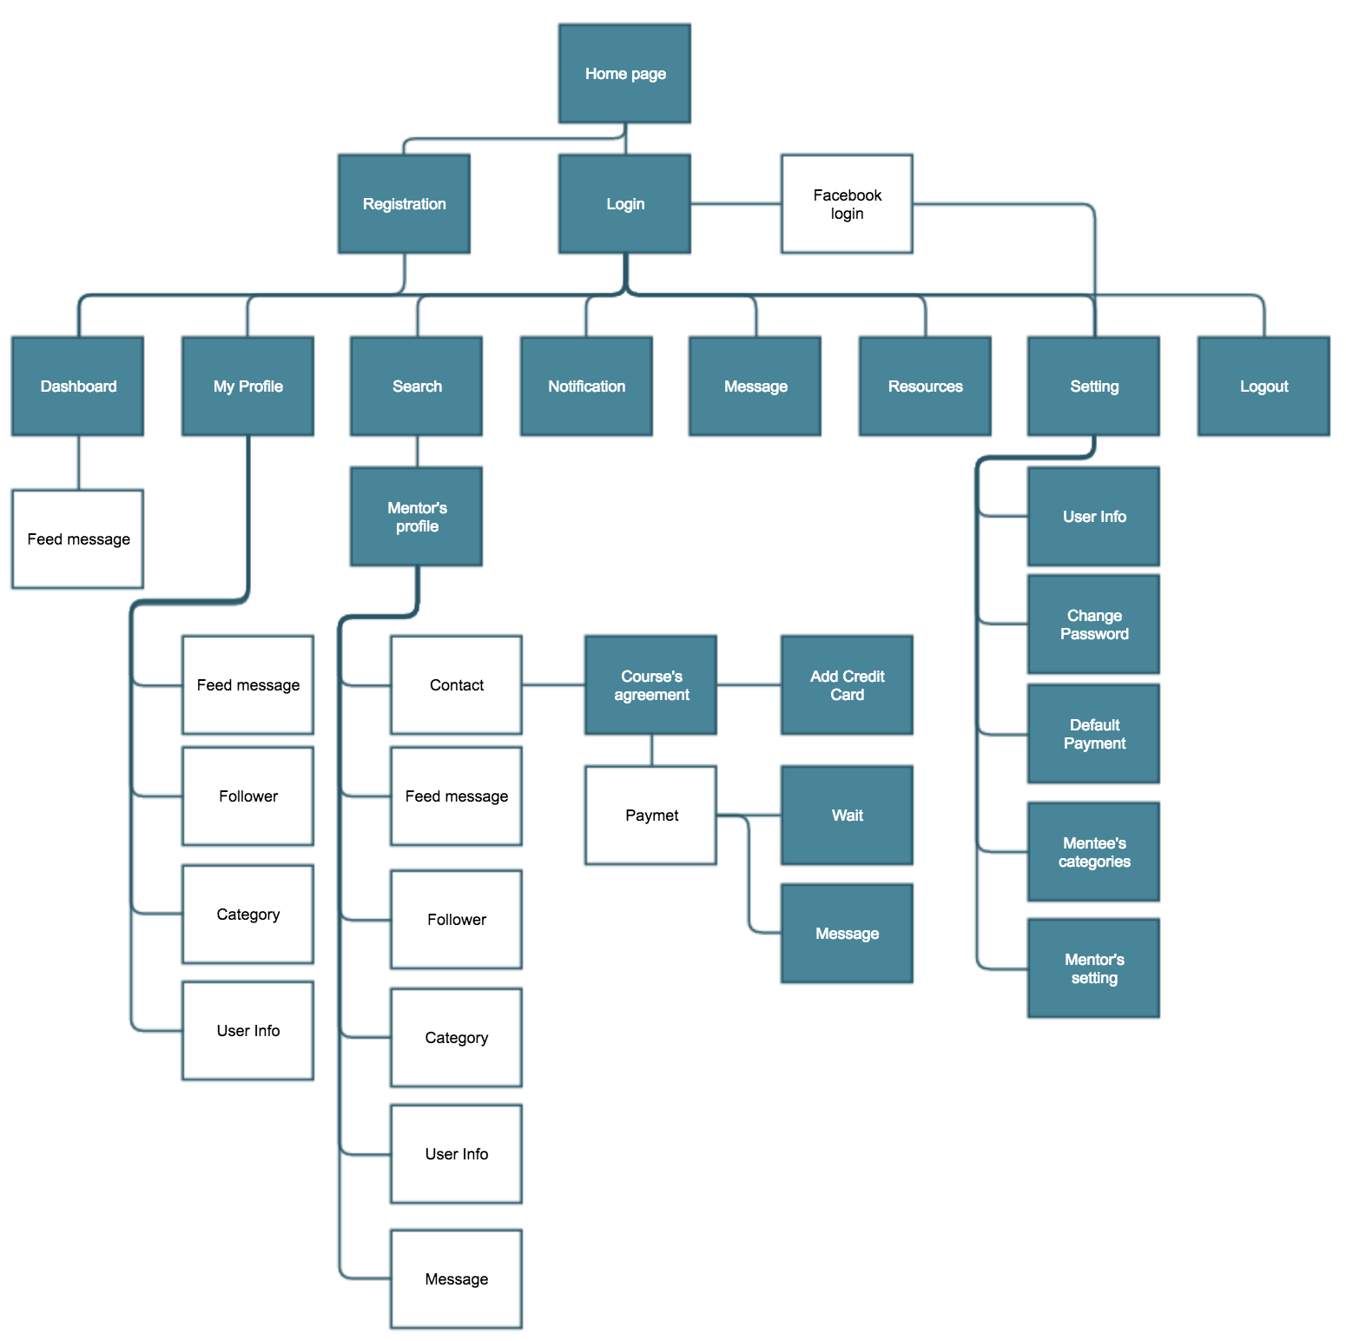

This is the database schema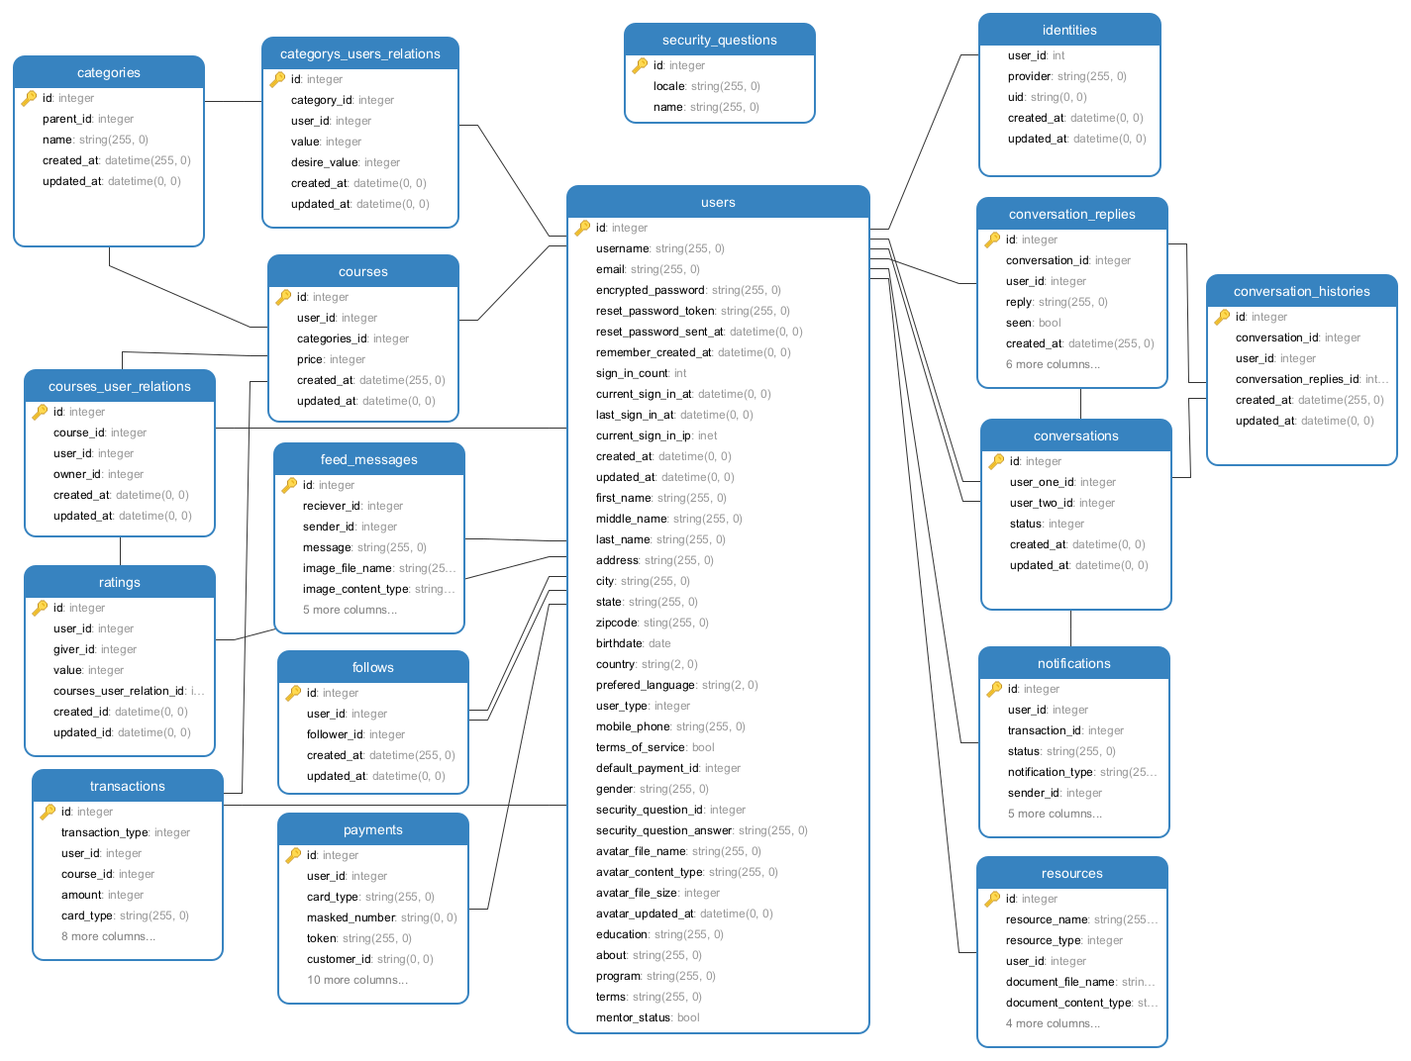

This is the framework architecture