# IMPLEMENTATION

1. Sprint 1
   1. The project was initiated. All the team members met and decided the frameworks and APIs to be used in the project.
   2. The team installed all the required frameworks and software required for the project. The working environment was ready and set to work.
   3. Landing page was made in this sprint. (*Figure 6.1)*
   4. Login functionality was implemented where user can login into the website using correct credentials. *(Figure 6.2)*
   5. Basic registration page was also created to test the login functionality.



*Figure 6.1: Main landing page*

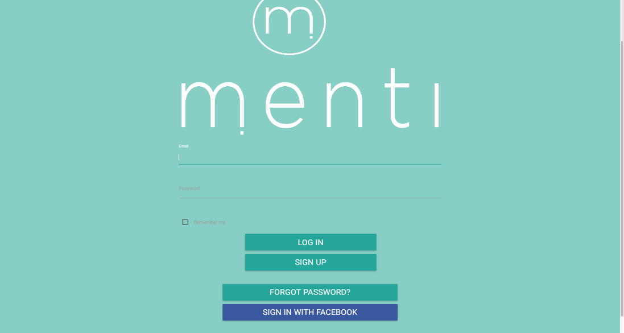

*Figure 6.2: Login page*

1. Sprint 2
   1. The login page was made responsive and mobile friendly.
   2. A better version of registration page was implemented according to the requirements *(Figure 6.4.1 & Figure 6.4.2)*
   3. Sign up with Social media accounts (Facebook) was added in this sprint. *(Figure 6.3)*

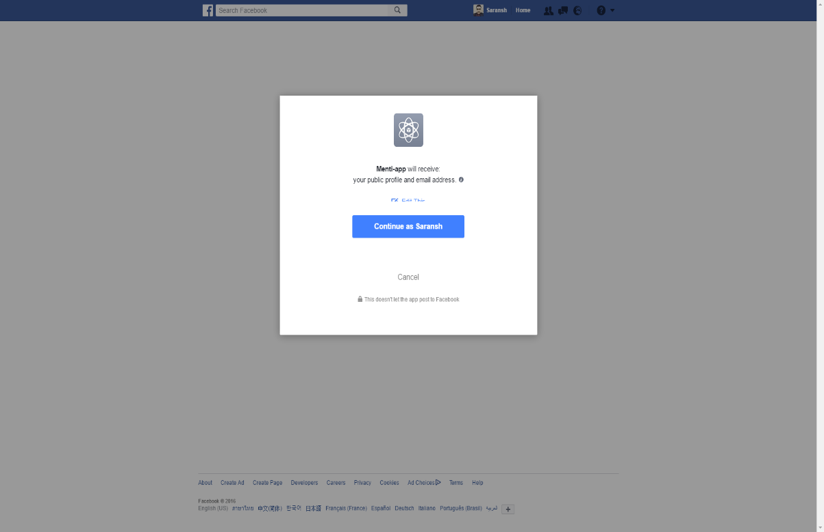

*Figure 6.3: Facebook Authentication*

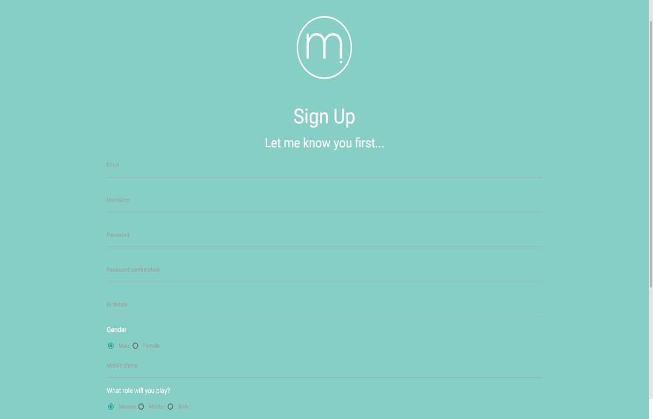

*Figure 6.4.1: Registration page*

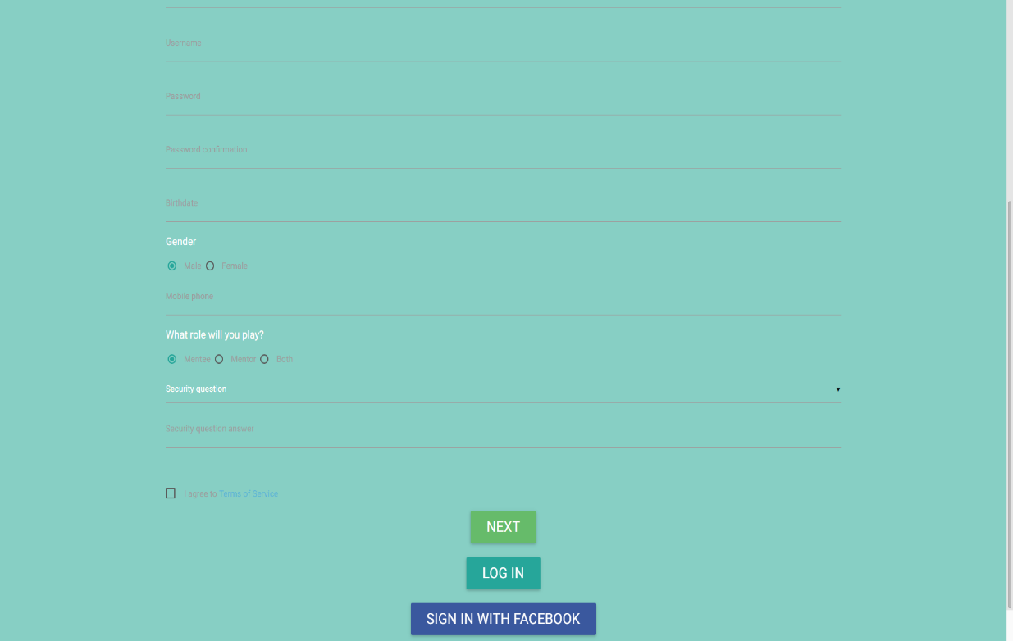

*Figure 6.4.2: Registration page*

1. Sprint 3
   1. Initial dashboard for the website was created. *(Figure 6.5)*
   2. Registration page was enhanced as requirements changed.
   3. Back-end for registration page was worked upon.

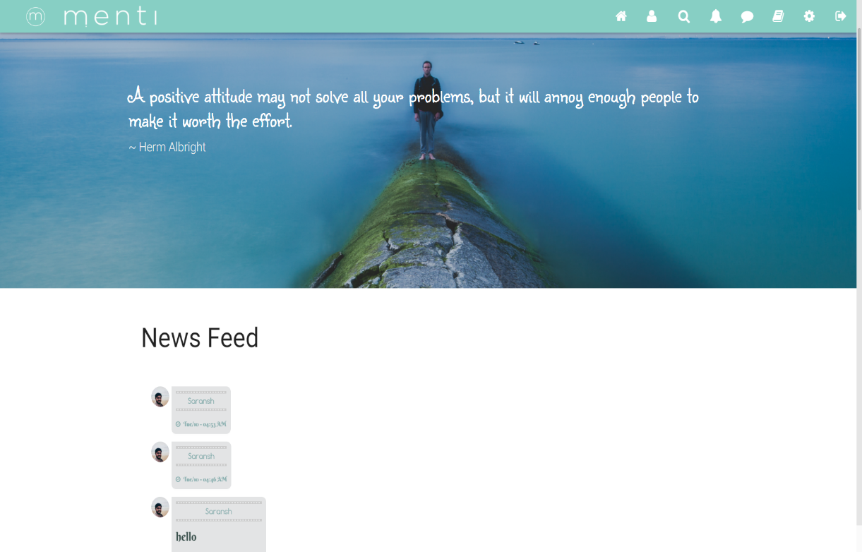

*Figure 6.5: Dashboard*

1. Sprint 4
   1. Settings page was created. *(Figure 6.6.1 & Figure 6.6.2)*

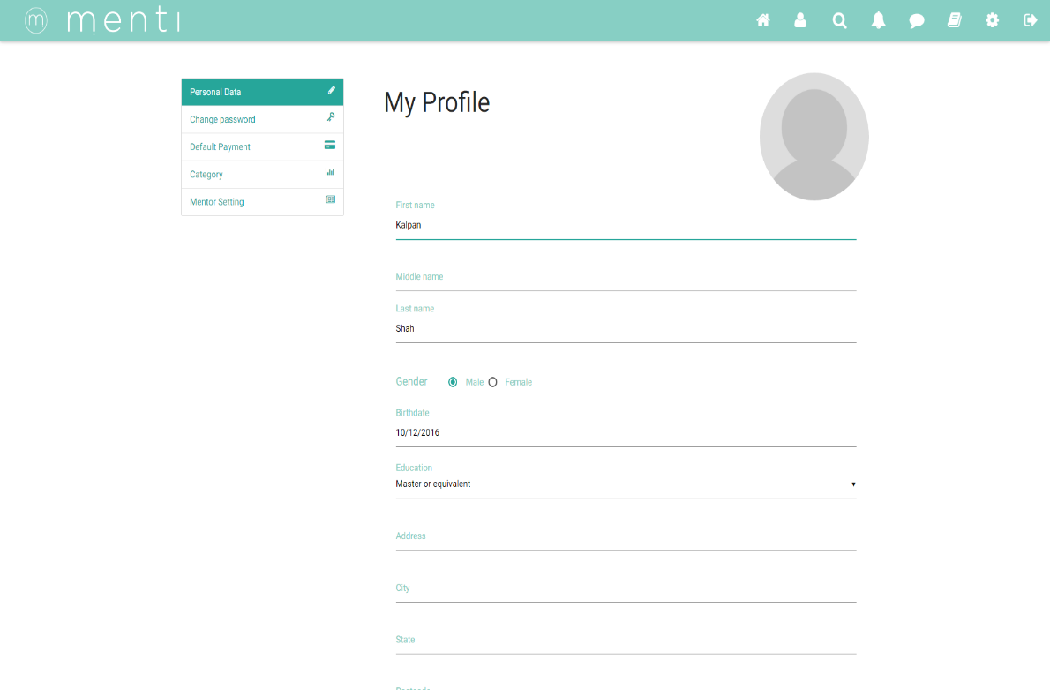

*Figure 6.6.1: Settings page for mentor*

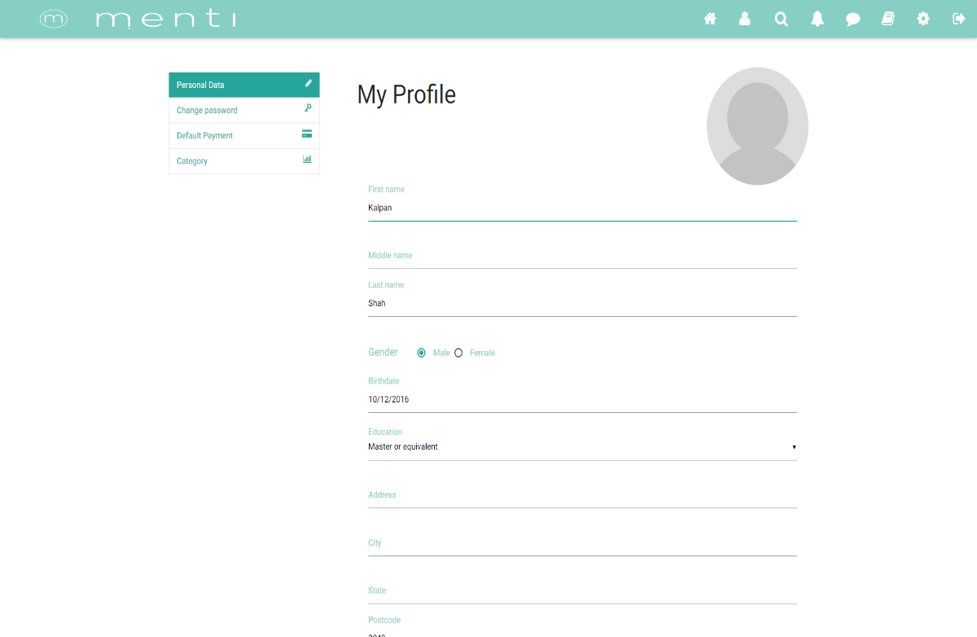

*Figure 6.6.2: Settings page for mentee*

1. Sprint 5
   1. Designed ‘My Profile page’. (Figure 6.6.1 & 6.6.2)
   2. Implemented Payment BrainTree API.
   3. Enhanced the dashboard. (Figure 6.5)
   4. Database schema for Feeds and Payment.
2. Sprint 6
   1. Initiated Mentor profile design.
   2. Initiated Mentor profile backend.
   3. Added Notification icon on header.
   4. Created Follow database schema.
   5. Enhanced Payment List design.
3. Sprint 7
   1. Enhanced mentor profile design. *(Figure 6.7)*
   2. Enhanced mentor profile back-end.

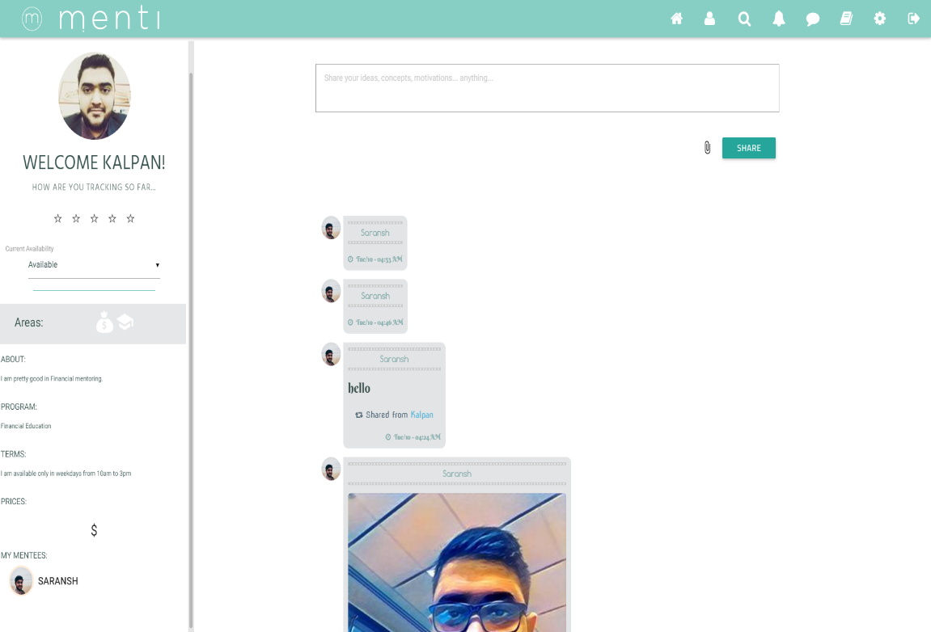

*Figure 6.7: Mentor Profile*

1. *Sprint 8*
   1. Implement design for Messaging page. *(Figure 6.8.1 & 6.8.2)*
   2. Implement back-end for Messaging page.

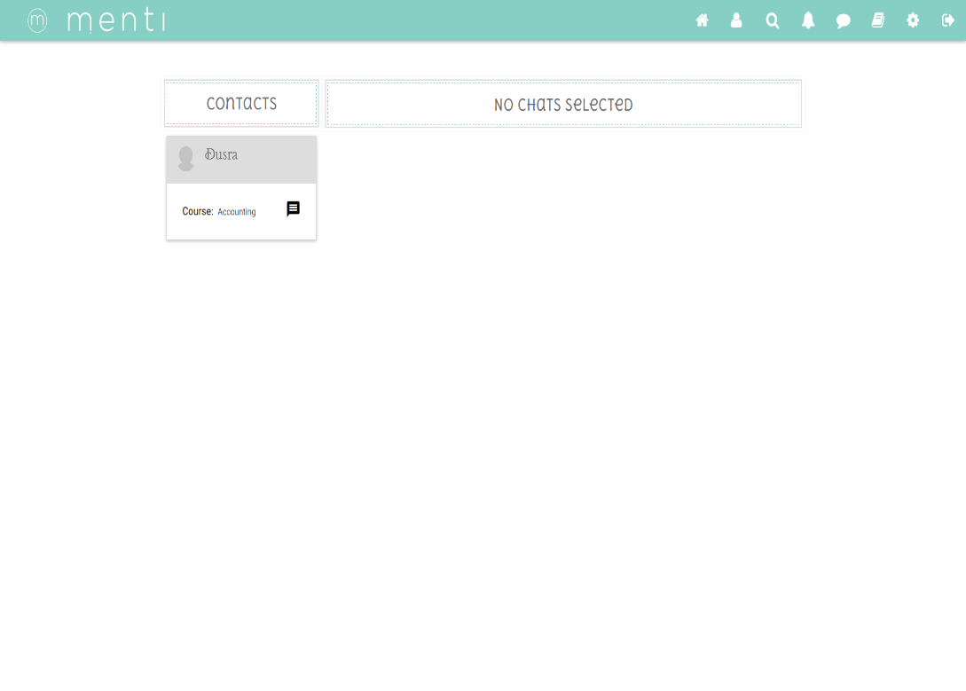

*Figure 6.8.1: Messaging landing page*

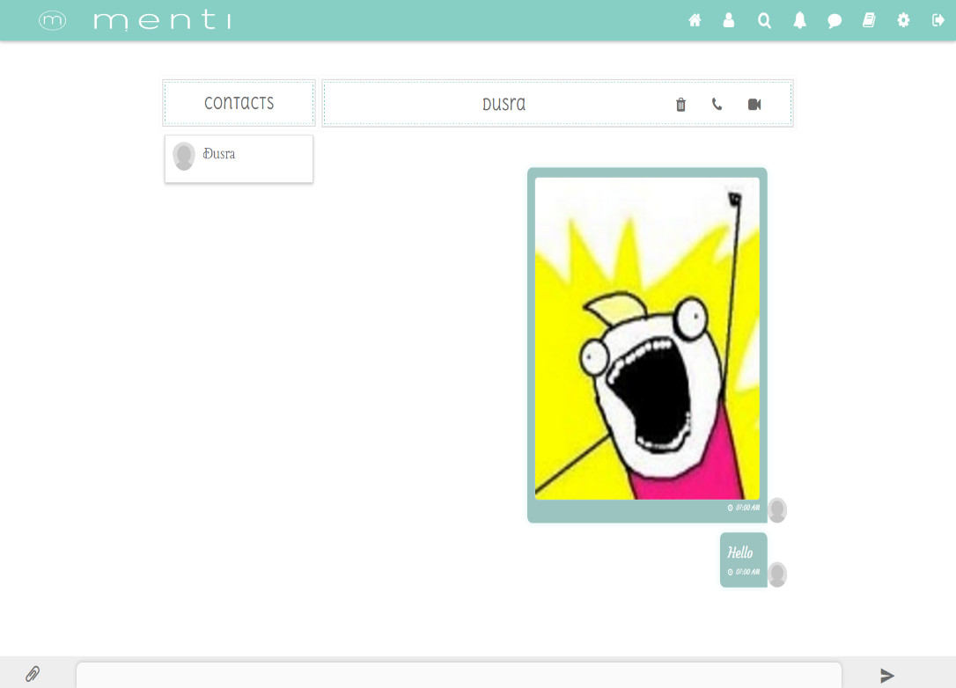

*Figure 6.8.2: Messaging main page*

1. *Sprint 9*
   1. Implemented search page design. *(Figure after update)*
   2. Implemented search page back-end.
2. Sprint 10
   1. Implemented resource page design. *(Figure after update)*
   2. Implemented resource page back-end.
   3. Fix major website bugs.