# 7. Deployment Instructions

Describe the deployment instructions, the basic specifications of the server, etc.

7.1. How to clone project to server

1. Clone the project repository

|  |
| --- |
| git clone <https://github.com/rittidate/menti-app.git> |

7.2. Setting up environment (OSX)

i. Install Homebrew

|  |
| --- |
| ruby -e "$(curl -fsSL https://raw.githubusercontent.com/Homebrew/install/master/install)" |

ii. Install Postgresql

|  |
| --- |
| brew install postgres |

- To change called directory

|  |
| --- |
| cp /usr/local/Cellar/postgresql/9.4.5_2/homebrew.mxcl.postgresql.plist ~/Library/LaunchAgents/ |

- To reload postgresql

|  |
| --- |
| launchctl unload ~/Library/LaunchAgents/homebrew.mxcl.postgresql.plist  launchctl load ~/Library/LaunchAgents/homebrew.mxcl.postgresql.plist |

***9.4.5_2 is version of postgresql on your machine.

iii. Install Ruby on Rails

- install RVM

|  |
| --- |
| curl -sSL https://get.rvm.io | bash -s stable |

- install ruby version 2.3.1

|  |
| --- |
| rvm install 2.3.1 |

- install rails version 4.2.6

|  |
| --- |
| gem install rails -v 4.2.6 --no-ri --no-rdoc |

iv. Install bundle gem install bundle

Bundler provides a consistent environment for Ruby projects by tracking and installing the exact gems and versions that are needed.

- install bundler

|  |
| --- |
| gem install bundler |

- go to project directory and install gems needed

|  |
| --- |
| bundle install |

v. Install heroku tool

<https://devcenter.heroku.com/articles/heroku-command-line>

Once installed, you’ll have access to the $ heroku command from your command shell. Log in using the email address and password you used when creating your Heroku account

|  |
| --- |
| heroku login |

vi. Change environment in ‘/.env’ or heroku environment

- All needed parameter put in this file.

|  |
| --- |
| RACK_ENV=  PORT=  SECRET_KEY_BASE=  FACEBOOK_APP_ID=  FACEBOOK_APP_SECRET_KEY=  BRAINTREE_ENVIRONMENT=  BRAINTREE_MERCHANT_ID=  BRAINTREE_PUBLIC_KEY=  BRAINTREE_PRIVATE_KEY=  AWS_S3_BUCKET_NAME=  AWS_ACCESS_KEY_ID=  AWS_SECRET_ACCESS_KEY= |

* Set up environment on heroku server in figure 7.1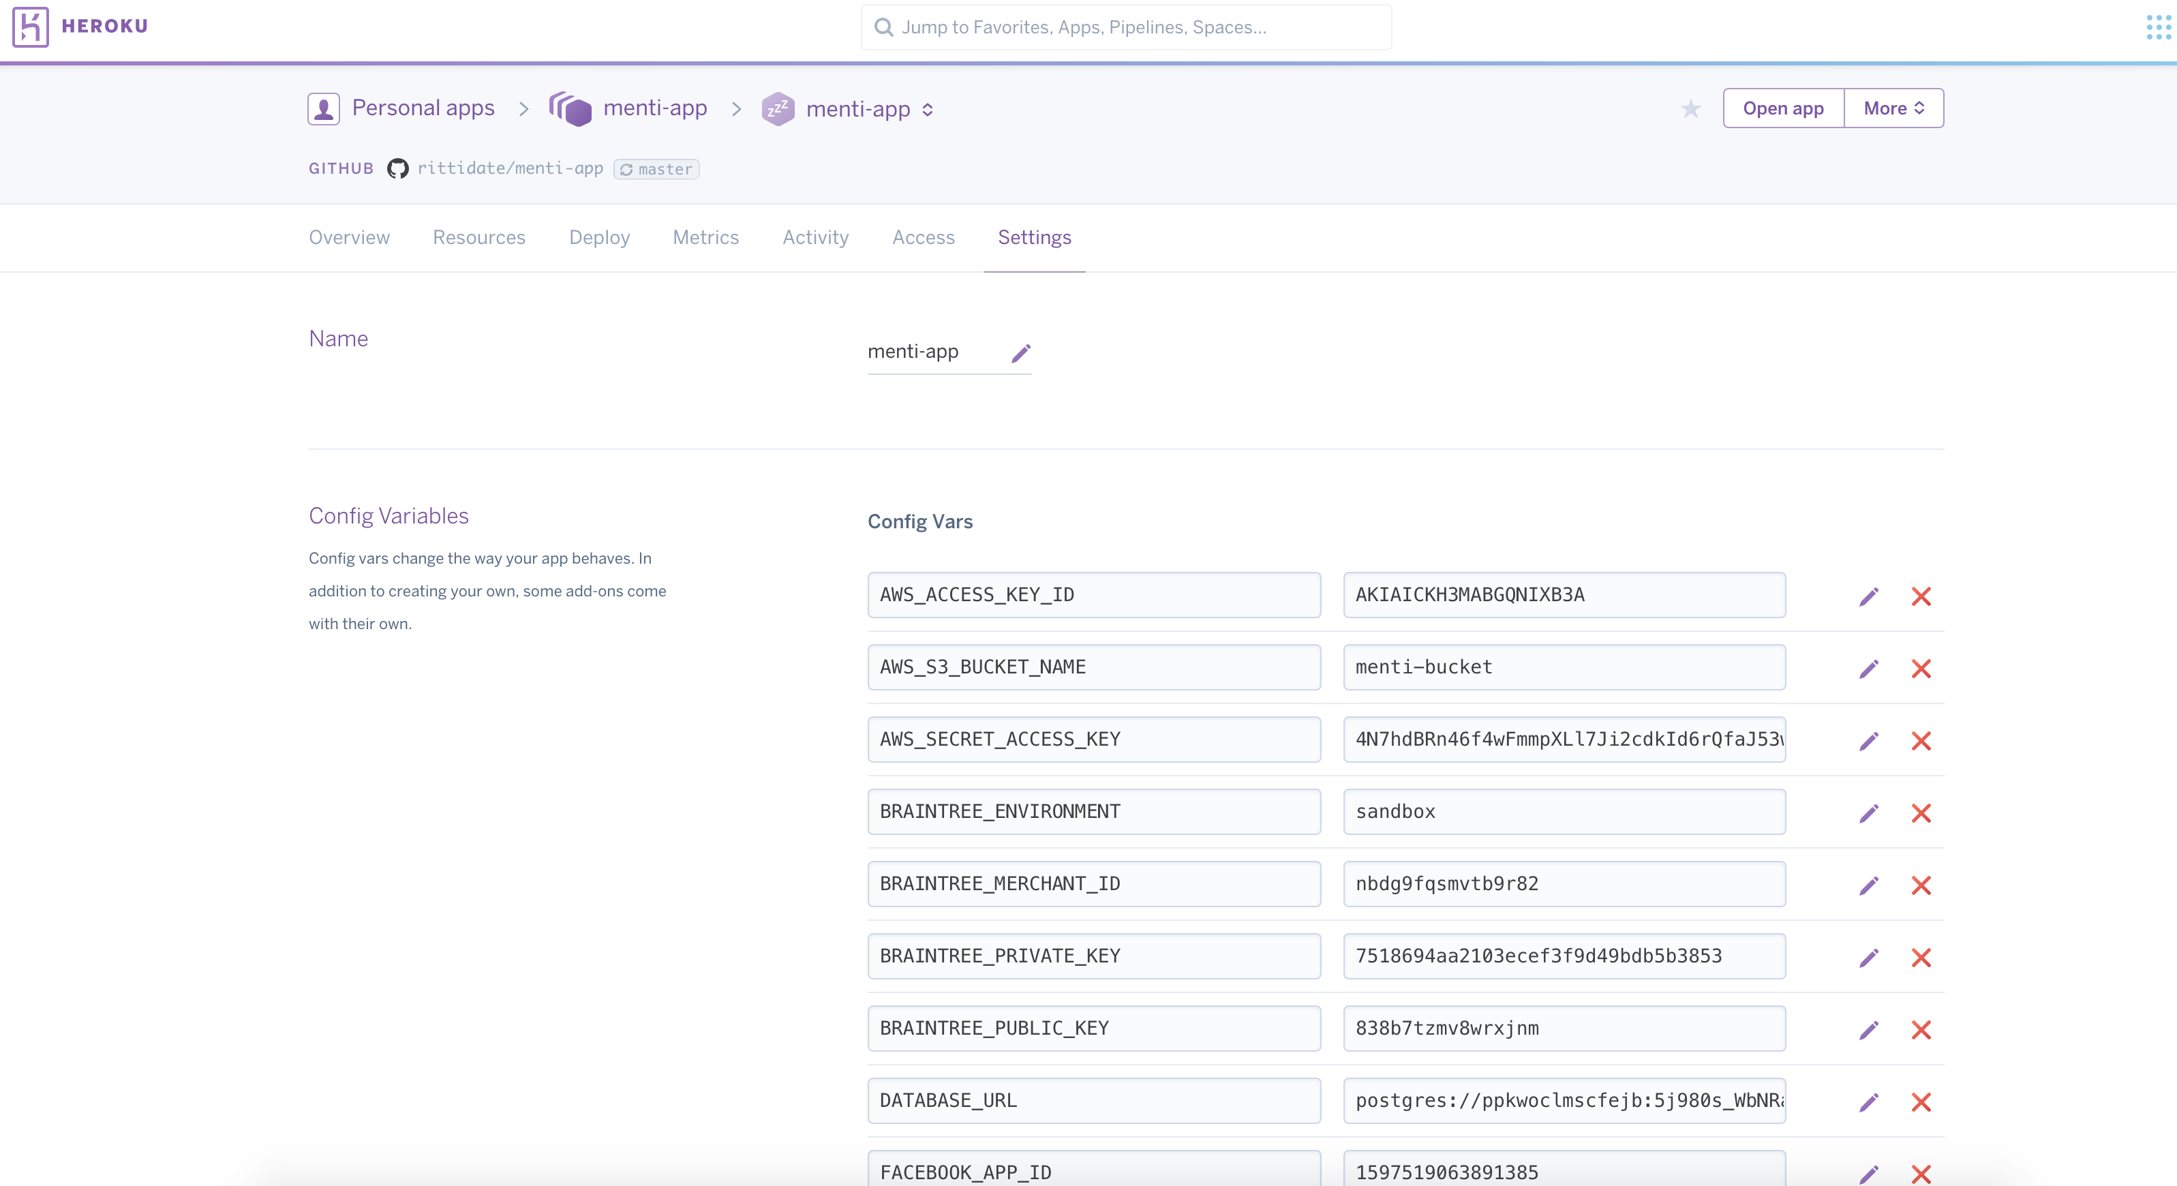

Figure 7.1 Heroku environment setup

vii. Setup the project database by using

|  |
| --- |
| #initial setup database  bundle exec rake db:setup    # migrate all database schema  bundle exec rake db:migrate  # insert initial data needed  bundle exec rake db:seed |

viii. Run rails on machine

**7.3 Other deployment**

For hosting, you have choices to choose the Heroku hosting or alternative hosting.

|  |
| --- |
| rails server |

i. Using the Heroku hosting

- Moving staging environment to production environment.

https://devcenter.heroku.com/articles/multiple-environments

- Changing from heroku domain to your domain

https://devcenter.heroku.com/articles/custom-domains

- Heroku pricing

https://www.heroku.com/pricing

ii. Alternative hosts which are compatible with this project.

- OpenShift

- Cloud Foundry

- AWS

For more information, http://blog.sudobits.com/2013/02/15/heroku-alternatives-for-deploying-rails-applications/

iii. The other services are developed in this project

- We use **AWS S3 service** to store files such as, images, documents and other files.

https://aws.amazon.com/s3

all information needed for AWS S3 service

* + - S3 bucket name
    - AWS ACCESS KEY ID
    - AWS SECRET ACCESS KEY

- **Facebook login app**

- **Braintree payment**

https://developers.braintreepayments.com/start/hello-server/ruby?_ga=1.215030231.197112222.1476859006