

< Project Title >

technical Report

Version 1

**Start Date: ?? /?? /????**

**Authors : Student1, s3515746**

**Student2, s3503567**

**Student3, s3492704**

**Student4, s3502607**

**Student5, s3446288**

Document Control

|  |  |  |  |  |  |
| --- | --- | --- | --- | --- | --- |
| **Version #** | **Implemented** | **Implementation** | **Reviewed** | **Approval** | **Reason** |
| **By** | **Date** | **By** | **Date** |
| 1 |  |  |  |  |  |
| 2 |  |  |  |  |  |
| 3 |  |  |  |  |  |
| 4 |  |  |  |  |  |
| 5 |  |  |  |  |  |

**STAFF or ENTITIES CONSULTED**

|  |  |
| --- | --- |
| **Name** | **Position / Organization** |
| Maria Spichkova | Lecturer-IF, RMIT University |

TABLE OF CONTENTS

**1** **Executive Summary**

**2** **introduction**

**3** **Requirements**

FUNCTIONAL REQUIREMENTS SPECIFICATION

NON FUNCTIONAL REQUIREMENTS SPECIFICATION

**4** **architecture**

**5** **TEchnical framework**

**6** **IMPLEMENTATION**

**7** **Deployment Instructions**

**8** **Test specifications**

**9** **testing results**

**10** **OTHER CONSIDERATIONS**

**11** **references**

# 

# 

# Executive Summary

Write here the executive summary of the project of the project (200-300 words).

—Overview and project aim

This project include the design and constructions of the Menti -- an exclusive website which allows mentoring become more efficient by using non face-to-face way. The primary aim of this was to design and construct such a website which members can successfully contact between mentor and mentee and do mentoring.

—Outline of Process and Planning stage

Initially, we separate our team into two teams -- frontend and backend. Fountend referred to design the straight version of our website and the backend is to add the function of payment and store the database.

—Outline the evolution

# introduction

Describe here the project objectives and goals in more details, add corresponding information on the project background and stakeholders. (min. 300 words)

Please note that all the tables and Figures in the report should ne named and numbered, like the Figure 1 below.

//The principle founder of this program has many years of experience in mentoring.

Until recently, mentoring has always been thought to be most efficient when conducted on a face-to- face basis. Recent research into human behavioural psychology suggests that a form of contact, which is not face-to- face, can have more honesty and deliver alternative benefits.

The timing for this unique model has now arrived, to make the ‘smart country’ even ‘smarter’.



**Figure 1:** <Caption of the figure>

# Requirements

## FUNCTIONAL REQUIREMENTS SPECIFICATION

Add here the specification of functional requirements.

## NON FUNCTIONAL REQUIREMENTS SPECIFICATION

Add here the specification of non-functional requirements, if required.

# architecture

Describe here the architecture of the system.

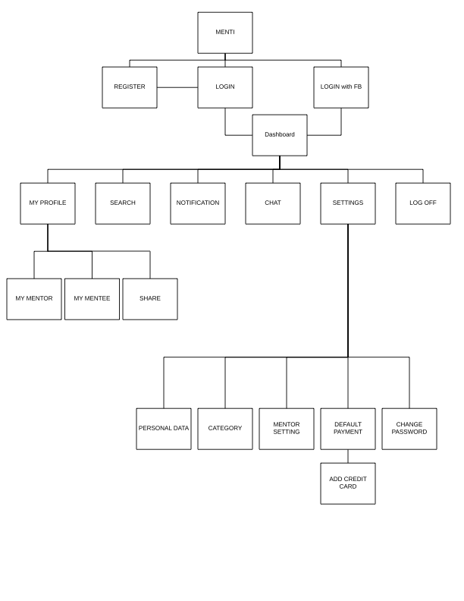

# TEchnical framework

Describe here all the technologies, environments, and languages you applied in the project.

TECHNICALS

FACEBOOK_APP Creation

1. Login to Facebook

Before creating a developer account, login in to your Facebook account.

2. Developer Account

You'll need Facebook developer account to get started. If you don't have one upgrade your personal Facebook account to a Facebook Developer account now. Skip this step, if you already have a developer account.

3. Create new Facebook app

Choose [**Apps**](https://developers.facebook.com/apps/) in the header navigation and select **Add a New App**

4. Choose Platform

Choose the platform you want to add. If your app is on multiple platforms, you'll be able to add them to your Facebook app later.

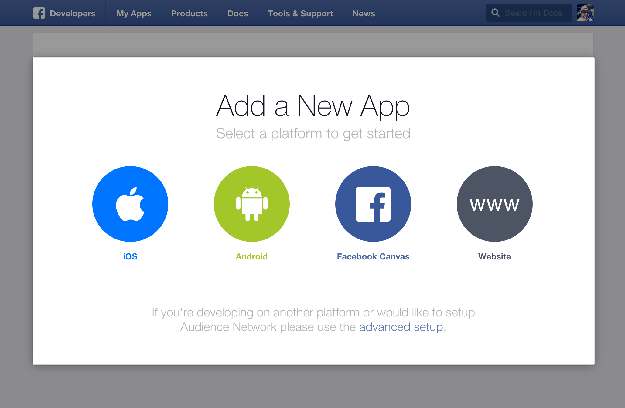

5. Choose a Name

Choose a name for your app and select **Create New Facebook App ID**. Choose a **category** for your app. If you're creating a test version of an existing Facebook app, select the app you're testing.

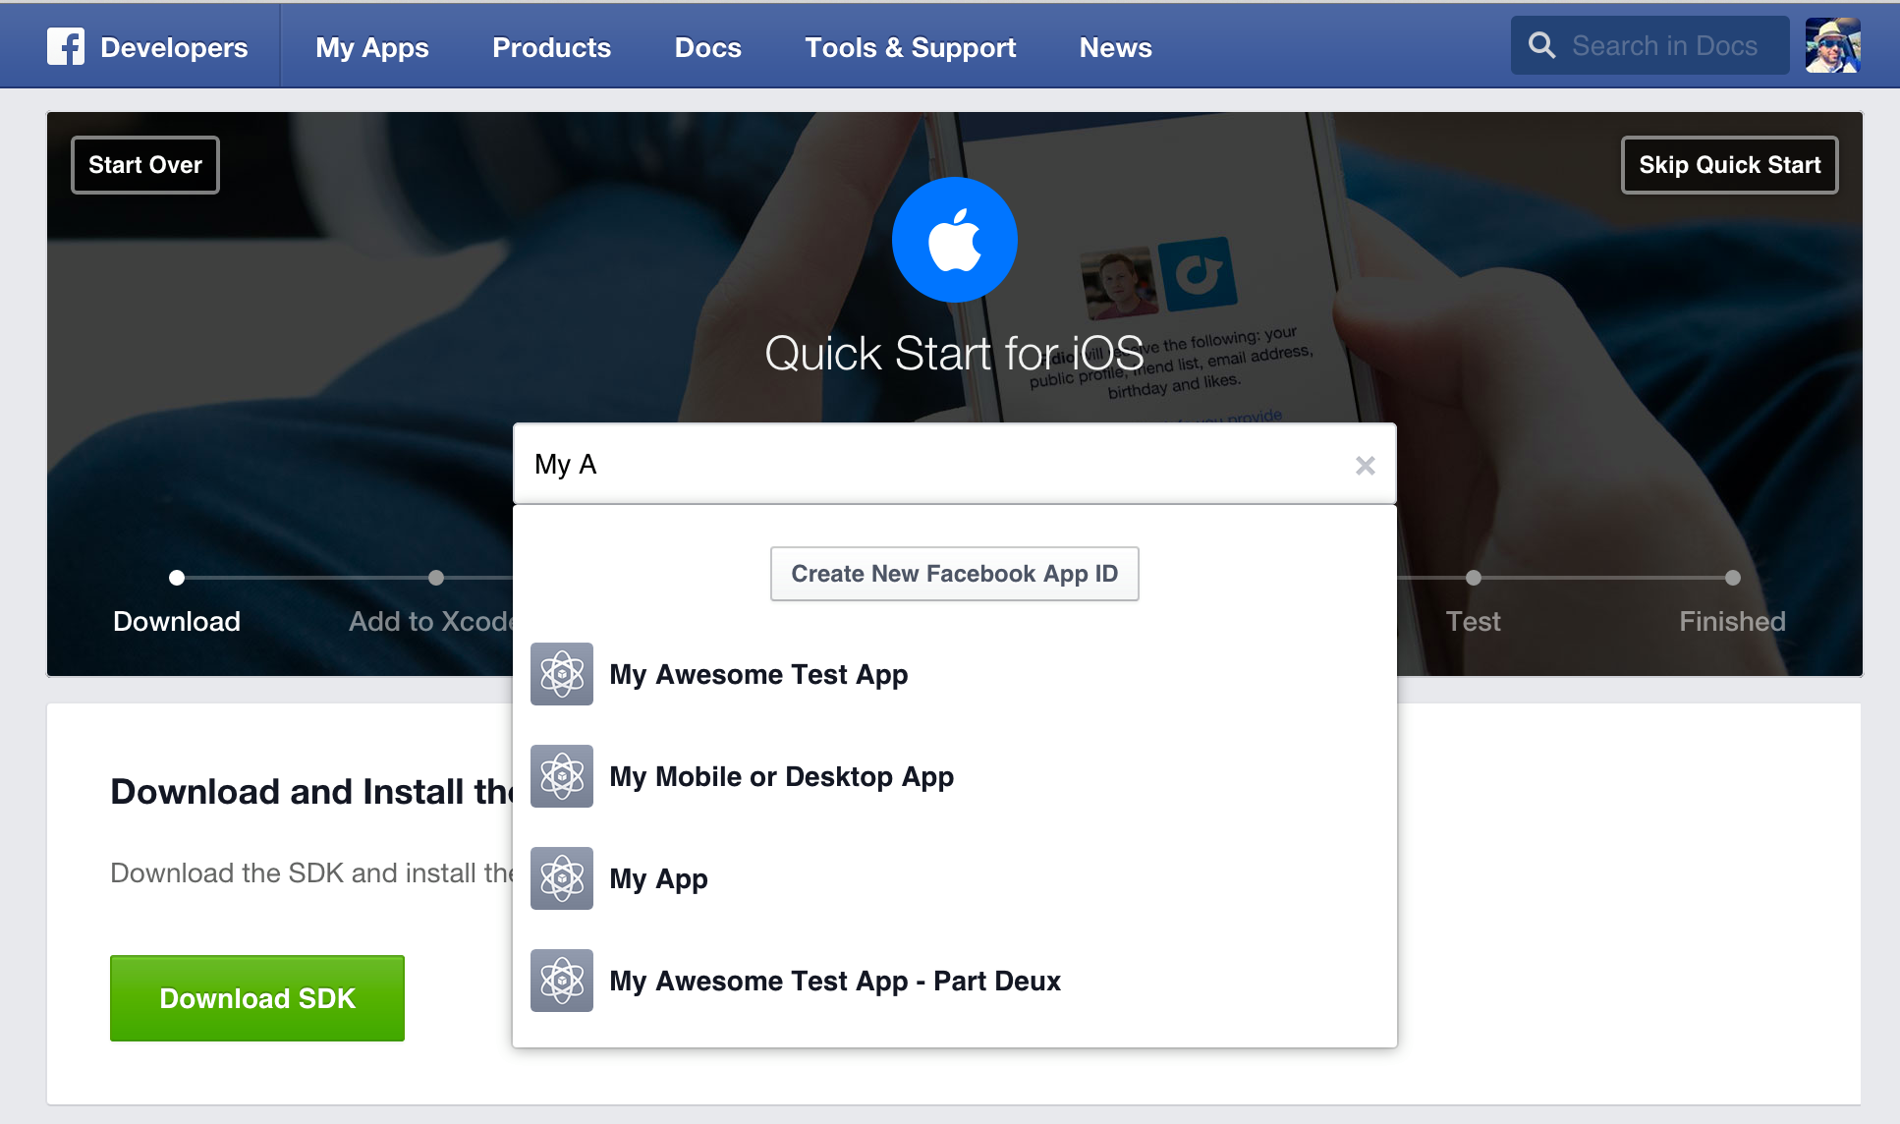

6. Follow "Quick Start" Steps

The quick start wizard will help you to set up your Facebook app for the selected platform. You can come back to the quick start wizard at a later time to either continue your setup or add a new platform to your app.

7. App ID

Your app will have a unique app ID. You will use this ID whenever you use one of our [SDKs](https://developers.facebook.com/docs/apis-and-sdks) or [Open Graph tags for sharing](https://developers.facebook.com/docs/sharing/webmasters/). You can find your app ID in your [app's dashboard](https://developers.facebook.com/apps/).

8. Protect your App Secret

Facebook auto-generates an app secret associated with your application. The application secret authenticates requests made by your application to Facebook servers and should be treated like a password.

Do not output your Facebook application secret in your web page markup; be careful when committing files containing this value into source control software such as a public Git or Subversion repository.

9. Contact Email

You need to add a contact email for each app. Go to your [app's dashboard](https://developers.facebook.com/apps/) and select the navigation item **Settings** in the left sidebar and provide a valid contact email.

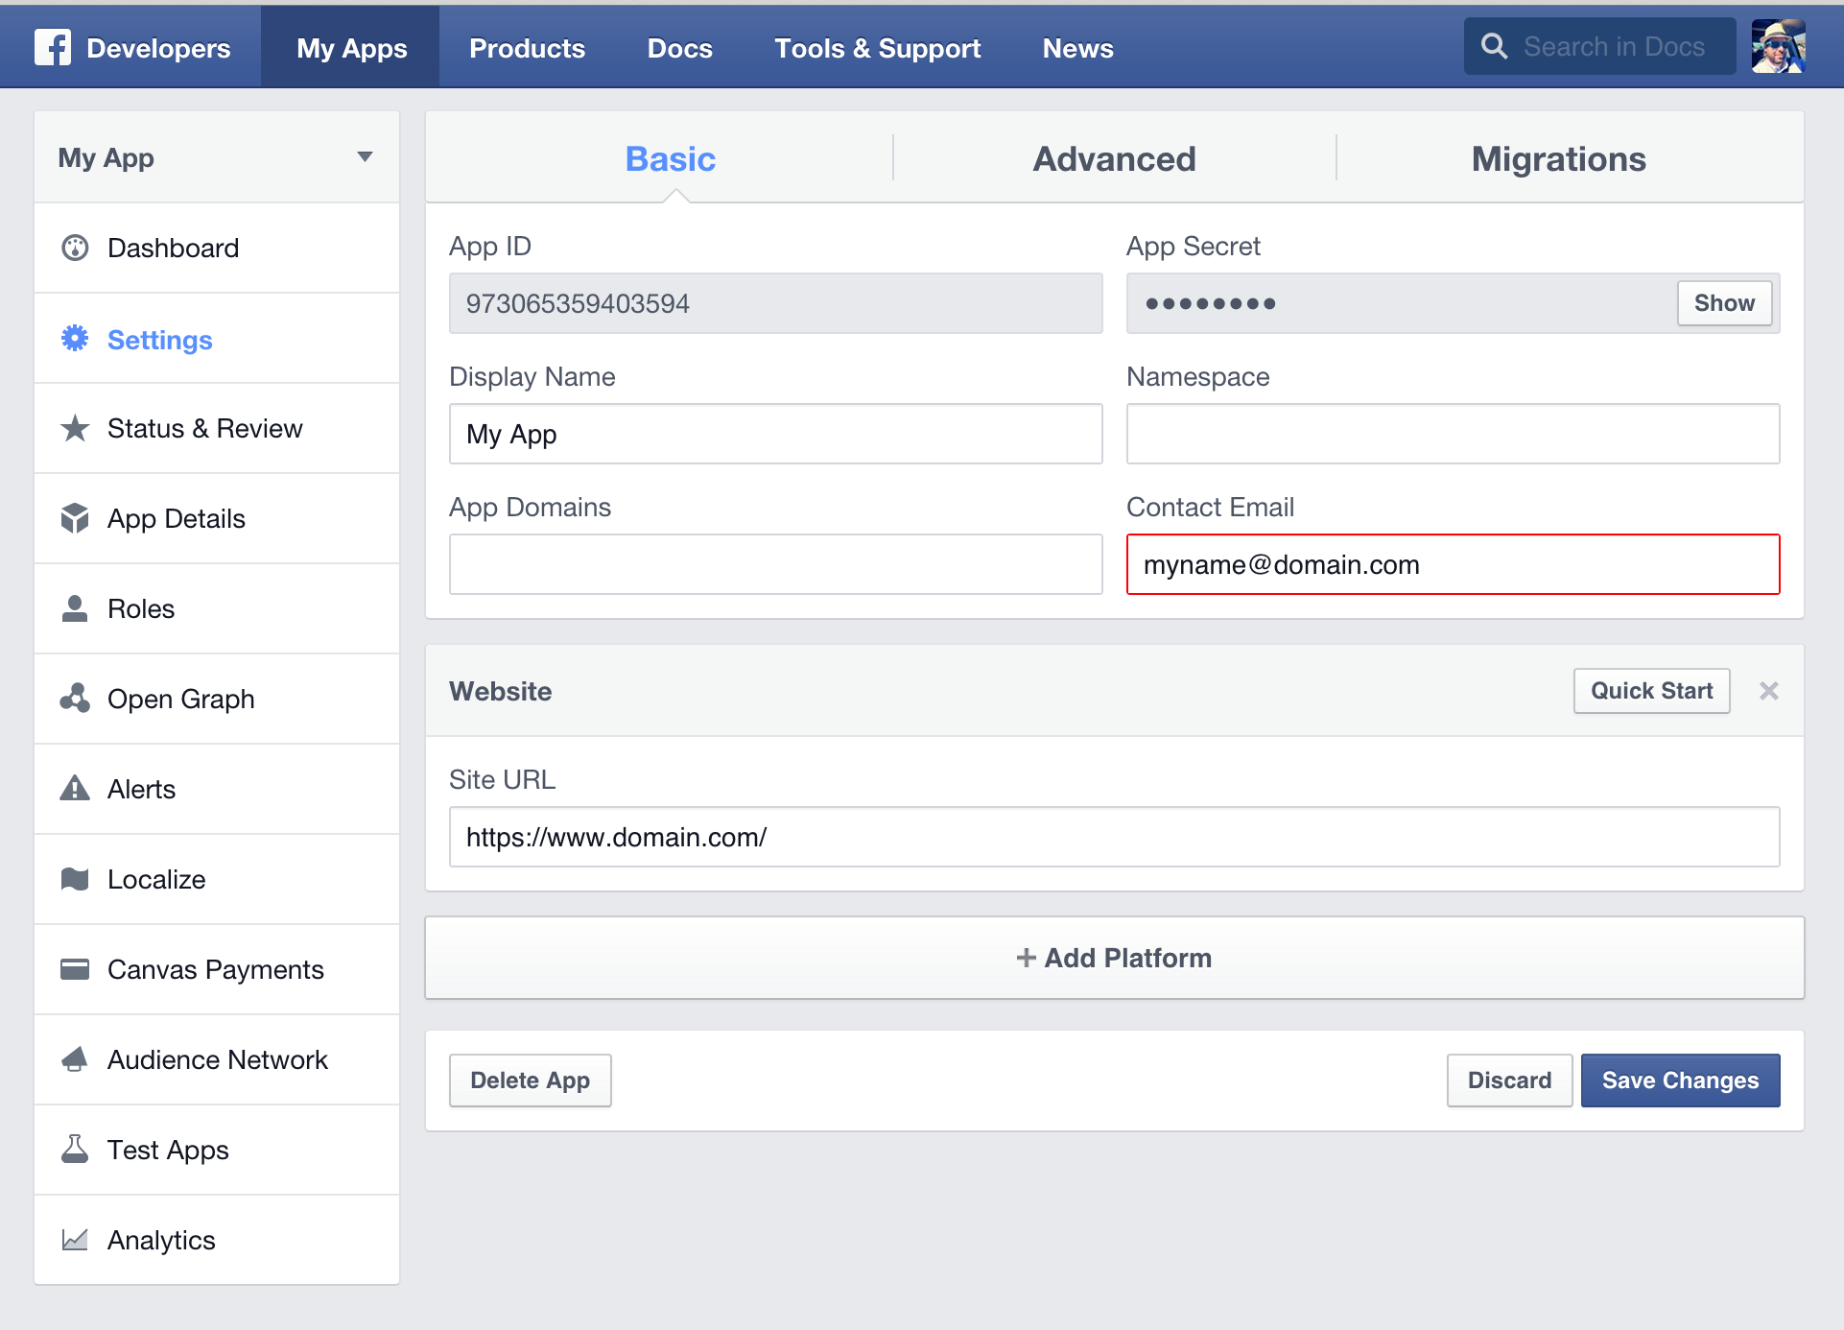

10. App Details

Select the App Details on the left sidebar to view and add additional information about your app.

If you want your app to be listed in app center, turn on the App Center Listed Platform setting for your website or mobile site. Add icons, promotional images, and videos. Make sure to follow the [App Center Guidelines](https://developers.facebook.com/docs/games/appcenter/guidelines) to be approved for listing in App Center.

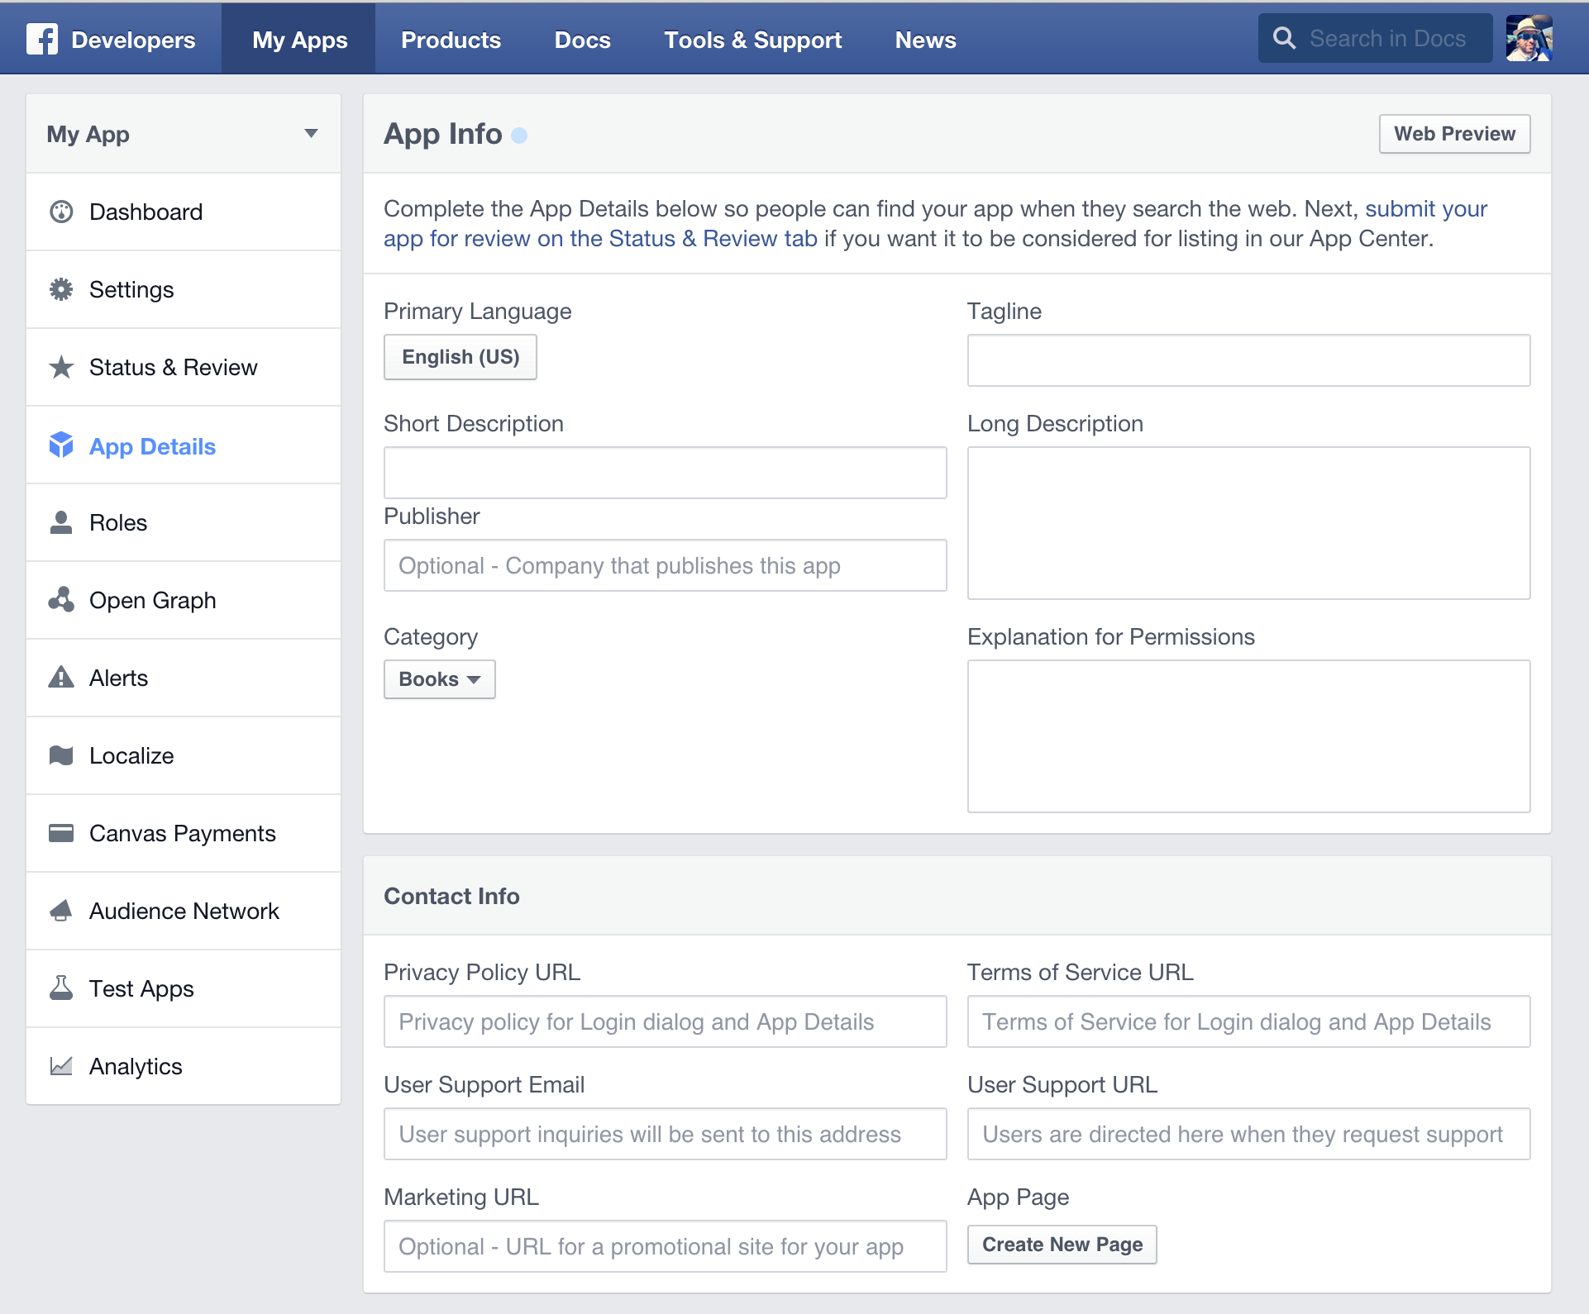

11. Disable Development Mode

New Facebook apps exist in development mode by default. This limits published actions and related objects such as friend tagging to Facebook Timelines owned by a developer of the application.

Once your application is ready for public use you can switch from development mode to public mode to allow your app to interact with Facebook accounts not associated with your app.

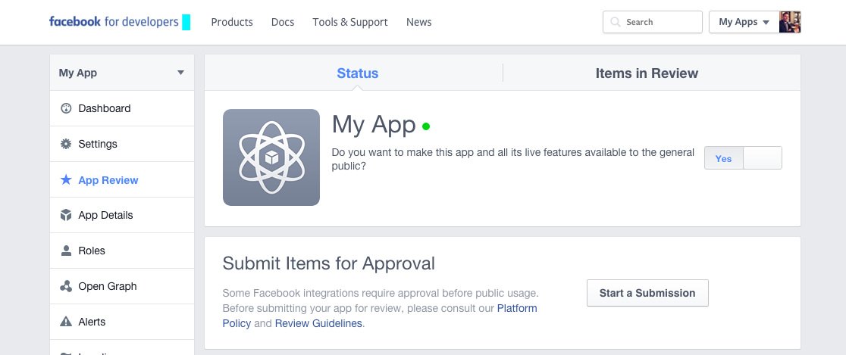

Submit Your App for Review

Once your app is ready you need to submit it for review. Learn more about the review process and what's required to pass review.

BRAINTREE CREATION

Create your own account in BrainTree_sandbox

Click Account->my user find ‘API Keys, Tokenization Keys, Encryption Keys’ and click View Authorizations

Find ‘Generate New API Key’ Button and New Public Key will be list in a form down below

Click View, MERCHANT_ID, PUBLIC_KEY, PRIVATE_KEY will be list in another form in new page.

AMAZON S3 BUCKET CREATION AND SETUP

1. Sign into the AWS Management Console and open the Amazon S3 console at <https://console.aws.amazon.com/s3>.
2. Click **Create Bucket**.

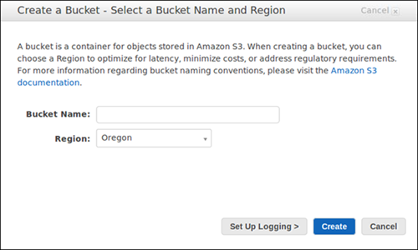

3. In the **Create a Bucket** dialog box, in the **Bucket Name** box, enter a bucket name.

The bucket name you choose must be unique across all existing bucket names in Amazon S3. One way to help ensure uniqueness is to prefix your bucket names with the name of your organization. Bucket names must comply with certain rules. For more information, see [Bucket Restrictions and Limitations](http://docs.aws.amazon.com/AmazonS3/latest/dev/BucketRestrictions.html) in the *Amazon Simple Storage Service Developer Guide*.

**Note:**After you create a bucket, you cannot change its name. In addition, the bucket name is visible in the URL that points to the objects stored in the bucket. Ensure that the bucket name you choose is appropriate.

4. In the **Region** box, select a region. For this exercise, select **Oregon** from the drop-down list.

You can choose a region to optimize latency, minimize costs, or address regulatory requirements. Objects stored in a region never leave that region unless you explicitly transfer them to another region. For more information about regions, see [Accessing a Bucket](http://docs.aws.amazon.com/AmazonS3/latest/dev/UsingBucket.html#access-bucket-intro) in the *Amazon Simple Storage Service Developer Guide*.

5. Click **Create**.

When Amazon S3 successfully creates your bucket, the console displays your empty bucket in the **Buckets** panel.

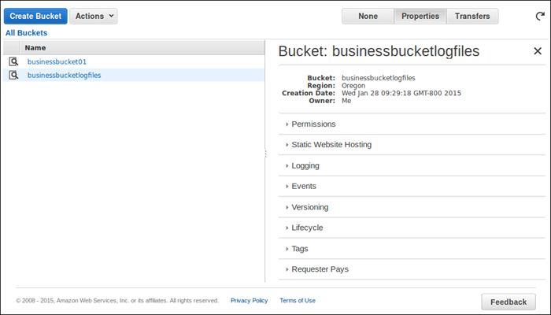

You've created a bucket in Amazon S3.

HAML-COFFEESCRIPT

Haml Coffee is a [Haml](http://haml-lang.com/) parser that understands [CoffeeScript](http://jashkenas.github.com/coffee-script/) and generates a JavaScript template that can be rendered to HTML in any JavaScript application like [Backbone.js](http://documentcloud.github.com/backbone/), [Express](http://expressjs.com/), [Spine.js](http://spinejs.com/),[JavaScriptMVC](http://javascriptmvc.com/), [Knockout JS](http://knockoutjs.com/) and many others.

Installation: Haml Coffee is available in NPM and you can be installed with



If you like to integrate Haml Coffee into the Rails 3.1 asset pipeline, check out

<https://github.com/emilioforrer/haml_coffee_assets>

Compile Haml Coffee

After the installation you will have a haml-coffee binary that can be used to compile single templates and even compile multiple templates recursively into a single file.

(For more options, please check

<https://docs.omniref.com/js/npm/haml-coffee/0.5.0/files/#advanced-haml-coffee-options>)

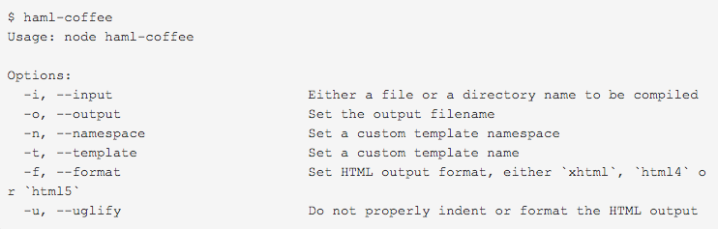

environmentals

development: heroku

production: os of server/ linux/ SQL or framework

//SQL

Languages

Ruby

framework/ SQL

ruby on rails

# IMPLEMENTATION

Describe the implementation of the app/webpage/tool/… that you developed; please provide the corresponding screenshots.

//webpages & screenshots

//red get the screenshots

sprint 1

1)project initiation

2)As an unauthenticated user i want to login into the website using my user name and password, so that i can start access the website contents.

sprint 2

1) As an authorized user i want to login into the website using my social media accounts i.e. facebook

2) Make the registration and login page responsive

3)Successfull login page

Sprint 3

1) Create initial dashboard

2) Enhance Registration Page

3) Registration page back-end

Sprint 4

1) Create setting page

sprint 5

1) My profile page

2) payment

3) update dashboard

4) Database schema for feeds

5) Database schema for payment

6) API connection for payment

sprint 6

1) Mentor profile design

2) Mentor profile backend

3) Notification icons on header

4) Follow database schema

5) Payment list design

sprint 7

1) Front-end for Mentor Profile(2)

2) Back-end for Mentor Profile(2)

# Deployment Instructions

Describe the deployment instructions, the basic specifications of the server, etc.

# Test specifications

Describe the testing frameworks you used within the project (if any), present the test cases related to the requirement specification.

//FUNCTIONS

//Testing for sign up, 2 pages

payment

change password

share new ideas/concepts/motivations

change personal data

change category add

change my profile

mentor change

follow parts

# testing results

Summarise the testing results.

### 

# OTHER CONSIDERATIONS

(if applicable)

# references

Please follow the referencing standards.