

< Project Title >

technical Report

Version ??.??

**Start Date: ?? /?? /????**

**Authors : Student1, s1234567**

**Student2, s1234567**

**Student3, s1234567**

**Student4, s1234567**

**Student5, s1234567**

**Student6, s1234567**

Document Control

|  |  |  |  |  |  |
| --- | --- | --- | --- | --- | --- |
| **Version #** | **Implemented** | **Implementation** | **Reviewed** | **Approval** | **Reason** |
| **By** | **Date** | **By** | **Date** |
| 1 |  |  |  |  |  |
| 2 |  |  |  |  |  |
| 3 |  |  |  |  |  |
| 4 |  |  |  |  |  |
| 5 |  |  |  |  |  |

**STAFF or ENTITIES CONSULTED**

|  |  |
| --- | --- |
| **Name** | **Position / Organization** |
| Maria Spichkova | Lecturer-IF, RMIT University |

TABLE OF CONTENTS

1 Executuve Summary 4

2 introduction 4

3 Requirements 4

FUNCTIONAL REQUIREMENTS SPECIFICATION 4

NON FUNCTIONAL REQUIREMENTS SPECIFICATION 4

4 architecture 4

5 TEchnical framework 5

6 IMPLEMENTATION 5

7 Deployment Instructions 5

8 Test specifications 5

9 testing results 5

10 OTHER CONSIDERATIONS 5

11 references 5

# 

# 

# Executuve Summary

Write here the executive summary of the project of the project (200-300 words).

# introduction

Describe here the project objectives and goals in more details, add corresponding information on the project background and stakeholders. (min. 300 words)

Please note that all the tables and Figures in the report should ne named and numbered, like the Figure 1 below.

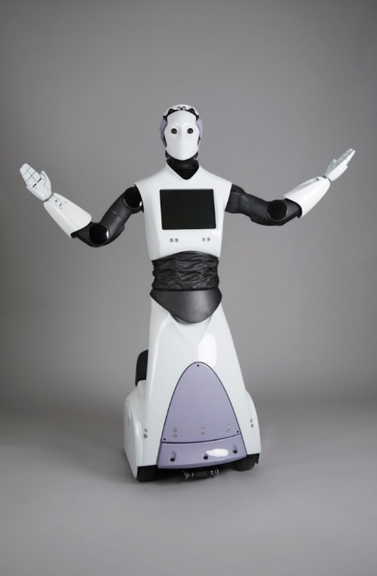

**Figure 1:** <Caption of the figure>

# Requirements

## FUNCTIONAL REQUIREMENTS SPECIFICATION

* The main aim of the system is to connect mentee to mentor for educational purposes.
* The system shall ask the user in the registration page whether the user is mentee or mentor.

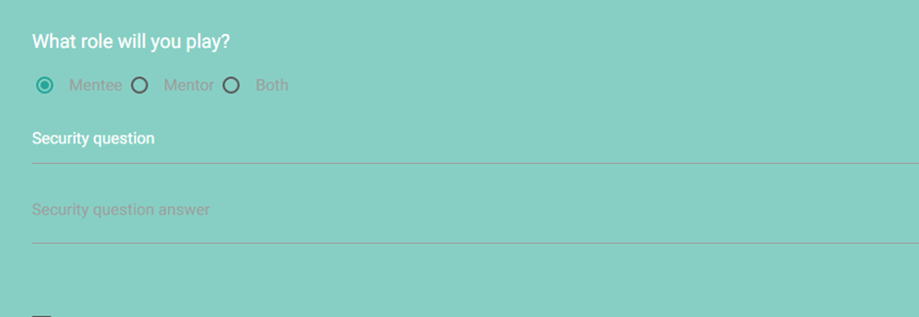

* The system shall make profile for each user, whether is a mentee, a mentor, or both after the registering.

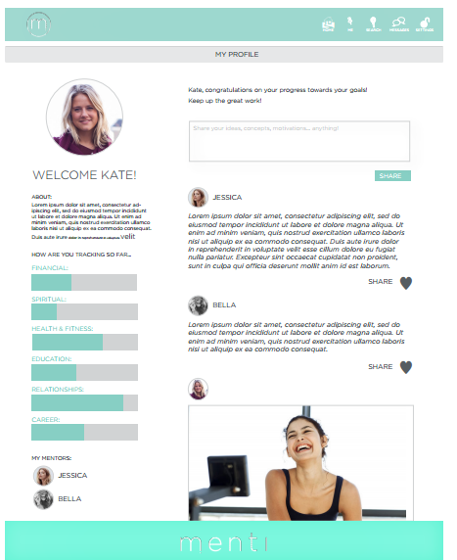

Mentee Profile

* Mentee member shall search for their preferred mentor.

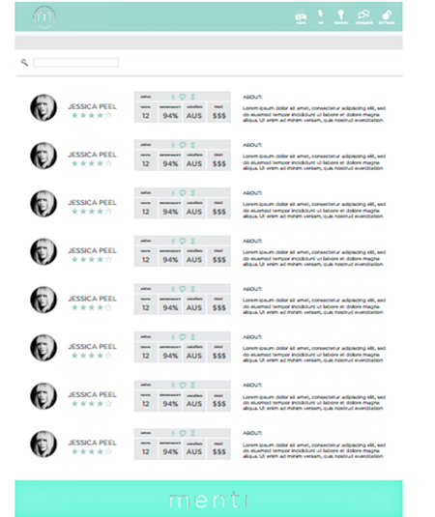

Search

* The system shall display mentor details such as description, rating, and rates for mentor skills. Moreover, the system shall able mentee to follow and rate mentor.

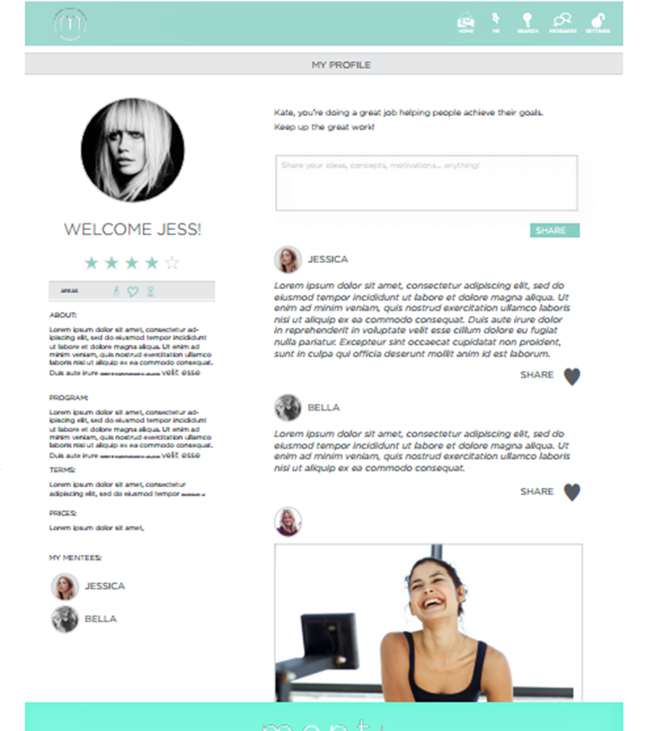

Mentor Profile

* If the mentor details meet the mentee expectations, the mentee can follow the chosen mentor and connect to through private messages between them. Also, users can see their history messages.

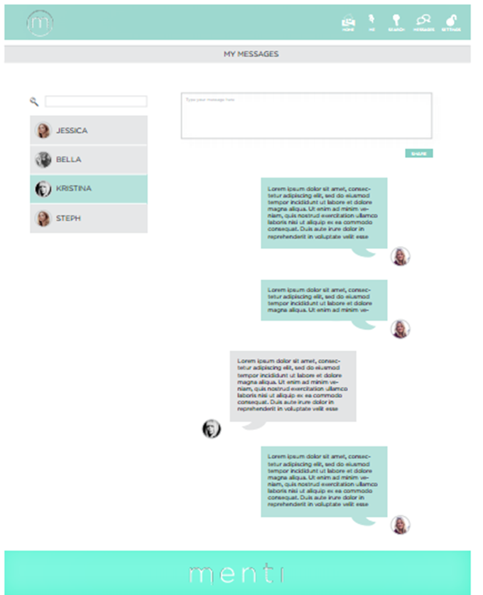

Messages, on the left hand side the user contacts

* The system shall allow Mentee to make payment in another webpage.

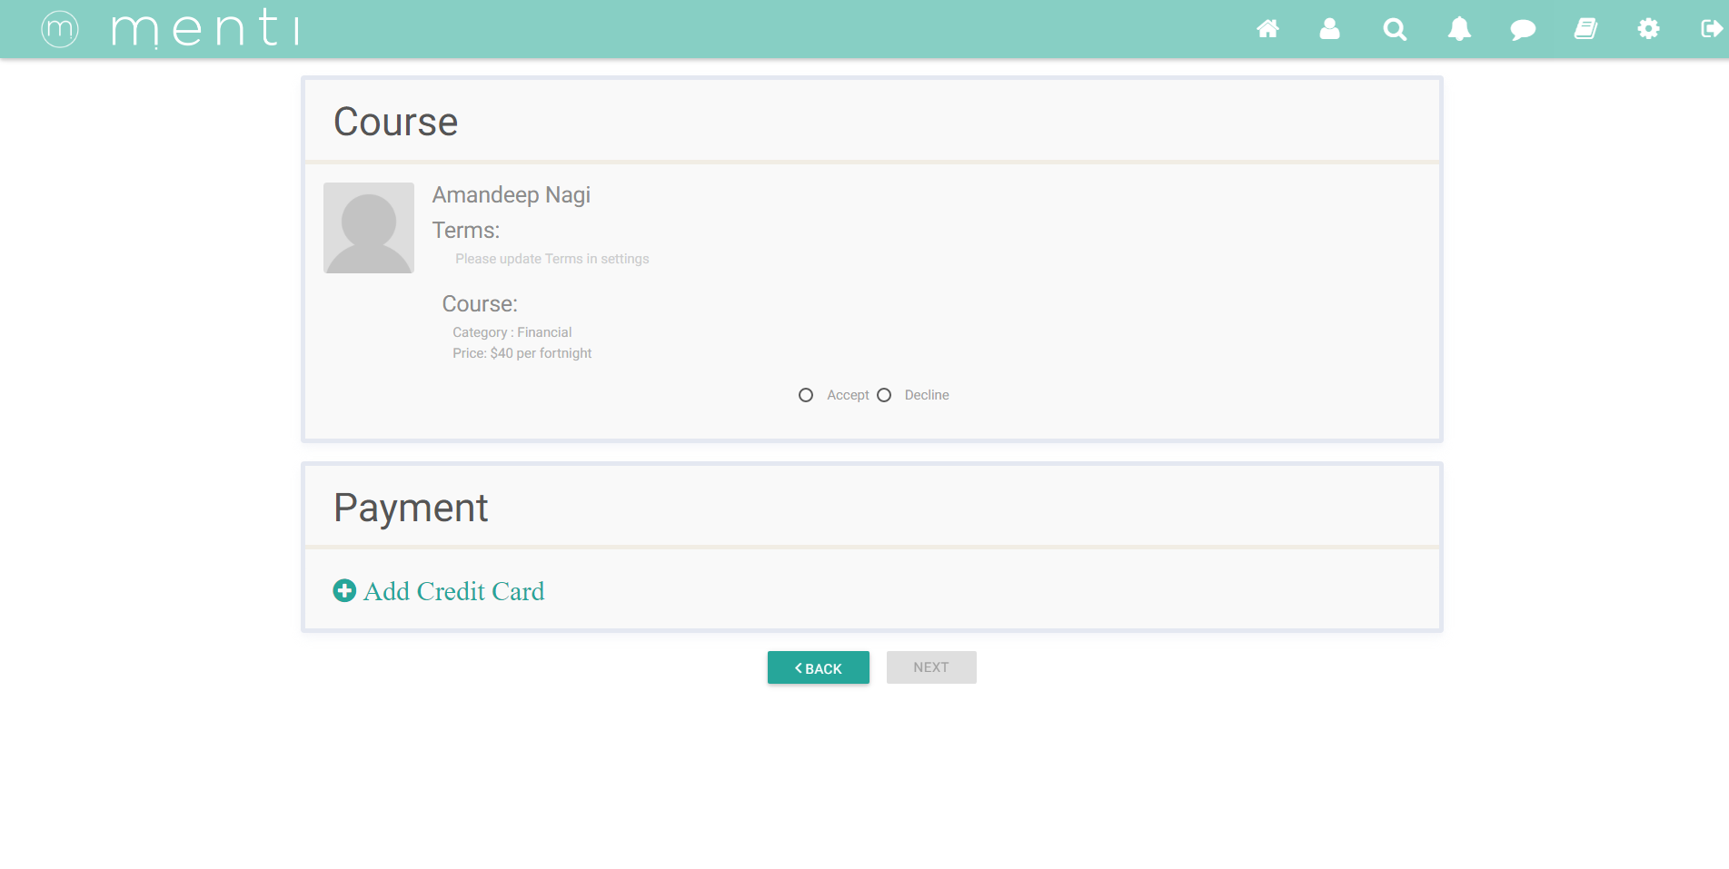

Payment Page

* The system shall allow user to search in resources in two different lists official resources & user generate resources. In addition to that, the system shall allow the user to upload their own resources.

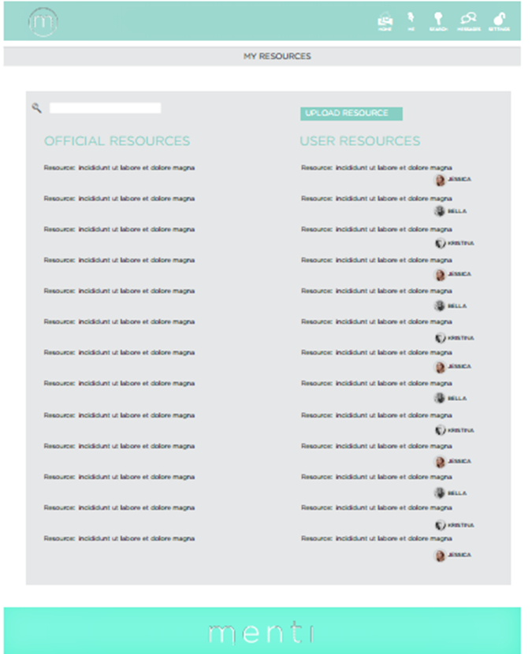

Resources Page

* The system shall allow users to share their thoughts, and it will be appearing in the home page. Who’s following this user will be able to see their thoughts in their own homepage. Also, they are able to make comments, and share the thought.

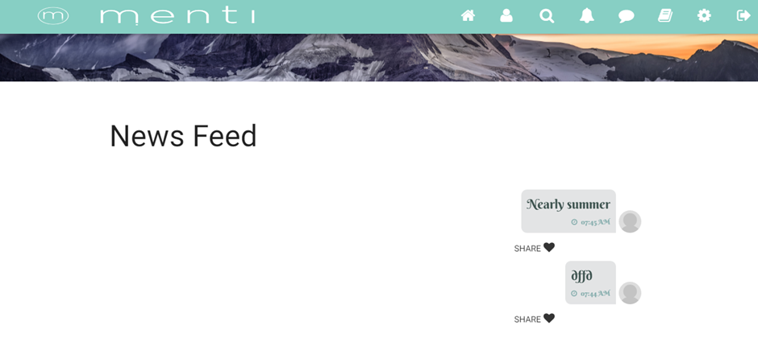

Home Page

* The system shall notify the user of any updates in the notification page.

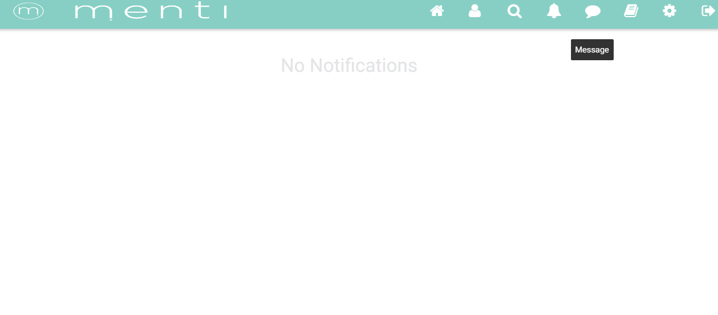

Notification Page

* The system shall allow update user details in the setting page.

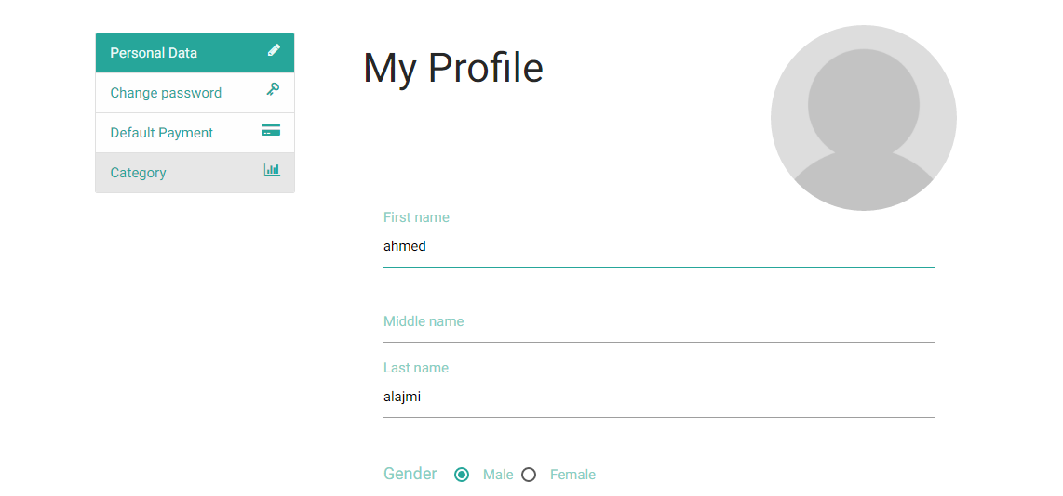

Setting Page

## NON FUNCTIONAL REQUIREMENTS SPECIFICATION

The system has non-functional requirements that can be used to evaluate the system operations:

* The system has a very good usability to assist the user to use the system in terms of navigation, notification, and in the website flow.
* The system focus on the user privacy and keep user confidential information private and invisible to other users such as credit cards details, and personal details.
* The system will generate reports from background information to gain insights into issues of importance.
* System availability is 95%.
* System performance:
* Respond Time: Not more than 5 seconds for the request.
* System reliability is 0.95
* System scalability: The system can handle up to 1000 request in a second.
* System security: The system has firewalls between application. The system has many areas:
* Uncontrol Area: Guests can visit this area and check the website services and benefits.
* Control Area: Authorised users only can access this area and use the website services such as users and admins.
* Restricted Area: Is the area that no one can access it, except for users such as admin. This is because it contains the databases and the servers.

Note: between each area there are firewalls and authentication access is required.

# architecture

Describe here the architecture of the system.

# TEchnical framework

Describe here all the technologies, environments, and languages you applied in the project.

# IMPLEMENTATION

Describe the implementation of the app/webpage/tool/… that you developed; please provide the corresponding screenshots.

# Deployment Instructions

Describe the deployment instructions, the basic specifications of the server, etc.

# Test specifications

## 

Describe the testing frameworks you used within the project (if any), present the test cases related to the requirement specification.

# testing results

Summarise the testing results.

### 

# OTHER CONSIDERATIONS

(if applicable)

# references

Please follow the referencing standards.