Apache NiFi processors

(GetHttp, PutFile, ExecuteCommand)

Prepared for: NostraData student project team

how to: Download + unzip file

Prepared by: Phatsakon Unsoda

17 August 2017

## Objective

To download zip file from ABS containing SA3 and Postcode mapping. Once the file downloaded, unzip it.

## Solution

1. Create **GetHttp** processor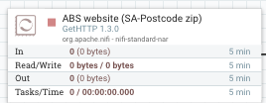

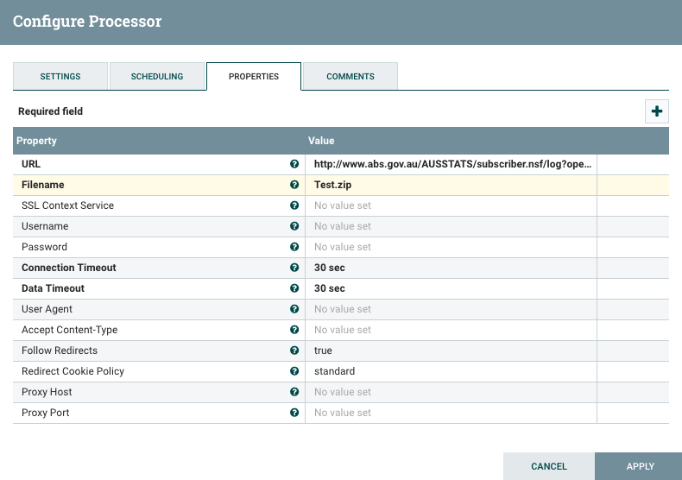

1. Create **PutFile** processor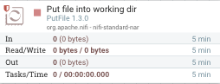

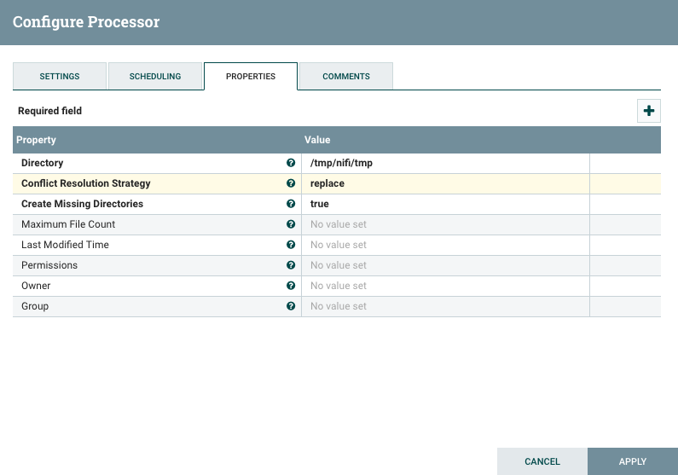

1. Create a **group** for them and add **output port**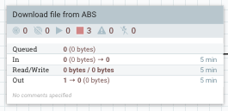

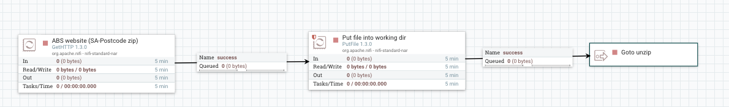

1. Create **ExecuteCommand** process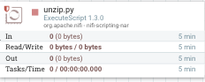

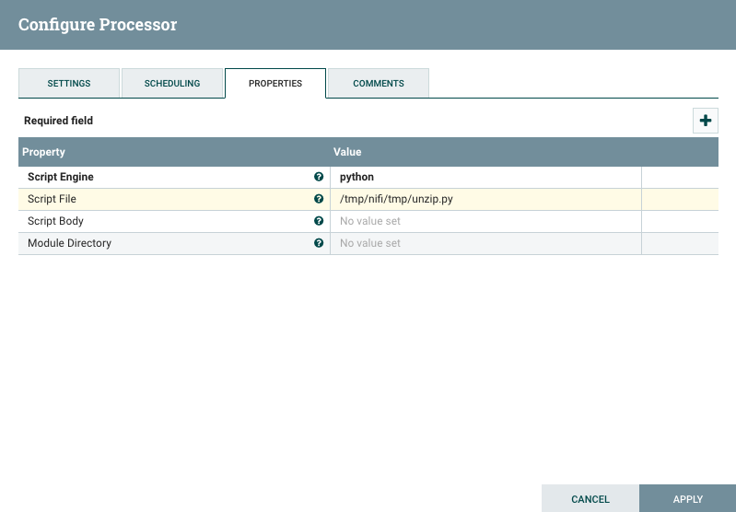

Note: Only one of Script File or Script Body may be used.

5. Create **unzip.py**

import zipfile

zip_ref = zipfile.ZipFile('/tmp/nifi/tmp/Test.zip', 'r')

zip_ref.extractall('/tmp/nifi/tmp/')

zip_ref.close()

6. **Link** them and test by first running the ‘**Processor Group**’