Cover page – Title

– Authors  
– Affiliations  
– Contact details  
– Date of publication

**TABLE OF CONTENTS**

ABSTRACT/ EXECUTIVE SUMMARY 3

INTRODUCTION 4

METHODOLOGY 5

RESULTS 6

DISCUSSION 7

CONCLUSION 7

REFERENCES 8

# ABSTRACT/ EXECUTIVE SUMMARY

The aim of this project is to successfully implement a data science modelling method and two to three subsequent techniques.

**FROM LECTURE NOTES**

A paragraph-length summary of the key arguments and findings

**Lecture note examples**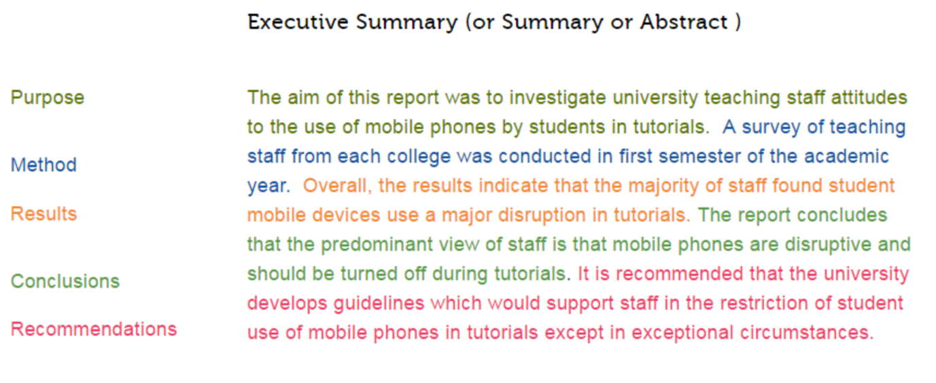

# INTRODUCTION

**FROM LECTURE NOTES**

Introduction

– Explanation of the problem

– Particularly important since many readers might not be experts in the topic area, or the analytical methods that were applied

– Often includes a literature review  
– Explain what’s already known, as well as gaps in knowledge

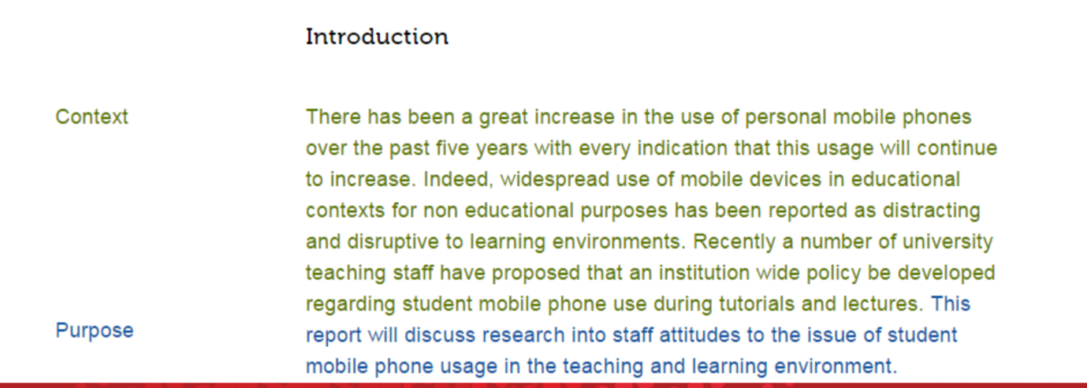

# METHODOLOGY

**FROM LECTURE NOTES:**

Methodology  
– Explanation of the research methods and data sources used

– Data collection process (particularly if new data was gathered) – Choice of variables used for analysis  
– Analytical techniques and models used

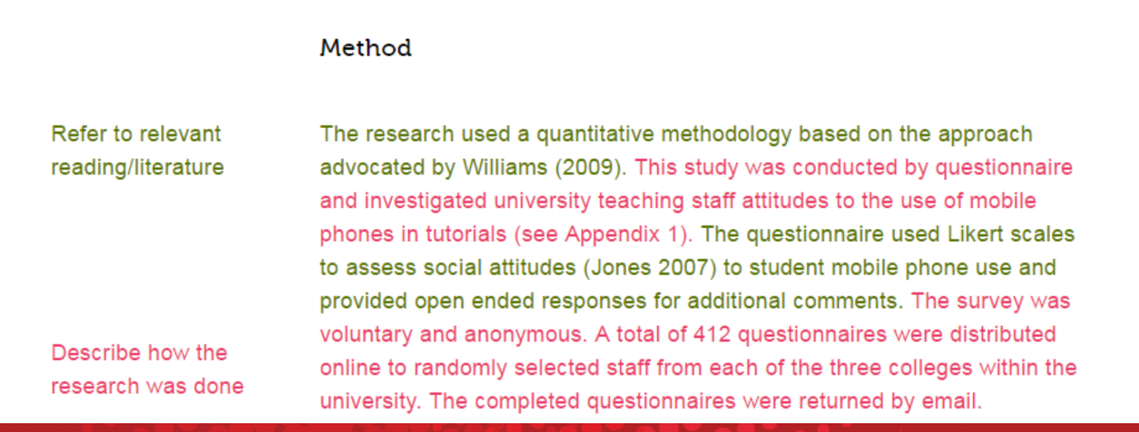

# RESULTS

**FROM LECTURE NOTES**

Results  
– Present the empirical findings of the analysis  
– Typically includes

– Descriptive statistics  
– Visualisations (graphs, charts, illustrative graphics) – Analytical / model outcomes

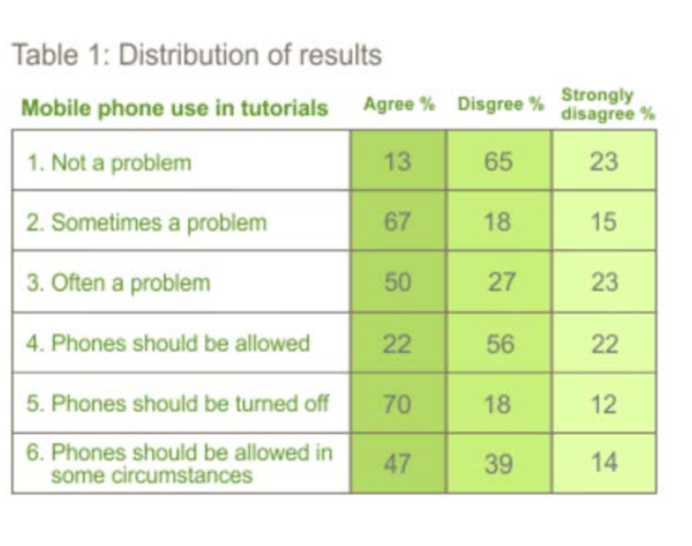

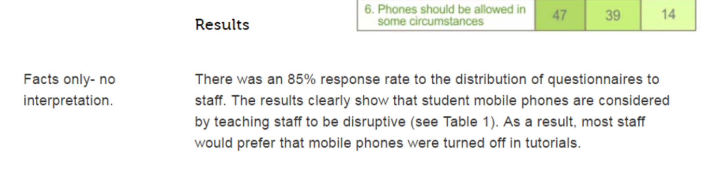

# DISCUSSION

# CONCLUSION

FROM LECTURE NOTES

Discussion

– Presentation of main argument

– Explains how the results address knowledge gaps and answer the research question

• Conclusion  
– Summarise findings  
– Explain wider applicability of results  
– Identify possible future developments and applications – New research questions that have opened up

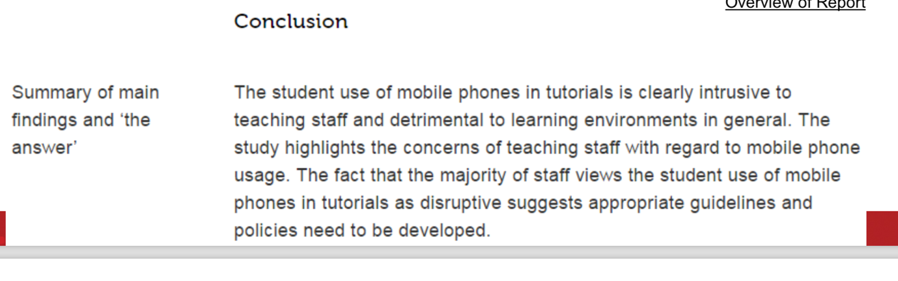

# REFERENCES