Assignment 2 – Adding Device Driver to Linux (25 Marks)

Operating Systems Principles (COSC1114_1750)

Rei Ito – s3607050

Lab – Wednesday 3:30-4:30PM

Tutor -  Paul Miller

2017

# Running Environment

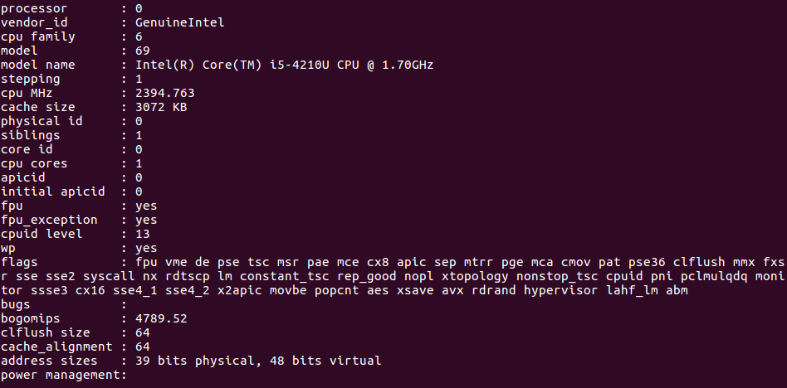

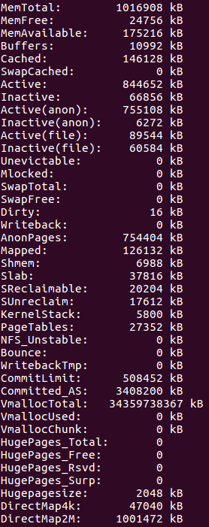

# Progress Diary

|  |  |  |  |  |
| --- | --- | --- | --- | --- |
| Stage | Step | Task Description | Comments | Time |
| 1 | 1 | Search for resources that can help/guide me to what needs to be done. Found: <http://derekmolloy.ie/writing-a-linux-kernel-module-part-2-a-character-device/> and <https://www.youtube.com/watch?v=_4H-F_5yDvo> | Resources to get me started | 30/09/17 to 30/09/17 |
|  | 2 | 2 Files created: ‘S3607050Device.c’ and ‘Makefile’ | Module code and make compiler commands | 30/09/17 to 30/09/17 |
|  | 3 | Compile commands added to ‘Makefile’ | Make ‘S3607050Device’ as a module | 30/09/17 to 30/09/17 |
|  | 4 |  |  | 30/09/17 to 30/09/17 |
|  | 5 |  |  | 30/09/17 to 30/09/17 |
|  | 6 |  |  | 30/09/17 to 30/09/17 |
|  | 7 |  |  | 30/09/17 to 30/09/17 |
|  | 8 |  |  | 30/09/17 to 30/09/17 |
|  | 9 |  |  |  |
|  | 10 |  |  |  |
|  | 11 |  |  |  |
|  | 12 |  |  |  |
|  | 13 |  |  |  |
|  | 14 |  |  |  |
|  | 15 |  |  |  |
|  |  |  |  |  |
|  |  |  |  |  |
|  |  |  |  |  |
|  |  |  |  |  |
|  |  |  |  |  |
|  |  |  |  |  |
|  |  |  |  |  |
|  |  |  |  |  |
|  |  |  |  |  |
|  |  |  |  |  |
|  |  |  |  |  |
|  |  |  |  |  |
|  |  |  |  |  |
|  |  |  |  |  |
|  |  |  |  |  |

## Proof:



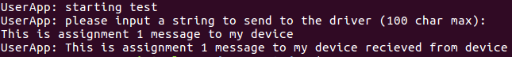

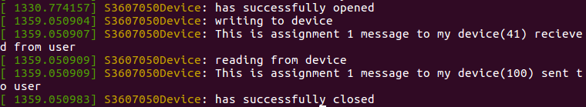

# Files Involved

## Makefile

## S3607050Device.c

## S3607050Device.h

## S3607050UserApplication.c

## S3607050UserApplication.h