The Role of AI in Modern Healthcare

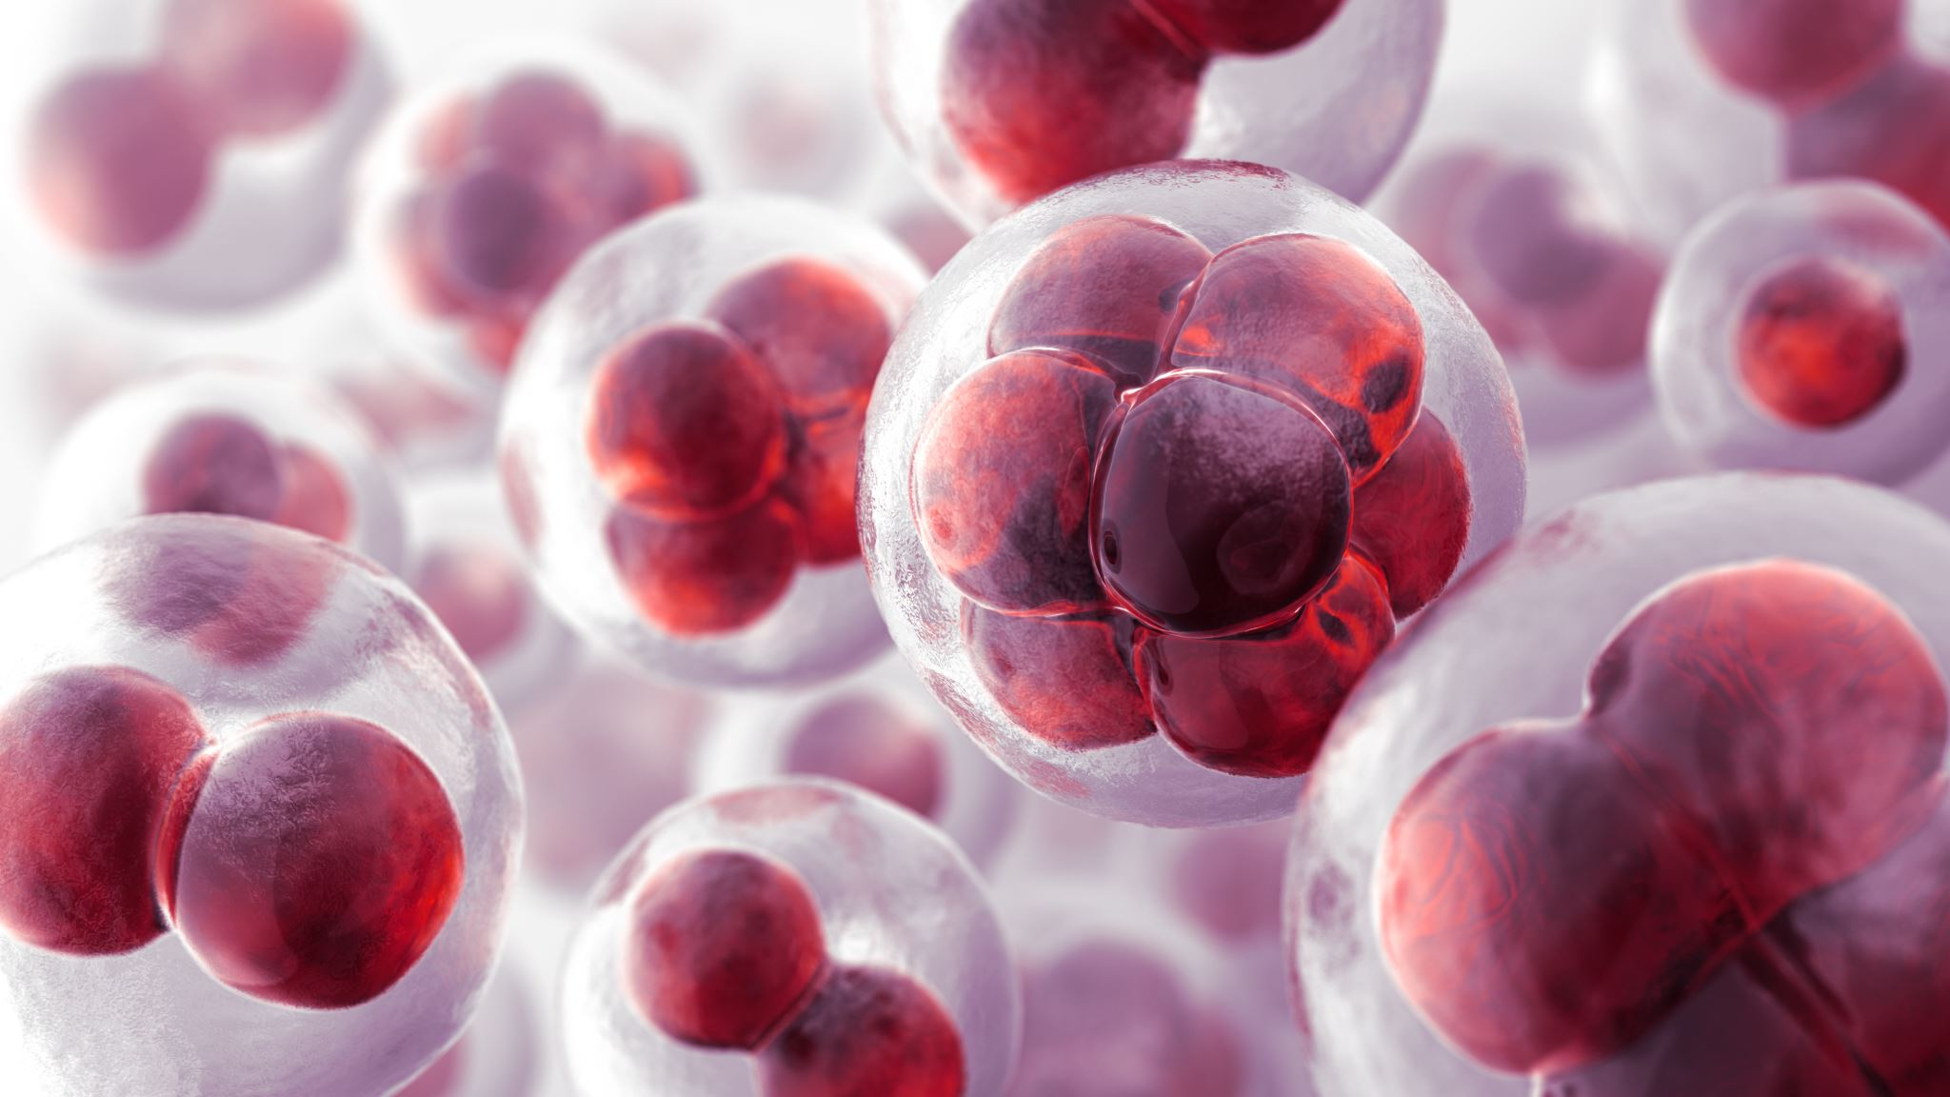



Bridging the gap between technology and healthcare

Contents

The Historical Journey of Artificial Intelligence 2

Understanding the relationship between AI, ml, dl, and nlp 2

Transforming Healthcare: Harnessing the power of AI in the Modern Era 2

Leveraging AI for Improved healthcare Delivery 2

The Role of AI in Hospitals and Clinics: transforming healthcare in the 21st Century 3

Artificial Intelligence in Modern Medicine – The Evolving Necessity of the Present and Role in Transforming the Future of Medical Care. 4

The Growing Impact of AI on Healthcare Efficiency and Patient Care 4

References 6

Figure 1 2

Figure 2 4

Table 1 5

# The Historical Journey of Artificial Intelligence

## Understanding the relationship between AI, ml, dl, and nlp

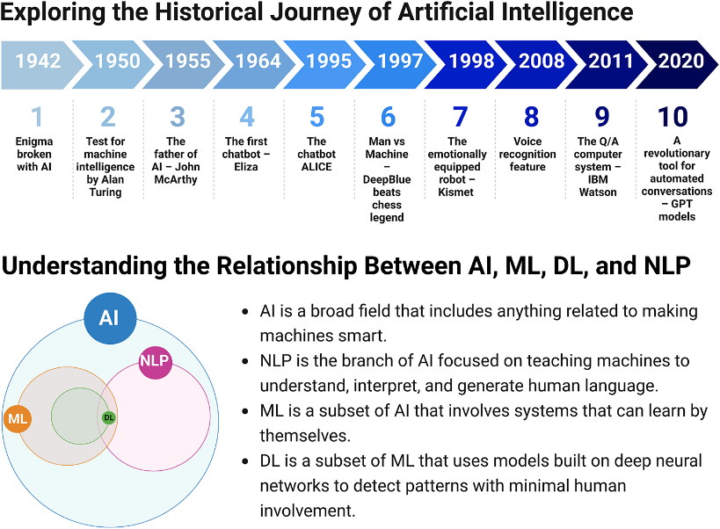Artificial intelligence is currently revolutionizing industries like healthcare, finance, and transportation, with its influence expected to expand even further. In the academic sphere, AI has been instrumental in creating intelligent tutoring systems—computer programs tailored to meet individual students' needs—which have significantly enhanced learning outcomes in subjects such as math and science. In research, AI is being used to analyze vast datasets, uncovering patterns that are difficult for humans to identify, leading to advancements in areas like genomics and drug discovery. In healthcare, AI has played a key role in developing diagnostic tools and personalized treatment plans. As AI continues to progress, it is essential to ensure its responsible development and use for the benefit of society as a whole. (Alowais, 2023)

Figure 1

# Transforming Healthcare: Harnessing the power of AI in the Modern Era

## Leveraging AI for Improved healthcare Delivery

By providing creative answers to enduring problems in the sector, artificial intelligence (AI) is transforming healthcare delivery. The use of AI technologies has the potential to improve operational effectiveness, patient care, and overall healthcare results.

In this post, we'll examine the most important uses of AI in healthcare delivery and the advantages they provide for patients, healthcare workers, and the whole healthcare system. Healthcare administrators will have more time to devote to patient care as a result of AI automating numerous administrative jobs. Large volumes of data, including electronic health records (EHRs) and medical paperwork, can be processed and analyzed by natural language processing (NLP) and machine learning algorithms to extract pertinent information, automate coding, and increase the precision of medical billing and claims processing.

Virtual assistants and catboats powered by AI may also schedule appointments, answer common patient questions, and provide basic medical information. Increasing diagnosis accuracy is one of AI's most exciting medical applications [13].

Medical imaging data from X-rays, CT scans, and MRIs can be analyzed by AI algorithms to look for abnormalities and help radiologists identify diseases including cancer, cardiovascular issues, and neurological disorders. AI's capacity to analyze and process enormous volumes of data enables more precise and quick diagnoses, lowering the possibility of a misdiagnosis and enhancing patient outcomes. By using patient data to identify those who are at risk of contracting specific diseases or problems, AI enables predictive analytics. In order to find trends and estimate the incidence of particular medical disorders, machine learning algorithms can examine patient demographics, medical histories, and lifestyle factors [14]. Early risk identification allows healthcare professionals to personalize treatment strategies, take proactive preventative action, and improve patient outcomes while lowering costs. (Patil, 2023)

# The Role of AI in Hospitals and Clinics: transforming healthcare in the 21st Century

Deep learning (DL), a subset of machine learning (ML), utilizes neural networks with multiple layers, allowing it to analyze complex data structures. Convolutional Neural Networks [1](CNNs) are especially adept at processing imaging data, making them invaluable for diagnosing diseases from medical images such as X-rays and MRIs. Advanced CNN architectures, including Residual Networks (ResNet), Inception, Visual Geometry Group (VGG), and Graph Convolutional Networks (GCNs), each offer unique strengths for tasks like image analysis, classification, and graph data processing. Recurrent Neural Networks (RNNs), which excel at handling sequential data, are commonly used to analyze time-series data, such as physiological signals gathered during patient monitoring, to predict health deteriorations or outcomes over time. For example, Long Short-Term Memory (LSTM) networks, a more advanced type of RNN, are widely employed in detecting sleep apnea from polysomnography data. Transformer models, such as BERT (Bidirectional Encoder Representations from Transformers) and GPT (Generative Pre-trained Transformer), represent a groundbreaking approach to processing clinical notes and extracting patient information with greater accuracy. Generative Adversarial Networks (GANs) and conditional diffusion models have become powerful tools for generating synthetic medical images used for training purposes without raising privacy concerns, while Graph Neural Networks (GNNs) are unlocking new opportunities in modeling complex biological and health networks, such as predicting protein interactions and understanding disease pathways. [The role of AI in hospitals and clinics.](https://www.mdpi.com/2306-5354/11/4/337) (Maleki Varnosfaderani, 2024)[A diagram of a healthcare system
](https://www.mdpi.com/2306-5354/11/4/337)

Figure 2

# Artificial Intelligence in Modern Medicine – The Evolving Necessity of the Present and Role in Transforming the Future of Medical Care.

## The Growing Impact of AI on Healthcare Efficiency and Patient Care

AI has the potential to revolutionize healthcare in the coming era, having already demonstrated its ability to improve efficiency in medical care delivery. AI techniques can quickly and accurately interpret large volumes of data, thereby enhancing patient care. However, AI has its limitations and cannot fully replace the clinical judgment of a physician at the bedside. Today, AI is integrated into medical practice, such as through computer vision in medical imaging. The ever-evolving field of medicine is becoming increasingly digital with rapid technological advancements. To maximize its benefits, the application and interpretation of AI models must be tailored to appropriate clinical settings. The future demands a smart and strategic use of AI to further improve the accuracy and efficiency of healthcare.

Telehealth clinics, remote monitoring of cardiac devices, and the interpretation of imaging studies by radiologists and cardiologists through electronic health records are already widely used, particularly during the COVID-19 pandemic. Additionally, online medical conferences and the use of social media for medical education represent new technological advancements in the field. AI is well on its way to shaping a better future in the post-COVID-19 era. (Bhattad, 2020)

Table 1

# References

Alowais, S. A. (2023). Revolutionizing healthcare: the role of artificial intelligence in clinical practice. *BMC medical education*, 689.

Bhattad, P. B. (2020). Artificial intelligence in modern medicine--the evolving necessity of the present and role in transforming the future of medical care. *Cureus*.

Maleki Varnosfaderani, S. a. (2024). The role of AI in hospitals and clinics: transforming healthcare in the 21st century. *Bioengineering, 11*, 337.

Patil, S. a. (2023). Transforming healthcare: harnessing the power of AI in the modern era. *International Journal of Multidisciplinary Sciences and Arts, 2*, 60--73.

1. CNNs are a type of deep learning model designed to analyze visual data. In medical imaging, they can identify patterns and anomalies, assisting radiologists in diagnosing diseases such as cancer and neurological disorders.