**Pup Inflation: Analysis of @dog_rates Twitter Handle**

Raghav Mittal, 301307947

In the report, we are going to talk about the following question: Has there been grade inflation on the @dog_rates Twitter, which rates the cuteness of users' dog pictures? In order to study about grade inflation, I gathered tweets for this account and in order to make sense of the data fetched, I decided to consider only those tweets where people have mentioned some form of rating (something numerical like 7/10 or 20/10). After discarding some more tweets where ratings were very hard to believe (like 100,000 on 10), left over data can be considered as “clean” data to work on.

To study about inflation in the grades, a statistical test was conducted to study how dog ratings are evolving with time. In order to this, the dog ratings were rendered into a scatter plot against the time when they were tweeted, and a best fit line is drawn fitting the data as shown in Figure 1. It is clearly visible that the best fit line confirms that dog ratings and time share a linear relationship. In addition to this, with the help of the statistical test performed, the slope of this line was found to be about 3.51593e-08 which is positive and hence, we can conclude that the ratings have increased over the time period of our observation i.e. Jan, 2016 – May, 2019. This fact can also be confirmed by looking at the correlation coefficient between the two factors which turns out to be approximately equal to 0.501 which makes us confident enough to say that as time passes by, it causes an increase in dog rating.

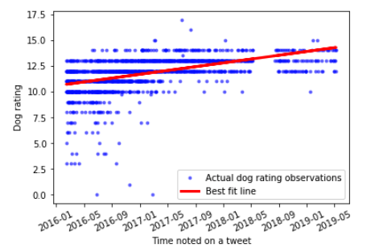

**Figure 1: Dog ratings from tweets over Jan, 2016 - May, 2019**

Additional tests were run with a null hypothesis stating that dog rating is completely independent of the time and there is no relationship between the two along with the alternative hypothesis stating the opposite which is that they do share a linear relationship. In order to conduct the test, I tried to find the difference between the values of rating predicted by best fit line v/s the ratings which were actually observed (and this difference is known as residual) since the test required this difference to be normally distributed. Figure 2 shows that it is actually normally distributed.

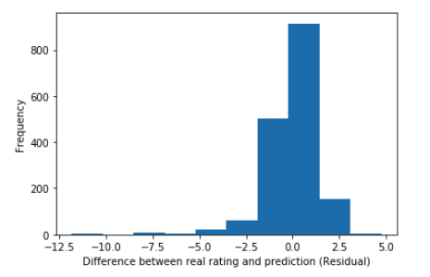

**Figure 2: Histogram representation of frequency of residual values**

After satisfying the assumption followed by performing the test, the p-value of the test comes out to be less than 0.5 which allows us to reject the null hypothesis and believe that dog ratings are actually linearly dependent on the time which also allows to believe in the theory given by the best fit line that ratings are eventually increasing as the time passes.