Documentation - I46_agedate – Insight46 Wave 1

For Submission to the NSHD Scientific Support Team
Name of person responsible for cleaning/derivation: | Molly Cartlidge
List any papers in which cleaned/derived variables have been used | Information about assessments completed during phases 1 and 2 can be found in the following protocol papers:  - Lane CA, Parker TD, et al. 2017. Study protocol: Insight 46 – a neuroscience sub-study of the MRC National Survey of Health and Development. BMC Neurol. 17(1):75.  - Murray-Smith et al. 2024. Updating the study protocol: Insight 46 - a longitudinal neuroscience sub-study of the MRC National Survey of Health and Development - phases 2 and 3. BMC Neurol. Jan 23;24(1):40.

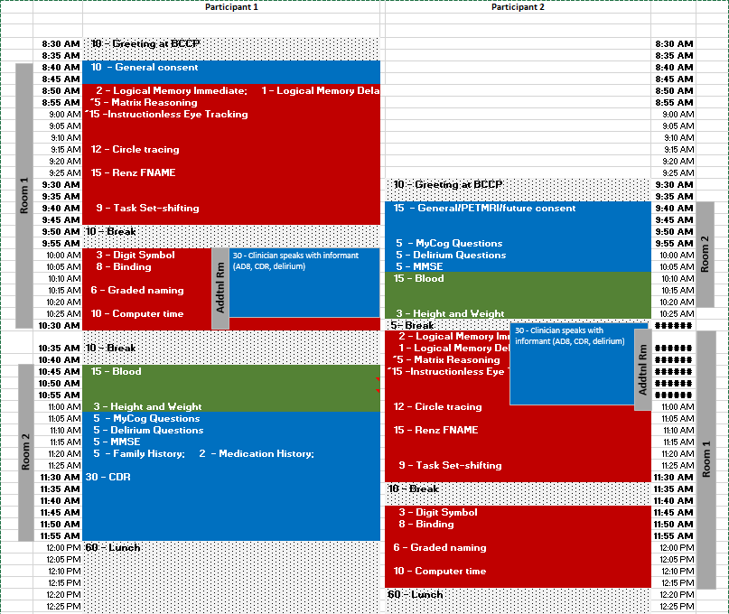
The schedule for an average “day 1” visit was as follows:

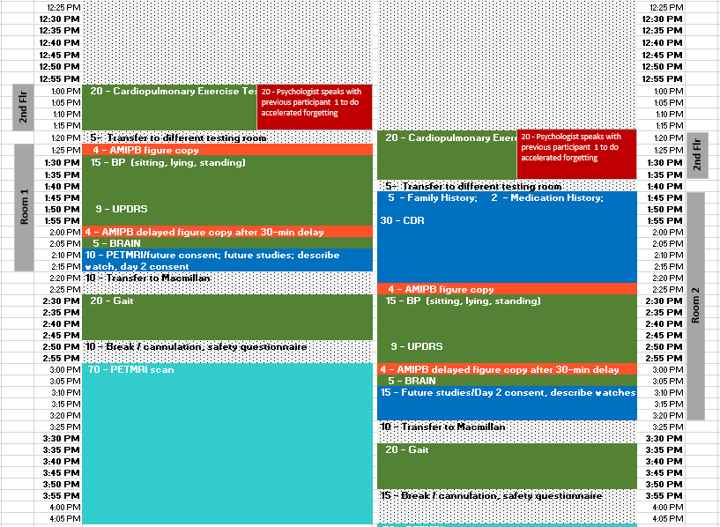
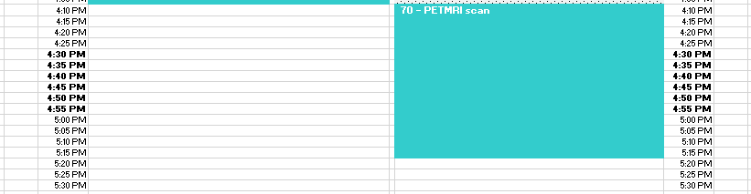

A typical “day 2” schedule looks as follows:
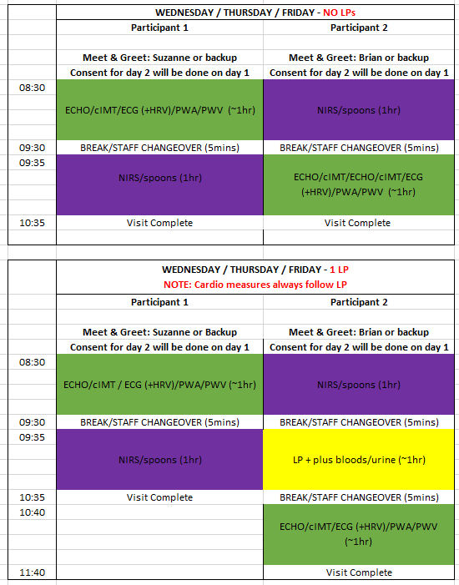
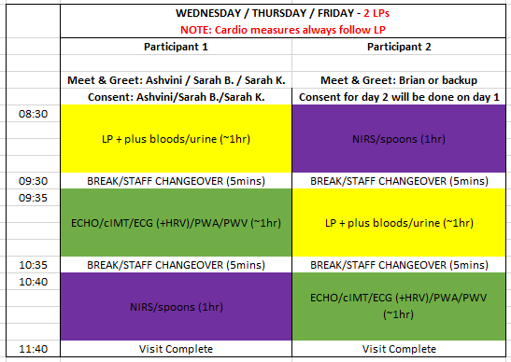

During the COVID-19 pandemic, participants were offered several assessment options: in-person clinic visit in London, remote assessment via computer, remote assessment via telephone, or a mix. More details about which assessments were completed via computer vs telephone remote assessment are described in Murray et al. 2024. Two participants completed a mixed visit with some assessments completed via a remove computer visit and the remaining assessments and PET/MRI scan completed in-person.

The assessments were divided as follows:
- Remote assessments via computer
  - Consent
  - AMIPB complex figure
  - Logical memory – immediate and delayed
  - Matrix reasoning
  - Graded naming test
  - FNAME-12
  - Delirium questions
  - Personal and family history
  - MyCog
  - STAI and PTQ self-complete questionnaires
  - BRAIN tap test
  - Sleep diary and Actiwatch description
  - CDR
  - AD8
- In-person clinic visit in London
  - ECHO, cIMT, ECG
  - MMSE
  - Accelerated forgetting AMIPB complex figure and FNAME
  - Circle tracing
  - Task Set-Shifting
  - Blood and urine collection
  - fNIRS
  - Height and weight
  - Blood pressure
  - UPDRS
  - Gait assessment
  - PET/MRI scan

