ALCOHOL

RATIONALE

Alcohol use has a significant influence on many dimensions of health amongst older people; capturing this is therefore important in NSHD for use as a covariate and potentially exposure or outcome measure depending on power. Previous NSHD work includes:

- Alcohol use was associated with slower memory decline from 43 to 53 years in men, but a more rapid decline in visual search speed over the same interval in women (Richards, Hardy, & Wadsworth, 2005).
- Higher levels of cognitive ability in childhood were associated with an increased risk of alcohol abuse in adulthood for both men and women at age 53 (Hatch et al., 2007).
- The prevalence of drink problems increased with level of alcohol consumption at age 53, with women being more likely to report problems then men with the same (Ely, Hardy, Longford, & Wadsworth, 1999).

Alcohol misuse in older people is thought to be common but under recognised (Dar, 2006), with increased drinking associated with loneliness and bereavement (Wilson et al., 2013). As with other populations, most alcohol related problems occur in non-dependent drinkers so it is important that assessment distinguishes lower levels (e.g. harmful and hazardous levels of alcohol consumption) as well as alcohol abuse or alcohol dependence. Detailed descriptions of these different alcohol related dimensions is available in Berks & McCormick, 2008.

Older adults may incur alcohol-related risks at lower levels of consumption. Older populations are suggested to have higher physiological sensitivity to alcohol, a higher risk of alcohol-related mental health problems and more co-morbid health conditions and medication use that alcohol can interact with (Towers et al., 2011). This has led to debate about appropriate thresholds that should be used to define clinically significant hazardous or binge drinking in this population (Towers et al., 2011). It also means that it may be useful to assess alcohol consumption in terms of beverage-specific quantity.

Estimates from population screening for alcohol misuse in older populations in New Zealand suggest around 50% of 55-70 year olds drink at harmful or hazardous levels although rates are suggested to decline after age 70 (Towers et al., 2011). Health Survey for England data suggests that 28% of men and 19% of women aged 65-74 had drunk on five or more days of the last week but rates of drinking higher than the recommended daily amounts on any day in the last week, whilst still significant at 28% of men and 18% of women aged 65-74, decrease at older ages (NatCen & UCL, 2011). Estimates from America suggest that the prevalence of alcohol misuse disorders in over 65s is about 16% (Menninger, 2002).

In addition to the negative health consequences of high levels of alcohol consumption it is important to acknowledge that a U-shaped relationship between alcohol consumption and many health outcomes is observed whereby those people who consume moderate amounts of alcohol have lower risk than abstainers and heavy drinkers. It is therefore not only important to capture alcohol misuse but also consumption across the full range.

EXISTING DATA IN THE NSHD

Alcohol use has been collected in NSHD using a combination of:
- CAGE to capture whether people have ever had alcohol misuse issues (age 43, 53, 60+).
- Beverage specific quantity measures for the last seven days (age 43, 53, 60+)
- Diet diaries (age 36, 43, 53 and 60+)

These items are shown in Appendix 1.

QUESTIONS USED IN OTHER STUDIES

- Other British birth cohort studies use a combination of BSFQ items and short or long AUDIT (a tool that identifies current alcohol misuse issues, available in 3, 5 and 10 item formats)
  - 1958 cohort: beverage specific quantity for last seven days and AUDIT-10
  - 1970 cohort: beverage specific quantity for last seven days and AUDIT-5
- ELSA uses three frequency questions and beverage specific quantity for the heaviest of the last seven days.
- HSE collects alcohol use much more widely using interviews, self completion and diet diaries
- Whitehall collects slightly different measures covering frequency of drinking, usual amount of drinks per drinking session and usual number of drinks when drinking each of a list of beverages

Key items are shown in Appendix 2.

CONSIDERATIONS FOR FUTURE DATA COLLECTION

- How do we balance the need for longitudinal consistency with the selection of the most appropriate measure for this age group?
- Do we need to distinguish between harmful, hazardous and dependent drinking or will there be insufficient power and need to do this?

Few of the standard screening tools are well validated for use in older populations and there is debate about the best thresholds that define harmful and hazardous drinking. Available tools include CAGE (currently used in NSHD), Alcohol-use Identification Test AUDIT (10 items), AUDIT-5 (5 items), AUDIT-3/AUDIT-C (3 items), Michigan Alcohol Screening Test – Geriatric Version MAST-G (24 items), SMAST-G (10 items), FAST (4 items) and Alcohol-Related Problems Survey ARPS (60 items) or shARPS (32 items).

A 2008 review of validation studies in populations aged 60 and over found evidence to support the use of AUDIT and AUDIT-C as screening tools for hazardous and harmful use of alcohol in older people in primary Care (Berks & McCormick, 2008); both tools performed significantly better than the CAGE which has been suggested to have particularly low sensitivity to detect hazardous drinking (less than 50%) in over 60 year olds (Adams, 2006). CAGE has, however, been suggested to be useful for detecting dependence (Berks & McCormick, 2008) and has been used previously in NSHD. It is worth noting that CAGE assesses lifetime problem drinking whereas other measures assess current problem drinking.

The EU Standardizing Measurement of Alcohol Related Troubles recommends the use of AUDIT for all populations and use of BSQF.

AUDIT-10 distinguishes between harmful, hazardous and dependent drinking.
AUDIT-5 allows identification of harmful or hazardous drinking (but no distinction between these).
AUDIT-3 allows identification of harmful or hazardous drinking (but no distinction between these).

LHA PROGRAMMES

All programmes.

RELATED VARIABLES
CVD , Diet, smoking, cancers, physical activity

RECOMMENDATIONS

1) Diet diaries are not being repeated.

2) Use AUDIT instead of CAGE. The 10 item AUDIT is the only scale that can distinguish between harmful, hazardous and dependent drinking but this may not be required (or power insufficient to use). AUDIT-5 or AUDIT-3 may therefore be sufficient as there is little gain in measure performance using the 10 item over the shorter measures): NB AUDIT must come BEFORE any BSFQ measures as its sensitivity depends on a general introduction.

3) Continue to collect beverage specific quantity using previous items to provide longitudinal consistency.

The items suggested are shown in Appendix 3.

The inclusion of the AUDIT-10 and BSFQ were agreed at a subgroup meeting on 23/10/13. Initially AUDIT-10 will be proposed but this can be reduced to AUDIT-5 or 3 if there is a need to reduce the length of assessment.

RELEVANT PUBLICATIONS
Babor, T. F., Higgins-biddle, J. C., Saunders, J. B., Monteiro, M. G., Higgins-biddle, J. C., Saunders, J. B., & Monteiro, M. G. (2001). The Alcohol Use Disorders Identification Test.
Berks, J., & McCormick, R. (2008). Screening for alcohol misuse in elderly primary care patients: a systematic literature review. International psychogeriatrics / IPA, 20(6), 1090–103. doi:10.1017/S1041610208007497
Bush, K., Kivlahan, D., McDonell, M., Finn, S., & Bradley, K. (1998). The AUDIT alcohol consumption questions (AUDIT-C): an effective brief screening test for problem drinking. Archives of internal medicine, 158(16), 1789–1795.
Dar, K. (2006). Alcohol use disorders in elderly people: fact or fiction? Advances in Psychiatric Treatment, 12(3), 173–181. doi:10.1192/apt.12.3.173
Ely, M., Hardy, R., Longford, N. T., & Wadsworth, M. E. (1999). Gender differences in the relationship between alcohol consumption and drink problems are largely accounted for by body water. Alcohol and alcoholism (Oxford, Oxfordshire), 34(6), 894–902. Retrieved from http://www.ncbi.nlm.nih.gov/pubmed/10659726
Hatch, S. L., Jones, P. B., Kuh, D., Hardy, R., Wadsworth, M. E. J., & Richards, M. (2007). Childhood cognitive ability and adult mental health in the British 1946 birth cohort. Social science & medicine (1982), 64(11), 2285–96. doi:10.1016/j.socscimed.2007.02.027
Menninger, J. a. (2002). Assessment and treatment of alcoholism and substance-related disorders in the elderly. Bulletin of the Menninger Clinic, 66(2), 166–83. Retrieved from http://www.ncbi.nlm.nih.gov/pubmed/12141383
NatCen, & UCL. (2011). Health survey for England 2011: health social care and lifestyles (Vol. 1, pp. 1–33).
Piccinelli, M., Tessari, E., Bortolomasi, M., Piasere, O., Semenzin, M., Garzotto, N., & Tansella, M. (1997). Efficacy of the alcohol use disorders identification test as a screening tool for hazardous alcohol intake and related disorders in primary care: a validity study. BMJ, 314(420).
Richards, M., Hardy, R., & Wadsworth, M. E. J. (2005). Alcohol consumption and midlife cognitive change in the British 1946 birth cohort study. Alcohol and alcoholism (Oxford, Oxfordshire), 40(2), 112–7. doi:10.1093/alcalc/agh126
SBI. (2006). Screening tools for alcohol related risk. Retrieved from http://www.ncl.ac.uk/ihs/engagement/documents/screeningtools.pdf
Towers, A., Stephens, C., Dulin, P., Kostick, M., Noone, J., & Alpass, F. (2011). Estimating older hazardous and binge drinking prevalence using AUDIT-C and AUDIT-3 thresholds specific to older adults. Drug and alcohol dependence, 117(2-3), 211–8. doi:10.1016/j.drugalcdep.2011.02.008
Wilson, G. B., Kaner, E. F. S., Crosland, A., Ling, J., McCabe, K., & Haighton, C. a. (2013). A Qualitative Study of Alcohol, Health and Identities among UK Adults in Later Life. (C. E. Newman, Ed.)PLoS ONE, 8(8), e71792. doi:10.1371/journal.pone.0071792

APPENDIX 1: Previous NHSD measures
CAGE questions (self-completed at 43, 53 and 60+ years)
The CAGE questions were asked of lifetime experience and where the answer to a question was ‘yes’, study members were asked whether they had experienced this ‘in the last year’.

The CAGE score is defined as the number of affirmative answers to these questions, ranging from 0 to 4. Subjects with CAGE scores of 2, 3 or 4 are referred to have drinking problems.

CAGE questions assess risk of alcohol abuse with more than 70% sensitivity and 80% specificity (Ewing, 1984; Bush et al., 1987; Buchsbaum et al., 1991) using the 4 following statements:

- Have you ever felt you ought to Cut down your drinking?
- Have people ever Annoyed you by criticising your drinking?
- Have you ever felt bad or Guilty about your drinking?
- Have you ever had to have a drink first thing in the morning to steady your nerves or get rid of hangover (Eye opener)?

The score was dichotomised to “2 or more” (indicating potential alcohol abuse) vs. “less than 2” ‘yes’ answers (see also Ely et al., 1999).

cudr09 | In the last year have you felt you ought to cut down on your drinking?
atdr09 | In the last year have people ever annoyed you by criticising your drinking?
bdr09 | In the last year have you ever felt bad or guilty about your drinking?
fdr09 | In the last year, have you ever had a drink first thing in the morning to steady your nerves?

Note there are variations in the name of variables from 1999 to 2009.

Alcohol self-completion questionnaires (43, 53 and 60+ years), i.e. BSFQ

The amount of alcohol consumed over a period of consecutive 7 days was also obtained (Richards et al., 2005). Study members were asked about the amount of alcoholic drinks consumed during this interval, within the categories of beers, wines, and spirits. Answers were given in terms of units: half pints of beer, glasses of wine and measures of spirits.

Consumption of alcohol was based on responses to the question ‘in the last 7 days how many of the following drinks have you had?

Three categories of drink were differentiated: spirits (measures of spirits or liqueurs), wine (glasses of wine, sherry, Martini or port), and beer (half pints of beer, larger, cider or stout).

dra09 | Have you drunk alcohol in the last year?
drs09 | In the last 7 days have you had any spirits or liqueurs?
ndrs09 | How many measures of spirits or liqueurs have you had in the last 7 days?
drw09 | In the last 7 days have you had any wine, sherry, martini or port?
ndrw09 | How many measures of wine, sherry, martini or port have you had in the last 7 days
drb09 | In the last 7 days have you had any beer, lager, cider, or stout?
ndrb09 | How many half pints of beer, lager, cider, or stout have you had in the last 7 days

Alcohol- Diet diaries (36, 43, 53, 60+ years)

Alcohol consumption was assessed using a food diary in which participants were asked to record information on the amount of alcohol consumed over 5 consecutive days. These intakes were summarised and coded in grams per day, using a specially designed data-entry program and analysed using in-house nutrient analysis program at MRC Human Nutrition Research. In 1982 and 1989, the diet diaries were complimented by an extra 2 days recall interview conducted by a research nurse (McNaughton, Mishra, Stephen, & Wadsworth, 2007).

Diet diaries 7-day recall for alcohol consumption in 1982,1989, 1999, 2009
  - 2-day recall -done by research nurse interviews
  - 5-days diaries –completed by study members

Summary of variables in two databases (one short & one detailed with all alcohol variables):
- The short version contains the variables for the average daily alcohol at age 36, 43, 53 and 60+ from the diet diaries.

avalc82 | average alcohol/day grams82
avalc89 | average alcohol/day grams89
avalc99 | average alcohol/day grams99
avalc09 | average alcohol/day grams09
avalc82u | average alcohol/day units82
avalc89u | average alcohol/day units89
avalc99u | average alcohol/day units99
avalc09u | average alcohol/day units09

- The detailed version contains all alcohol variables for the average daily alcohol at age 36, 43, 53 and 60+ from the diet diaries and those from questionnaires (including CAGE questions) at age 43, 53 and 60+ with questions about alcohol consumption as:
    - wnr= Weight of red wine consumption
    - wnw=Weight of white wine consumption
    - bci=Weight of beer and cider consumption
    - wnf Weight of wine, sherry, vermouth consumption
    - spi=Weight of spirits consumption

av82wnr | av grams/day red wine 82
av82wnw | av grams/day wine wine 82
av82bci | av grams/day beer 82
av82wnf | av grams/day sherry 82
av82spi | av grams/day spirits 82
av82wnru | av unit/day red wine 82
av82wnwu | av unit/day wine wine 82
av82bciu | av unit/day beer 82
av82wnfu | av unit/day sherry 82
av82spiu | av unit/day spirits 82

Similar for each year so the quantities reported were approximately equivalent to units of alcohol. The total number of drinks was used as the measure of consumption of alcohol (U) in the past week, (multiplied by 8 to give alcohol consumption in grams) (Royal College of Physicians, 1996).

Moderation means a maximum of 3-4 units a day for men and 2-3 units for women (with one unit representing half a pint of average-strength beer, one small glass of wine or a standard pub measure of spirits or fortified wine such as sherry).

APPENDIX 2: Measures used in other studies

1958 (National Child Development Survey)

- AUDIT 10
- Beverage specific items shown below:

- | BEER
- | In the last seven days, that is not counting today but starting from last [^7 days before
date of interview] how much beer, stout, lager, ale or cider have you had? |
- | INTERVIEWER: EXCLUDE LOW ALCOHOL AND ALCOHOL FREE DRINKS.
- | RECORD IN HALF PINT UNITS.
- | LARGE CAN = 2 HALF PINT UNITS
- | SMALL CAN = 1 HALF PINT UNIT
- | Range: 0..200 |
- | SPIRITS
- | And in the last seven days, how many measures of spirits or liqueurs have you had, like
- | Gin, Whisky, Rum, Brandy, Vodka or Advocaat? |
- | INTERVIEWER: ENTER NUMBER OF SINGLE MEASURES
- | Range: 0..200 |
- | WINE
- | (In the last seven days,) how many glasses of wine have you had? |
- | INTERVIEWER: EXCLUDE LOW ALCOHOL AND ALCOHOL FREE DRINKS
- | ENTER NUMBER OF GLASSES
- | Range: 0..200 |
- | SHERRY
- | (In the last seven days,) how many glasses of martini, vermouth, sherry, port or similar
- | drinks have you had? |
- | INTERVIEWER: ENTER NUMBER OF GLASSES
- | Range: 0..200 |
- | OTHDRINK
- | (In the last seven days,) how many glasses of other
- | drinks have you had? |
- | INTERVIEWER: ENTER NUMBER OF GLASSES

1970 British Birth Cohort

- AUDIT-5
- Beverage specific items shown below

In the last seven days, that is not counting today but starting from last [^day of week 7 days before date of interview] what types of alcoholic drink have you had?
1 Normal strength (less than 6 % alcohol) beer, lager, stout or cider
2 Strong beer, lager, stout or cider (6% alcohol or more)
3 Spirits or Liqueurs (e.g. Gin, Whisky, Brandy, Rum, Vodka, Advocaat, Cocktails)
4 Sherry or Martini (including Port, Vermouth, Cinzano and Dubonnet)
5 Wine (including sparkling wine and Champagne)
6 Alcoholic soft drinks or ‘alcopops’ or pre-mixed alcoholic drinks such as Bacardi Breezer, Smirnoff Ice or WKD
7 Other alcoholic drinks 8 None

| IF CM has drunk normal beer in last 7 days (DRINKS=1)
| BEERN
| In the last seven days, how much normal strength beer, lager, stout, ale or cider
| have you had? INTERVIEWER: CODE NUMBER OF PINTS |
| Range 1...200 (allow fractions) |
| HELP SCREEN |
| 275 ml bottle = 1⁄2 pint
| 330 ml bottle = 1⁄2 pint
| 440 ml can = 1 pint
| 500 ml can or bottle = 1 pint
| 600 ml bottle = 1 pint
| 660 ml bottle = 1 1⁄2 pints
| 700 ml bottle = 1 1⁄2 pints
| 750 ml bottle = 1 1⁄2 pints
| 1 litre bottle = 2 pints
| 2 litre bottle = 4 pints |

| IF CM has drunk strong beer in last 7 days (DRINKS=2) |
| BEERS
| In the last seven days, how much strong beer, lager, stout, ale or cider have you
| had? INTERVIEWER: CODE NUMBER OF PINTS |
| Range 1...200 (allow fractions)
| HELP SCREEN |
| 275 ml bottle = 1⁄2 pint
| 330 ml bottle = 1⁄2 pint
| 440 ml can = 1 pint
| 500 ml can or bottle = 1 pint
| 600 ml bottle = 1 pint
| 660 ml bottle = 1 1⁄2 pints
| 700 ml bottle = 1 1⁄2 pints
| 750 ml bottle = 1 1⁄2 pints
| 1 litre bottle = 2 pints
| 2 litre bottle = 4 pints |

| IF CM has drunk spirits in last 7 days (DRINKS=3)
| SPIRITS
| And in the last seven days, how many measures of spirits or liqueurs have you had,
| like Gin, Whisky, Rum, Brandy, Vodka or Advocaat? |
| INTERVIEWER: CODE THE NUMBER OF SINGLES – COUNT DOUBLES AS TWO
| SINGLES

| IF CM has drunk sherry or similar in last 7 days (DRINKS=4) |
| SHERRY
| (In the last seven days,) how many glasses of martini, vermouth, sherry, port or
| similar drinks have you had? |
| INTERVIEWER: ENTER NUMBER OF GLASSES

| IF CM has drunk wine in last 7 days (DRINKS=5) |
| WINE
| (In the last seven days,) how much wine, including sparkling wine and champagne
| have you had? |
| INTERVIEWER: PLEASE NOTE THAT RESPONDENT MAY GIVE ANSWER IN
| BOTTLES AND GLASSES. CODE THE MEASURE THE RESPONDENT USED. |
| 1 Bottles or parts of bottles
| 2 Glasses
| 3 Both bottles or parts of bottle, and glasses |
| IF answer to be provided in bottles or parts of bottles [WINE = 1 OR 3]|
| (In the last 7 days) Were the glasses of wine that you drank large (250 ml), standard (175 ml) or small (125 ml) glasses? [^Please do not include the glasses of wine that you drank from a bottle which you have already told me about].
| (In the last 7 days) how many large (250 ml) glasses of wine did you have?
| (In the last 7 days) how many standard (175 ml) glasses of wine did you have? |||

| IF CM has drunk alcopops in the last 7 days (DRINKS = 6)
| ALCOPOP
| (In the last seven days,) how many alcopops have you had?
| INTERVIEWER: ENTER NUMBER OF 275 ML BOTTLES.
| Range: 1..200 |

ELSA

Thinking now about all kinds of drinks, how often have you had an alcoholic drink of any kind during the last 12 months? Tick one box Almost every day 1 Five or six days a week 2 Three or four days a week 3 Once or twice a week Once or twice a month 5 Once every couple of months 6 Once or twice a year 7 Not at all in the last 12 month

Did you have an alcoholic drink in the seven days ending yesterday? Yes 1 No 2

On how many days out of the last seven did you have an alcoholic drink? One 1 Two 2 Three 3 Four 4 Five 5 Six 6 Seven 78

Please think about the day in the last week on which you drank the most. (If you drank the same amount on more than one day, please answer about the most recent of those days.) From this list, please tick all the types of alcoholic drink which you drank on that day. For the ones you drank, write in how much you drank on that day. EXCLUDE NON-ALCOHOLIC OR LOW-ALCOHOL DRINKS, EXCEPT SHANDY.
Write in how much drunk on that dayNormal strength beer, lager, stout, cider or shandy (less than 6% alcohol) – exclude bottles/cans of shandy
Strong beer, lager, stout or cider (6% alcohol or more, such as Tennants 02 Extra, Special Brew, Diamond White)
Spirits or liqueurs, such as gin, whisky, rum, brandy, vodka, or cocktails
Sherry or martini (including port, vermouth, cinzano, dubonnet)
Wine (including babycham and champagne)
Alcoholic soft drinks or ‘alcopops’ (such as Barcardi Breezer, Smirnoff Ice)
Other kinds of alcoholic drink

APPENDIX 3: Measures suggested for inclusion in 2014

      - AUDIT: 10, 5 or 3 item options shown below (taken from SBI, 2006)
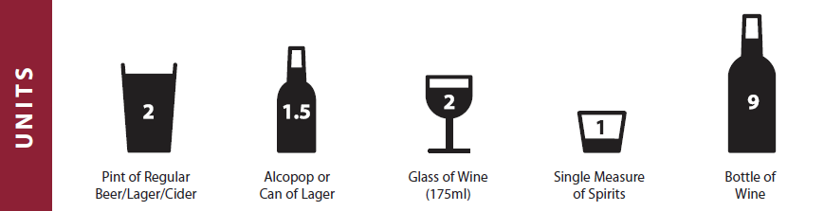
10 items (Babor et al., 2001)
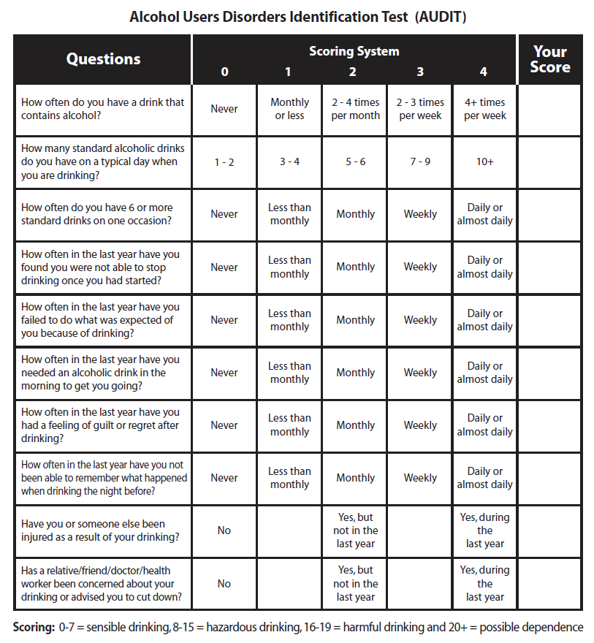
5 Items (Piccinelli et al., 1997):
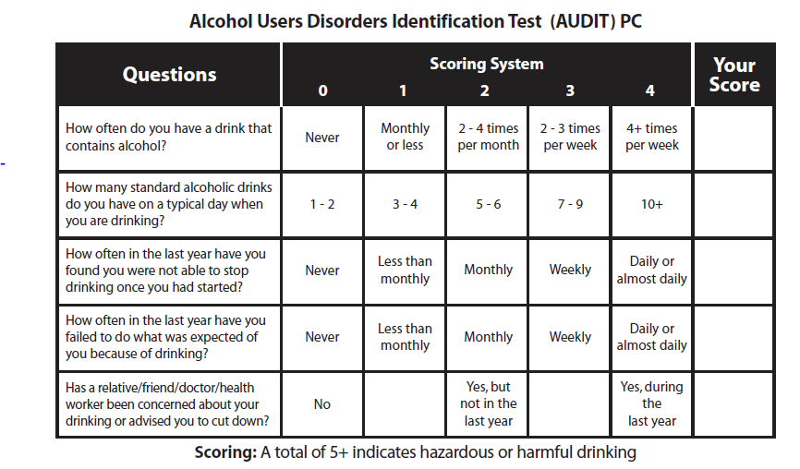
items (Bush, Kivlahan, McDonell, Finn, & Bradley, 1998):3
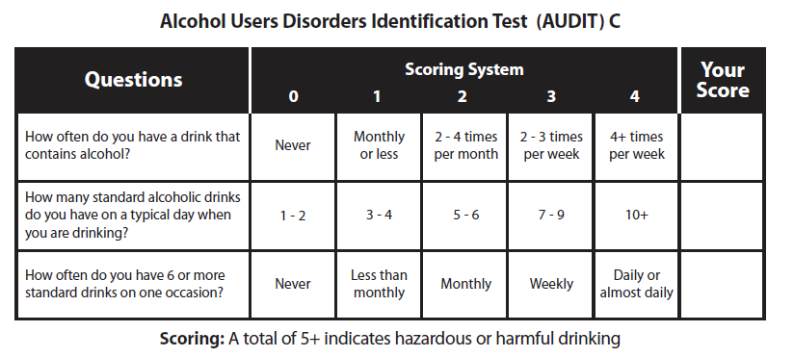
2. Beverage specific quantity (taken from 06-10 pre assessment questionnaire)

9. Have you drunk alcohol in the last year?

No 0 → go to Q12
Yes, but only on
special occasions 1
Yes, more often 2

10. In the last 7 days have you had any of the following drinks? Do not count non-alcoholic drinks.

a. Spirits or liqueurs (e.g. whisky, gin, brandy)

No 0 → go to Q10b
Yes 1

If yes, how many measures?

Measures

b. Wine, sherry, martini, or port

No 0 → go to Q10c
Yes 1

If yes, how many glasses?

Glasses

c. Beer, lager, cider, or stout

No 0 → go to Q11a
Yes 1

If yes, how many ½ pints?

