Created by MR Nov 2008: Updated (13/05/10) by SB for coh8h, cog11h, cog15h

Cognitive function in childhood, adolescence and early adulthood

Cognitive function was first tested at age 8 years in a school setting, and again in this setting at ages 11 and 15 years. A test of verbal comprehension given at the latter age was then re-administered at age 26 years (with 10 additional items of increased difficulty to avoid a ceiling effect), as part of the first interview of the survey member as an adult.

All coding to create the variables are described below and can be found in $mr/cogchad/crsv.j. Variables are located in the save file $mr/cogchad/d081114.sv (which also includes SERNO, SEX and INF), and all cognitive variables are continuous.

Age 8 years

Raw variables (N.B. all these are included in the ‘cogchad’ save file)
VOC8R – a 50-item vocabulary test
SC8R – a 35-item verbal comprehension (sentence completion) test
R8R – mechanical reading (pronunciation) using the same words as for vocabulary
PI8R – a 60-item non-verbal ability (picture intelligence) test
For all ‘R’ variables 99 indicates missing data
VOC8N – as above for vocabulary but normalised to a mean of 100 and an SD of 15
SC8N - as above for sentence completion but normalised to a mean of 100 and an SD of 15
R8N - as above for mechanical reading but normalised to a mean of 100 and an SD of 15
PI8N - as above for picture intelligence but normalised to a mean of 100 and an SD of 15
For all ‘N’ variables 999 indicates missing data

Derived summary variable
COG8H – RH’s standardised cognitive score at age8 - standardised for whole population available on each test see note below.

Formula
COG8H=(VOC8H+SC8H+R8H+PI8H)/4

Where VOC8H, SC8H, R8H, PI8H are the standardised to the whole population available on each test versions of the variables VOC8R, SC8R, R8R, PI8R.

Descriptive statistics

 | N | Min | Max | Mean | SD
SC8R | 4259 | 0 | 34 | 14.20 | 7.78
R8R | 4259 | 0 | 49 | 17.02 | 10.27
VOC8R | 4259 | 0 | 40 | 16.28 | 5.99
PI8R | 4266 | 0 | 60 | 40.20 | 9.48

13/05/10: Updated by SB to include COG8H
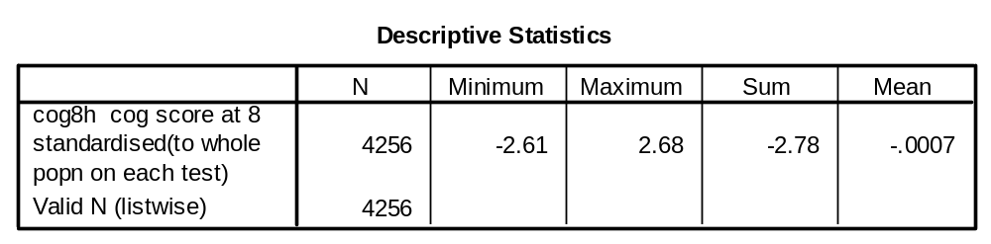

Age 11 years

Raw variables (N.B. all these are included in the ‘cogchad’ save file)
GA11R – an 80-item verbal and non-verbal ability test
V11R – the 40 verbal items from above
NV11R – the 40 non-verbal items from above
VOC11R – the same 50 words used at age 8 years for vocabulary
R11R - the same 50 words used at age 8 years for mechanical reading
A11R – a 50-item arithmetic test
For all ‘R’ variables 99 indicates missing data except GA11R, where 999 is used
GA11N – as above for the verbal and non-verbal ability test but normalised to a mean of 100 and an SD of 15
V11N - as above for the verbal ability test items but normalised to a mean of 100 and an SD of 15
NV11N - as above for the non-verbal ability test items but normalised to a mean of 100 and an SD of 15
VOC11N - as above for the vocabulary items but normalised to a mean of 100 and an SD of 15
R11N - as above for the mechanical reading items but normalised to a mean of 100 and an SD of 15
A11N - as above for the arithmetic items but normalised to a mean of 100 and an SD of 15
For all ‘N’ variables 999 indicates missing data

Derived summary variable
COG11H – RH’s standardised cognitive score at age11 - standardised for whole population available on each test see note below.

Formula

COG11H=(R11H+VOC11H+GA11H+A11H)/4

Where R11H, VOC11H, GA11H, A11H are the standardised to the whole population available on each test versions of the variables R11R, VOC11R, GA11R, A11R

Descriptive statistics

 | N | Min | Max | Mean | SD
GA11R | 4032 | 0 | 80 | 45.01 | 15.88
V11R | 4032 | 0 | 40 | 23.40 | 9.17
NV11R | 4032 | 0 | 40 | 21.61 | 7.50
VOC11R | 4027 | 0 | 49 | 29.99 | 7.45
R11R | 4027 | 0 | 50 | 36.43 | 10.50
A11R | 4025 | 0 | 50 | 26.39 | 11.74

13/05/10: Updated by SB to include COG11H
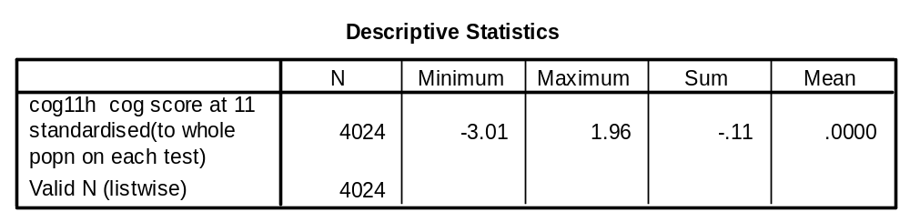

Age 15 years

Raw variables (N.B. all these are included in the ‘cogchad’ save file)
GA15R – the Heim AH4 Group Ability Test, a 130-item verbal and non-verbal ability test
V15R – the 65 verbal items from above
NV15R – the 65 non-verbal items from above
R15R – the Watts Vernon Reading Test, a 35-item verbal comprehension (sentence completion) test
M15R – a 47-item mathematics test
For all ‘R’ variables 99 indicates missing data, except for GA15R, where 999 is used
GA15N – as above for the Heim AH4 Group Ability Test but normalised to a mean of 100 and an SD of 15
V15N - as above for the verbal items of the AH4 but normalised to a mean of 100 and an SD of 15
NV15N - as above for the non-verbal items of the AH4 but normalised to a mean of 100 and an SD of 15
R15N - as above for the Watts Vernon but normalised to a mean of 100 and an SD of 15
M15N – as above for mathematics but normalised to a mean of 100 and an SD of 15
For all ‘N’ variables 999 indicates missing data

Derived summary variable
COG15H – RH’s standardised cognitive score at age15 - standardised for whole population available on each test see note below.

Formula
COG15H=(R15H+GA15H+M15H)/3

Where R15H, GA15H, M15H are the standardised to the whole population available on each test versions of the variables R15R, GA15R, M15R.

Descriptive statistics
 | N | Min | Max | Mean | SD
GA15R | 3982 | 0 | 125 | 73.84 | 20.04
V15R | 4018 | 0 | 65 | 35.46 | 11.45
NV15R | 4019 | 0 | 65 | 38.60 | 10.50
R15R | 4014 | 0 | 35 | 24.47 | 6.6
M15R | 4015 | 0 | 46 | 14.26 | 10.21

13/05/10: Updated by SB to include COG15H 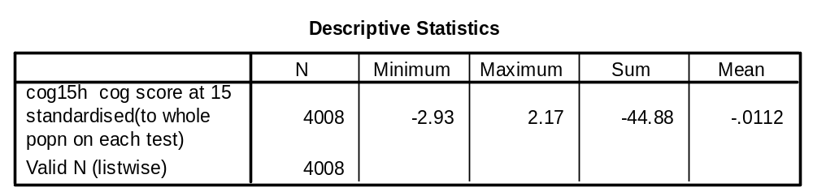

Age 26 years

Raw variable (N.B. included in the ‘cogchad’ save file)
WV26R – the first 35 items of the Watts Vernon Reading Test, as used at age 15 years (missing = 99)
R26R – the Watts Vernon Reading Test used at 15 years, with an additional 10 items of increased difficulty to avoid a ceiling effect (missing = 99)
R26N – as above but normalised to a mean of 100 and an SD of 15 (missing = 999)

Descriptive statistics

 | N | Min | Max | Mean | SD
WV26R | 3715 | 0 | 35 | 28.76 | 5.4
R26R | 3714 | 0 | 45 | 32.79 | 8.26

