Created by MR Nov 2008: Updated (13/05/10) by SB for coh8h, cog11h, cog15h

Updated (Jan 2104) by KM for GA15R

Updated (Feb 2014) by KM adding WV26H, R26H

Cognitive function in childhood, adolescence and early adulthood

Cognitive function was first tested at age 8 years in a school setting, and again in this setting at ages 11 and 15 years. A test of verbal comprehension given at the latter age was then re-administered at age 26 years (with 10 additional items of increased difficulty to avoid a ceiling effect), as part of the first interview of the survey member as an adult.

Age 8 years

Raw variables (N.B. all these are included in the ‘cogchad’ save file)
VOC8R – a 50-item vocabulary test
SC8R – a 35-item verbal comprehension (sentence completion) test
R8R – mechanical reading (pronunciation) using the same words as for vocabulary
PI8R – a 60-item non-verbal ability (picture intelligence) test
For all ‘R’ variables 99 indicates missing data
VOC8N – as above for vocabulary but normalised to a mean of 100 and an SD of 15
SC8N - as above for sentence completion but normalised to a mean of 100 and an SD of 15
R8N - as above for mechanical reading but normalised to a mean of 100 and an SD of 15
PI8N - as above for picture intelligence but normalised to a mean of 100 and an SD of 15
For all ‘N’ variables 999 indicates missing data

Derived summary variable
COG8H – RH’s standardised cognitive score at age8 - standardised for whole population available on each test see note below.

Formula
COG8H=(VOC8H+SC8H+R8H+PI8H)/4

Where VOC8H, SC8H, R8H, PI8H are the standardised to the whole population available on each test versions of the variables VOC8R, SC8R, R8R, PI8R.

Descriptive statistics

 | N | Min | Max | Mean | SD
SC8R | 4259 | 0 | 34 | 14.20 | 7.78
R8R | 4259 | 0 | 49 | 17.02 | 10.27
VOC8R | 4259 | 0 | 40 | 16.28 | 5.99
PI8R | 4266 | 0 | 60 | 40.20 | 9.48

13/05/10: Updated by SB to include COG8H
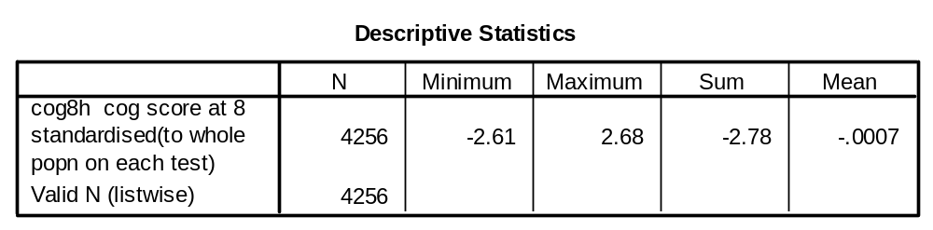

Age 11 years

Raw variables (N.B. all these are included in the ‘cogchad’ save file)
GA11R – an 80-item verbal and non-verbal ability test
V11R – the 40 verbal items from above
NV11R – the 40 non-verbal items from above
VOC11R – the same 50 words used at age 8 years for vocabulary
R11R - the same 50 words used at age 8 years for mechanical reading
A11R – a 50-item arithmetic test
For all ‘R’ variables 99 indicates missing data except GA11R, where 999 is used
GA11N – as above for the verbal and non-verbal ability test but normalised to a mean of 100 and an SD of 15
V11N - as above for the verbal ability test items but normalised to a mean of 100 and an SD of 15
NV11N - as above for the non-verbal ability test items but normalised to a mean of 100 and an SD of 15
VOC11N - as above for the vocabulary items but normalised to a mean of 100 and an SD of 15
R11N - as above for the mechanical reading items but normalised to a mean of 100 and an SD of 15
A11N - as above for the arithmetic items but normalised to a mean of 100 and an SD of 15
For all ‘N’ variables 999 indicates missing data

Derived summary variable
COG11H – RH’s standardised cognitive score at age11 - standardised for whole population available on each test see note below.

Formula

COG11H=(R11H+VOC11H+GA11H+A11H)/4

Where R11H, VOC11H, GA11H, A11H are the standardised to the whole population available on each test versions of the variables R11R, VOC11R, GA11R, A11R

Descriptive statistics

 | N | Min | Max | Mean | SD
GA11R | 4032 | 0 | 80 | 45.01 | 15.88
V11R | 4032 | 0 | 40 | 23.40 | 9.17
NV11R | 4032 | 0 | 40 | 21.61 | 7.50
VOC11R | 4027 | 0 | 49 | 29.99 | 7.45
R11R | 4027 | 0 | 50 | 36.43 | 10.50
A11R | 4025 | 0 | 50 | 26.39 | 11.74

13/05/10: Updated by SB to include COG11H
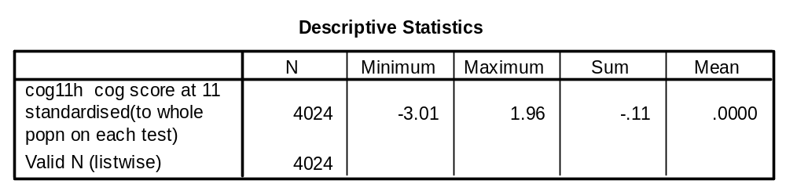

Age 15 years

Raw variables (N.B. all these are included in the ‘cogchad’ save file)
GA15R – the Heim AH4 Group Ability Test, a 130-item verbal and non-verbal ability test
V15R – the 65 verbal items from above
NV15R – the 65 non-verbal items from above
R15R – the Watts Vernon Reading Test, a 35-item verbal comprehension (sentence completion) test
M15R – a 47-item mathematics test
For all ‘R’ variables 99 indicates missing data, except for GA15R, where 999 is used
GA15N – as above for the Heim AH4 Group Ability Test but normalised to a mean of 100 and an SD of 15
V15N - as above for the verbal items of the AH4 but normalised to a mean of 100 and an SD of 15
NV15N - as above for the non-verbal items of the AH4 but normalised to a mean of 100 and an SD of 15
R15N - as above for the Watts Vernon but normalised to a mean of 100 and an SD of 15
M15N – as above for mathematics but normalised to a mean of 100 and an SD of 15
For all ‘N’ variables 999 indicates missing data

Derived summary variable
COG15H – RH’s standardised cognitive score at age15 - standardised for whole population available on each test see note below.

Formula
COG15H=(R15H+GA15H+M15H)/3

Where R15H, GA15H, M15H are the standardised to the whole population available on each test versions of the variables R15R, GA15R, M15R.
5/02/14: Updated by KM to revise statistics for variable GA15R [Final version of this data on the road map produced slightly different figures from the original documentation]

Descriptive statistics
 | N | Min | Max | Mean | SD
GA15R | 4017 | 0 | 125 | 74.06 | 20.092
V15R | 4018 | 0 | 65 | 35.46 | 11.45
NV15R | 4019 | 0 | 65 | 38.60 | 10.50
R15R | 4014 | 0 | 35 | 24.47 | 6.6
M15R | 4015 | 0 | 46 | 14.26 | 10.21

13/05/10: Updated by SB to include COG15H 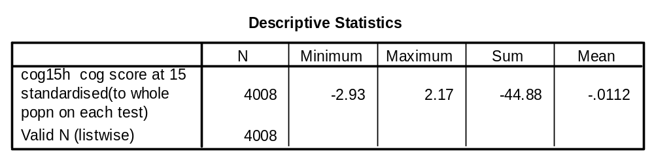

Age 26 years

Raw variable (N.B. included in the ‘cogchad’ save file)
WV26R – the first 35 items of the Watts Vernon Reading Test, as used at age 15 years (missing = 99)
R26R – the Watts Vernon Reading Test used at 15 years, with an additional 10 items of increased difficulty to avoid a ceiling effect (missing = 99)
R26N – as above but normalised to a mean of 100 and an SD of 15 (missing = 999)
WV26H – KM’s standardised version of the Watts Vernon Reading Test at age26 - standardised for whole population available on the test
R26H – KM’s standardised version of the Watts Vernon Reading Test at age26, with an additional 10 items of increased difficulty to avoid a ceiling effect

Descriptive statistics

 | N | Min | Max | Mean | SD
WV26R | 3715 | 0 | 35 | 28.76 | 5.4
R26R | 3714 | 0 | 45 | 32.79 | 8.26
WV26H | 3715 | -5.33 | 1.16 | -.0007 | .99993
R26H | 3714 | -3.97 | 1.48 | .0003 | 1.00038

