## Experiment No. 3

## Autocorrelation and Energy Spectral Density of a Deterministic Energy Signal

**Task 1**: **Discrete-Time Fourier Transform (DTFT) and Energy Spectral Density (ESD)**

For the discrete signal:

u[n] = [1, 1, 1, 1, 1]

where n = [-2, -1, 0, 1, 2]

The **Discrete-Time Fourier Transform** (DTFT) is given by:

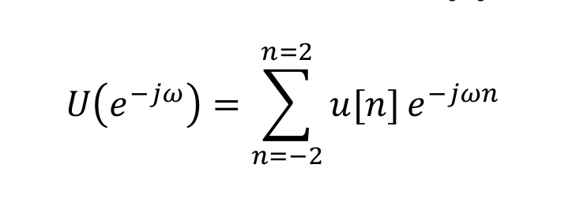

The **Energy Spectral Density** (ESD) is computed as:

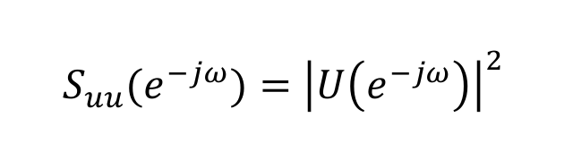

where ω ranges from -2π to 2π.

**MATLAB Code:**

#### Plots:

1. Amplitude Spectrum

2. Phase Spectrum

3. Energy Spectral Density

### Task 2: Autocorrelation and Verification of Wiener–Khinchin Theorem

The autocorrelation of u[n] is defined as: R_uu[m] = Σ u[n]u[n+m]

The DTFT of R_uu[m] should be equal to the ESD.

#### MATLAB Code:

% Autocorrelation calculation  
m = -4:4;  
R_uu = zeros(1, length(m));  
for i = 1:length(m)  
 for j = 1:length(u_n)  
 if (j+m(i) > 0 && j+m(i) <= length(u_n))  
 R_uu(i) = R_uu(i) + u_n(j) * u_n(j+m(i));  
 end  
 end  
end  
  
% DTFT of autocorrelation  
S_from_R = zeros(size(omega));  
for k = 1:length(omega)  
 S_from_R(k) = sum(R_uu .* exp(-1j * omega(k) * m));  
end  
  
% Verification Plot  
figure;  
plot(omega, abs(S_uu), 'b', 'LineWidth', 1.5);  
hold on;  
plot(omega, abs(S_from_R), 'r--', 'LineWidth', 1.5);  
title('Verification of Wiener-Khinchin Theorem');  
xlabel('ω (rad)'); ylabel('Magnitude');  
legend('|U|^2', 'DTFT{R_{uu}}');  
grid on;

#### Plots:

1. Autocorrelation R_uu[m] vs m

2. |U(e^(-jω))|^2 and DTFT{R_uu} (Verification Plot)

### Results:

|  |  |
| --- | --- |
| Quantity | Description |
| U(e^(-jω)) | Frequency-domain representation of u[n] |
| S_uu(e^(-jω)) | Computed as |U(e^(-jω))|^2 |
| R_uu[m] | Triangular-shaped autocorrelation function |
| Verification | S_uu(e^(-jω)) = DTFT{R_uu[m]} confirmed |

### Conclusion

In this lab, we verified that the Energy Spectral Density (ESD) of a discrete-time energy signal is equal to the Fourier Transform of its autocorrelation function, confirming the Wiener–Khinchin theorem. The amplitude and phase spectra were plotted successfully, and both the ESD and DTFT of autocorrelation produced matching results, validating the theoretical relationship.