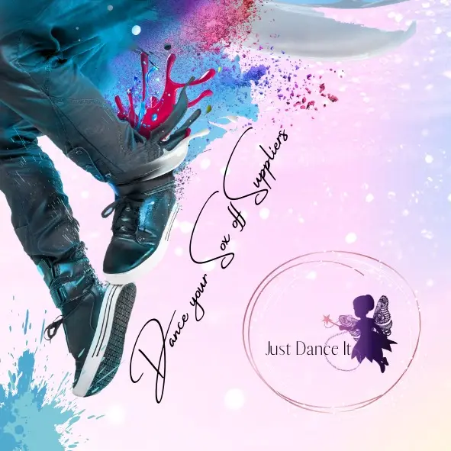Dance Your Sox Off Suppliers
Dance Clothing & Accessories Catalog 2026 Edition Tagline: Just Dance It
382 Kommetjie Cres, Garsfontein, Pretoria, 0042 Tel: +27 82 563 8813 Email: hello@dancesox.co.za Website: www.dancesox.co.za
Table of Contents
- Leotards
- Tights
- Accessories
- Dance Bags
- Water Bottles
- Ordering & Contact Information
Leotards
RAD Black Leotard Comfortable and durable leotard for practice. Sizes: 8–14 Inquire
Red Spider Strap Leotard Perfect for stage performance. Sizes: 12–18 Inquire
Sparkle Pink Leotard Shimmering pink leotard for young dancers. Sizes: 6–12 Inquire
Classic Black Leotard Timeless design for all dance styles. Sizes: 8–14 Inquire
Velvet Purple Leotard Soft velvet finish for premium comfort. Sizes: 10–16 Inquire
Tights
Pink Ballet Tights Soft ballet tights. Sizes: 8–14 Inquire
Black Dance Tights Durable tights for practice. Sizes: 12–18 Inquire
Convertible Tights Ideal for quick changes. Sizes: 8–16 Inquire
Fishnet Performance Tights Strong weave for stage durability. Sizes: 10–18 Inquire
Accessories
Dance Hair Kit Includes ties, pins, and nets. Inquire
Sparkle Scrunchies Glitter finish for stage looks. Inquire
Dance Socks Breathable cotton blend. Inquire
Leg Warmers Soft ribbed knit for warm-ups. Inquire
Dance Bags
Classic Dance Bag Spacious bag for all gear. Inquire
Compact Tote Lightweight and stylish. Inquire
Mesh Shoe Bag Ventilated compartment for shoes. Inquire
Water Bottles
Hydrate Bottle BPA-free, 750ml capacity. Inquire
Logo Bottle Branded with Dance Your Sox Off Suppliers. Inquire
Insulated Bottle Keeps drinks cool for hours. Inquire
Ordering & Contact Information
Thank you for dancing with us! Follow us on Facebook & Instagram Contact: hello@dancesox.co.za

