

Data Technician

Table of contents
Day 1: Task 1 2
Day 2: Task 1 2
Day 2: Task 2 3
Day 2: Task 3 4
Day 3: Task 1 4
Day 3: Task 2 5
Dataset: 5
Step 1: Create a Pivot Table 5
Step 2: Use the SWITCH Function 5
Submission: 6
Day 3: Task 3 6
Day 4: Task 1 7
Course Notes 9
Additional Information 10

Day 1: Task 1

Please complete the below boxes on commons laws and regulations that must be followed when working with customers data, use the below bulleted list to support your answers.

- What is it
- Why is it important
- Provide a real-world example of how you can follow it
- How does it impact working with data
- What could happen if you breached it

Data Protection Act | The DPA is the main data protection law in the UK that helps people to take charge of their personal data, enabling businesses to process it lawfully. For example, when the data controller give people options about how their personal data will be used when relying on a legal basis other than consent, e.g. allowing individuals to opt out of publishing a profile about them, but using the same profile for internal management purposes. According to UK law, unauthorized processing of sensitive personal information can lead to fines up to 17.5 GBP, warnings, reprimands, and even bans on data processing.
GDPR | GDPR is a law that tells controllers (organisations) how to use, collect, and share personal data in a legal and fair way. It includes getting clear consent, giving people the right to access and delete their data, and ensuring that data is processed fairly and for a specific purpose. An example of using GDPR lawfully is when only authorized medical staff have access to sensitive health records. Breaching GDPR can result in financial penalties, reputational damage, loss of customer trust, and potential legal action from individuals whose data have been unlawfully processed.
Freedom of Information Act | The FOIA is providing the public right to request access to records from any federal agency, in simpler terms, it keeps citizens in the known about their government. For example, it keeps citizens up to date with what the council is spending money on, or what the budget was for a specific project. Breaching FOIA ends with a fine.
Computer Misuse Act | The Computer Misuse Act is a law that makes it illegal to access computer systems and data without authorization. An example of computer misuse is hacking, i.e. a student finding a teacher’s computer password and accessing their files. Depending on the severity of the breach, it results in financial penalties and imprisonment.

Day 2: Task 1

Please research and complete the following tasks within the retail-sales_dataset.xlsx document, paste a print screen into the provided boxes below:

- In the sheet ‘retail_sales_dataset’ add all available data between columns A –J into a ‘table’
- Using the ‘sort’ function, sort ‘Age’ to ‘largest to smallest’
- Using the ‘SUM’ function, show me the commission total in cell ‘L10’
- Using the ‘AVERAGE’ function, show me the average commission in cell ‘L11’

Print screen 1 | 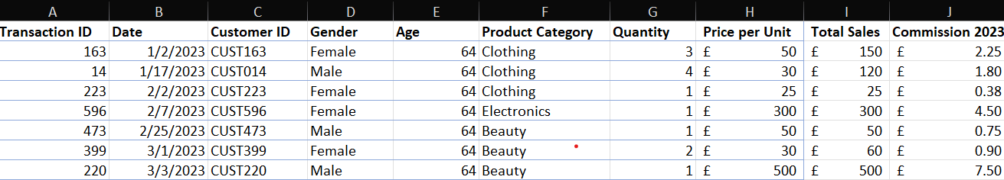
Print screen 2
Print screen 3 | 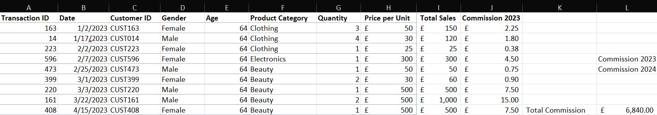
Print screen 4 | 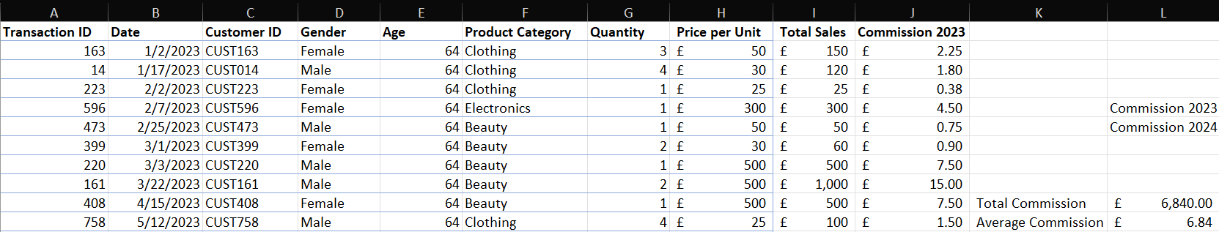

Day 2: Task 2

Please research and complete the following tasks within the retail-sales_dataset.xlsx document, paste print screens into the provided box below:



Print screen 1 | TASK 1  - ENGLISH 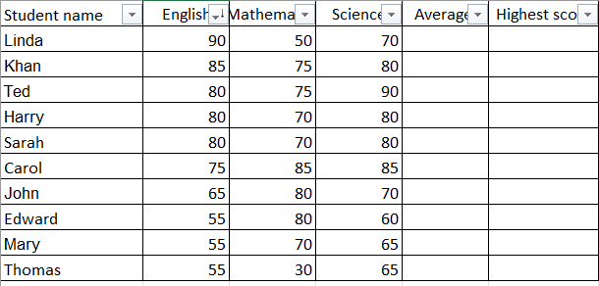  - MATHEMATICS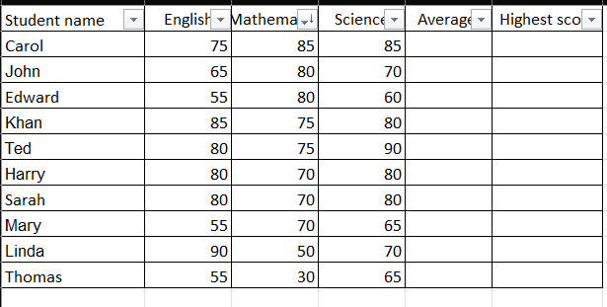  - SCIENCE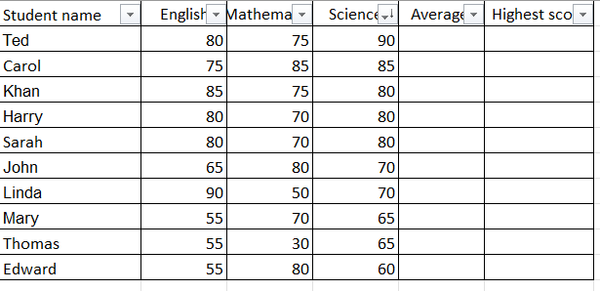  TASK 2  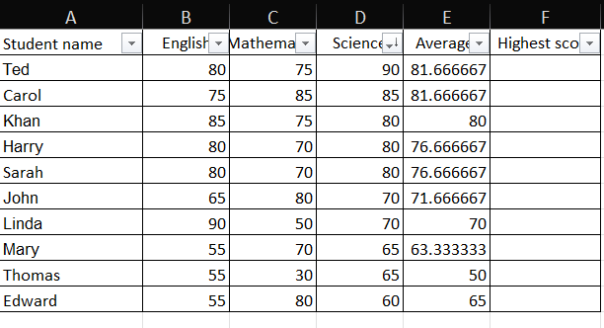  TASK 3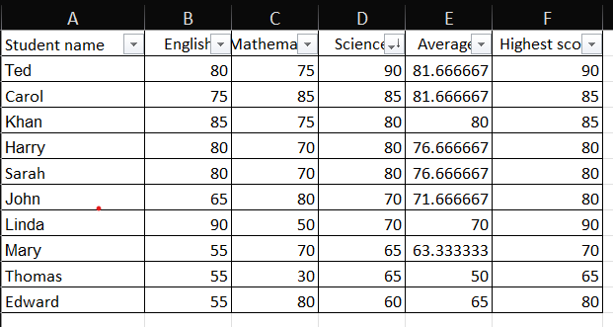  TASK 4 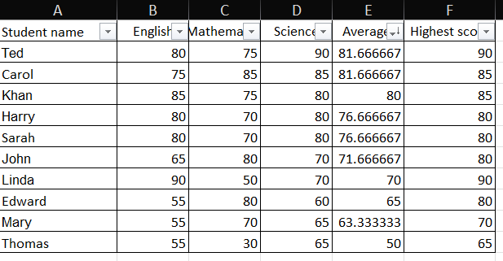  TASK 5  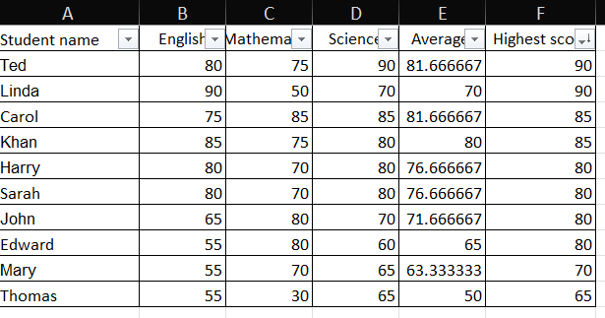  TASK 6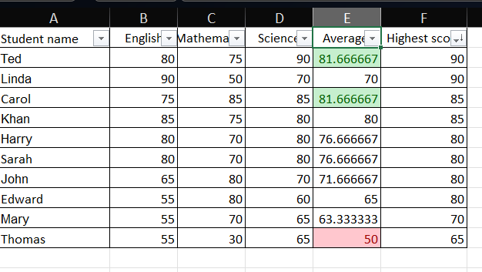

Day 2: Task 3

Using the skills developed today, have some fun with the data set you have imported. Paste your work below and enjoy!

Print screen 1 | For this task, I downloaded the Student Performance Status dataset from Kaggle (Student Performance Factors Dataset)  Dataset sorted by Attendance Level, from largest to smallest:  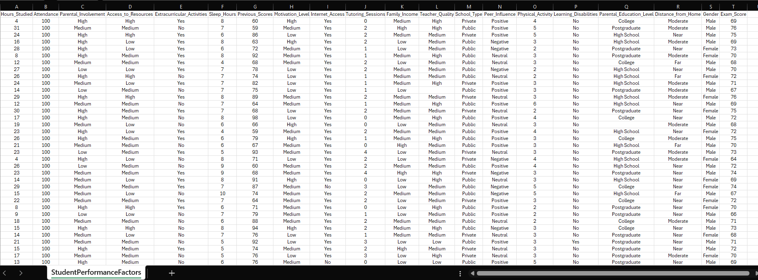  Dataset sorted by Exam Score:  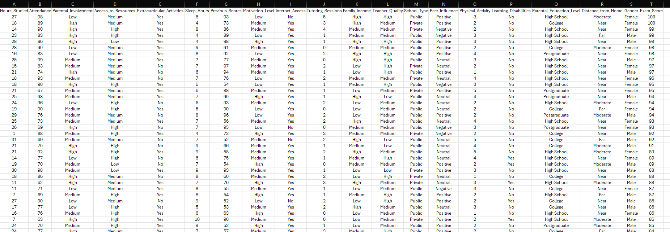  Highlighting the best exam score, 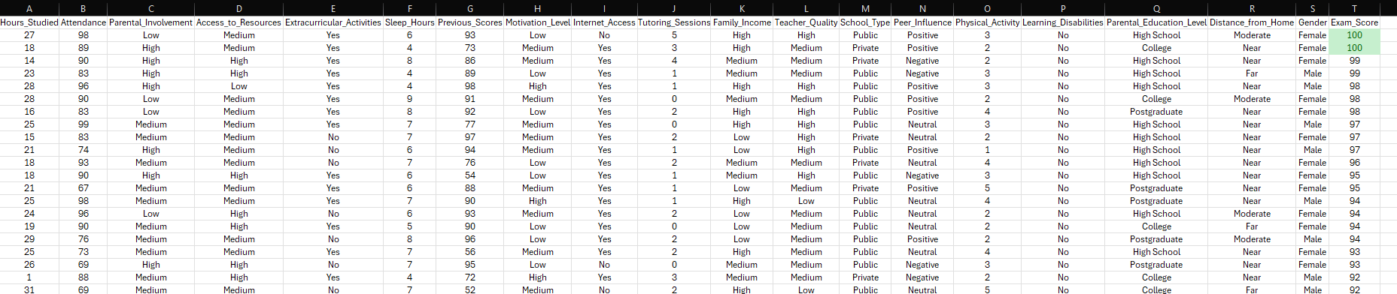and the worst exam score,  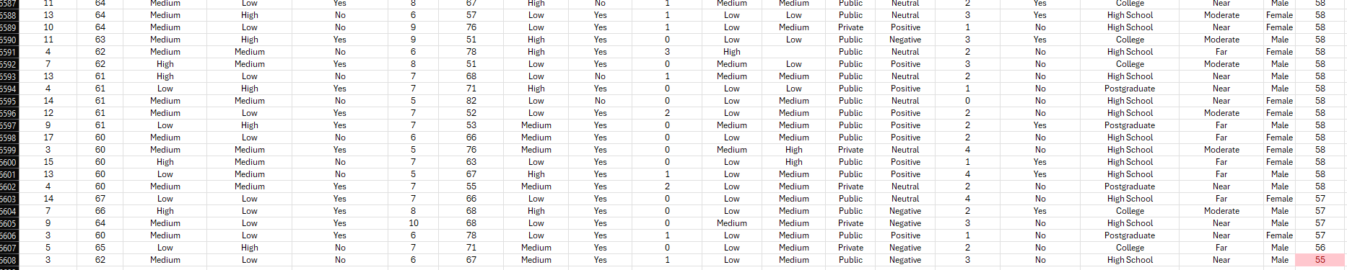

Day 3: Task 1

Please download the dataset ‘Day_3_Task_1_Bike_Sales_Pivot_Lab.xlsx’ and the lab instructions.

Do not worry if you do not complete the lab, just working with data and playing with the pivot table will be good experience.

Please paste your final pivot table below and complete the reflection questions:

Print screen 1 | 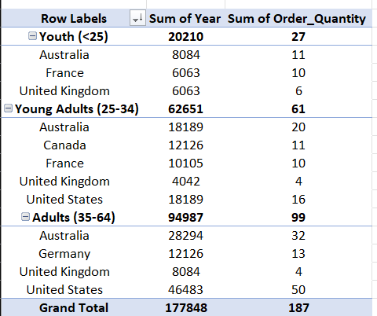
In which markets does Germany have customers? | Germany has customers in the Adults market.
What country has sales in all markets? | Australia and United Kingdom have sales in all markets.
What are the most profitable markets by country, age group, and gender? | 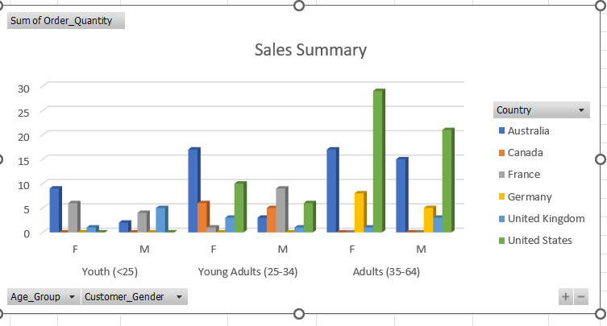The most profitable market by country, age group, and gender is the Adults market, with Adult Females in the United States buying the most product.
Any other findings? | We can also see that the Youth are buying the least product, probably due to the age group they are in, assuming they do not have enough funds to buy a great quantity of products.  Moreover, we can see that Canada and Germany have very limited sales in all sectors, while France is dominating in the Youth Females and Young Adults Males, but has very small sales in the Adults category for both genders.

Day 3: Task 2

The dataset below tracks the sales performance of different products in various counties in England. Please paste the dataset into a blank Excel workbook. Your task is to:
- Create a Pivot Table to summarise the data by county and product.
- Use the SWITCH function to categorise products based on their sales volume.

Dataset:
County | Product | Sales Volume
Yorkshire | Laptops | 500
Yorkshire | Smartphones | 200
Cornwall | Laptops | 700
Cornwall | Printers | 400
Lancashire | Smartphones | 150
Lancashire | Laptops | 600
Essex | Printers | 800
Essex | Smartphones | 300
Durham | Laptops | 250
Durham | Printers | 300
Greater Manchester | Smartphones | 600
Greater Manchester | Laptops | 400

Step 1: Create a Pivot Table
- Select the dataset (columns A to C).
- Insert a Pivot Table to summarise the data by County in the rows and Products in the columns. Use Sales Volume as the value to be summarised.

Step 2: Use the SWITCH Function
In a new column next to your data, use the SWITCH function to categorise products based on Sales Volume as follows:
  - For sales greater than 600: "High"
  - For sales between 300 and 600: "Medium"
  - For sales less than 300: "Low"
SWITCH Function Example:
=SWITCH(TRUE, C2 > 600, "High", C2 >= 300, "Medium", "Low")
- Apply this formula to each row, and check if the products are categorised correctly.

Submission:
- A completed Pivot Table summarising sales by county and product.
- A new column in the dataset categorising products by sales volume using the SWITCH function.
  - Please paste your completed work below

Print screen 1 | 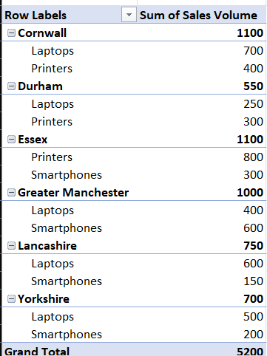  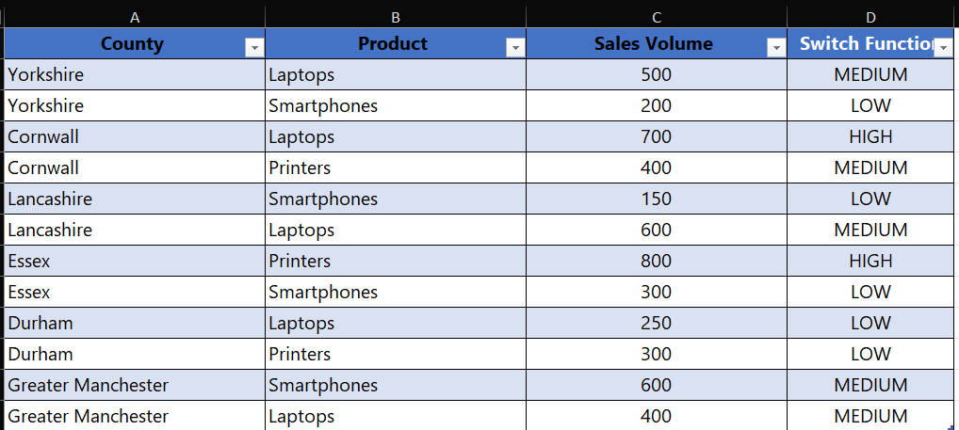

Day 3: Task 3

Please download the dataset ‘Day_3_Task_3_Bike_Sales_Visualisations_Lab.xlsx’ and the the lab instructions. Do not worry if you do not complete the lab, just working with data and playing with the charts will be good experience.

Please paste your results below:

Print screen 1 | LINE CHART – Revenue and Profit by Year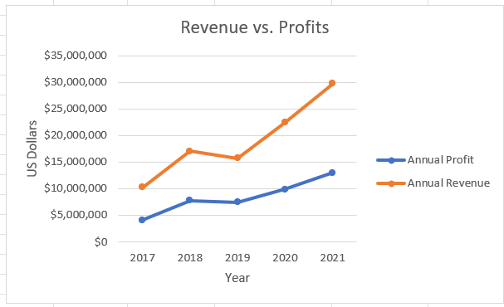  COLUMN CHART – Product Revenue by Country 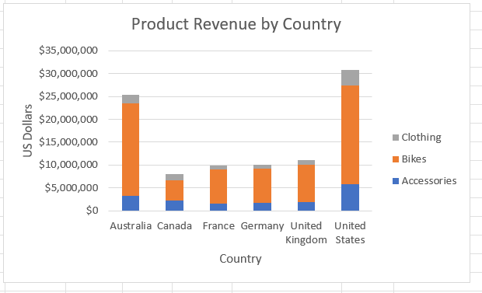  PIE CHART – Revenue Comparison by Age Group  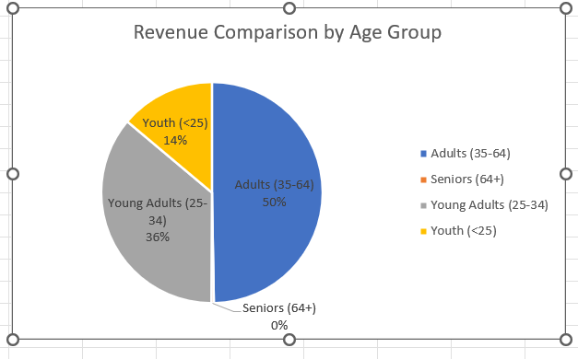

Day 4: Task 1

You have been asked to deliver your analysis findings to the board of directors, with your analysis you have identified that customers are leaving your company at the 12-month point, this is typically when they receive their renewal price.

Conduct research and complete the below questions:

How would you prepare for the delivery? | Before delivering your analysis to the stakeholders, you should do some research on your audience, i.e. how implied they are in the project and what influence they have in it. Your presentation should be tailored for them, engaging, concise, and clear. It is also good practice to be prepared for any questions they may have, especially if it is expected for you to run into any issues and concerns during the project.
What tools would you use for the delivery? | For a successful delivery, you should use interactive tools, like graphs, charts, dashboards, as well as pools and Q&A sessions to keep the audience engaged. Visuals like graphs and charts help simplify the information and highlight key trends without overwhelming the audience with too much information, while keeping it concise and clear, too. Pools and Q&A sessions encourage stakeholders pose any questions they may have, while also giving you an opportunity to showcase the fact that you thought about potential risks and difficulties.
What is prospecting and why would you complete this before your delivery? | Prospecting is the process of identifying and prioritizing stakeholders.  It is normal for the stakeholders to have different needs and be on different levels of importance in a project, so you should identify who are the key stakeholders, i.e. the ones with the most influence and interest, and create strategies as needed for them.  Prospecting helps in personalizing the communication with the stakeholders, whether it is calls, emails, or social meetings, depending on them and their role in the project.
Tell me best practices for public speaking and providing updates to senior leaders | To be good at public speaking requires lots of practice. Anxiety can be difficult, and sometimes it can get the worst of us. A good practice to combat this is to record your speech and listen back to it, make any changes needed, avoid any filler words (e.g. “like”, “uhm”, “erm”) and then repeat until you are satisfied with it. It is also helpful to practice delivering your speech to a small audience that you trust, to make it less intimidating.  Moreover, you should work on confident body language (gestures and good posture) and clear speech, with supporting evidence. Maintaining eye contact with the audience is a strong suit as it gives the impression that you are well prepared and confident, and not at all nervous.  Beginning with a strong hook and ending with a call to action will make the presentation more rounded and memorable.
What will you show the board in your delivery? | Additional to a clear presentation, you should have charts and graphs prepared, to show progress on tasks, costs, and how much time is left for the project to be completed. Moreover, you should have a section in which you talk about what the next steps are and how you plan to go about it, plus any challenges and risks that you may encounter.  You should also be prepared for any questions that the board may have and make sure that you have allocated enough time for feedback.
How will you articulate the changes that are needed? | Sorry I didn’t understand this question
Provide a list of online resources and videos that will support your preparation for public speaking | https://courses.lumenlearning.com/wm-publicspeaking/chapter/supporting-materials/  https://www.toastmasters.org/resources/public-speaking-tips  https://cacgsomerset.co.uk/10-tips-for-effective-public-speaking/
Evaluate tools that provide visualisation.  Tell me what they are.  Tell me what you would choose when delivering your presentation and why | Example of tools that provide visualisation are Powerpoint, Prezi, Tableau, Google Charts, Power Bl.  Personally, I would choose a tool like Powerpoint or Prezi, as you can create a presentation with slides and images that will make your speech more entertaining and easier to follow.  Power Bl and Tableau are tools that help visualise and create charts and graphs from your dataset. They are perfect for large datasets, as it is quick and easy to implement.

Course Notes

It is recommended to take notes from the course, use the space below to do so, or use the revision guide shared with the class:

Additional Information

We have included a range of additional links to further resources and information that you may find useful, these can be found within your revision guide.

END OF WORKBOOK

Please check through your work thoroughly before submitting and update the table of contents if required.

Please send your completed work booklet to your trainer.

