

Data Technician

Name:
Course Date:
Table of contents
Day 1: Task 1 3
Day 1: Task 2 3
Day 3: Task 1 4
Day 4: Task 1: Written 6
Day 4: Task 2: SQL Practical 9
Course Notes 19
Additional Information 19

Day 1: Task 1

Please research and complete the below questions relating to key concepts of databases.

What is a primary key? | A primary key is a column (or a set of columns) in a database that uniquely identifies each record.
How does this differ from a secondary key? | A primary key is unique and non-null and it is used to identify each record, while a secondary key is a field or a combination of fields that is basis for retrieval. A secondary key can be null, unless explicitly restricted. They can also be unique, but it is not mandatory.
How are primary and foreign keys related? | A foreign key is a field in a table that references the primary key of another table to create a link between them.
Provide a real-world example of a one-to-one relationship | A real life example of a one-to-one relationship is between a husband and a wife.
Provide a real-world example of a one-to-many relationship | A real life example of a one-to-many relationship is between a customer and subscriptions, i.e. a customer can have multiple subscriptions.
Provide a real-world example of a many-to-many relationship | A real life example of a many-to-many relationship is between students and university courses, i.e. students can enrol in many courses, and courses can have many students.

Day 1: Task 2

Please research and complete the below questions relating to key concepts of databases.

What is the difference between a relational and non-relational database? | Relational database stores data in a table format with rows and columns, where the columns contain data attributes, and the rows have data values. Tables in a relational database can be linked to gain deeper insights into the interconnection between diverse data points. They ensure consistency and accuracy across data entries through the relationships between tables.  Non-relational databases use a variety of data models for accessing and managing data. They are optimized specifically for applications that require large data volume and flexible data models. They are beneficial for applications that require rapid development.
What type of data would benefit off the non-relational model?  Why? | Because non-relational databases have flexible schemas, the type of data that would benefit off it is unstructured, semi-structured, or rapidly changing (e.g. IoT platforms, data found in social media, large datasets). Non-relational databases do not have a fixed schema, which means that data can be added and modified easily without altering the database’s structure. They can scale horizontally to handle large volumes of data and are optimized for high-volume, real-time data processing.

Day 3: Task 1

Please research the below ‘JOIN’ types, explain what they are and provide an example of the types of data it would be used on.

Self-join | Self-join is a type of JOIN query used to compare rows within the same table. Self-join joins a table to itself, unlike the other JOIN queries. An example would be a table that contains employees and their bosses, since bosses are also employees.
Right join | Right join is a type of JOIN query that returns all records from the right table and the matching records from the left table. If there are no matches, then the result values will be NULL.  An example would be a table that consists of Customers and a table that consists of Orders; using right-join we can see all orders and which customer made them. Right-join will show us even orders that have a missing customer reference.
Full join | Full join is a type of JOIN query that returns all records when there is a match in the left or right table records. For example, on the same tables as before, Customers and Orders, full join will return all customers and all order, so all records from both tables whether the other table matches or not.
Inner join | Inner join is a type of JOIN query that returns records that have matching values in both tables. Inner join only returns rows with a match in both tables. On an example with a Categories table and a Products table, if a row in the Products table does not have a CategoryID, or the CategoryID is not present in the Categories table, then there would be no result returned.
Cross join | Cross join is a type of JOIN query that returns the Cartesian product of two tables, where no matching condition is required, i.e. every row from the first table combined with every row from the second table. A good example to visualise how cross join works is working on a table with clothing products, and a table with available colours. Cross join will return all clothing products combined with all available colours.  E.g. a table having clothing products such as t-shirts, jeans, sweaters, combined with a table with colours such as red, blue, green, the result would be a red t-shirt, blue t-shirt, green t-shirt, red jeans, blue jeans, etc.
Left join | Left join is a type of JOIN query that returns all records from the left table, and the matching records from the right table. If there is no match in the right table, NULL values are recorded. For example, using left join on a table that holds Customers and a table that holds Orders, the result will be all Customers, even those who have not yet placed any orders, where NULL values will be showed.

Day 4: Task 1: Written

In your groups, discuss and complete the below activity. You can either nominate one writer or split the elements between you. Everyone however must have the completed work below:

Imagine you have been hired by a small retail business that wants to streamline its operations by creating a new database system. This database will be used to manage inventory, sales, and customer information. The business is a small corner shop that sells a range of groceries and domestic products. It might help to picture your local convenience store and think of what they sell. They also have a loyalty program, which you will need to consider when deciding what tables to create.

Write a 500-word essay explaining the steps you would take to set up and create this database. Your essay should cover the following points:
- Understanding the Business Requirements:
  - What kind of data will the database need to store?
  - Who will be the users of the database, and what will they need to accomplish?
- Designing the Database Schema:
  - How would you structure the database tables to efficiently store inventory, sales, and customer information?
  - What relationships between tables are necessary (e.g., how sales relate to inventory and customers)?
- Implementing the Database:
  - What SQL commands would you use to create the database and its tables?
  - Provide examples of SQL statements for creating tables and defining relationships between them.
- Populating the Database:
  - How would you input initial data into the database? Give examples of SQL INSERT statements.
- Maintaining the Database:
  - What measures would you take to ensure the database remains accurate and up to date?
  - How would you handle backups and data security?

Your essay should include specific examples of SQL commands and explain why each step is necessary for creating a functional and efficient database for the retail business.

Please write your 500-word essay here | Our business is a small, family owned shop and will need a database that consists of tables that track Sales, Products, Inventories, Suppliers, and Customers.  The users that have access to the database will be the Owners (full access), Store Manager (full access), Assistant Manager (full access), Retail Assistants (viewing access only), and IT Support (full access). It would be best practice to have the Owners, Store Manager, and Assistant Manager handle stock details and orders, while the Retail Assistants are keeping track of how the stock is doing and what needs to be ordered. The IT Support are granted full technical privileges for systems maintenance and troubleshooting, however, they are not concerned with sensitive information to comply with the DPA and UK GDPR.  Our database structure looks like the following image, with Products being the main table, its primary key being referenced in the Suppliers, Inventory, and Sales tables.  Customers have a separate table that are directly linked to Sales. We decided to store their name and email, date of birth as a demographic indicator, loyalty points to keep track of their purchases, and the store location to keep track whether they visit the same store or not.  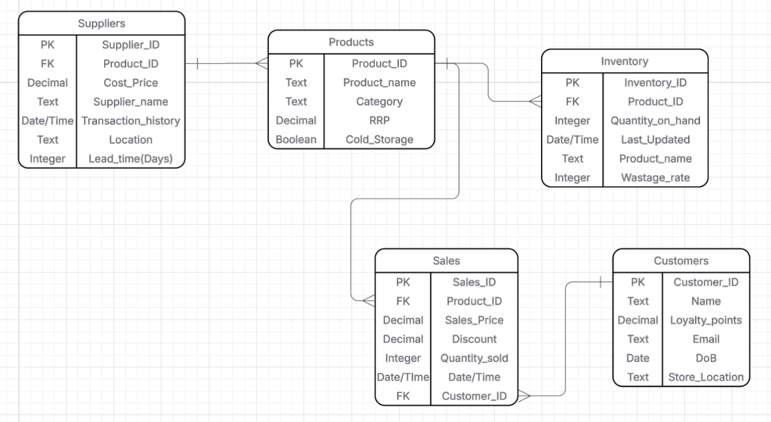  We used SQL to create our database and tables, and the relationships between them are clearly defined by naming their Primary and Foreign Keys and how they are referenced.  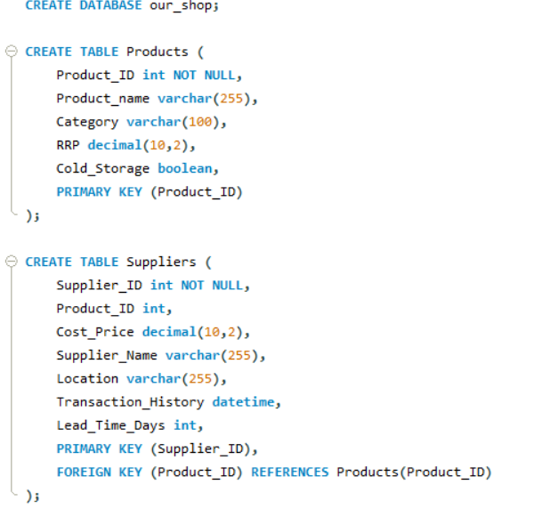  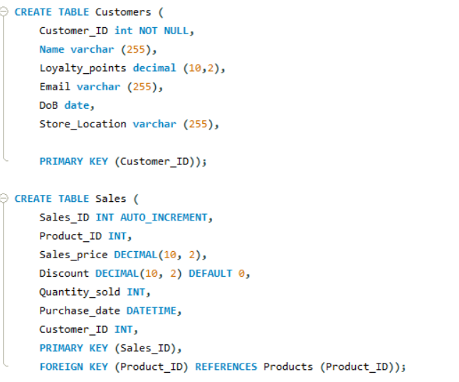  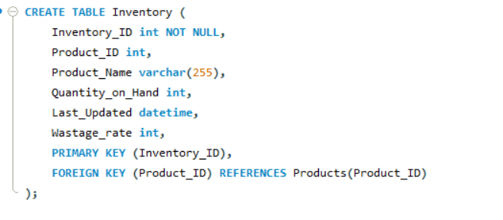  There are examples below on how we decided to populate the database.  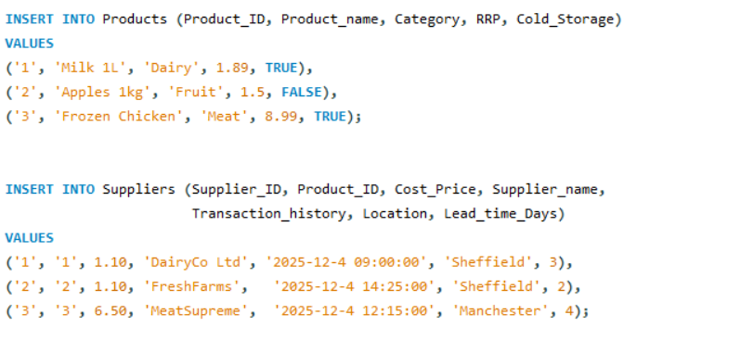  To maintain accuracy and reliability, the database will follow the practices below:  - Regular inventory checks, to ensure the physical stock matches the recorded quantities;  - Integrity checks to ensure data consistency and eliminate duplicates; ensure that all the details are up-to-date;  - Discarding of outdated records, such as discontinued products, old suppliers, to keep the systems updated.  Regarding backups, they will be scheduled regularly and stored both locally and remotely (on the cloud or other physical regions). Access is, as mentioned, role-based, which means that only authorized personnel can amend sensitive data. All sensitive and personal information will be handled to comply with the DPA and UK GDPR. This way, we ensure the database environment is well-structured and reliable, and it supports operational accuracy, safeguards sensitive information, and strongly aligns with recognised best practices for a small business.

Day 4: Task 2: SQL Practical

In your groups, work together to answer the below questions. It may be of benefit if one of you shares your screen with the group and as a team answer / take screen shots from there.

Setting up the database:

- Download world_db(1)
- Follow each step to create your database

For each question I would like to see both the syntax used and the output.

- Count Cities in USA: Scenario: You've been tasked with conducting a demographic analysis of cities in the United States. Your first step is to determine the total number of cities within the country to provide a baseline for further analysis.

*Note: The limit is 10 rows for all exercises, unless stated otherwise.

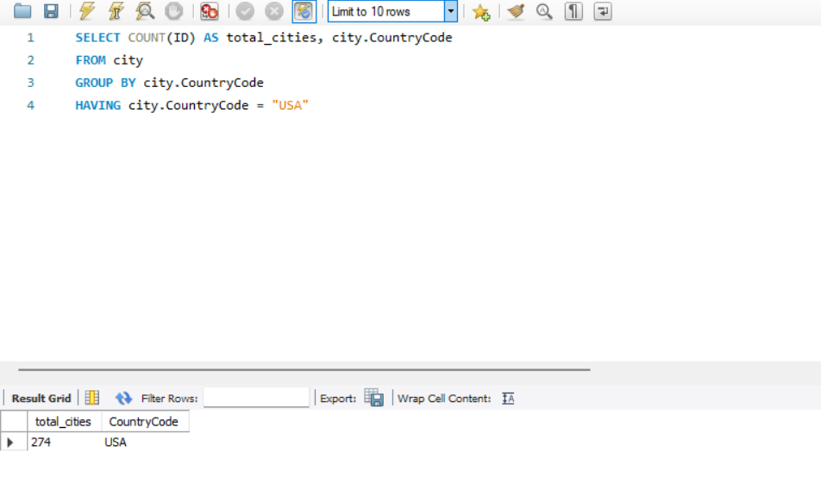

- Country with Highest Life Expectancy: Scenario: As part of a global health initiative, you've been assigned to identify the country with the highest life expectancy. This information will be crucial for prioritising healthcare resources and interventions.

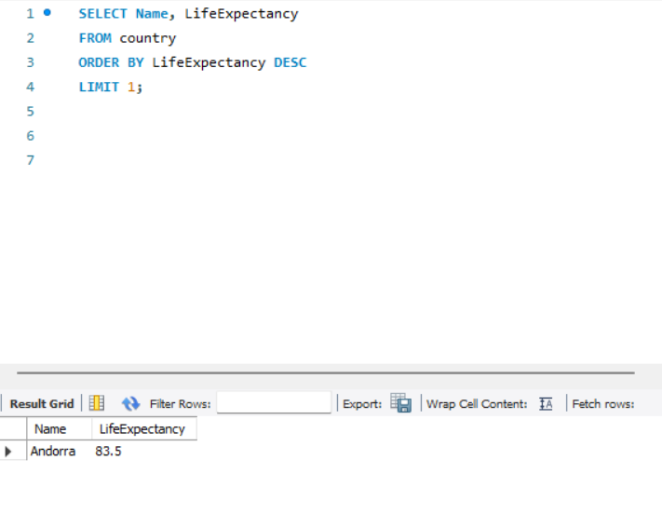

- "New Year Promotion: Featuring Cities with 'New : Scenario: In anticipation of the upcoming New Year, your travel agency is gearing up for a special promotion featuring cities with names including the word 'New'. You're tasked with swiftly compiling a list of all cities from around the world. This curated selection will be essential in creating promotional materials and enticing travellers with exciting destinations to kick off the New Year in style.

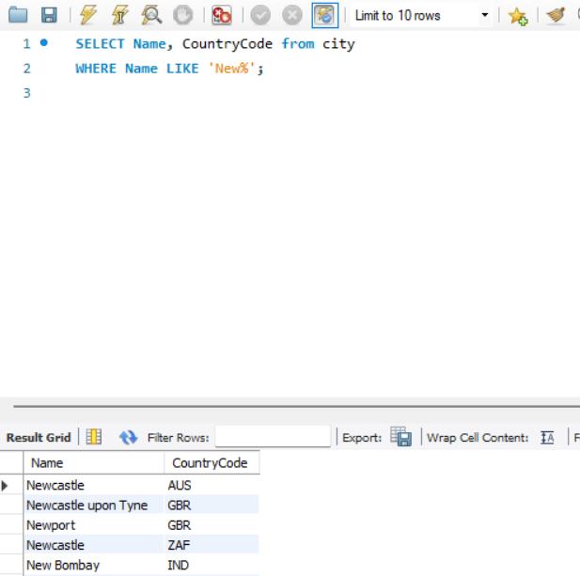

- Display Columns with Limit (First 10 Rows): Scenario: You're tasked with providing a brief overview of the most populous cities in the world. To keep the report concise, you're instructed to list only the first 10 cities by population from the database.

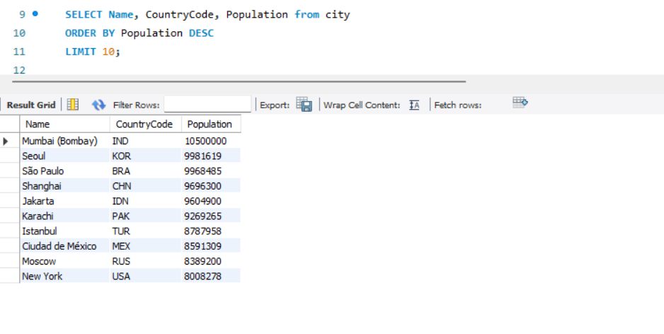

- Cities with Population Larger than 2,000,000: Scenario: A real estate developer is interested in cities with substantial population sizes for potential investment opportunities. You're tasked with identifying cities from the database with populations exceeding 2 million to focus their research efforts.

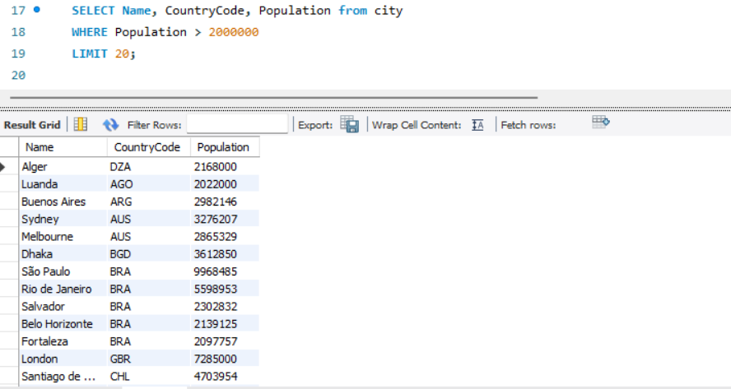

- Cities Beginning with 'Be' Prefix: Scenario: A travel blogger is planning a series of articles featuring cities with unique names. You're tasked with compiling a list of cities from the database that start with the prefix 'Be' to assist in the blogger's content creation process.

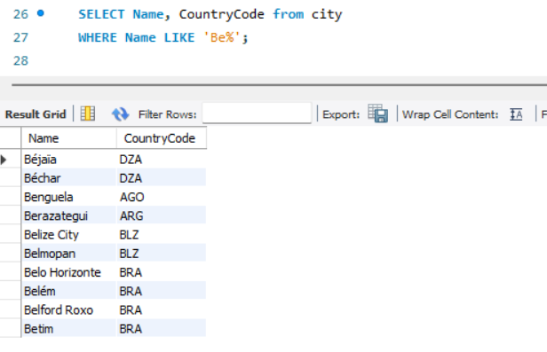

- Cities with Population Between 500,000-1,000,000: Scenario: An urban planning committee needs to identify mid-sized cities suitable for infrastructure development projects. You're tasked with identifying cities with populations ranging between 500,000 and 1 million to inform their decision-making process.

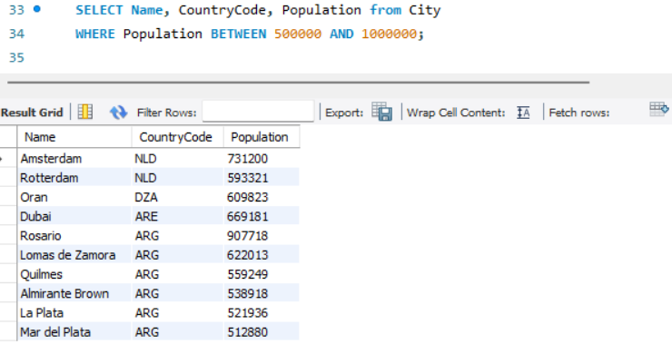

- Display Cities Sorted by Name in Ascending Order: Scenario: A geography teacher is preparing a lesson on alphabetical order using city names. You're tasked with providing a sorted list of cities from the database in ascending order by name to support the lesson plan.

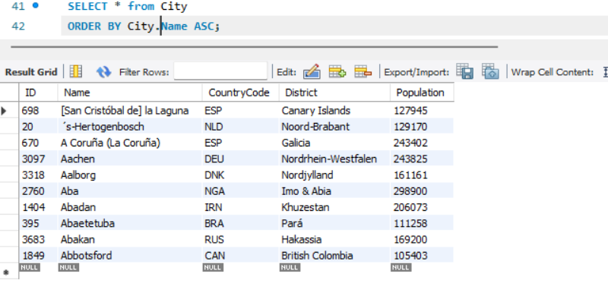

- Most Populated City: Scenario: A real estate investment firm is interested in cities with significant population densities for potential development projects. You're tasked with identifying the most populated city from the database to guide their investment decisions and strategic planning.

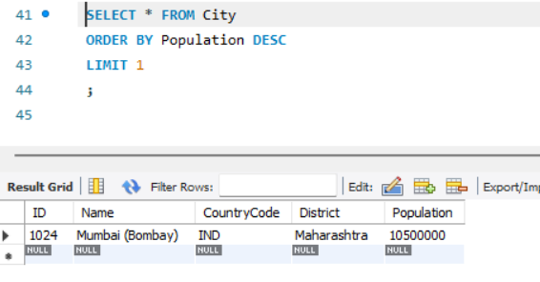

- City Name Frequency Analysis: Supporting Geography Education Scenario: In a geography class, students are learning about the distribution of city names around the world. The teacher, in preparation for a lesson on city name frequencies, wants to provide students with a list of unique city names sorted alphabetically, along with their respective counts of occurrences in the database. You're tasked with this sorted list to support the geography teacher.

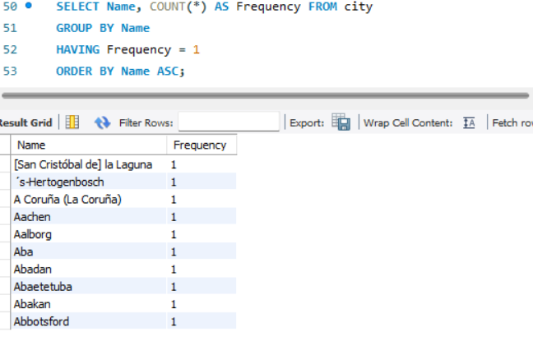

- City with the Lowest Population: Scenario: A census bureau is conducting an analysis of urban population distribution. You're tasked with identifying the city with the lowest population from the database to provide a comprehensive overview of demographic trends.

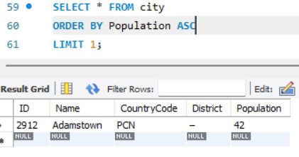

- Country with Largest Population: Scenario: A global economic research institute requires data on countries with the largest populations for a comprehensive analysis. You're tasked with identifying the country with the highest population from the database to provide valuable insights into demographic trends.

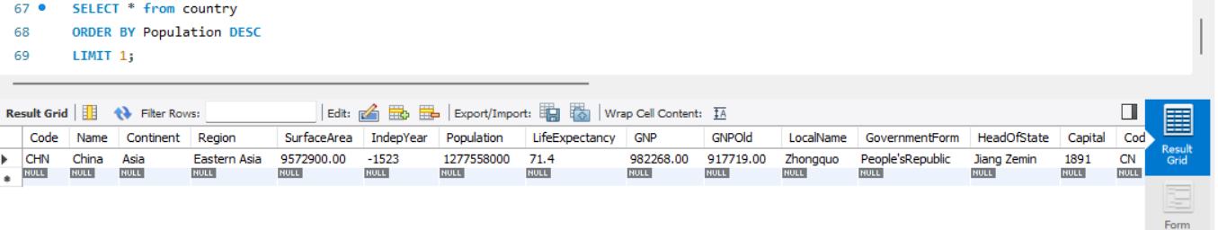

- Capital of Spain: Scenario: A travel agency is organising tours across Europe and needs accurate information on capital cities. You're tasked with identifying the capital of Spain from the database to ensure itinerary accuracy and provide travellers with essential destination information.

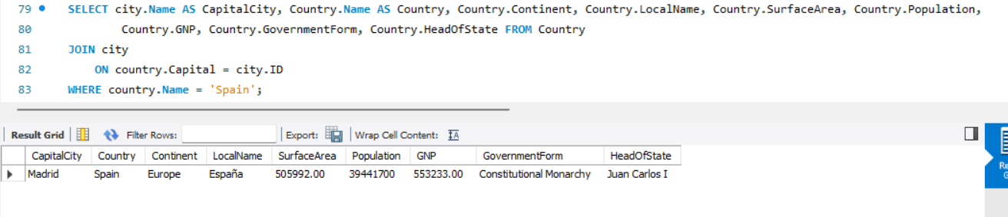

- Country with Shortest Life Expectancy: Scenario: A healthcare foundation is conducting research on global health indicators. You're tasked with identifying the country with the shortest life expectancy from the database to inform their efforts in improving healthcare systems and policies.

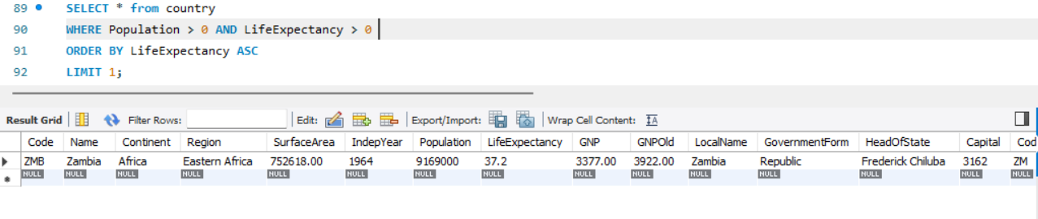

- Cities in Europe: Scenario: A European cultural exchange program is seeking to connect students with cities across the continent. You're tasked with compiling a list of cities located in Europe from the database to facilitate program planning and student engagement.
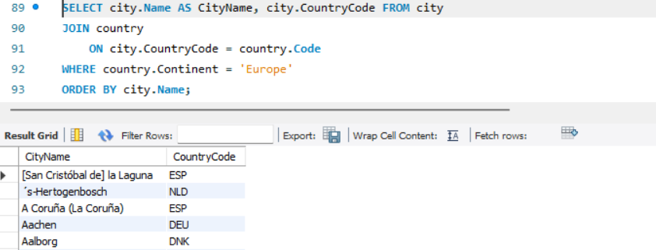

- Average Population by Country: Scenario: A demographic research team is conducting a comparative analysis of population distributions across countries. You're tasked with calculating the average population for each country from the database to provide valuable insights into global population trends.

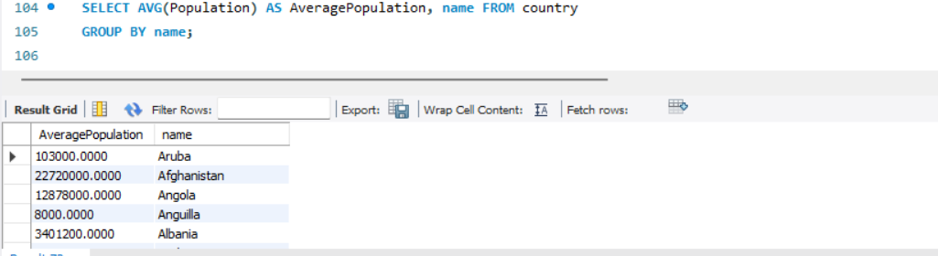

- Capital Cities Population Comparison: Scenario: A statistical analysis firm is examining population distributions between capital cities worldwide. You're tasked with comparing the populations of capital cities from different countries to identify trends and patterns in urban demographics.

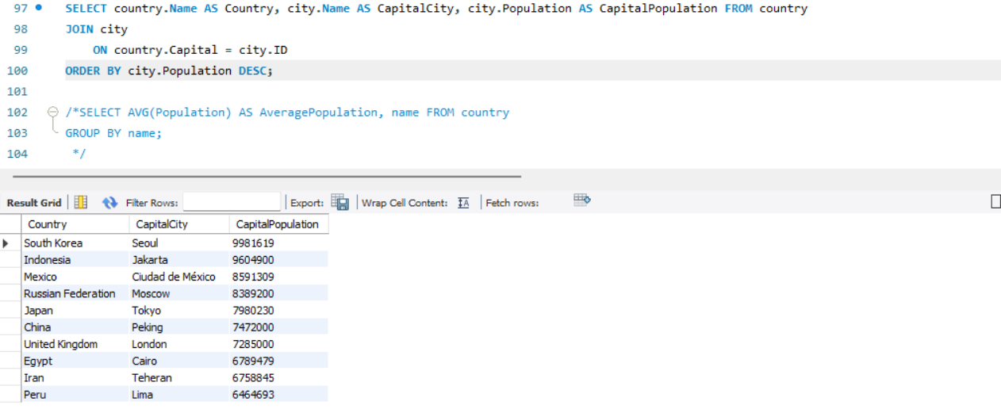

Disregard the commented code please!

- Countries with Low Population Density: Scenario: An agricultural research institute is studying countries with low population densities for potential agricultural development projects. You're tasked with identifying countries with sparse populations from the database to support the institute's research efforts.

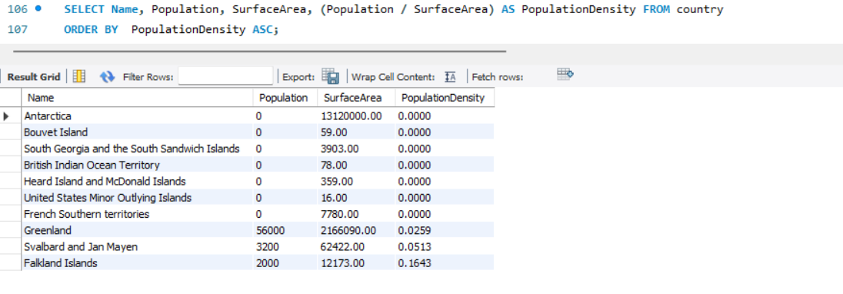

Another screenshot where we only take into consideration Countries with Population > 0.
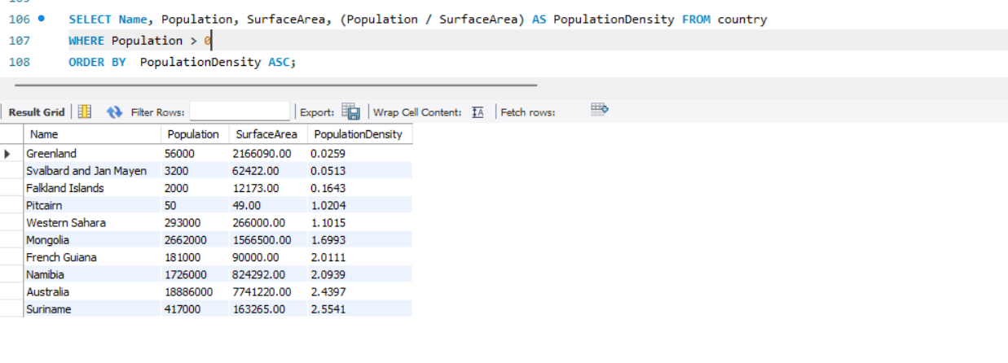

- Cities with High GDP per Capita: Scenario: An economic consulting firm is analysing cities with high GDP per capita for investment opportunities. You're tasked with identifying cities with above-average GDP per capita from the database to assist the firm in identifying potential investment destinations.

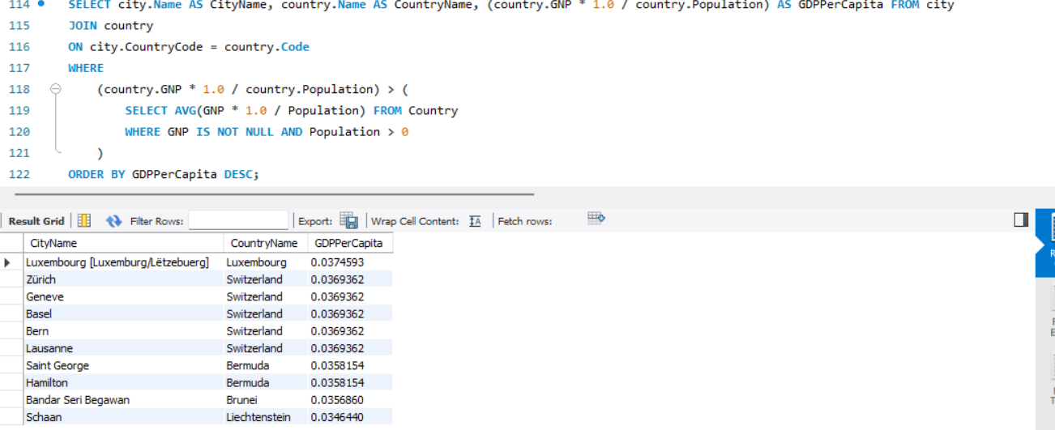

- Display Columns with Limit (Rows 31-40): Scenario: A market research firm requires detailed information on cities beyond the top rankings for a comprehensive analysis. You're tasked with providing data on cities ranked between 31st and 40th by population to ensure a thorough understanding of urban demographics.

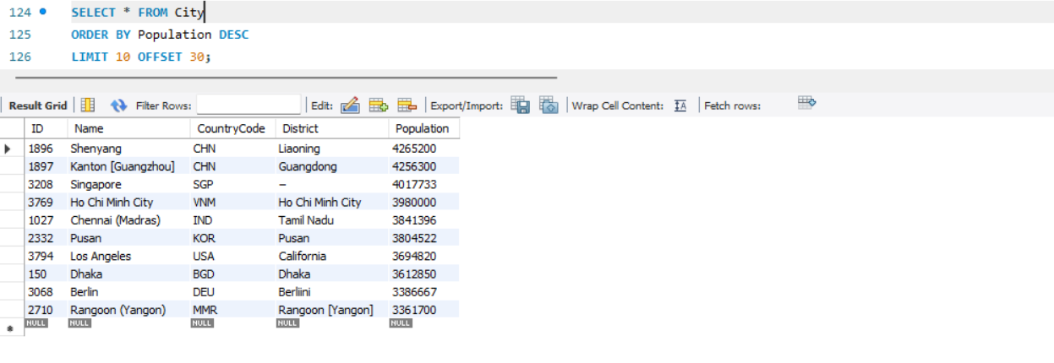

Course Notes

It is recommended to take notes from the course, use the space below to do so, or use the revision guide shared with the class:

Additional Information

We have included a range of additional links to further resources and information that you may find useful, these can be found within your revision guide.

END OF WORKBOOK

Please check through your work thoroughly before submitting and update the table of contents if required.

Please send your completed work booklet to your trainer.

