1. 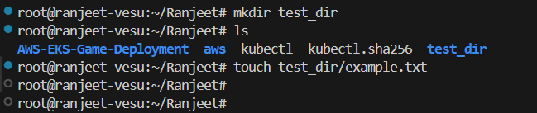

From mkdir i have create test_dir and from touch cmd i have created empty file called example.txt  
  
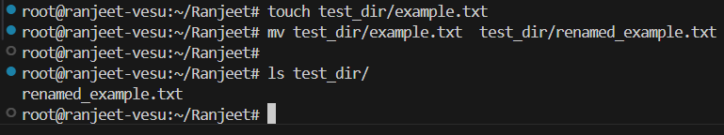  
Mv cmd is used for moving directory from one directory to another directory but it is also used for renaming the dir

2.

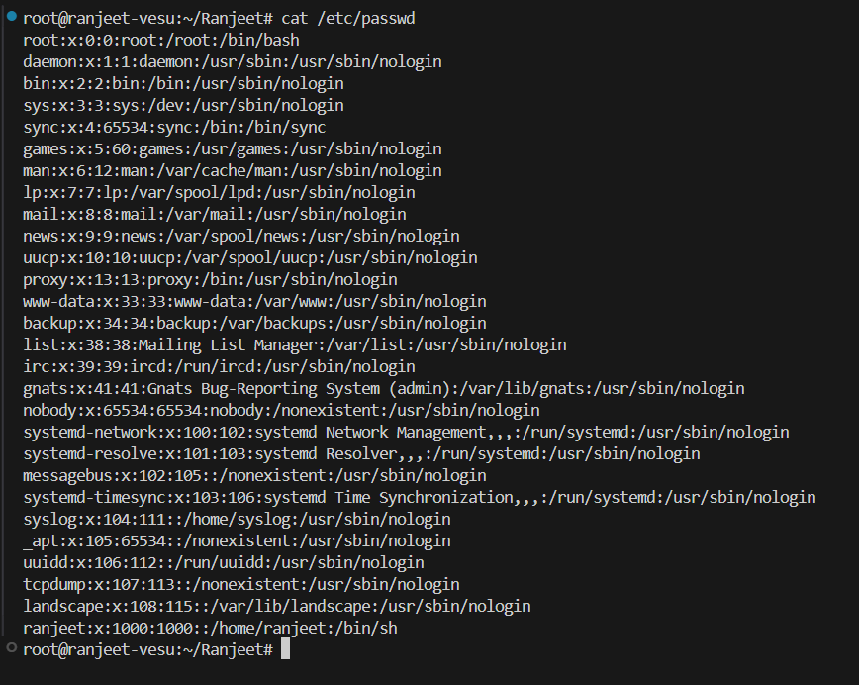

From Cat We can view the content of file and also we can update or append the file

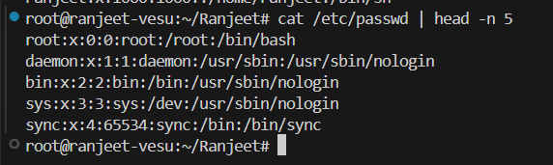

From cat we will view the content and head will show first output with number of line that we require with sign of –n , give number for view number of line

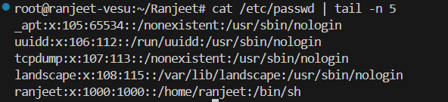

From cat we will view the content and tail will show last output with number of line that we require with sign of –n , give number for view number of line

3.

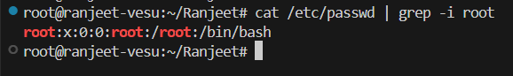

From grep we can find the word from any file and –i indicats ignore case sensitiv

4.

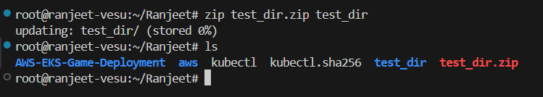

Zip cmd is use for compressing the file or directory

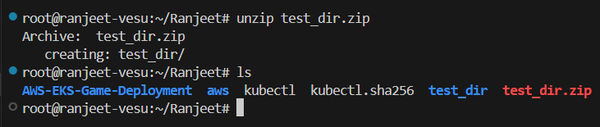

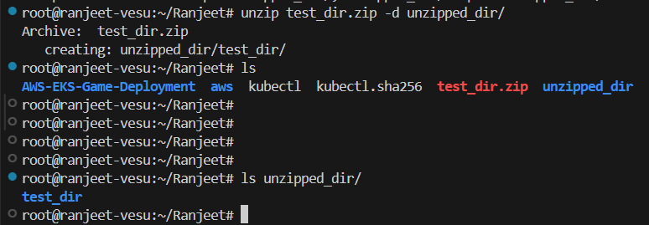

Will create new dir with the name of unzipped_dir and will extract the test_dir.zip there with help of unzip cmd

5.

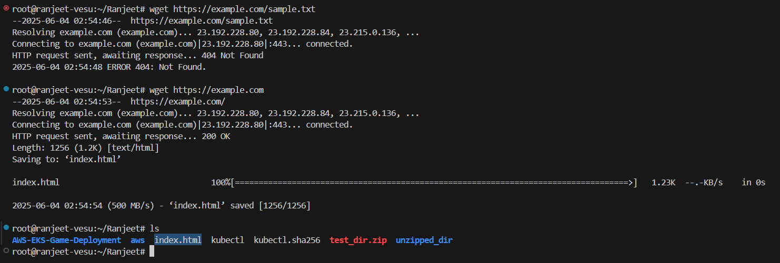

I tried to download <https://example.com/sample.txt> but i got 404. So i tried to download <https://example.com> it got download successfully with index.html as mentioned above snapshot

6.

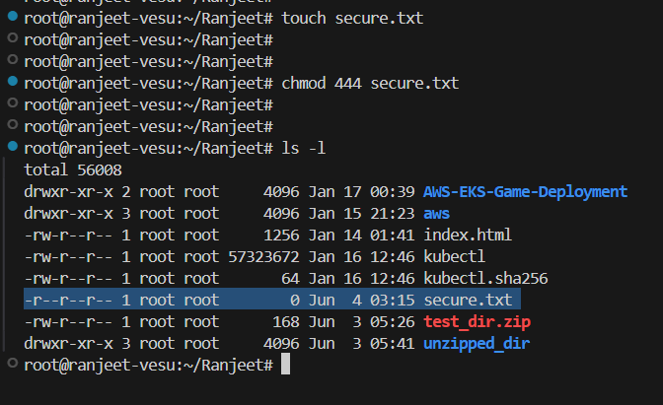

Created file with touch cmd and change permission with chmod 444 which will change read permission for all

7.

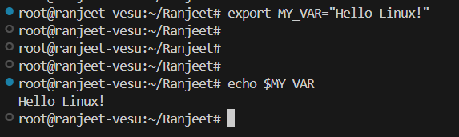

I used export cmd to create env var and cross checked with echo cmd