**Question 1.**

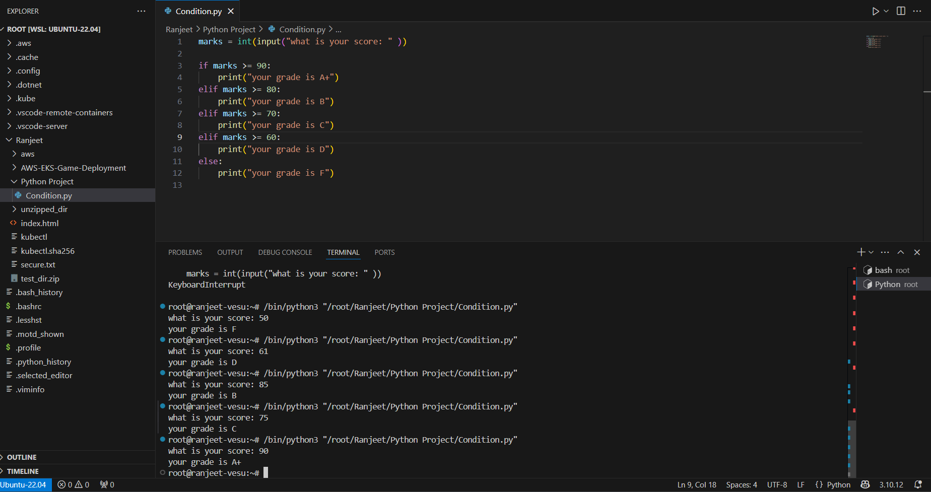

I have used input function to take input from the user and used if and elif for output of Grade

And if the marks would have below 60 they would be Failed

**Question 2.**

# Created an empty dictionary for student grades

grades = {}

while True:

print("\nChoose an option:")

print("1. Add new student")

print("2. Update student grade")

print("3. Print all grades")

print("4. Exit")

choice = input("Enter your choice (1-4): ")

if choice == "1":

name = input("Enter student name: ")

grade = input("Enter grade: ")

if name in grades:

print("Student already exists.")

else:

grades[name] = grade

print("Student added.")

elif choice == "2":

name = input("Enter student name to update: ")

if name in grades:

grade = input("Enter new grade: ")

grades[name] = grade

print("Grade updated.")

else:

print("Student not found.")

elif choice == "3":

print("\nStudent Grades:")

for name, grade in grades.items():

print(f"{name}: {grade}")

elif choice == "4":

print("Exiting program.")

break

else:

print("Invalid choice. Try again.")

I have created dictionary with name of grades  
As per requirement i added new student and his grade   
  
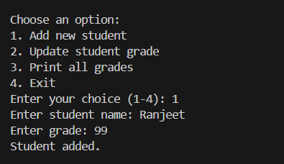

Second requirement was to update an existing student’s grade.

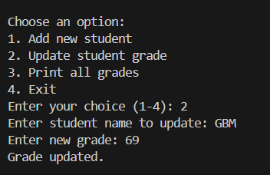

also print all grades of students.   
  
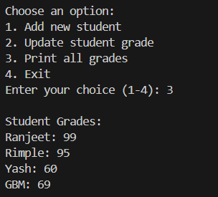

**Question: 3**  
  
  
I have created file by python code and update it   
  
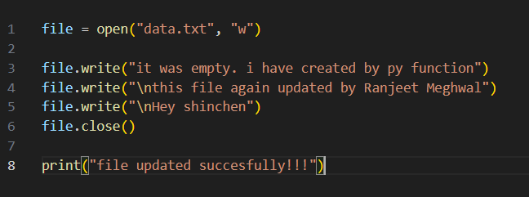

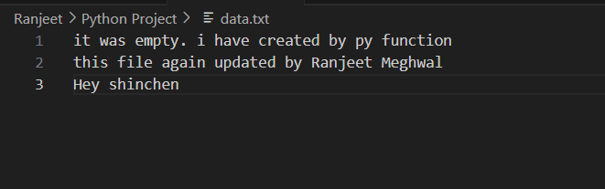

**Question: 4**I used open in read mode and open the file and read it via py code  
  
