**Question:1**

**I have created** [**data.py**](http://data.py) **which contains dictionary   
  
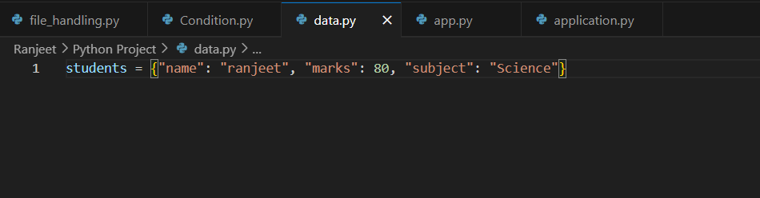**

**I have created Code which import this dictionary and route would be /api   
  
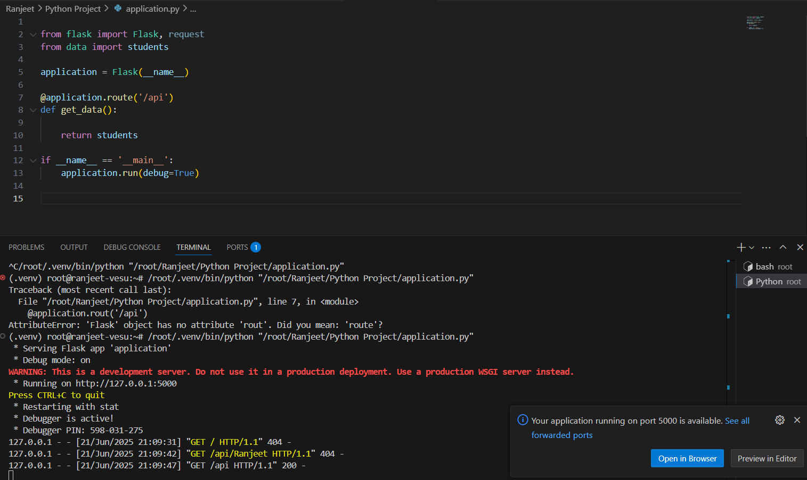**

**Here is the output.  
  
