# Data

The data sources I used to inform my model are as listed in Table 1. These predictors were selected with guidance from the [2018 LTSA report](http://www.ercot.com/content/wcm/lists/144927/2018_LTSA_Report.pdf), with the relevant figure shown below, generated by a survey of ERCOT stakeholders. Note here that natural gas prices and weather conditions, included as predictors in my model, are listed among the most important drivers in the ERCOT grid.

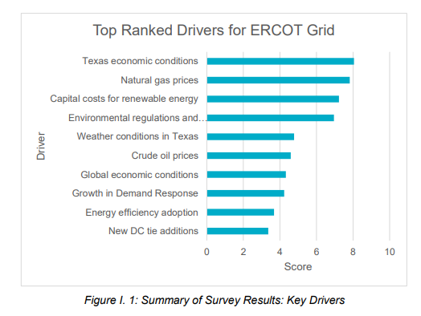

|  |  |  |  |  |
| --- | --- | --- | --- | --- |
| Table 1: Data Sources | | | | |
| **Name** | **Source** | **Notes** | **Date Range** | **Time Resolution Downloaded** |
| Historical SPP | [ERCOT](http://mis.ercot.com/misapp/GetReports.do?reportTypeId=13061&reportTitle=Historical%20RTM%20Load%20Zone%20and%20Hub%20Prices&showHTMLView=&mimicKey) |  | 2011-2019 | 15 minutes |
| Historical Temperature | [NOAA](https://www.ncdc.noaa.gov/cdo-web/datatools/lcd) | Houston Airport | 2011-2020 | 1 hour |
| Temperature Forecasts | [USGS](http://regclim.coas.oregonstate.edu/visualization/rccv/states-counties/) | Texas-wide used, Mean Model Used | 2020-2099 | 10 years |
| US Natural Gas Price Forecasts | [EIA](https://www.eia.gov/outlooks/aeo/data/browser/#/?id=13-AEO2018&cases=ref2018&sourcekey=0) | Industrial Used | 2016-2050 | 1 year |
| Historical US Natural Gas Price | [EIA](https://www.eia.gov/dnav/ng/hist/n3035us3A.htm) | Monthly available, Industrial Used | 1997-2019 | 1 year |
| Historical and Forecasted Peak and Annual Demand | [ERCOT](http://www.ercot.com/content/wcm/lists/114580/2017_Long-Term_Hourly_Peak_Demand_and_Energy_Forecast.pdf) | Extrapolate for 2027-2039 | 2007-2026 | 1 year |
| Historical Texas GDP | [US Bureau of Economic Development](https://fred.stlouisfed.org/series/TXNGSP) |  | 1997-2019 | 1 year |
| Texas GDP Forecasts | [ERCOT](http://www.ercot.com/content/wcm/lists/144927/2018_LTSA_Report.pdf) | Growth rate applied to 2019 GDP | 1.4% growth (normal), 2.2% (high) | 1 year |

# Scenarios

BAU

High economic growth:

* Affects GDP growth rate and NG prices

High Renewable Penetration:

* + Affects renwable energy costs