UX PACIFIC
UX Pacific Shop
Master Ecommerce Product, Feature, Architecture,
Design System and Launch Blueprint
A professional reference for strategy, product scope, digital and physical commerce, customer journeys, administration, URLs, APIs, pricing, UI rules, QA risks and implementation priorities.

Prepared for | UX Pacific Shop
Prepared on | 01 June 2026
Document type | Master project report and production implementation blueprint
Current source | C:\xampp\htdocs\SHOPMohitSir\UX_Shop_New

DECISION DOCUMENT
This report distinguishes the current implementation from the required production scope. Recommended catalog, pricing, policies and workflows are product decisions until formally approved.

Document Control
Field | Value
Purpose | Define the complete ecommerce product, required implementation, operating model and launch criteria.
Audience | Founder, product owner, designer, developer, QA tester, content operator and admin team.
Current-state basis | Observed PHP pages, API endpoints, database schema, current database records, design tokens and QA evidence.
Scope rule | Current implementation and launch recommendations are explicitly separated to avoid treating assumptions as shipped behavior.
Version | 1.0 - 01 June 2026

Status Legend
Status | Meaning
Implemented | Present in the current codebase or database and available for verification.
Partial | Present, but incomplete, inconsistent, or blocked by a defect.
Required | Recommended minimum for a credible production launch.
Future | Useful growth capability after the launch baseline is stable.

How To Use This Report
- Use Sections 2-5 to align the business, audience, product assortment and pricing.
- Use Sections 6-12 as the implementation scope for customer, admin, payment, email and content work.
- Use Sections 13-18 as the design, engineering, QA and launch acceptance reference.
- Resolve the open product decisions before final copywriting, catalog migration or production deployment.

1. Executive Summary
UX Pacific Shop is an ecommerce storefront for UX learners, designers and early-career professionals. Its strongest product direction is a focused catalog of practical UX assets: templates, UI kits, mockups, research workbooks, interview resources, bundles, freebies and selected physical learning merchandise.
The existing project already contains a meaningful end-to-end foundation: public discovery pages, authentication, cart, checkout, Razorpay integration, COD handling, customer account pages, wishlist, reviews, contact capture, admin operations and a MySQL schema. It is not production-ready yet. Payment lifecycle, order inventory handling, freebie downloads, canonical domain choice, placeholder content and mobile overflow require correction before launch.
Recommended product position
A curated UX resource shop that helps learners and working designers move faster: download useful assets immediately, buy guided physical practice tools when needed, and return to one account for orders, downloads, wishlists and reviews.

Launch Recommendation
Decision Area | Recommendation | Reason
Launch model | Start with digital-first commerce and a small physical catalog. | Digital products reduce fulfilment risk while the physical workflow is stabilized.
Core catalog | Prioritize 8-12 polished digital SKUs, 4-5 bundles, 3-5 physical SKUs and 5-8 real freebies. | Enough variety for discovery without diluting product quality.
Payments | Razorpay Card/UPI plus COD for eligible physical products only. | Matches the existing implementation and keeps the rule understandable.
Pricing | Use simple INR price points and clearly separated personal/commercial licenses. | Reduces checkout ambiguity and supports creator-friendly upsell.
Readiness | Do not deploy to production until all P0 defects are resolved and retested. | The current payment and inventory risks can create order or revenue errors.

2. Purpose, Goals and Audience

Why This Website Exists
UX Pacific Shop exists to convert useful UX learning and working materials into a dependable commerce experience. Instead of forcing customers to search across unrelated sources, the shop should present trusted, curated resources with clear previews, prices, license terms, delivery expectations and post-purchase access.

Business Goals
- Sell digital UX resources with immediate, reliable fulfilment after verified payment.
- Sell selected physical resources with accurate inventory, address capture, COD eligibility and shipping status.
- Build trust through a polished visual system, clear product information, transparent policies and dependable email communication.
- Create a reusable customer relationship through accounts, order history, wishlists, reviews, freebies and future offers.
- Give administrators one practical workspace for catalog, order, user, review, message and content operations.
- Measure conversion, cart health, payment success, product performance and repeat purchase behavior.

Primary Target Audiences
Audience | Need | Best Products | Key UX Requirement
UX students and beginners | Structured practice and portfolio support | Workbooks, templates, starter kits, freebies | Simple language, affordable entry prices and visible outcomes
Early-career designers | Job-readiness and presentation quality | Portfolio kits, interview bundles, mockups, badge packs | Fast comparison, clear previews and license clarity
Freelancers and creators | Reusable production assets | UI kits, design systems, mockups, commercial licenses | Commercial usage terms and efficient downloads
Mentors and educators | Teaching aids and repeatable exercises | Printed workbooks, poster sets, bundles | Bulk purchase path and clear fulfilment
Returning customers | Access and continuity | Downloads, order details, wishlist, new releases | Reliable account history and transactional email

Core Personas
Persona | Situation | Purchase Trigger | Likely Path
Aarav - UX learner | Building a first case study | Needs an affordable portfolio template and workbook | Freebie -> product detail -> personal license -> Razorpay -> download
Maya - freelance designer | Preparing a client dashboard project | Needs a UI kit with commercial usage | Search -> UI kit -> commercial license -> checkout -> download
Rohan - job seeker | Preparing for interviews | Needs bundled practice resources | Bundles -> interview prep bundle -> cart -> payment -> order history
Neha - design educator | Runs a classroom workshop | Needs printed workbooks and posters | Physical catalog -> quantity -> address -> COD/online payment -> shipment updates

Non-Goals For Initial Launch
- Do not launch as a large general marketplace with third-party sellers.
- Do not add complex subscription tiers until one-time purchase, fulfilment and reporting are stable.
- Do not expand into international tax, multi-currency or multi-language checkout before the India-first baseline is reliable.
- Do not treat decorative content as a substitute for clear product previews, license terms and download instructions.

3. Catalog Strategy, Categories and Pricing

Current Database Catalog
The database currently contains six categories, six active products, five active bundles and one active freebie. The table below records the observed state; it is not the recommended final launch catalog.
Type | Item | Category | Price | Observed Notes
Product | Design Career Badge Pack | UX Resources | INR 199 | Digital; old price INR 499
Product | Mobile App Mockup Pack | Mockups | INR 299 | Digital; featured
Product | SaaS UI Kit Essentials | UI Kits | INR 599 | Digital; featured
Product | UX Research Workbook | Workbooks | INR 499 | Digital; featured
Product | UXPacific UI Template | Templates | INR 399 | Digital; featured
Product | kmlm Booklet | Templates | INR 89 | Physical placeholder content; retire or replace
Bundle | Portfolio Builder Kit | Bundles | INR 999 | Observed active bundle
Bundle | UX Interview Prep Bundle | Bundles | INR 899 | Observed active bundle
Bundle | SaaS Launch Bundle | Bundles | INR 1,299 | Observed active bundle
Bundle | Research Sprint Bundle | Bundles | INR 799 | Observed active bundle
Bundle | Creator Starter Bundle | Bundles | INR 1,099 | Observed active bundle
Freebie | ui kits essentials | UI Kit | Free | Placeholder file URL; replace with owned downloadable asset

Recommended Launch Categories
Category | Purpose | Suggested Range | Launch Minimum
Templates | Portfolio, case study, resume and presentation accelerators | INR 299-799 | 3 polished products
UI Kits | Reusable interface components and design-system starters | INR 599-1,199 | 2 polished products
Mockups | Presentation-ready screens, devices and portfolio visuals | INR 299-699 | 2 polished products
UX Resources | Interview, career, research and process assets | INR 199-699 | 3 polished products
Workbooks | Digital and printed guided practice material | INR 349-699 | 2 digital + 1 physical
Bundles | Outcome-focused combinations with visible savings | INR 799-1,499 | 4-5 bundles
Freebies | Lead-generation assets that demonstrate quality | Free | 5-8 real downloads

Recommended Digital Product Assortment
Product | Category | Personal | Commercial | Fulfilment
Portfolio Case Study Template | Templates | INR 399 | INR 599 | ZIP + PDF guide
UX Resume and Cover Letter Kit | Templates | INR 299 | INR 449 | ZIP + editable files
SaaS Dashboard UI Kit | UI Kits | INR 599 | INR 899 | Figma file + guide
Design System Starter Pack | UI Kits | INR 799 | INR 1,199 | Figma file + tokens
Mobile App Mockup Pack | Mockups | INR 299 | INR 499 | ZIP assets
UX Research Workbook | Workbooks | INR 499 | INR 699 | PDF workbook
UX Interview Toolkit | UX Resources | INR 399 | INR 599 | PDF + worksheets
Design Career Badge Pack | UX Resources | INR 199 | INR 299 | ZIP assets

Recommended Physical Product Assortment
Product | Category | Price | Fulfilment Note
UX Research Field Notebook | Workbooks | INR 349 | Inventory tracked; suitable entry product
UX Canvas Workbook - Printed Edition | Workbooks | INR 599 | Address required; protect packaging
UX Process Poster Set | UX Resources | INR 499 | Tube or flat-pack shipping decision required
Creator Sticker Pack | UX Resources | INR 199 | Low-cost add-on and bundle enhancer
Design Career Badge Pack - Physical | UX Resources | INR 249 | Optional companion to digital badge pack

Bundle and Pricing Rules
- Keep bundle savings visible and believable: target 20-35% below the sum of included products.
- Use rounded INR prices for customer-facing license variants. Avoid calculated-looking values such as INR 838.60.
- Show old price only when it reflects a genuine, supportable offer.
- Apply shipping to physical items only. Recommended baseline: INR 50 flat shipping, with an approved free-shipping threshold such as INR 999.
- Apply tax using one centrally managed server-side rule. The current checkout visibly applies 18%; finance approval is required before launch.
- Never accept product type, price, tax, stock or shipping values from the browser as authoritative.

Product Content Requirements
Field | Required Standard
Title | Clear outcome-focused name; remove placeholders and test data.
Slug | Stable, lowercase, readable URL key.
Preview media | Cover image plus useful gallery or preview pages; consistent aspect ratio.
Description | What it solves, what is included, who it is for and how delivery works.
Type | Digital, physical or both; always sourced from the database.
License | Personal and commercial rules displayed before checkout.
Stock | Real inventory for physical SKUs; digital products use availability status, not fake scarcity.
Files | Owned, secure, versioned download assets; no placeholder URLs.
SEO | Meta title, description, canonical URL and meaningful image alt text.

4. Information Architecture
The target information architecture keeps public discovery simple while separating authenticated customer tasks and administrative operations. The current PHP implementation already contains most of the listed destinations.
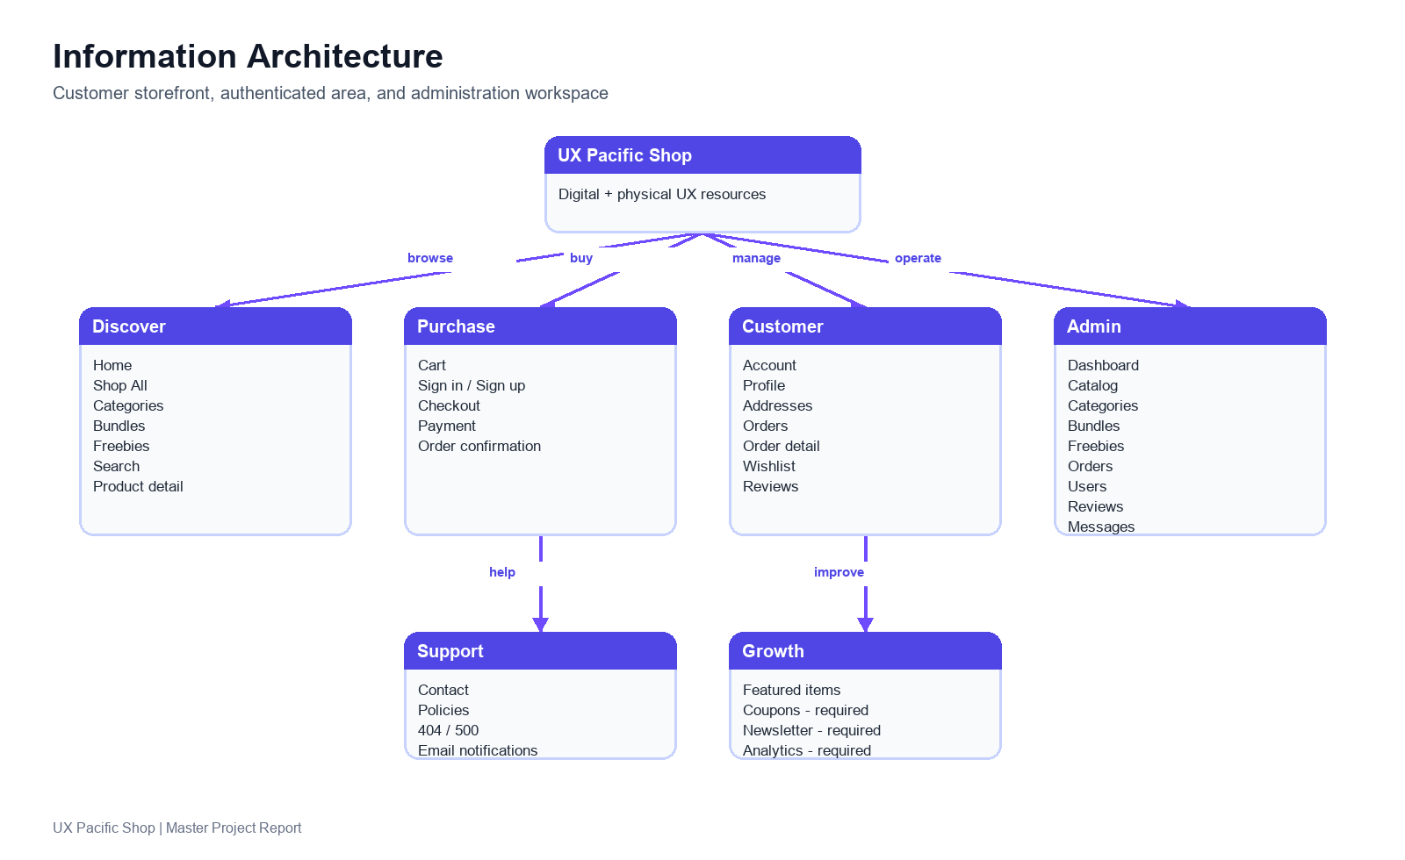

Current Sitemap and Purpose
Area | Page / Route | Purpose | State
Discover | index.php | Homepage: hero, featured value, catalog entry points | Implemented
Discover | shopAll.php | All products, filters, sorting and pagination | Implemented
Discover | category.php | Category landing and filtered discovery | Implemented
Discover | product.php?id={id} | Product detail, license/type, quantity and add-to-cart | Implemented
Discover | bundles.php | Bundle catalog and bundle details | Implemented
Discover | freebies.php | Free downloadable lead magnets | Partial
Discover | search.php?q={query} | Search results | Implemented
Purchase | cart.php | Cart contents, quantities, removal and totals | Implemented
Purchase | checkout.php | Address, delivery, payment and order review | Partial
Purchase | order-confirmation.php | Post-order confirmation | Partial
Account | signin.php / signup.php | Authentication | Implemented
Account | forgot-password.php / reset-password.php | Password recovery | Implemented
Account | account.php | Profile, address and account overview | Implemented
Account | orders.php | Order history and review access | Implemented
Account | wishlist.php | Saved products | Implemented
Support | contact.php | Customer message submission | Implemented
Support | policies.php | Terms, privacy, delivery, return and download rules | Implemented
Admin | admin/admin-login.php | Administrator authentication | Implemented
Admin | admin/admin-dashboard.php | Back-office workspace | Implemented
Errors | 404.php / 500.php | Custom error presentation | Partial

Recommended URL Direction
Current | Recommended Public URL | Reason
product.php?id=11 | /products/uxpacific-ui-template | Readable, shareable and SEO-friendly product URL
shopAll.php?category=ui-kits | /categories/ui-kits | Stable category landing
bundles.php?quick=bundle&id=1 | /bundles/portfolio-builder-kit | Clear bundle identity
search.php?q=dashboard | /search?q=dashboard | Preserve search intent
shopAll.php filters in JS only | /shop?category=ui-kits&type=digital&sort=price-low | Shareable filter state and browser history

Canonical-domain decision required
Current project signals are inconsistent: the sitemap and robots file reference https://uxpacific.shop/ while application configuration has referenced https://shop.uxpacific.com. Choose one canonical production domain before launch and align redirects, sitemap, canonical tags, email links and payment callbacks.

5. Click-by-Click Navigation and Redirect Matrix
This matrix is the operational map for every major customer click. Where current behavior is incomplete, the required production behavior is recorded so development and QA have one acceptance reference.

Public Discovery
Starting Location | Click / Action | Expected Destination or Result | Notes
Header | Logo | index.php | Returns to homepage
Header | Home | index.php | Primary navigation
Header | Products | shopAll.php | Product listing
Header | Bundles | bundles.php | Bundle listing
Header | Freebies | freebies.php | Lead-magnet listing
Header | Search icon / field submit | search.php?q={encoded query} | Empty-query behavior should remain helpful
Header | Cart icon | cart.php | Badge should reflect current quantity
Header | Sign In | signin.php | Hidden or replaced by account menu after login
Header mobile | Menu toggle | Expandable mobile navigation | Must not create horizontal overflow
Homepage | Featured product card | product.php?id={product id} | Use slug URL in future
Homepage / categories | Category card | shopAll.php?category={slug} | Prefer category route in future
Shop listing | Product card | product.php?id={product id} | Card metadata must match PDP
Shop listing | Category filter | Filtered listing | Required: reflect state in URL
Shop listing | Price range | Filtered listing | Required: reflect state in URL
Shop listing | Product-type checkbox | Digital / physical subset | Required: reflect state in URL
Shop listing | Sort selector | Sorted visible products | Required: reflect state in URL
Product detail | Choose license/type | Price and eligibility refresh | Server must validate type
Product detail | Quantity +/- | Quantity updates within allowed limits | Quantity cannot fall below 1
Product detail | Add to cart | Cart state updates with visible feedback | Cart should persist after refresh
Bundles | Open bundle | Bundle detail modal or route | Prefer stable shareable route
Freebies | Download | File download or authentication gate | Currently blocked by schema defect

Authentication and Protected Areas
Starting Location | Click / Action | Expected Destination or Result | Notes
signin.php | Valid login | Requested redirect or account.php | Preserve checkout intent
signin.php | Invalid login | Inline error; remain on sign-in | Do not reveal whether an email exists
signin.php | Forgot password | forgot-password.php | Reset flow
signup.php | Valid registration | Signed-in session and account or intended route | Document exact product decision
signup.php | Already registered email | Inline error with sign-in route | No duplicate account
forgot-password.php | Submit email | Neutral success response | Send reset email if eligible
reset-password.php | Valid token + new password | signin.php with success message | Invalidate token after use
Protected route | Guest opens account.php | signin.php?redirect=account.php | Observed guard pattern
Protected route | Guest opens checkout.php | signin.php?redirect=checkout.php | Observed guard pattern
Protected route | Guest opens orders.php | signin.php?redirect=orders.php | Observed guard pattern
Protected route | Guest opens wishlist.php | signin.php?redirect=wishlist.php | Observed guard pattern
Profile menu | Logout | Public state; redirect to homepage or sign-in | Back button must not restore private content
Google button | Click Google sign in/up | Real OAuth flow or remove button | Currently placeholder toast only

Cart, Checkout and Order
Starting Location | Click / Action | Expected Destination or Result | Notes
cart.php | Increase quantity | Line subtotal and totals recalculate | Server authoritative
cart.php | Decrease quantity | Quantity stops at 1 | Remove is separate action
cart.php | Remove item | Item removed; totals update | Show empty state if final item
cart.php | Continue shopping | shopAll.php | Keep cart contents
cart.php | Proceed to checkout | checkout.php or sign-in redirect | Guest checkout not currently baseline
checkout.php | Digital-only cart | Digital delivery notice; no address requirement | COD unavailable
checkout.php | Physical cart | Shipping address required | INR 50 current shipping rule
checkout.php | Select Card / UPI | Razorpay initiation | Payment amount must equal server total
checkout.php | Select COD | Allowed only for eligible physical order | Digital order must reject COD
checkout.php | Place order | Create valid order exactly once | Prevent duplicate submission
Payment gateway | Payment success | Verify payment -> order confirmation | Commit stock after verification
Payment gateway | Payment failure/cancel | Return actionable state; preserve cart | Release any reservation
order-confirmation.php | View orders | orders.php | Do not trust localStorage as order source
orders.php | Open order detail | Order detail UI | Show fulfilment and payment status
orders.php | Submit eligible review | Review recorded for moderation | Prevent duplicates

Admin Operations
Admin Location | Action | Expected Result
admin/admin-login.php | Valid admin login | Open admin dashboard
Dashboard overview | Open analytics | Display operational metrics from server data
Products | Create / edit / duplicate / toggle / delete | Catalog changes persist with validation and audit visibility
Categories | Create / edit / delete | Category navigation and catalog remain consistent
Bundles | Create / edit / delete | Bundle composition, price and visibility persist
Freebies | Create / edit / delete | Owned file URL and download data persist
Orders | Filter / inspect / update status | Customer-visible status stays synchronized
Users | Filter / inspect / block / edit | Access change is explicit and traceable
Reviews | Moderate review | Visibility changes after moderation
Messages | Read / update / archive | Support inbox remains manageable
Theme | Toggle admin theme | Preference persists without layout regression

6. Complete Feature Inventory and Implementation Scope

Storefront Features
Feature | Current State | Launch Requirement
Homepage | Implemented | Clear positioning, featured products, categories, bundles, freebies and trust messaging
Product listing | Implemented | Stable filters, sorting, pagination, empty state and URL-backed filter state
Category discovery | Implemented | Readable category routes and consistent product counts
Product detail | Implemented | Gallery, pricing, license/type, stock, quantity, add-to-cart, related content and SEO metadata
Bundles | Implemented | Visible included products, savings, eligibility and stable URLs
Freebies | Partial | Real owned files, download tracking, clear access rules and working schema
Search | Implemented | Live suggestions, result page, no-result state, keyboard navigation and query persistence
Policies | Implemented | Approved terms, privacy, refund, shipping and digital-delivery wording
Contact | Implemented | Validated submission, visible success/failure and admin inbox workflow
Error pages | Partial | Wire Apache routing to branded 404 and 500 pages

Authentication and Account Features
Feature | Current State | Launch Requirement
Sign up | Implemented | Validation, duplicate handling, password visibility, confirmation and mobile layout
Sign in | Implemented | Valid/invalid behavior, remember-session decision, redirect intent and throttling
Google OAuth | Placeholder | Implement completely or remove visible buttons
Password reset | Implemented | SMTP delivery, expiring token, neutral response and retest
Logout | Implemented | Session invalidation, redirect, back-button and multi-tab testing
Profile | Implemented | Editable identity data with clear success/error feedback
Password change | Implemented | Current-password verification and session policy
Addresses | Implemented | Add, update, delete, default address and checkout reuse
Order history | Implemented | Reliable server-backed detail, payment state, fulfilment state and download access
Wishlist | Implemented | Add/remove/toggle, empty state and account visibility
Account deletion | Implemented API | Confirmation, policy decision and safe data retention handling

Commerce Features
Feature | Current State | Launch Requirement
Cart | Implemented | Add, update, remove, merge, persistence and accurate totals
Digital purchase | Partial | Verified payment, secure delivery entitlement and email
Physical purchase | Partial | Real inventory, shipping address, stock lifecycle and fulfilment tracking
Mixed cart | Needs explicit rule | Decide whether one order can contain both types and define shipping/COD behavior
COD | Implemented | Physical-only server enforcement
Razorpay Card/UPI | Partial | Create, verify, callback, webhook secret and failure recovery
Coupons | Required | Admin-defined code, dates, eligibility, usage limits and server-calculated discount
Tax | Implemented visibly | Finance-approved rule, server authority and invoice wording
Shipping | Implemented baseline | Admin-configurable flat rate and approved free-shipping threshold
Order confirmation | Partial | Server-backed confirmation page and reliable email
Downloads | Required hardening | Authenticated entitlement, expiring links and versioned files
Reviews | Implemented | Eligibility, duplicate prevention and moderation

Growth and Operations Features
Feature | Priority | Requirement
Analytics dashboard | Launch | Revenue, order, payment, product and fulfilment visibility
Email templates | Launch | Brand-consistent reset, order, payment and delivery messages
Coupon management | Launch | Needed for promotions without manual price changes
SEO controls | Launch | Canonical tags, sitemap alignment, metadata and structured data
Newsletter capture | Next sprint | Consent-aware subscriber capture and source tracking
Abandoned cart reminders | Future | Only after consent, deliverability and event tracking exist
Bulk orders | Future | Educator inquiry workflow for physical items
Product versioning | Future | Notify digital buyers when updated files are available
Download limits | Future | Configurable policy for fraud prevention without harming legitimate buyers

7. Digital and Physical Purchase Workflows
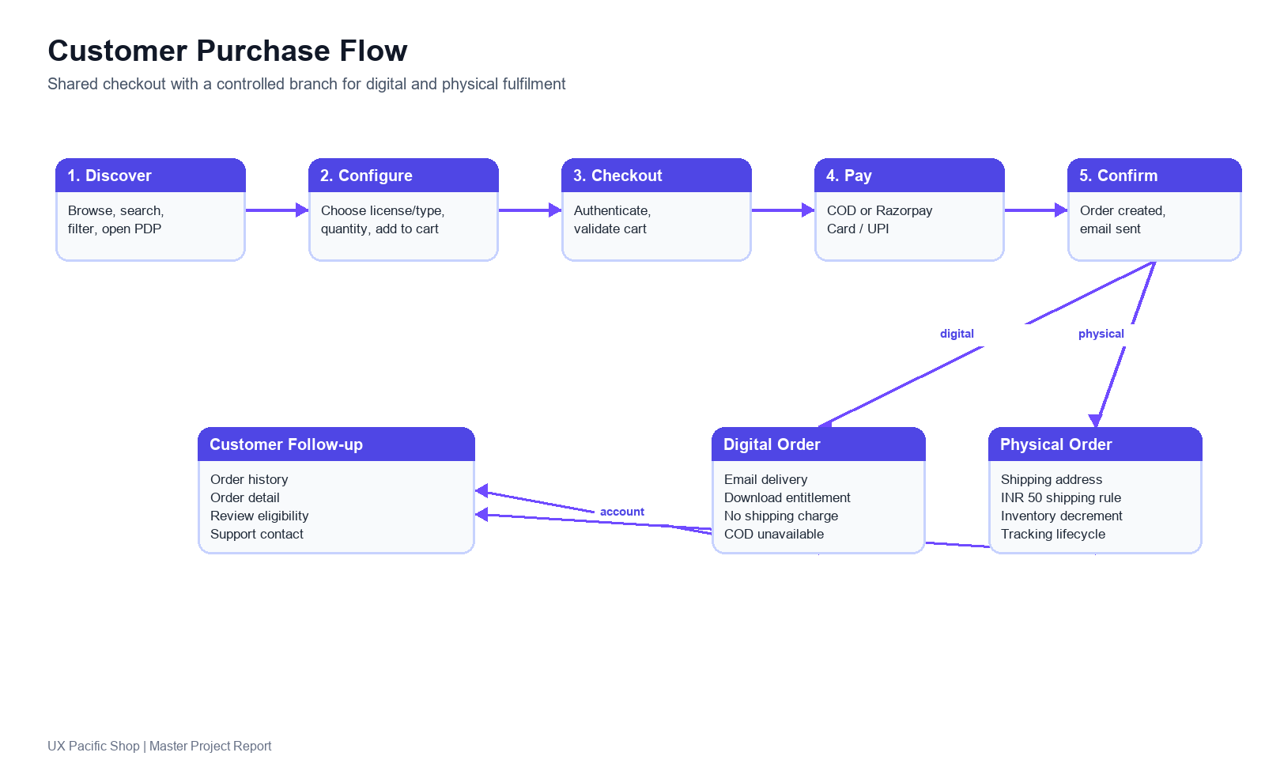

Digital Product Workflow
- Customer discovers a digital product through homepage, listing, category, search or bundle.
- Product detail explains contents, preview media, license options, price and immediate delivery.
- Customer selects personal or commercial license and adds the product to cart.
- Checkout removes physical-only requirements and disables COD.
- Server recalculates product eligibility, price, tax and total using database values.
- Razorpay payment starts. On verified success, the order becomes paid exactly once.
- Customer reaches a server-backed confirmation page and receives an order email.
- Account order detail exposes the entitled download through a secure delivery mechanism.

Physical Product Workflow
- Customer discovers a physical product with visible stock and delivery expectations.
- Product detail allows valid quantity selection and adds the physical SKU to cart.
- Checkout requires a valid shipping address and applies the approved shipping rule.
- Customer selects online payment or COD if eligible.
- Server validates inventory and creates the order. Inventory is committed only at the approved lifecycle event.
- Admin moves the order through processing, shipped and delivered states; tracking data should be added when available.
- Customer sees current fulfilment status in order history and receives email updates.

Mixed-Cart Product Decision
Required before implementation sign-off
Decide whether customers may purchase digital and physical items together. Recommended baseline: allow a mixed cart, require address and shipping for the physical portion, disable COD if business policy requires online payment for mixed orders, and deliver digital entitlements only after the order payment condition is satisfied.

Recommended Order Lifecycle
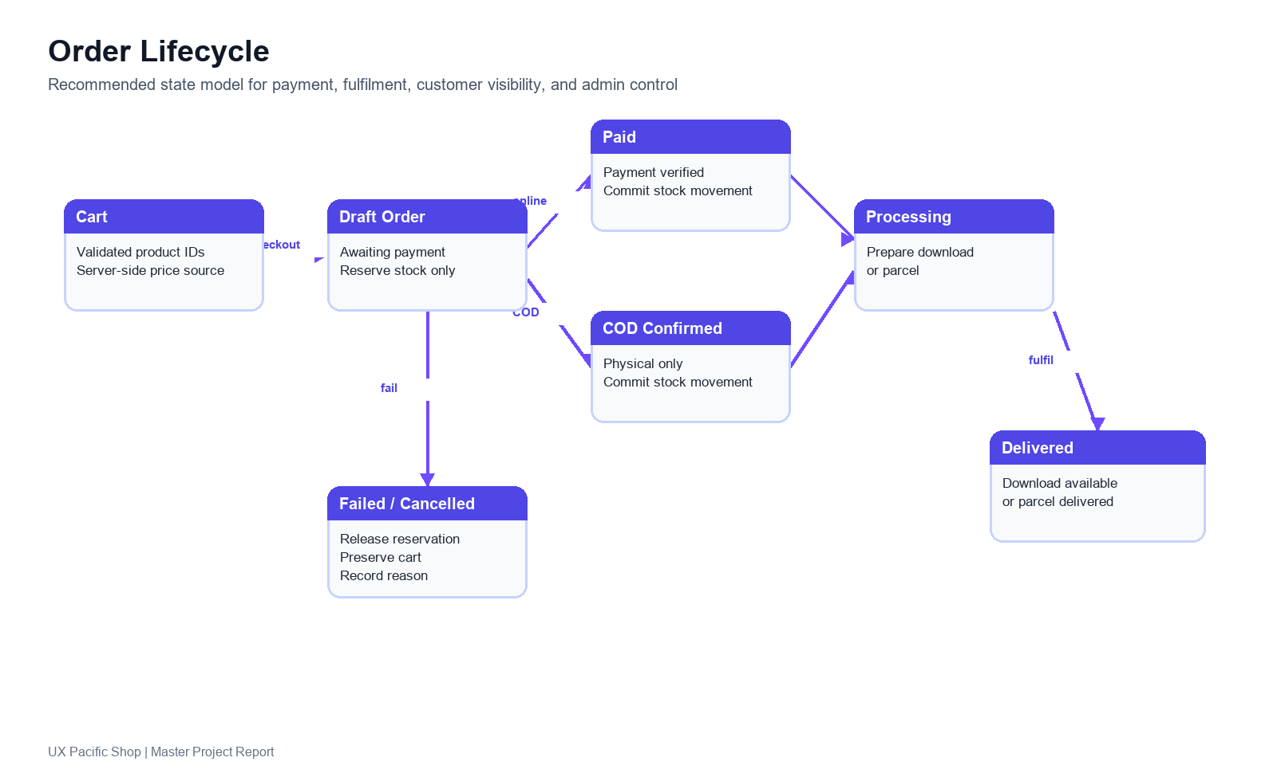

Lifecycle Rules
- A draft or awaiting-payment order must never permanently consume stock.
- Online inventory movement is committed after verified payment; failed or cancelled payment releases any reservation.
- COD inventory policy must be explicit. Recommended: commit stock when COD order is confirmed and record cancellation reversals.
- Every status change should be visible to administrators and reflected consistently in the customer account.
- Digital download entitlements are issued only after the required payment state is reached.
- Webhook processing must be idempotent so repeated gateway events cannot duplicate an order or stock movement.

8. Technical Architecture and Data Model
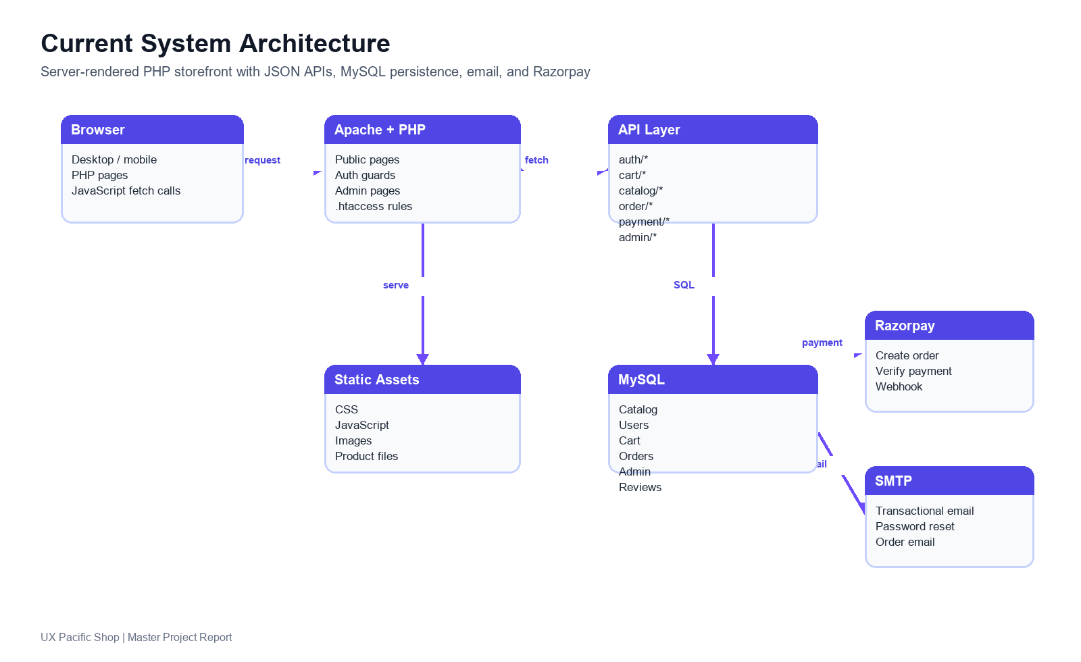

Current Technical Shape
Layer | Current Implementation | Production Requirement
Web | Apache + PHP pages with CSS and JavaScript | Harden routing, caching, canonical URLs and error handling
API | JSON endpoints grouped by auth, cart, catalog, order, payment, user and admin | Consistent validation, CSRF posture, authorization and error contract
Database | MySQL schema plus migrations | Apply required migrations, validate indexes, back up and rehearse restore
Payments | Razorpay create, verify and webhook endpoints | Configure production keys and webhook secret; test success, fail, cancel and replay
Email | SMTP-based transactional mail | Verify inbox delivery, templates, sender identity, logs and retry behavior
Assets | Local static assets and URLs | Secure owned downloads, optimized images and stable file storage

Database Entity Catalog
Entity | Purpose | Key Relationships
categories | Catalog grouping and navigation metadata | products.category_id
products | Digital and physical SKU records | category, cart, orders, bundle items, reviews, wishlist
bundles | Curated product combinations | bundle_items
bundle_items | Bundle composition | bundles, products
freebies | Free lead-magnet assets | download tracking
users | Customer identity and profile | cart, orders, addresses, wishlist, reviews, tokens
addresses | Reusable customer shipping addresses | users
cart | Current intended purchase | users/session, products
orders | Commerce transaction header | users, order_items, payment and fulfilment data
order_items | Purchased product snapshots | orders, products
wishlist | Saved customer products | users, products
reviews | Product feedback and moderation | users, products, orders
contact_messages | Support inquiries | admin workflow
password_reset_tokens | Expiring recovery tokens | users
admins | Back-office authentication | admin workspace
featured_items | Homepage or merchandising promotion | products or bundles
inventory_movements | Traceable stock changes | products, orders
user_tokens | Session/token support where used | users

Data Rules
- Store an order-item snapshot of name, price, type and license at purchase time so later catalog edits do not rewrite history.
- Use database product records as the authority for price, availability, stock, shipping eligibility and type.
- Track stock changes with reason, order reference, quantity delta and timestamp.
- Store only the minimum customer information required for fulfilment and support.
- Keep payment provider IDs and verification state auditable without exposing secrets to the browser.

9. API Catalog
The following API inventory is based on the current codebase. It should be treated as the regression-test map and authorization review checklist.
API Group | Current Endpoints
Authentication | _bootstrap.php  auth/admin-login.php  auth/check_admin.php  auth/csrf.php  auth/forgot-password.php  auth/login.php  auth/login-process.php  auth/logout.php  auth/reset-password.php  auth/session.php  auth/signup.php  auth/verify-reset-token.php
Cart, Catalog and Search | cart/add.php  cart/list.php  cart/merge.php  cart/remove.php  cart/update.php  catalog/detail.php  catalog/list.php  catalog/view.php  product/get_details.php  product/search.php  freebies/download.php
Order, Payment and Customer | order/create.php  order/get.php  payment/razorpay-create-order.php  payment/razorpay-verify.php  payment/webhook.php  contact/send.php  reviews/submit.php  user/delete_account.php  user/profile.php  user/update_password.php  user/update_profile.php  wishlist/add.php  wishlist/list.php  wishlist/remove.php  wishlist/toggle.php
Address | address/add.php  address/delete.php  address/get.php  address/set-default.php  address/update.php
Admin | admin/stats/overview.php  admin/stats/analytics.php  admin/product/create.php  admin/product/delete.php  admin/product/duplicate.php  admin/product/get.php  admin/product/list.php  admin/product/save.php  admin/product/toggle_status.php  admin/product/update.php  admin/categories/list.php  admin/categories/save.php  admin/categories/delete.php  admin/bundles/list.php  admin/bundles/save.php  admin/bundles/delete.php  admin/freebies/list.php  admin/freebies/save.php  admin/freebies/delete.php  admin/order/list.php  admin/order/get_details.php  admin/order/update_status.php  admin/order/delete.php  admin/user/list.php  admin/user/save.php  admin/user/block.php  admin/user/delete.php  admin/reviews/list.php  admin/reviews/moderate.php  admin/messages/list.php  admin/messages/update.php

API Acceptance Rules
- Require authentication and authorization for every private customer or admin endpoint.
- Validate CSRF protection strategy for state-changing browser requests.
- Return consistent JSON success, error and validation structures.
- Never reveal database errors, secrets, tokens or stack traces to the browser.
- Recalculate cart, checkout and payment amounts server-side.
- Make payment verification and webhook processing idempotent.
- Rate-limit authentication, password-reset, contact and freebie-download abuse paths.

10. Email, Notification and Communication Plan
Email is part of the product, not a background detail. The current project contains SMTP configuration and the mail host was reachable during QA, but actual inbox delivery still needs end-to-end verification. A historical log entry recorded an SMTP expectation error, so production sign-off must include real mailbox evidence.
Trigger | Recipient | Required Content | Launch State
Password reset request | Customer | Secure expiring reset link, expiry note, ignore-if-not-requested guidance | Required verification
Order placed - online | Customer | Order ID, item summary, amount, payment state, support route | Required verification
Order placed - COD | Customer | Order ID, item summary, amount due, shipping address, support route | Required verification
Digital fulfilment | Customer | Order ID, download access instructions, license reminder | Required
Physical shipped | Customer | Order ID, carrier/tracking when available, expected delivery guidance | Required
Payment failed | Customer | Actionable retry route without duplicate order risk | Required
Contact submission | Customer | Acknowledgement and response expectation | Recommended
Contact submission | Admin/support | Message details and admin workflow link | Recommended
Low stock | Admin | Product, remaining inventory and action link | Next sprint

Email Verification Checklist
- Send every launch-critical template to real test inboxes on at least two providers.
- Verify sender name, from address, reply-to address, subject, body, links and mobile rendering.
- Confirm reset links expire and cannot be reused.
- Confirm order emails are sent only after the correct order state transition.
- Check SMTP logs for errors, retry behavior and accidental duplicate sends.
- Verify no secret, internal path or sensitive payment payload is included.

11. Administration and Operating Model
The admin workspace is the operational control plane. The current dashboard already exposes the core sections below; launch readiness depends on permission checks, validation, reliable data and a repeatable operating process.
Admin Module | Current Capability | Required Operating Standard
Overview | Summary statistics and dashboard navigation | Accurate server-derived KPIs and useful empty/error states
Analytics | Analytics view | Revenue, order, payment, product and date-range reporting
Products | Create, edit, duplicate, toggle status, delete | Validation, real assets, license/type rules and audit awareness
Categories | List, save, delete | Slug uniqueness and safe deletion behavior
Bundles | List, save, delete | Composition validation and savings calculation
Freebies | List, save, delete | Working schema, owned files and download visibility
Orders | List, detail, status update, delete | Status lifecycle, payment clarity and reversible-safe operations
Users | List, save, block, delete | Least privilege, confirmation and retention policy
Reviews | List and moderate | Clear visibility state and moderation workflow
Messages | List and update | Support ownership, status and archive handling
Theme | Admin theme toggle | Persistent, accessible light/dark appearance

Daily Admin Checklist
- Review payment failures, awaiting-payment orders and COD orders.
- Progress physical orders through processing, shipped and delivered states.
- Monitor inventory and restock physical SKUs before they reach zero.
- Review customer messages and moderate new reviews.
- Check new product, bundle and freebie changes on the live storefront after publishing.
- Inspect mail and application logs for repeated errors.

12. Design System
The current storefront already has a dark visual identity and recurring purple accent. The design system below turns that direction into a reusable product rulebook for customer and admin interfaces.

Brand Direction
Attribute | Rule
Position | Confident, practical and creator-focused; premium enough to feel trustworthy without becoming intimidating.
Visual mood | Dark digital workspace with purposeful purple accents, clear hierarchy and restrained glow.
Content tone | Direct, encouraging and outcome-led. Explain what a customer gets and what it helps them do.
Imagery | Show actual resource previews, not generic decoration. Keep product-cover ratios consistent.

Color Tokens
Token | Observed / Recommended Value | Use
bg-main | #01010D | Primary storefront background
card-bg | #050519 | Product cards and elevated surfaces
card-bg-soft | #07071D | Secondary surface
accent | #6F4BFF | Primary CTA, active state and focus emphasis
accent-soft | #9B8CFF | Secondary accent and subtle highlight
accent-hover | #5B2EE6 | Interactive hover state
text-primary | #FFFFFF | Primary dark-theme text
text-muted | rgba(255,255,255,0.75) | Secondary dark-theme text
success | #10B981 | Confirmed state
warning | #F59E0B | Attention state
danger | #EF4444 | Destructive and validation error state
info | #06B6D4 | Informational state

Typography
Role | Recommendation | Usage
Primary UI font | Inter | Navigation, forms, buttons, cards, tables and body copy
Optional display font | Gabarito or approved display face | Marketing headings only; keep admin UI on Inter
Body | 16px / 1.5 | Readable product and policy copy
Small UI | 12-14px / 1.4 | Labels, badges and metadata
Section heading | 28-40px | Public page hierarchy
Admin heading | 20-28px | Operational hierarchy

Spacing, Radius and Elevation
System | Tokens | Rule
Spacing | 4, 8, 12, 16, 24, 32, 48, 64px | Use consistent increments; avoid one-off spacing values unless layout demands it
Radius | 6, 10, 14, 20px and pill | Inputs/buttons 10px; cards 14-20px; badges pill
Transitions | 150ms, 220ms, 340ms | Use restrained motion for hover, modal and menu feedback
Shadows | sm, md, lg, xl | Use elevation sparingly on overlays and cards
Borders | soft and subtle white alpha borders | Separate dark surfaces without heavy outlines

Core Components
Component | Required Variants and States
Button | Primary, secondary, ghost, danger; default, hover, focus, disabled, loading
Input | Text, email, password, phone, textarea, select, checkbox, radio; default, focus, error, disabled
Product card | Digital, physical, bundle, freebie; price, old price, rating, stock/type badge, CTA
Header | Desktop nav, mobile menu, search, cart badge, signed-out and signed-in account states
Modal | Quick view, confirmation, review and support; focus trap, close control and mobile fit
Toast | Success, error, warning and info; accessible announcement and dismiss behavior
Empty state | Cart, wishlist, orders, search and admin tables with one clear next action
Skeleton | Listing, product detail, cart, orders and admin data loading
Table | Admin sort, filter, responsive overflow, empty and error state
Badge | Digital, physical, featured, bestseller, status and stock

Responsive Rules
Viewport | Required QA Sizes | Design Rule
Mobile | 360, 375, 390, 414px | Single-column priority, touch targets >=44px, no horizontal overflow, compact header
Tablet | 768, 820, 1024px | Adapt grid and filters deliberately; avoid stretched mobile layout
Desktop | 1366, 1440, 1920px | Constrain readable content width; preserve consistent card geometry

Accessibility Baseline
- Provide meaningful alt text for product images and accessible labels for icon-only controls.
- Use visible keyboard focus states and logical tab order.
- Associate form errors with the relevant fields and announce important state changes.
- Meet readable contrast for text, disabled states and subtle borders.
- Use semantic headings and real buttons or links for interactive controls.
- Trap focus in modals and return focus to the triggering control on close.

13. Current QA Findings and Production Blockers
The findings below are known current-state risks discovered during QA inspection. They must be tracked independently and retested after correction. This report does not modify application code.
ID | Severity | Area | Finding | Required Outcome
QA-001 | Critical | Payment | Razorpay webhook cannot operate without a configured webhook secret; endpoint returned service-unavailable behavior. | Configure secret and verify signed webhook processing
QA-002 | High | Order security | Order creation trusts browser-provided available_type, allowing shipping or inventory behavior to be influenced client-side. | Derive product type from database only
QA-003 | High | Inventory | Physical stock is decremented when an online-payment draft is created, before payment success; failure path does not restore it. | Use reservation or post-verification commit
QA-004 | High | Freebies | Freebie download fails because the active database schema lacks download_count expected by the endpoint. | Apply schema migration and retest
QA-005 | Medium | Responsive CSS | Homepage exhibits horizontal overflow at tested mobile widths. | Remove overflow and retest 360-414px
QA-006 | Medium | Authentication UX | Google sign-in/up buttons are visible but only show a coming-soon toast. | Implement OAuth or remove CTA
QA-007 | Medium | Order confirmation | Confirmation depends on localStorage, briefly shows success and redirects if lastOrder is absent; browser data is not authoritative. | Load order by authorized server data
QA-008 | Medium | Content | Placeholder physical product and freebie content are present in the live catalog data. | Replace with approved real catalog content
QA-009 | Medium | Links | Footer/community links include placeholder hash targets. | Replace or remove dead CTAs
QA-010 | Medium | Errors | Custom 404 page exists but unknown URLs use Apache default handling. | Wire branded error routing
QA-011 | Medium | URL / UX | Listing filters and sort state are not persisted in the URL. | Use query-backed state
QA-012 | Medium | Security | Environment secrets live under webroot, although blocked by .htaccess. | Move secrets outside public document root where possible
QA-013 | Low | Footer | Footer presentation and year/contact information are inconsistent. | Normalize approved footer content
QA-014 | Low | Accessibility | Shared navigation imagery includes missing or unclear alt behavior. | Add meaningful accessible text
QA-015 | Low | Server hardening | HTTP responses expose server-version detail. | Review server banner policy

Known Working Baseline
- Guest access guards redirect protected customer pages to sign-in with redirect intent.
- Basic invalid login, invalid signup and invalid forgot-password validation paths respond visibly.
- Cart quantity and visible tax totals recalculated correctly in sampled cart checks.
- Major sampled pages did not produce blocking JavaScript console errors.
- Debug scripts and sensitive dotfiles were blocked by web-server rules during inspection.
- SMTP host connectivity was reachable, but actual inbox delivery remains unverified.

14. Security, SEO and Performance Baseline

Security Checklist
- Keep secrets outside public webroot where deployment allows; block dotfiles at the server level as defense in depth.
- Enforce server-side price, type, stock, shipping, tax, discount and order-total calculation.
- Protect admin routes and APIs with dedicated admin authorization checks.
- Use secure session cookie flags, rotate sessions after authentication and verify logout invalidation.
- Rate-limit login, password reset, contact and download endpoints.
- Sanitize output, validate inputs and prevent error detail leakage.
- Verify Razorpay signatures and make webhook/order handling idempotent.
- Use entitlement-based downloads instead of exposing unrestricted purchased-file URLs.
- Log important admin changes and stock movements.

SEO Checklist
- Choose and enforce one canonical domain with HTTPS redirects.
- Add unique title, meta description and canonical tags to public content pages.
- Generate a sitemap from active public URLs and align robots.txt.
- Add product structured data where accurate, including price, availability and review aggregate only when valid.
- Use readable slug routes and redirect legacy query URLs if routes change.
- Avoid indexing account, cart, checkout, admin and internal API paths.

Performance Checklist
- Optimize product media formats and dimensions; lazy-load below-the-fold images.
- Measure homepage, listing, product detail, cart and checkout on mobile network conditions.
- Reduce layout shift by reserving image and skeleton space.
- Cache safe static assets and compress CSS, JavaScript and images.
- Track API response time for search, cart, checkout, order creation and admin lists.
- Verify that third-party payment loading failure produces an actionable customer error.

15. Implementation Roadmap

Phase 0 - Production Blockers
Workstream | Required Work | Exit Criteria
Payment | Configure webhook secret; verify signatures; test success, failure, cancel and replay | No payment blocker; idempotent order behavior
Order security | Derive type, price, shipping and stock rules from database | Browser tampering cannot alter server totals or fulfilment
Inventory | Replace draft-time permanent decrement with approved lifecycle | Failure and cancellation preserve accurate stock
Freebies | Apply missing schema migration and replace placeholder file | Download succeeds and count updates
Content | Remove placeholder catalog and dead links | All public content approved
Responsive | Resolve homepage mobile overflow | No horizontal scroll at required mobile widths
Domain | Approve canonical domain and align configuration | All public links and callbacks use one domain

Phase 1 - Launch Baseline
- Finalize launch catalog, license wording, shipping rule, tax decision and policy content.
- Harden digital download entitlement and order-confirmation data source.
- Verify password reset and all transactional emails with real inbox evidence.
- Add coupon management, robust empty/error/loading states and branded error routing.
- Complete responsive, browser, accessibility and regression passes across all major routes.
- Create backup, restore, deployment and rollback procedures.

Phase 2 - Conversion and Operations
- Improve URL-backed filtering, SEO metadata and structured product data.
- Add operational analytics, inventory alerts and stronger admin auditability.
- Add newsletter capture with consent and campaign-source tracking.
- Improve product previews, related products and bundle upsell.

Phase 3 - Growth
- Evaluate educator bulk-order inquiry, product update notifications and digital versioning.
- Evaluate abandoned-cart reminders only after consent and deliverability are established.
- Evaluate regional expansion, international payment and tax only after India-first stability.

16. Launch Acceptance Checklist
Area | Acceptance Check | State
Business | Catalog, prices, licenses, tax, shipping and policies approved | Required
Content | No placeholder copy, assets, URLs or dead links | Required
Authentication | Signup, login, logout, reset, protected routes, persistence and mobile UI tested | Required
Catalog | Listing, search, filters, sort, category, PDP, stock and out-of-stock tested | Required
Cart | Add, duplicate, quantity, remove, persistence, tax, shipping and empty state tested | Required
Checkout | Digital, physical, mixed-cart decision, address, COD and online payment tested | Required
Payment | Success, fail, cancel, webhook and duplicate-event behavior verified | Required
Orders | Confirmation, history, detail, status, stock movement and review eligibility tested | Required
Email | Reset, order and fulfilment emails verified in real inboxes | Required
Admin | Product, category, bundle, freebie, order, user, review and message operations tested | Required
Responsive | 360, 375, 390, 414, 768, 820, 1024, 1366, 1440 and 1920px checked | Required
Browser | Chrome, Firefox, Edge and Safari-relevant checks completed | Required
Accessibility | Keyboard, labels, focus, contrast, headings and modal behavior checked | Required
Security | Authorization, server authority, secret handling, rate limits and error leakage reviewed | Required
SEO | Canonical domain, redirects, sitemap, robots, metadata and index exclusions aligned | Required
Operations | Backup, restore, deployment, rollback, monitoring and support ownership documented | Required

17. KPIs and Open Decisions

Recommended KPIs
KPI | Why It Matters
Store conversion rate | Shows whether discovery and trust turn into purchases
Product-detail to add-to-cart rate | Measures product content and pricing effectiveness
Cart-to-checkout completion rate | Highlights checkout friction
Payment success rate | Detects gateway or verification failures
Average order value | Measures bundle and upsell strength
Digital download success rate | Confirms fulfilment reliability
Physical fulfilment time | Tracks operational quality
Repeat purchase rate | Measures long-term catalog value
Freebie-to-purchase conversion | Measures lead-magnet effectiveness
Support contact rate per order | Reveals unclear product, payment or fulfilment behavior

Open Decisions Register
Decision | Recommended Direction | Owner
Canonical domain | Choose uxpacific.shop or shop.uxpacific.com and standardize | Founder / Engineering
Mixed cart | Allow with explicit shipping and COD rule | Product / Operations
Shipping threshold | Approve INR 50 baseline and optional INR 999 free-shipping threshold | Operations / Finance
Tax rule | Approve applicable tax and invoice wording | Finance
Digital license text | Publish personal and commercial usage terms | Product / Legal
Refund policy | Separate digital and physical policy wording | Product / Legal
Google OAuth | Implement completely or remove public CTA | Product / Engineering
Physical launch SKUs | Approve real items, packaging and stock quantities | Operations
Download delivery | Choose secure entitlement and file-hosting approach | Engineering
Admin deletion policy | Prefer archive/disable where history matters | Product / Engineering

18. Appendix: Route Reference and Test Matrix

Public and Customer Page Reference
Route | Access | Primary QA Coverage
index.php | Public | Hero, navigation, cards, footer, responsive overflow
shopAll.php | Public | Catalog, category, type, price, sorting, pagination, URL state
category.php | Public | Category loading and consistency
product.php?id={id} | Public | Gallery, price, type/license, quantity, cart, stock
bundles.php | Public | Bundle cards, details, contents and pricing
freebies.php | Public | Download eligibility, file and tracking
search.php?q={query} | Public | Valid, empty, invalid and no-result searches
cart.php | Public/session | Add, update, remove, persistence, totals and empty state
signin.php | Public | Valid, invalid, redirect, password visibility and mobile UI
signup.php | Public | Required fields, duplicate email, passwords and mobile UI
forgot-password.php | Public | Neutral response and email
reset-password.php | Public token | Valid, invalid, expired and reused token
checkout.php | Protected | Digital, physical, address, payment and duplicate prevention
order-confirmation.php | Order context | Authorized server data and navigation
account.php | Protected | Profile, password, addresses and links
orders.php | Protected | Filter, details, status and reviews
wishlist.php | Protected | Add, remove and empty state
contact.php | Public | Validation, success and admin visibility
policies.php | Public | Approved content and links
404.php / 500.php | Error | Routing, branding and status code

Admin Page Reference
Route | Access | Primary QA Coverage
admin/admin-login.php | Public admin entry | Valid/invalid login and redirect
admin/admin-dashboard.php | Admin protected | Every dashboard module, authorization and responsive table behavior
admin/addproduct.php | Admin protected | Create validation, content and asset behavior
admin/editproduct.php | Admin protected | Update, status and data persistence

QA Regression Viewports
Class | Viewports | Required Checks
Mobile | 360, 375, 390, 414px | Header, menu, cards, PDP, cart, checkout, forms, modals, footer, overflow and touch targets
Tablet | 768, 820, 1024px | Grid, filters, account, checkout, admin tables and modal fit
Desktop | 1366, 1440, 1920px | Content width, grid density, header, cards, checkout and admin workspace

Final Project Definition
UX Pacific Shop should launch as a dependable, focused ecommerce product: customers discover high-quality UX resources, understand exactly what they are buying, complete an accurate payment flow, receive the right digital or physical fulfilment, and return to a useful account. Administrators should be able to operate the catalog and orders without manual database work. The next implementation effort should be governed by the blocker list and acceptance checklist in this report.

