EX:NO: 14 **MINI PROJECT – TELEGRAM CHATBOT**

DATE :

**AIM :**

To create a basic Chatbot named **Rbot** in the application Telegram using Python programming language where you could perform some of the basic function such as text, tell the time, date, weather and perform simple google searches.

**PROJECT ABSTRACT :**

We would be creating an AI based Chat-Bot which can be used specifically with the application “Telegram”. We are installing few specific modules from the Python library for this project to run in Telegram. The main module that we have used form the python library is the module named “telegram.ext”. We have also installed few other modules in order to run its processes. We have built a multi-purpose Chat-Bot where you can chat with it when you are bored to kill your boredom and ask it various questions. It can handle simple questions and texting, open basic sites in google such as YouTube, Yahoo, and Facebook. It can also tell you today’s news, tell a joke, inform you about the current weather and temperature and also give short info about famous personalities.

Our code consists of a total of 3 file

* The main file : This is main program and it handles the incoming messages from the Chatbot and sends it to the Responses file.
* The Responses file : This is the file containing all the responses given out by the Chatbot. The incoming message is read then it is handles by its respective functions.
* The constants file : This is the file containing the API key for the Chatbot. This API key is necessary to create a Chatbot in Telegram. Only the users having this API key can make any changes in the workings of the Bot.

**PYTHON CODE :**

The main file :

import constants as Keys

from telegram.ext import *

import Responses as R

print("Bot started..")

def start_command(update, context):

update.message.reply_text('type something random to get started')

def help_command(update, context):

update.message.reply_text('if you need help whyyyy')

def handle_message(update, context):

text = str(update.message.text).lower()

cool = R.sample_responses(text)

update.message.reply_text(cool)

def error(update, context):

print(f"Update {update} caused error {context.error}")

def main():

updater = Updater(Keys.API_KEY, use_context=True)

dp = updater.dispatcher

dp.add_handler(CommandHandler("start", start_command))

dp.add_handler(CommandHandler("help", help_command))

dp.add_handler(MessageHandler(Filters.text, handle_message))

dp.add_error_handler(error)

updater.start_polling()

updater.idle()

main()

The Responses file :

from GoogleNews import GoogleNews

import pyjokes

import pywhatkit

from datetime import datetime

from pyowm.owm import OWM

import wikipedia

googlenews = GoogleNews()

googlenews = GoogleNews('en','d')

googlenews.search('India')

googlenews.getpage(0)

googlenews.result()

new = googlenews.gettext()

def sample_responses(input_text):

user_message = str( input_text ).lower()

text = set( user_message.split(' ') )

if len( text.intersection({'hello', 'hi', 'sup'}) ) != 0:

return "Hello :)"

if user_message in ('who are you?', 'who are you'):

return "I am the bot!"

if len( text.intersection({"time", "time?"}) ) != 0:

now = datetime.now()

date_time = now.strftime("%d/%m/%y, %H:%M:%S")

return str(date_time)

if user_message in ('where are you from?'):

return "i am from python"

if user_message in ("open facebook"):

return pywhatkit.search('Facebook')

if user_message in ("open youtube"):

return pywhatkit.search("youtube")

if user_message in ('open yahoo mail'):

return pywhatkit.search("yahoo mail")

if user_message in ('who made you?'):

return "Aaqil and Monisha"

if user_message in ('which country do u belong to?'):

return "canada"

if user_message in ('tell me about yourself'):

return "Hi i am Grembot you can chat with me ask me the time ask me the news and ask me a joke and so much more!"

if user_message in ('how are you today?','how are you') :

return 'I am good if you are good'

if user_message in ('news', 'tell me the news') :

return new

if user_message in ('joke','tell me a joke'):

return pyjokes.get_joke()

if len( text.intersection({'weather', 'weather?'}) ) != 0:

owm = OWM('2e2abc5781ed9df22dd627dd7555ac43')

mgr = owm.weather_manager()

weather = mgr.weather_at_place('Chennai,IN').weather

temp_dict_celsius = weather.temperature('celsius')

return str("Today's weather forecast : " + str(weather.detailed_status))

if len( text.intersection({'temp', 'temperature'}) ) != 0:

owm = OWM('2e2abc5781ed9df22dd627dd7555ac43')

mgr = owm.weather_manager()

weather = mgr.weather_at_place('Chennai,IN').weather

temp_dict_celsius = weather.temperature('celsius')

return str("The current Temperature is " + str(temp_dict_celsius['temp']))

if len(text.intersection({'google','Google','search','Search'}))!=0: inp= user_message.replace("Google","").replace("google","").replace("search","").replace("Search",")

out = wikipedia.summary(inp, sentences=2)

return str(out)

return "I do not understand you."

The constants file :

API_KEY="1899903013:AAH-6lc10voGjxKvTVyHO7WoYJvwvEr3P-o"

**OUTPUT :**

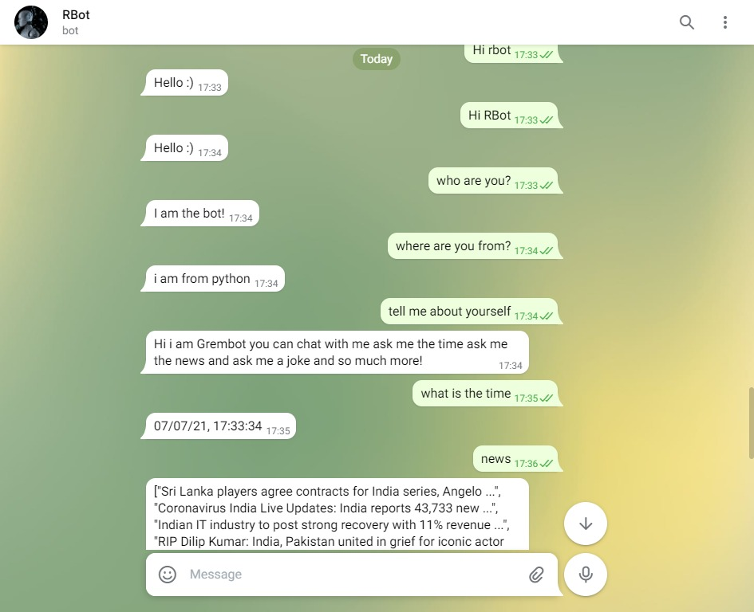

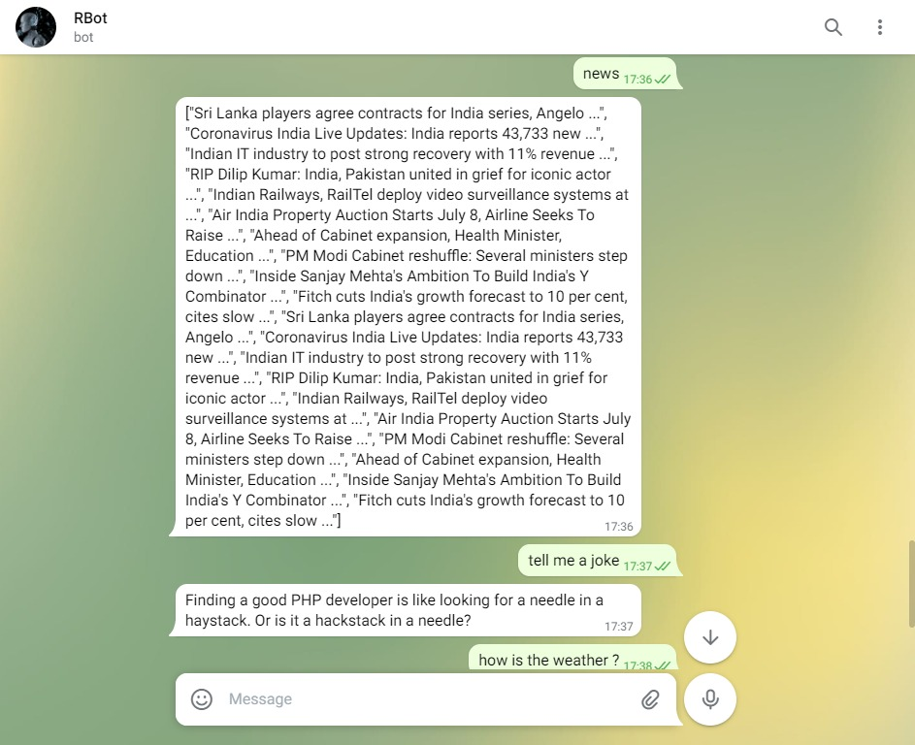

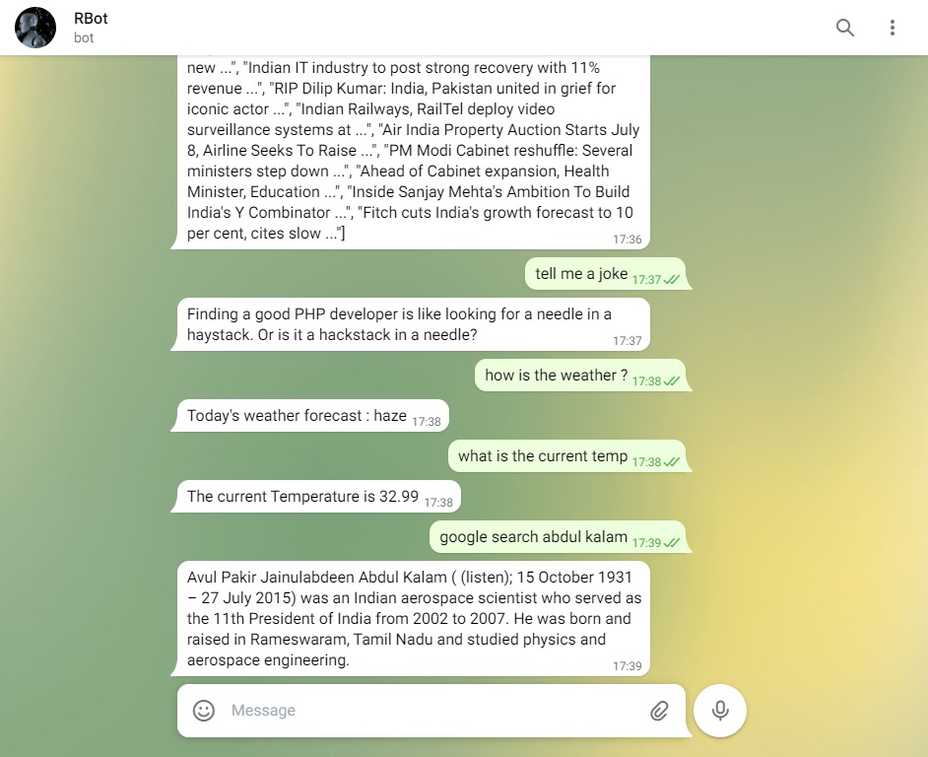

**RESULT :**

Hence we have successfully created a AI Chat-Bot in the application Telegram using Python Programming Language.