Saline Bucket Testing Platform   
User’s Guide

Maurice Montag, Jeffrey Herron  
University of Washington, Seattle, USA

# Saline Bucket Construction:

# Saline Bucket Bill of Materials:

|  |  |
| --- | --- |
| Home Depot All Purpose Bucket  <https://www.homedepot.com/p/The-Home-Depot-5-Gal-Homer-Bucket-05GLHD2/100087613> | $3.25 |
| Salt (as pure as possible, with no anti-caking agents)  <https://www.amazon.com/Morton-Canning-Pickling-Salt-Box/dp/B00GZCEZ4O> | $9.47 |
| Distilled Water (approx. 3 gal) | Approx. $4.00 |
| Assorted Alligator Clips  <https://www.amazon.com/WGGE-WG-026-Pieces-Colors-Alligator/dp/B06XX25HFX> | $5.99 |
| BNC to Alligator clip cables (pack of two)  <https://www.amazon.com/Double-Alligator-Cable-Probe-Oscilloscope/dp/B00ORLGNVS/>  [one reviewer noted a possible impedance mismatch]  (look into that) | $7.89 |
| Siglent SDG2042X Function Generator  <https://www.amazon.com/Siglent-Technologies-SDG2042X-Arbitrary-Function-Generators/dp/B01410O55U#customerReviews> | $499.00 |
| Rigol DS1054Z Digital Oscilloscope  <https://www.amazon.com/Rigol-DS1054Z-Digital-Oscilloscopes-Bandwidth/dp/B012938E76> | $349.00 |
| 24”x24” Titanium Sheeting  <https://store.tmstitanium.com/products/199g/titanium-sheet-plate/cp-grade-2/0.020-thick-24.000-wide-24.000-long>  Or if building only one or two buckets:  <https://store.tmstitanium.com/products/198g/titanium-sheet-plate/cp-grade-2/0.020-thick-12.000-wide-24.000-long> | $65.00 |
| Total Cost (as of 10/1/2019): | $943.60 |

## Assembly:

1. Cut the titanium sheeting into 1” wide by 2’ long strips.
   1. This can be done with a bandsaw or metal shears, preferably electric metal shears for smoother cuts. These have worked well for us: <https://www.amazon.com/WEN-3650-4-0-Amp-Variable-Electric/dp/B01M5G99E7>.

Remember that power tools can be dangerous, and they should only be operated by people who understand their use.

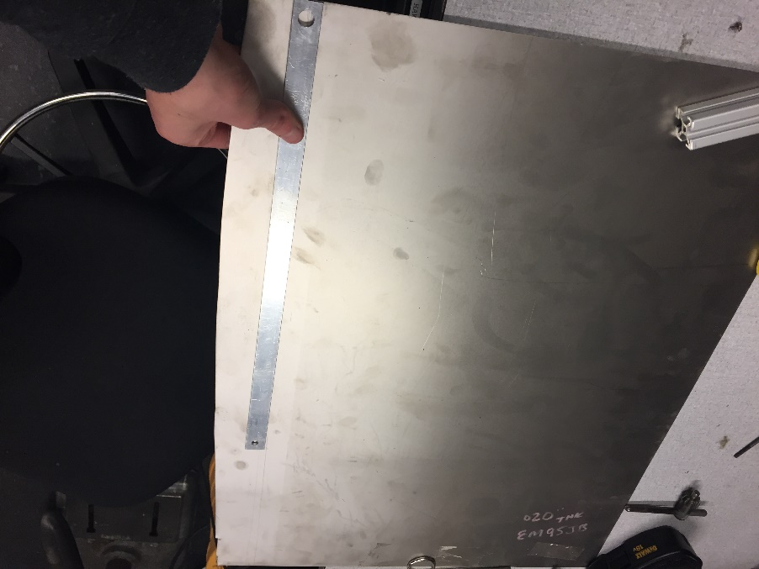

Figure : Measure out one inch from the side of the sheet

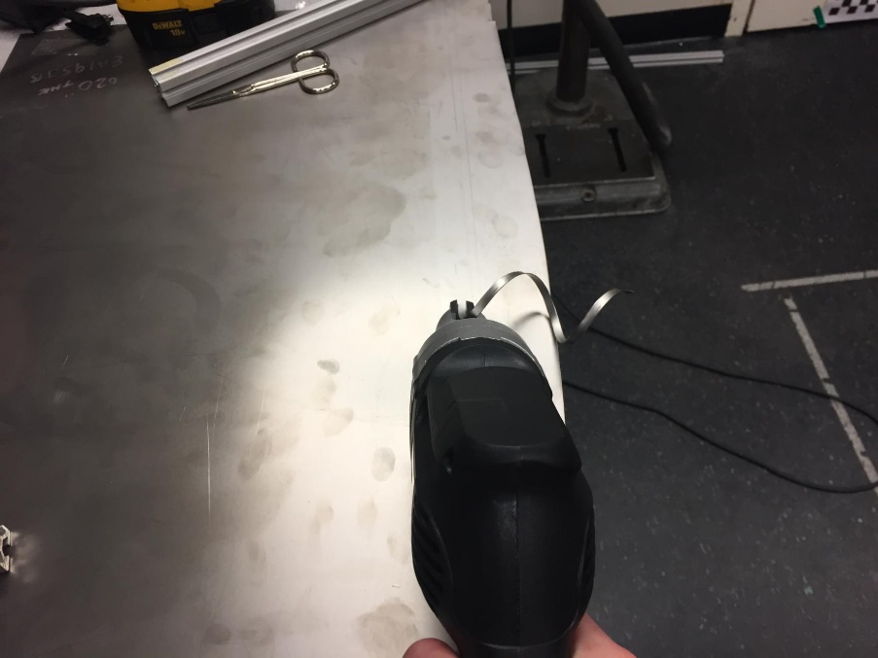

Figure : Use the metal sheers to cut the titanium, go slow and be careful. It's hard to make straight cuts with the metal sheers.

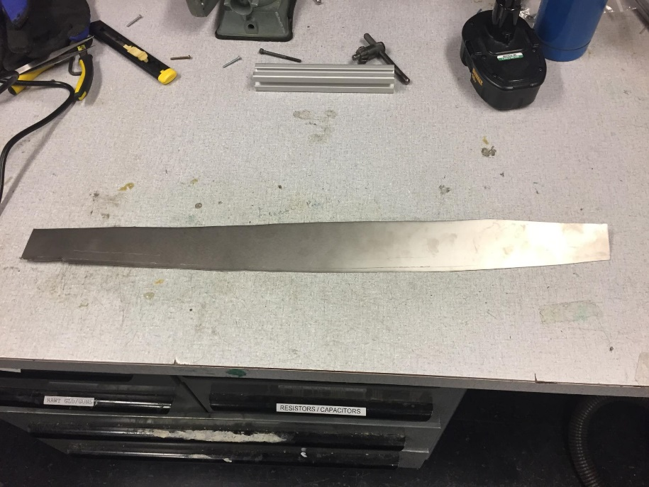

Figure : Final product, as you can see it is very difficult to make straight cuts, although it is not too important for this application.

* 1. File down any rough edges on the titanium strips.
  2. Each 24”x24” sheet of titanium is enough for 24 strips. Since each bucket only requires 3 or 4 strips, this is enough for 6-8 buckets. While it is always helpful to have spare titanium for electrode replacements, if the goal is only to build one bucket, purchasing the cheaper 12”x24” sheet is likely the best idea.

1. Create the saline solution.
   1. Create a 0.9% weight by volume saline solution with the salt and the distilled water. Start with three gallons of distilled water and add 102.2 grams of *non-iodized* salt. Alternatively, feel free to use other tank volumes and calculate how much salt you need accordingly.
   2. Thoroughly mix the salt into the distilled water, making sure that all of it has dissolved.
   3. Take an impedance measurement of the saline solution with your development system. For example, this could be done using the impedance measurement functionality with an Activa PC+S or Summit System while connected to a DBS electrode. The optimum electrical impedance of this solution is 1kOhm +/- 10%
   4. If the impedance of the solution is too high, add a small amount of salt and measure again. If the impedance is too low, add a small amount of water and measure again.
2. Insert the electrodes.
   1. Insert each titanium strip into the tank such that the bottom of the strip touches the bottom of the bucket
   2. Bend the strip at the point where it exits the tank, such that the strip forms a narrow V with the point of the V resting on the lip of the bucket with one half of the strip inside the bucket, touching the bottom, and one half outside the bucket, ready for attachment of alligator clips.

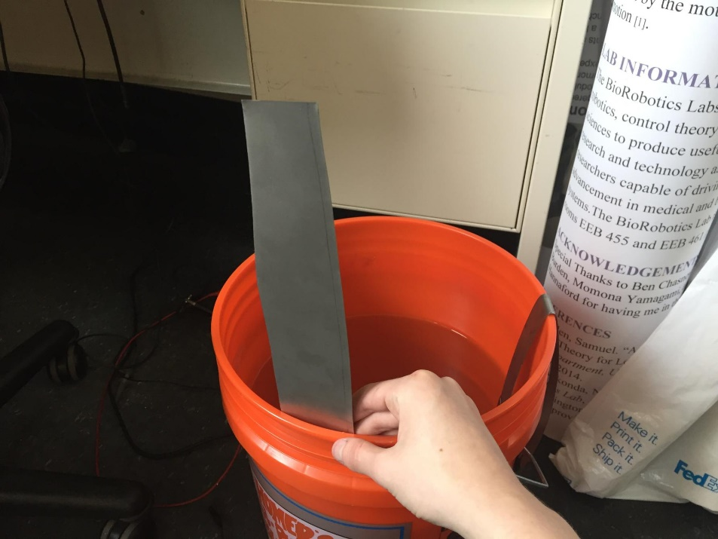

Figure : Insert the strip into the tank until it touches the bottom

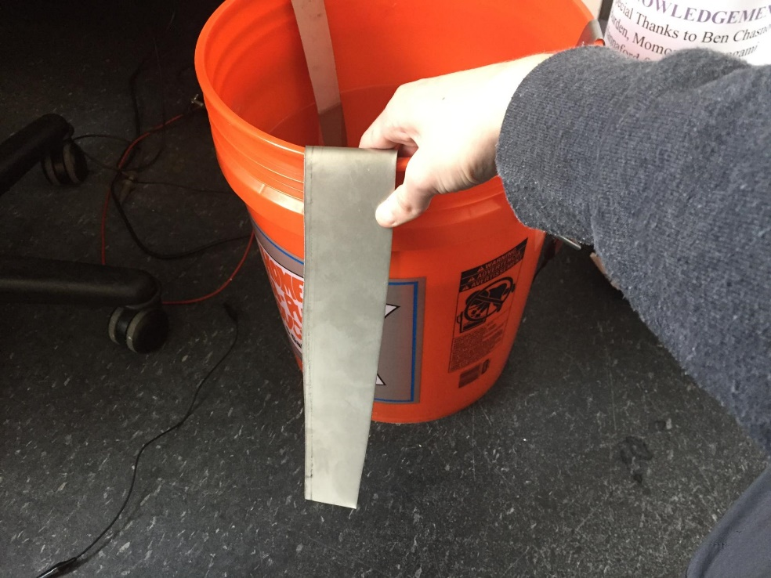

Figure : Then bend at the point where the strip leaves the tank. It can help to remove the strip from the tank at this point, and bend it further, so the strip lies closer to the edge of the tank.

1. Set up and attach devices to electrodes
   1. Unpack and plug in the two devices. They should both come pre-calibrated and work right out of the box.
   2. Connect one of the BNC-Alligator clip cables to Output #1 on the function generator. (connect the BNC end to the function generator). If the bucket is too far away from where the generator will be stored, BNC couplers can be purchased, and the BNC cables included with the function generator can be used as extensions.
   3. Clip the alligator cable ends of the BNC-Alligator cable to electrodes on opposite sides of the saline tank. If the cables are too short, other alligator clips or other wire can be used as extensions.
   4. Connect a voltage probe to the CH1 input on the oscilloscope.
   5. Using alligator clips, connect the tip of the voltage probe to an unused titanium strip. (The third one).
   6. Connect the ground plug of the voltage probe to a metal object, preferably a small piece of titanium sheet clamped to the lid of the bucket.
   7. Connect the negative output of the function generator to this small titanium plate, possibly using another alligator clip at a junction point, or connected directly to the function generator’s negative electrode.
   8. The small titanium ground plate provides an easy to access grounding point for devices under test that require it.
2. Find something to cover the bucket with.
   1. The tank should be covered with something to help keep out dust and other debris. There are lids for home depot buckets that would likely work well.

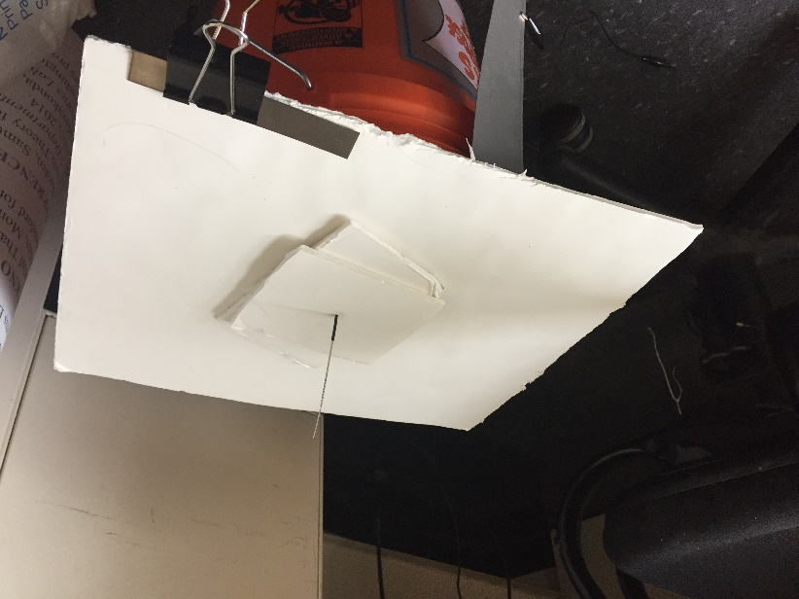

Figure : We used a piece of foam with a small hole in the middle to allow for the insertion of a DBS electrode into the tank

# Using the Software

## Installation:

1. Download the .exe file from the releases page on the GitHub. Make sure that you have the required drivers installed before use.
2. Due to licensing issues, we cannot bundle the software with the required drivers. The current version of the application can work with any .NET compatible VISA driver. We recommend Keysight’s VISA driver, which can be downloaded from here: (<https://www.keysight.com/main/software.jspx?id=2175637&pageMode=CV&cc=US&lc=eng>)
   1. The download page will prompt you for your name and email, input these if you wish.
   2. Double click on the installer and accept the license terms.
   3. If prompted, choose to install Keysight VISA as primary VISA.
   4. After the installation has completed, restart your computer.
3. Make sure both devices are connected via USB and turned on before opening the program.

## Working with the Source Code

1. You may also download the source code for the project on GitHub (available at <https://github.com/uwgridlab/cnt-testsuite-unified-application>).
2. You will need to separately download the release of the testing lib, and store the DLL in the base project directory, or in another accessible location.
3. You will need Microsoft Visual Studio (or similar) configured for C# and .NET development.
4. If you need to add an implementation for a different oscilloscope or function generator, consult the readme in the testing library repository for information on that code.

## Before you get started:

Do not attempt to change settings on the physical devices while they are under computer control. No buttons on either device should be touched when the application is running, unless there is an emergency. The application cannot tell when someone is operating a device by hand, and will not know if settings have been changed, which can lead to crashes or unexpected behavior.

Due to possible noise issues when using a USB connection, the application also supports connecting to devices over ethernet. After running the program once, edit the generated file called config.cfg, and change the line “INTERFACE=USB” to “INTERFACE=ENET”. After saving the file and restarting the program, you will be prompted to input the IP addresses of the two instruments. The IP addresses can be found in various menus on the instruments. We recommend having the instruments and the test computer on the same LAN, a small ethernet router can be purchased for extra convenience if desired, or if the ethernet ports in a room connect directly to external IP addresses, as is the case in our lab.

For the Siglent SDG2042X, first make sure LAN connectivity is enabled by pressing the following sequence of buttons: Utility (panel button), Page (1/2), Interface. You will see a setting called “LAN State.” Make sure that this setting is set to “On.” To view the IP address, press the button marked “LAN Setup,” while still in the interface menu. Make sure that DHCP is set to “On” unless you know that it should be set otherwise.

For the Rigol DS1054Z, first make sure LAN connectivity is enabled by pressing the following sequence of buttons: Utility (panel button), IO Setting, LAN Conf. In the LAN setting box pop-up, the IP address of the scope can be seen. Make sure that DHCP is enabled, and that Auto IP and Static IP are not. If the values are not set properly, they can be changed by pressing the “Configure” button while in the LAN Conf. menu.

For other devices, consult the device user’s manual for instructions on LAN setup.

In the case of ethernet routers, make sure that any router purchased for use in this setup has DHCP functionality, as in, it hosts a DHCP server for the LAN. It could also be helpful for the router to have address reservation, which allows the user to set specific IP addresses for specific devices. This could be useful, as it will stop the IP addresses of the devices from changing in the event of a router or device power cycle.

## UI Elements:

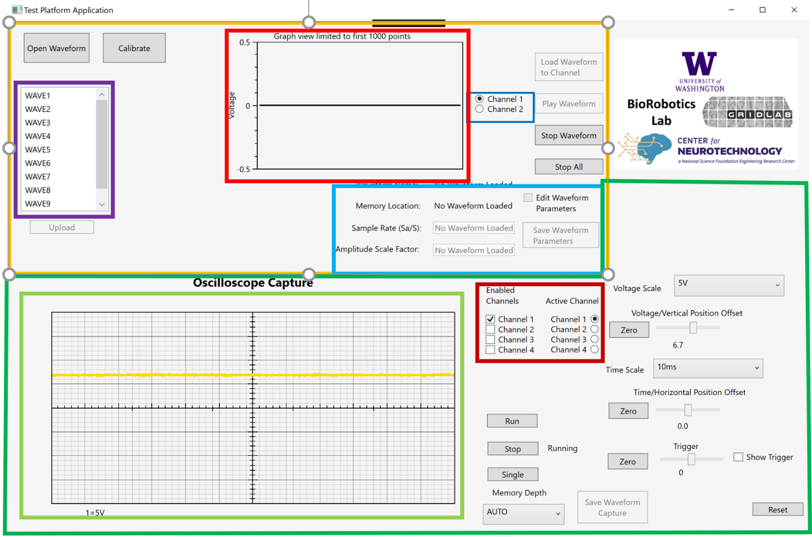The UI elements marked in orange control the function generator part of the testing platform.

The UI elements marked in green control the oscilloscope part of the testing platform.

# Function Generator Usage

The testing platform allows the user to upload recorded waveforms for playback with the function generator. Clicking the “Calibrate” button will play a 25 Hz 500 mVpp sine wave on whichever function generator channel is selected.

The blue rectangle shows the function generator channel selector buttons. Whichever channel is selected is the channel that function generator operations will be done on.

To open and use saved waveforms with the program, first click on the “Open Waveform” button; this will open a windows file dialog where you can select the waveform file you want to use. (Look at the Waveform File Format section at the end of this document for help creating these files). Once a file has been selected, the (first 1000 points of the) waveform will be drawn on the graph view diagram, shown in red. **Do not use waveform files with more than 8000000 points, the software will reject them.**

Function generators have a limited number of memory locations where arbitrary waveforms can be saved. Once you’ve opened a waveform, you can choose the memory location where you want it to be saved by double clicking on one of the memory locations on the memory location scrollbar, shown in purple. Once you’ve done this, the waveform is saved to that memory location on the computer, where it can be scaled, or its sample rate changed, more on that later. Waveforms that have been saved to a memory location on the computer, but not uploaded, are shown in yellow.

To get the waveform uploaded to the function generator’s memory, select the waveform from the waveform memory location scrollbar, and then click the upload button, located under the scrollbar.

Once a waveform has been uploaded to a memory location, it will show as green in the memory location scrollbar. It must still be loaded into a channel’s active memory before it can be output. When an uploaded waveform is selected, the “Load Waveform” button will become enabled. When clicked, it will load the selected waveform into active memory for the selected channel. This can take over 20 seconds for the largest waveforms. When complete, the play button will become enabled. This is done per channel, and different waveforms can be loaded into different channels, or the same waveform can be loaded into both at once if desired.

In addition, when loading large waveforms into memory (around 5 million+ points), some function generators (namely Siglent’s series), send the OPC* operation complete code back to the program before they are actually done loading in the waveform. If you are in the same room as the function generator, and it is a model with this problem, wait for a beep and a click before clicking “Play Waveform”. If you are not, there is no actual harm in clicking “Play Waveform” as soon as it is enabled, just understand that there may be a further delay before the waveform is actually output.

When the waveform has been successfully loaded, clicking “Play Waveform” will output it from the function generator, on the selected channel. During playback, waveform files play on repeat until stopped. To restart a waveform at the beginning, click “Restart Waveform” during playback, the button is the same as the “Play Waveform” button, just with different text. To stop waveform playback for the current waveform, click “Stop Waveform.” To stop waveform playback for all waveforms playing on the function generator, click “Emergency Stop”

## Waveform Editing:

Some waveform properties can be edited with the program, specifically the amplitude scale and playback sample rate can be edited. To edit a waveform, select a memory location from the memory location scrollbar, and then check the “edit waveform parameters” checkbox.

When the box is checked, the amplitude scale and sample rate can be changed. These UI elements are located in the light blue rectangle. After changing the sample rate and/or amplitude scale, click the “Save Waveform” button. The program will then generate your new waveform, and check if the resulting amplitude is too high or if a DC offset has been induced. If this is the case, the program will reject the edits made to the waveform. The edited waveform must be uploaded to the function generator again, and if currently playing, loaded into active memory in order for the output to reflect the edits. There are no changes made to the waveform .txt files during this process.

## Waveform File Format for Function Generator Upload:

Waveforms that can be used with this program are stored as text files. The first line of the text file should be “samplerate=(your sample rate in Hz).” Setting the sample rate ensures accurate playback of the waveform. Each line following this should be a single decimal number, *preferably between -0.5 and 0.5*. For safety concerns, the maximum Vpp that a waveform can have is 1. If there is an error in capturing your data, and the resulting waveform has a slight DC offset, but the Vpp is still less than or equal to 1, the program will remove the DC offset for you when you open the file. If the Vpp of your waveform is greater than 1, the program will reject your waveform when you try to open it. Below is a screenshot of a waveform file opened in notepad.

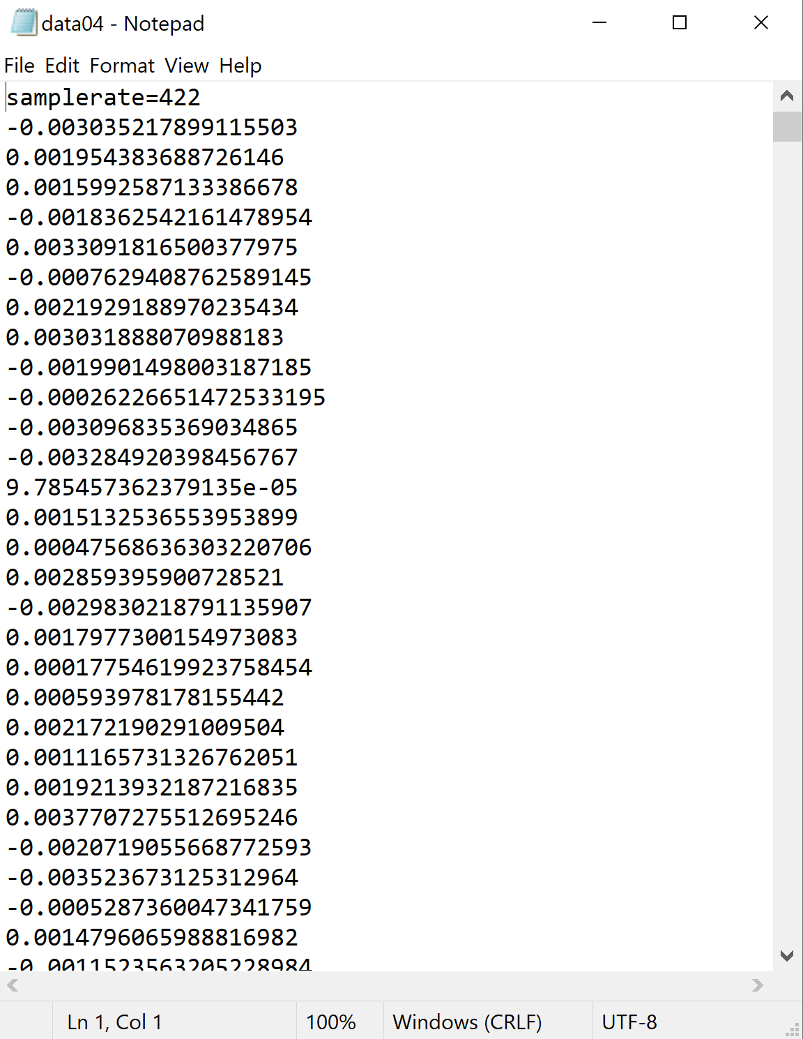

## As you can see, numbers in scientific notation format are allowed.

# Oscilloscope Usage:

The testing platform uses an oscilloscope to allow for real time monitoring of the voltages in the tank, and other probes can be connected to the device under test to capture other data, such as raw stimulation output, among other things. 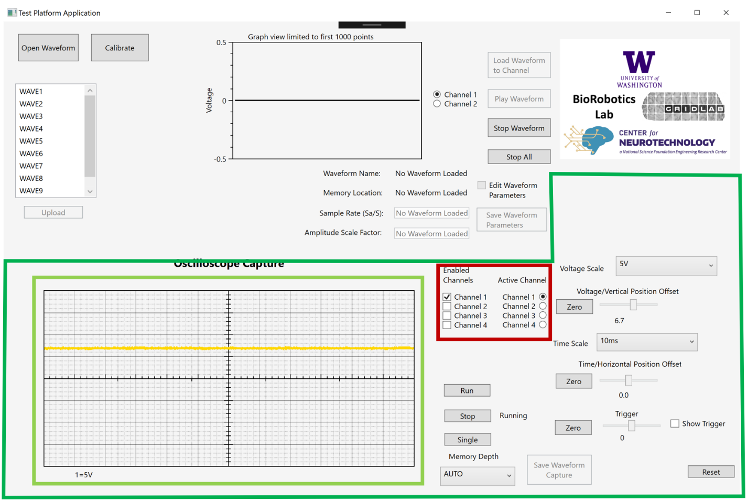

The light green rectangle marks the oscilloscope capture display. This is where the raw waveform data captured from the oscilloscope can be seen. The display updates multiple times per second and shows a general overview of the incoming waveforms. In the dark red box, to the left of the oscilloscope capture display, is the enabled channel selector. In this case the connected oscilloscope has four channels, which can be turned on and off by checking their respective boxes on the channel selector. Underneath the display is the active channel selector. This chooses which channel is affected by changes to the voltage scale or offset values, and which one is downloaded when a waveform is captured. Underneath that, the voltage scales for the enabled channels are shown.

The UI elements in the darker green outline are the oscilloscope controls. If you have used an oscilloscope before, these controls likely map how you would expect. The voltage scale and offset control the vertical scale or offset on the display, and each channel has a unique voltage scale and offset. The time scale and time/position offset are global, they are the same for every channel.

The run/stop controls work identical to a physical oscilloscope, clicking stop pauses the collection of data, clicking run starts it again.

The trigger settings can also be adjusted with the application. Click the “Show Trigger” checkbox to see the trigger as a dashed line over the waveform display, just like it would be shown on the oscilloscope screen. The trigger position can be shifted up and down using the slider and clicking the “Single” button has the same effect as pushing the “Single” button on the oscilloscope itself.

## Downloading Oscilloscope captures:

To get a higher resolution look at any interesting events in the signal, the scope must be stopped, and the deep memory saved to the computer as a CSV file (which can be then viewed in MATLAB or other programs). The memory depth (how many points it saves at once) of the oscilloscope can and must be set before deep memory download can happen. By default, the oscilloscope’s memory depth is set to automatic, however, we cannot download the deep memory waveform when the mem depth is set to auto. If you know you wish to capture an event, change the memory depth to a value other than auto before beginning your session (e.g. before enabling function generator output).

A higher memory depth gives a clearer look at an event, and depending on your time scale, a farther look back into the waveform preceding the captured event. However, it does take a longer time to download to the computer, and the larger files might be difficult to open in non-specialized programs such as excel.

When enabling different channels, the allowed memory depths can change, depending on the oscilloscope. When this happens, the set memory depth will change to the equivalent in the listing of new memory depths, e.g. if you have the biggest possible memory depth set, and then enable another channel, you will still have the biggest possible memory depth, even though it might only be half as much as before.

After setting the memory depth (you must do this while the scope is running), click on “Save Waveform Capture.” This will stop the scope (if it is not already stopped) and download the waveform data for the active channel to a timestamped CSV file on your computer to a folder named “captures” which will be created in the program directory if it does not already exist.

You can only download one channel at a time, but by leaving the scope paused, and switching the active channel, you can download waveforms of different channels from the same capture. Do not try to enable other channels when the scope is stopped, as this can switch the memory depth back to auto, preventing you from downloading deep memory data until the scope is restarted and stopped again.

When you are finished downloading the waveforms, click “Run” to restart the scope if you want to collect more waveform data.

The waveform data is returned in a three column CSV file, with the first column being the channel, the second being the voltage, and the third being the relative timestamp, with the first point captured set at time t=0. The time gap between points depends on deep memory depth and time scale settings.