Imagine yourself as a promising junior data scientist from a media company that works with data analysis in the sports field.

The Data Architect (AD) asked for your help, since DBM was missing because he got sick.

Your task will be analyze the entity-relationship diagram that the AD gives you and implement it physically, writing the scripts and sending it so that it is correct and can continue asking you for more things - yes, the day will be full!

To do so, observe the following figure from the ERD:

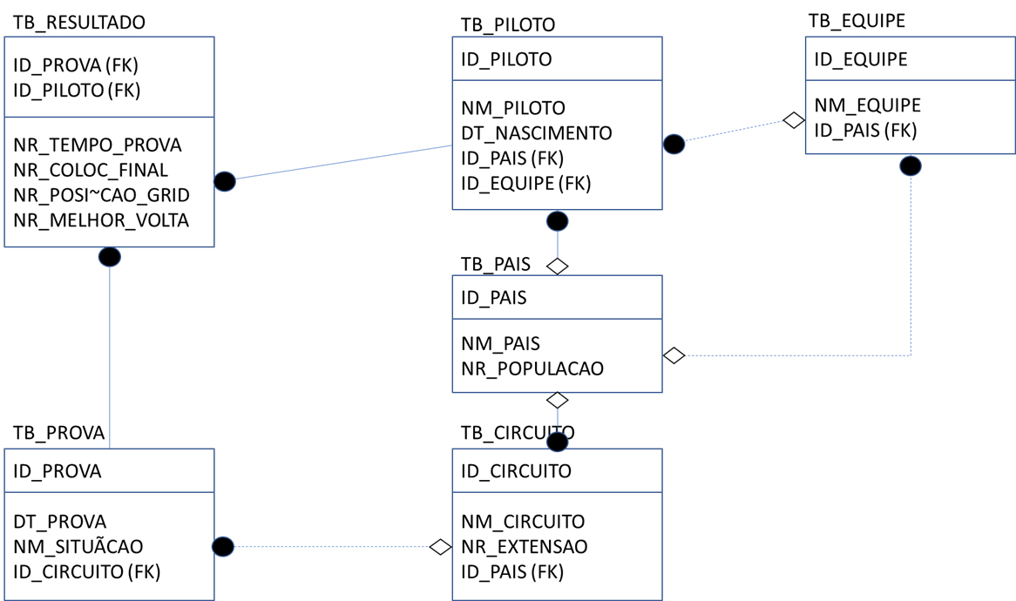 [Clique para obter mais opções](https://bb.cruzeirodosulvirtual.com.br/webapps/blackboard/content/listContent.jsp?course_id=_594070_1&content_id=_5704706_1&mode=reset#contextMenu)

And elaborate the scripts and constraints for creating this base. The expected document for this delivery will be a .sql file