**Maximizing Astronaut Productivity**

Matthew Gergley, Riley Morgan, Cameron Netherton, Minxiong Zheng

Department of Mathematics, Utah Tech University

Math 3700: Mathematical Modeling

Dr. Vinodh Chellamuthu

December 9, 2022

**Table of Contents**

1. Abstract
2. Introduction
   1. Assumptions
3. Schematic Diagram
4. Model
   1. Space Team Equation
   2. Ground Team Equation
   3. Productivity Equation
5. Parameter Table
6. Results
7. Conclusion & Future Work
8. Contributions
9. Appendix
10. Works Cited

# **1. Abstract**

NASA astronauts are required to go through lengthy and tedious training to be prepared for the rough conditions they will encounter in space and the work they must complete. The schedule on the International Space Station (ISS) is hectic and filled with high-priority work that can cause great stress to the astronauts. Dealing with this stress while being as productive as possible is a challenging feat. In order to mitigate the amount of stress astronauts will experience, we have developed a set of equations to model cortisol levels, an indicator of stress, and map it to their corresponding productivity level. Using this model, we can implement an optimal daily schedule for the astronauts that will ultimately increase productivity and decrease stress for the astronauts.

# 

# **2. Introduction**

Astronauts are faced with extreme environments and are relied on to complete difficult and high priority tasks that most people are incapable of doing. With such an important and unique occupation, it is paramount that we are able to understand the stress associated with the demands of this career and find opportunities to lower stress and maximize productivity.

Our problem analyzes a group of people who will travel to the International Space Station (ISS), and be assigned tasks to help and assist the astronauts who were already there [5]. The new astronauts complete rigorous training and are physically prepared for the mission they are assigned to go on. However, it can be extremely difficult to prepare for the high stress and pressure the work will lead to. Astronauts face unique stressors when they are isolated for long periods of time, and are required to accomplish critical jobs under tight deadlines. They are exposed to microgravity, radiation, unusual light-dark cycles, higher levels of CO2, nutritional changes and constant noise to name a few [6]. With such an intense and important job, it is crucial to find ways to reduce the stress they feel from urgent and crucial tasks because it not only matters to their performance but it also affects their health.

A way in which we can monitor the stress levels these astronauts face is by measuring the level of cortisol that is being produced within their bodies. Cortisol is often referred to as the stress hormone. As your body feels stressed, your adrenal glands create and release cortisol into your bloodstream [7]. With the goal of lowering the stress levels of astronauts, we need to be able to find ways in which we can lower the levels of cortisol and yet maintain the high productivity that is required for such a high stake job. While the normal amount of cortisol in your body is dependent on the time of day, we have found that the average cortisol level is 20.39 nmol/L with a standard deviation of 7.74 nmol/L [29]. Anything outside of the first standard deviation range will thus be considered high or low depending on which side of the spectrum the cortisol level is on. Both low and high levels of cortisol can be dangerous which is why we need to aim to keep the levels in the normal range. By doing so we can maintain the astronauts safety while achieving high productivity.

Dopamine is a very crucial neurotransmitter and hormone in the brain that impacts someone’s ability to complete tasks. In layman's terms, more dopamine means more productivity and likewise more productivity means more dopamine [1]. Dopamine is made by the adrenal glands, located on top of the kidneys. It is a neurohormone, thus it is released by the hypothalamus in the brain. Many people’s knowledge of dopamine is that it is what makes you happy and brings pleasure but it does a plethora of other things. Other functions of dopamine consist of movement, memory, pleasurable reward, motivation, behavior, cognition, attention, sleep, arousal, mood, learning, and lactation [2]. It is also important to note that low amounts of dopamine act as a vasodilator[[1]](#footnote-0) and high doses act as a vasoconstrictor[[2]](#footnote-1). This is notable since astronauts will be under high amounts of stress which leads to high levels of cortisol which is also a vasoconstrictor (increases blood pressure) [2,3]. As a result, when they complete and work through tasks, dopamine will also increase constricting blood vessels further [2,3]. Dopamine and cortisol have a direct relationship as well. When you have a dopamine deficiency, your body will naturally increase the production of cortisol. A great way to view this phenomena is from the point of view of cortisol being the backup “energy” hormone by providing additional power so the brain and body can function properly without the appropriate levels of cortisol [9]. This can be easily observed in cases where you go from a normal state of comfort and balanced hormone levels to being stressed about a task or upcoming event. Your body will produce more cortisol naturally and in return lowers the dopamine levels you previously had. Essentially when focusing on these two hormones we can view them being a balance scale always staying at equilibrium; while this is a very simplified explanation of dopamine and cortisol it is useful information to develop our mathematical model.

While dopamine is an important hormone that can map to how productive one might be, our model will focus on cortisol alone and mapping that to a normal curve to represent productivity. The rationale behind this is that both high and low levels of cortisol will decrease a person's productivity and thus the closer one's cortisol level is to the average, the more productive and efficient they are. And by using the normal curve of cortisol levels, we can find the productivity of the astronauts at a given time. As a result, we can use this information to develop a schedule that produces the highest overall efficiency for a 24 hour schedule while keeping stress levels in a healthy range.

Cortisol has many triggers that cause it to change besides simply a hard or urgent task. In fact, basic human functions increase and decrease cortisol levels constantly. Human exercise increases cortisol within the body, since as discussed before, blood pressure increases during physical activity. Sleep is another factor in cortisol levels. The ability to fall asleep stems from the notion of having low cortisol levels at night since there’s a natural decrease in cortisol levels throughout the day. While sleeping, the cortisol levels will remain low until the body’s natural “wake up” time where the cortisol levels will spike up essentially waking you up. These two and a few others will be considered in our model. Beyond the scope of our model are other basic human functions such as eating which is more difficult to model since it solely depends on the food and is a situation by situation basis on how it affects one's cortisol levels. However, the factors we have ultimately decided to include cover the main stressors for humans throughout a 24 hour period and will be sufficient in showing the stressors that will affect our modeled astronauts.

# **2a**. **Assumptions**

In our model, we have created a set of assumptions so that we can monitor the change of stress and productivity of our astronauts based on numerous factors. Our assumptions are as follows:

1. Cortisol levels have a direct correlation with the stress our modeled astronauts undergo.
2. Average cortisol levels correlate to max productivity.
3. It takes 39 hours to get from earth to the space station.
4. After our ground astronauts and space astronauts have been together for 7 days, their stress levels can be modeled using the same equation at the time of their next intersection.
5. Every person does the same amount of work and is equally affected by each stress factor.
6. Each task is completed with no errors that would cause additional stress.
7. Productivity is zero when one is not working.

# **3. Schematic Diagram**

**Figure 1**

Figure 1 represents the basic diagram in which our model will follow throughout our simulations. Our ground team represents the astronauts that start on the ground and will be traveling to the space station while the space team represents the astronauts that are already in space working on the ISS. When time is equal to zero in our model, there are two separate teams that undergo different circumstances that change their productivity and cortisol levels. However, as time goes on, the two teams will meet at the ISS and start to undergo similar daily routines. With similar schedules and requirements, the two teams will start to undergo similar stress factors and will then be able to be modeled as one combined team. After time x, we will then be able to monitor the cortisol levels and productivity of the entire group using the combined team equation.

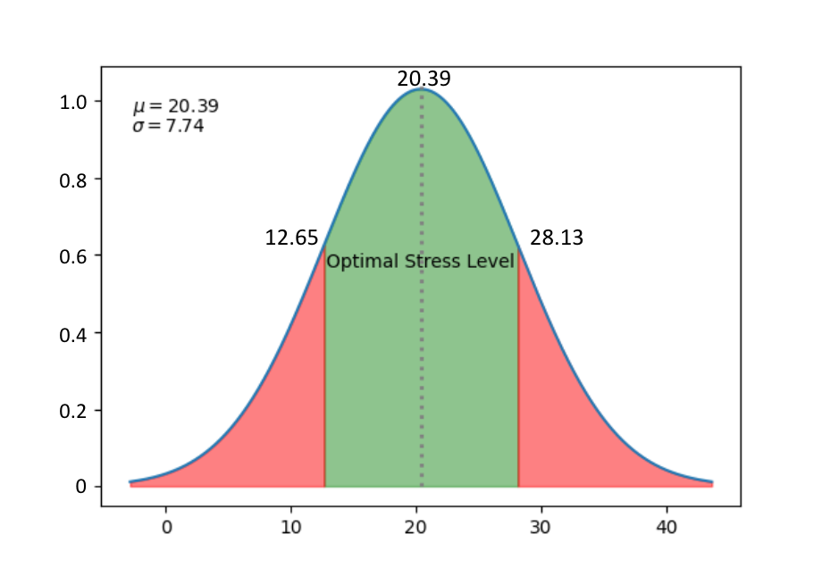

**Figure 2**

In order to translate our astronauts' average stress levels to show the efficiency at which they are working, we used a normal distribution curve of our cortisol levels as seen in figure 2. Using data on the average cortisol levels and the assumption that performance is at its highest when cortisol levels are closest to the mean (20.39 nmol/L), we are able to track overall productivity on a scale from 0 to 1, with 1 being 100% productive and 0 being unproductive [29]. In figure 2, we can observe that within plus or minus one standard deviation (7.74 nmol/L) of the mean we continue to have high productivity, however, as we get further from the mean in either direction productivity significantly decreases [29]. Thus showing the importance of finding a schedule that keeps the astronauts cortisol levels close to the mean.

# **4. Model**

To manage and analyze the cortisol levels and productivity of our astronauts we have developed three equations. Our model consists of two different differential equations that track the change in cortisol levels of our space team (equation 1) and ground team (equation 2) and an additional productivity equation that maps the cortisol levels from our two groups to a normal curve to show the corresponding efficiency based on their astronaut's stress level (equation 3).

{"type":"$$","font":{"size":8,"family":"Times New Roman","color":"#000000"},"code":"$$\\left(1\\right)\\,\\,\\,\\,\\,\\,\\,\\,\\,\\,\\frac{dC_{S}}{dt}=b\\left(t\\right)\\cdot \\left(C_{S}\\cdot C_{G}\\right)+u\\left(t\\right)\\cdot \\left(\\frac{w\\left(t\\right)}{p_{M}\\left(t\\right)}\\right)+\\left(-s\\left(t\\right)-r\\left(t\\right)+wo\\left(t\\right)-z\\left(t\\right)+tr\\left(t\\right)\\right)\\cdot Cs-\\left(\\frac{\\left(Cs-20.39\\right)}{7.74}\\right)\\cdot weight$$","backgroundColor":"#ffffff","id":"2-0-0-0-0","backgroundColorModified":false,"aid":null,"ts":1670269961479,"cs":"g8HXixIabG4NGX+/sSbCIA==","size":{"width":556,"height":25}}

{"font":{"size":"9","color":"#000000","family":"Times New Roman"},"type":"$$","code":"$$\\left(2\\right)\\,\\,\\,\\,\\,\\,\\,\\,\\,\\,\\frac{dC_{G}}{dt}=b\\left(t\\right)\\cdot\\left(C_{G}\\cdot C_{S}\\right)+u\\left(t\\right)\\cdot\\left(\\frac{w\\left(t\\right)}{p_{M}\\left(t\\right)}\\right)+\\left(-s\\left(t\\right)-r\\left(t\\right)+wo\\left(t\\right)+d\\left(t\\right)-z\\left(t\\right)\\right)\\cdot C_{G}-\\left(\\frac{C_{G}-20.39}{7.74}\\right)\\cdot weight\\,$$","backgroundColor":"#ffffff","aid":null,"backgroundColorModified":false,"id":"5-0-0","ts":1670269932293,"cs":"zB4I1X9s+VoedsZdRMkq0g==","size":{"width":610,"height":28}}

**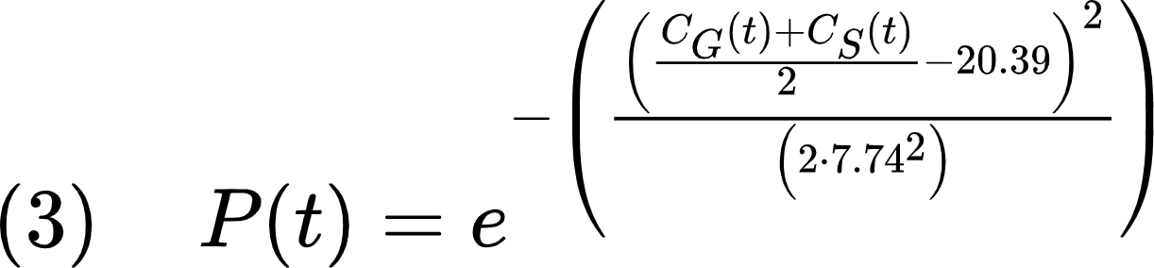**

| **Symbol Table** | |
| --- | --- |
| **Symbol** | **Description** |
| CS | Cortisol levels of researchers (Space) |
| CG | Cortisol levels of researchers (Ground) |
| P(t) | Productivity of researchers |
| b(t) | Interaction between teams |
| u(t) | Urgency factor |
| w(t) | Amount of work |
| pM(t) | Workforce population |
| s(t) | Sleep factor |
| r(t) | Relaxation factor |
| z(t) | Natural decrease factor |
| wo(t) | Workout factor |
| d(t) | Space flight factor |
| tr(t) | Training factor |

# **4a. Space Team Equation{"aid":null,"type":"$$","code":"$$\\left(1\\right)\\,\\,\\,\\,\\,\\,\\,\\,\\,\\,\\frac{dC_{S}}{dt}=b\\left(t\\right)\\cdot \\left(C_{S}\\cdot C_{G}\\right)+u\\left(t\\right)\\cdot \\left(\\frac{w\\left(t\\right)}{p_{M}\\left(t\\right)}\\right)+\\left(-s\\left(t\\right)-r\\left(t\\right)+wo\\left(t\\right)-z\\left(t\\right)+tr\\left(t\\right)\\right)\\cdot Cs-\\left(\\frac{\\left(Cs-20.39\\right)}{7.74}\\right)\\cdot weight$$","id":"2-0-0-0-1","font":{"family":"Times New Roman","size":8,"color":"#000000"},"backgroundColor":"#ffffff","backgroundColorModified":false,"ts":1670356303511,"cs":"APmP+OmZvmGUdiFU89wJGg==","size":{"width":556,"height":25}}**

Breaking down the space team differential equation (equation 1), we have included several factors that both increase and decrease cortisol levels in the astronauts. These factors include common activities such as team interactions, sleeping, working, relaxing and others. Examining the first component of equation 1 we observe, $b(t)⋅(C_{s}⋅C_{G})$, which is the interaction between the space team (CS) and the ground team (CG) multiplied by the interaction rate (b(t)) which can be found in the table in section 6. This replicates the two groups interacting with each other at the rate b(t). The rate b(t) is a time dependent variable that is only active when the teams are working together.

The following piece of the differential equation factors in the increase in stress due to the work required from the team as shown by $u(t)⋅(\frac{w(t)}{p_{M}(t)})$. The parameter u(t), is the urgency associated with completing work. This stress factor is based on the time t and changes every 24 hours to signify a new urgency for that day. When u(t) is above one, the urgency of the work increases the stress of our team and when u(t) is below one, the stress of the team decreases. Our urgency factor is limited between 0.5 and 1.5 to minimize the effect of the urgency factor and was randomly selected for each day's worth of work. The variable w(t) is the amount of work required at time t, and pm(t) is the number of people at the space station that are working at that time. Since w(t) is divided by pM(t), we notice that as more team members arrive at the space station, the amount of stress caused by working decreases due to the increase in the number of people available to work.

Examining the next set of stress factors in our equation, we have our change in cortisol levels due to sleep [s(t)], relaxation [r(t)], working out [wo(t)], natural decrease [z(t)], and training [tr(t)] multiplied by our cortisol level of our space team as follows $(-s(t)-r(t)+wo(t)-z(t)+tr(t))⋅C_{S}$. The negative signs in this section of the equation indicate a decreasing stress factor, while the addition signs indicate an increasing stress factor. These parameters can be found in the parameter table in section 6. All of these variables are time-dependent within our model which means that as time changes, so do the values of these variables. s(t) is the rate at which our astronauts' stress levels decrease due to sleep. Since this factor only is applicable when one is asleep, the decrease in stress due to sleep will only be noticeable when our time t is during the sleep portion of the astronaut's schedule. Similarly, this logic can be applied to the other variables in this equation. These factors will then be added together and multiplied by the cortisol level of the space team to determine the change in cortisol at time t.

The last portion of this equation involves the rate at which the body naturally stabilizes the cortisol level back toward the average as follows $(\frac{(C_{S}-20.39)}{7.74})⋅weight$. CS subtracted by 20.39 gives us the difference of the space team's overall cortisol level from the mean. Then by dividing that result by 7.74 (the associated standard deviation) we are able to find how many standard deviations our cortisol level is from the mean [29]. The number of standard deviations is then multiplied by our weight factor to force the cortisol level closer to the body's natural average. This is important because it represents the body's ability to control its stress hormones and without this factor the cortisol levels will continue to increase or decrease without resetting. Together these components combine together to model time dependent shifts in cortisol levels within our space team of astronauts.

# **4b. Ground Team Equation{"code":"$$\\left(2\\right)\\,\\,\\,\\,\\,\\,\\,\\,\\,\\,\\frac{dC_{G}}{dt}=b\\left(t\\right)\\cdot\\left(C_{G}\\cdot C_{S}\\right)+u\\left(t\\right)\\cdot\\left(\\frac{w\\left(t\\right)}{p_{M}\\left(t\\right)}\\right)+\\left(-s\\left(t\\right)-r\\left(t\\right)+wo\\left(t\\right)+d\\left(t\\right)-z\\left(t\\right)\\right)\\cdot C_{G}-\\left(\\frac{C_{G}-20.39}{7.74}\\right)\\cdot weight\\,$$","backgroundColorModified":false,"backgroundColor":"#ffffff","type":"$$","aid":null,"id":"5-0-1","font":{"family":"Times New Roman","size":"9","color":"#000000"},"ts":1670356150883,"cs":"1tVmjOW/hSZ6mV3E/oim5w==","size":{"width":610,"height":28}}**

Our ground team is modeled by equation 2, which analyzes the cortisol levels over time based on the condition of several stress factors our team of astronauts being shipped to space will experience. The ground team differential equation is similar to the space team differential equation in many ways as both teams will often face similar stress factors. However, the main difference that can be noticed is how time affects both teams differently.

Breaking down our ground team equation (equation 2), we find that $b(t)⋅(C_{s}⋅C_{G})$ affects the amount of stress this team faces. Once again, b(t) is our interaction rate which is a time-dependent variable that will either increase or decrease stress based on the time within the model. The multiplication between CS and CG represents the two groups interacting with each other which is then multiplied by our rate b(t) to determine how it affects the cortisol levels.

Our second factor of equation 2 is as follows, $u(t)⋅(\frac{w(t)}{p_{M}(t)})$. u(t) represents the time-dependent random urgency factor that either increases or decreases the stress associated with daily work. Similar to equation one, the time factor t corresponds with the urgency of the work for that particular day. The urgency rate, u(t), is bounded between 0.5 and 1.5 to limit the overall effect it has on the model. w(t) shows the amount of work required in the model at time t and pM(t) is the number of astronauts available to complete the required work at that particular time. As more astronauts show up at the space station, the stress caused by work will decrease due to the extra help available to accomplish the required tasks. Together these parameters determine the stress our astronauts undergo while working at the International Space Station.

Similarly to equation 1, our ground team has a combination of several other stressors that will be multiplied by CG to model the overall effects of the combined stress factors. The combination of stress factors is modeled by $(-s(t)-r(t)+wo(t)+d(t)-z(t))⋅C_{S}$. s(t) and r(t) are seen as decreasing stress factors and represent the time-dependent decrease in stress due to sleep [s(t)] and relaxation [r(t)]. wo(t) and d(t) are seen as time-dependent stress increasers that represent the increase in stress due to working out [wo(t)] and flying to the space station [d(t)]. The last factor is z(t), is a natural decreasing factor and will help in lowering overall stress. These factors change based on the time within the model and will be combined to determine the increase or decrease to the ground teams overall cortisol levels at time t.

The last portion of this equation is the body's natural pull back to the mean as shown $(\frac{(C_{G}-20.39)}{7.74})⋅weight$. This piece of the equation works the same as explained above in the space team equation. As each of these compartments are combined together, they are able to model the rate of change of the cortisol levels in the ground team.

# **4c. Productivity Equation**

****

The productivity equation uses the normal probability distribution function with the mean (the average cortisol levels of healthy young adults) of 20.39 nmol/L, and the standard deviation of 7.74 nmol/L [29]. Equation 3 uses the cortisol levels of both teams at a given time, t, to retrieve the corresponding productivity from the normal curve shown in figure 2. This equation allows us to retrieve the efficiency of our teams at any time given the cortisol levels.

In this equation, we take the cortisol level of both teams (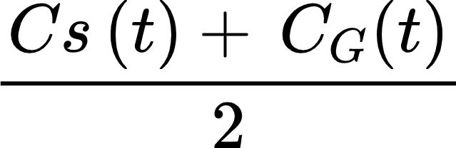) to find the average cortisol level of the entire group. The remaining portion of the equation follows the normal distribution model using the corresponding average and standard deviation. We can assume that productivity has a normal distribution in relation to stress through the Yerkes-Dodson Law. The law states that there is an empirical relationship between pressure (stress/cortisol levels) and performance (productivity) [30]. This law is logical since human beings will not be productive if there is no stress, in other words no need to get a task done, and if there is too much stress they won’t be able to focus and complete a task with high accuracy. Additionally, our cortisol data follows a normal distribution which allows us to map our data to a normal curve [29]. The highest level of productivity will occur between one standard deviation from the mean. In this equation, P(t) is bounded from 0 to 1, where 1 represents the highest productivity level and 0 represents the lowest productivity of the whole group. Using this equation, we are able to determine the efficiency of our teams based on stress levels to help us find an optimal daily schedule.

# **5. Parameter Table**

| **Stress Factor** | **Symbol** | **Value** |
| --- | --- | --- |
| Work | w(t) | 250 (estimate) |
| Sleep | s(t) | [0, 0.91] (appendix) |
| Relaxation | r(t) | [0, 5] (estimate) |
| Flight Stress | d(t) | [0, 2.2] (appendix) |
| Exercise | wo(t) | [0, 0.8] (estimate) |
| Interactions | b | [-1, .25] (estimate) |
| Training | tr(t) | [0, 0.1] (estimate) |
| Weight | weight | 0.2 (estimate) |
| Natural Decrease | z(t) | [0, 0.1] (estimate) |
| Workforce Population | pM(t) | [7,14] |

# **6. Results**

After running our model and testing our equations we were able to find hundreds of possible schedules and their corresponding effectiveness. Below are the results from our average schedule, as well as our best-performing schedule based on overall average productivity.

Our average schedule was formed by finding the daily schedule that outputs the average overall productivity from all of the possible schedules. The resulting schedule assigned 10 hours to work, 3 hours to relaxation, 3 hours to working out, and 8 hours to sleeping as seen in figure 3.

**Figure 3**

From our average schedule, our resulting astronauts' cortisol levels can be seen in figure 4. Here we can visualize the trends in our data and how each team's stress levels changed over time.

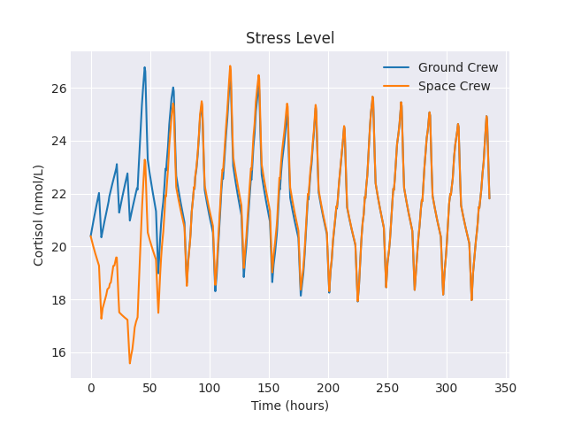**Figure 4**

This chart allows us to view cyclic increases and decreases in cortisol levels throughout the 14-day period. Early on in the chart, we notice a major difference between the stress levels of the two teams. After the two teams meet (hour 39), we notice the cortisol levels start to act similarly between the two groups. This schedule generated average minimum levels slightly above 18 nmol/L and highs from 24 to 26 nmol/L. Considering that our mean is set at 20.39 nmol/L with a standard deviation of 7.74 nmol/L, our model seems to match what we would expect from an average schedule as it remains bounded within one standard deviation from the mean.

Figure 5, uses our productivity equation to map the daily average productivity using a line graph. Here we notice a major decrease in overall productivity during the first couple of days followed by a slight increase towards the end of the 14-day model. This graph charts the average productivity from the entire 24 hour hours to determine the productivity for that day. As a result we notice the productivity to be around 0.34. This is because in all non-working hours, have a set productivity of zero since no work is being accomplished. Without context to other results it may be hard to truly determine the meaning of this chart. Thus it is important we continue to examine results from other schedules.

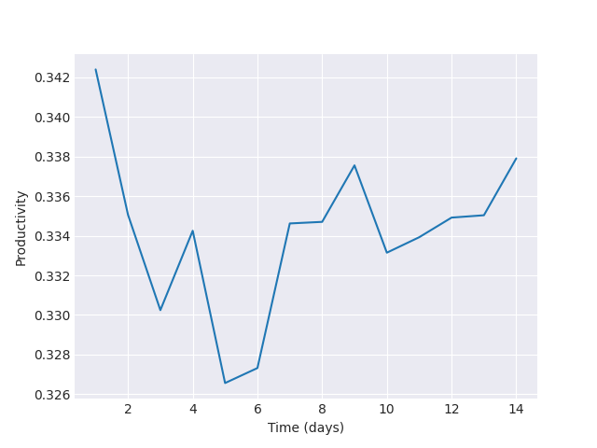

**Figure 5**

Our next modeled schedule is our optimal schedule which resulted in the highest average productivity. This schedule consisted of 12 hours of work, 4 hours of relaxation, 1 hour of working out, and 7 hours of sleep as depicted in figure 6.

**Figure 6**

The results from this schedule can be seen in figure 7 which visualizes the change in cortisol levels for both teams dependent on the new schedule.

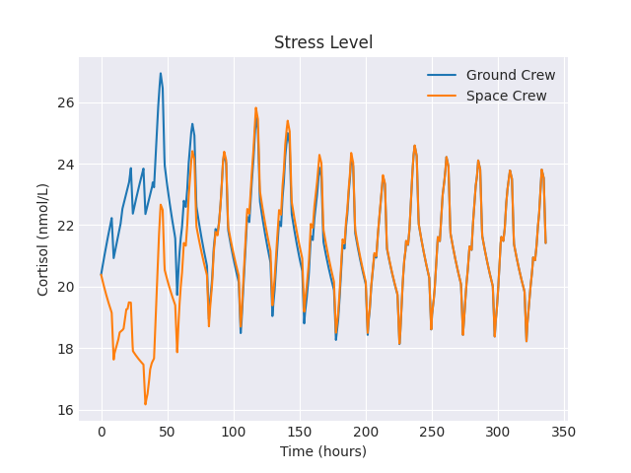**Figure 7**

Our optimal schedule produced cortisol levels that stayed much closer to the mean of 20.39 nmol/L. Throughout the cyclic 14-day period, the normal lower bound was from 18-19 nmol/L and the upper bound was near 24 nmol/L. While both our average and best schedule follow similar line shapes during the 14-day model, the main difference is in how far from the mean both chart lines vary. Over the long run, the optimal schedule performed much better than the average schedule as the cortisol levels stayed closer to the body's average cortisol level indicating a healthier cortisol balance.

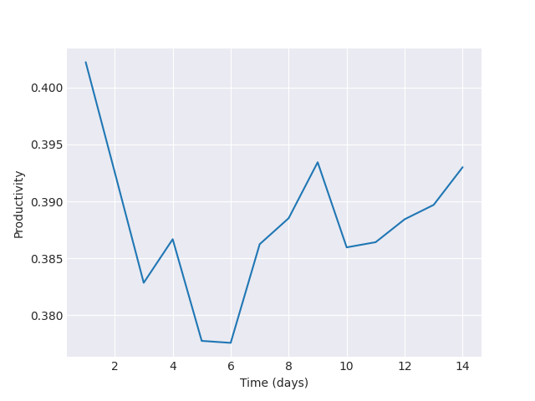**Figure 8**

The resulting productivity chart for our optimal schedule (figure 8) shows a much higher level of productivity from day 0 to 14 in comparison to the average schedule. The lowest level of productivity from this schedule is significantly higher than the highest productivity from our average schedule. Neither chart varies more than .05 in the entire 14 days modeled which shows small fluctuation in productivity. Thus, both charts results indicate that each 0.001 measurement of productivity holds significant value. This allows us to understand how important the jump in productivity was from our average schedule to our optimal schedule and the consequence that optimal time allocation has on increasing productivity.

# **7. Conclusion & Future Work**

To begin this project our initial goal was to be able to model astronauts' stress levels in a way that could be used to help find a solution to their overwhelming workload and schedule. By using our explained set of equations we have been able model the effects of several stress factors as well as test hundreds of combinations of schedules to find a reasonable schedule that both provides high productivity and healthy amounts of stress. As we work towards concluding our research and findings, there are many additional items we are still looking to complete in the future. As a team, we want to work towards finding more accurate parameters and possibly include other stress factors that can make our model more accurate. We would also like to dive more into how significant 0.001 productivity is in our model. For the time being, however, we have been able to create a model which outputs an optimal schedule based on a variety of time-dependent factors and has the opportunity to be a major benefit to our astronauts.

# **8. Contributions**

As a team we all contributed to the logic behind the model, and worked together to edit the paper. Matt completed the abstract, introduction, works cited, appendix, and contributed to the equation explanation. Riley worked on the schematic model, equation explanation, results, conclusion and future work and helped on some of the code. Cameron focused on the code that powered our model. Additionally, he worked on putting together our video and built some of the diagrams in the paper. Minxiong contributed to the code and helped with the productivity equation.

# **9. Appendix**

Namely, our parameter table contains rates that have been transformed from literature to fit the purposes of our model. Here, the derivation of said rates will be shown:

Sleep: s(t)

Our mean, 20.39nmol/L will decrease to a low of 1.8nmol/L at the end of the day right before bed. Humans will reach that mean level at the time of waking up since the increase in cortisol is a factor of the waking up phenomenon. Therefore, we can look at a percent difference to get our rate as follows:

$\%diff: \frac{max-min}{max}⋅100=$ $\frac{20.39-1.8}{20.39}⋅100 = 91\% = 0.91 = s(t)$

Flight Stress: d(t)

The flight stress was calculated using values from literature as well, using a different method relating to a linear slope of the change in cortisol from the launch, time t = 0 hrs, to arrival at the space station, time t = 39 hrs. Using the value of 32.5118mcg/dL, the initial cortisol level of astronauts at the launch, and 14.4618mcg/dL the cortisol levels at the arrival at the ISS. The calculation is as follows:

$rate of change = slope =|\frac{ΔCortisol}{Δtime}|= |\frac{32.5118 - 14.4618}{39 - 0}|=2.16=2.2$

# **10. Works Cited**

[1] <https://habitgrowth.com/dopamine/>

[2]<https://my.clevelandclinic.org/health/articles/22581-dopamine>

[3]<https://www.premierhealth.com/your-health/articles/women-wisdom-wellness-/beware-high-levels-of-cortisol-the-stress-hormone>

[4]<https://medlineplus.gov/ency/article/003561.htm>

[5]<https://spacenews.com/pace-of-work-put-strain-on-private-astronaut-mission-to-iss/>

[6]<https://www.nasa.gov/content/dont-stress-the-small-stuff-nasa-1ym-research-helps-combat-stress-and-fatigue>

[7]<https://www.premierhealth.com/your-health/articles/women-wisdom-wellness-/beware-high-levels-of-cortisol-the-stress-hormone#:~:text=As%20your%20body%20perceives%20stress,alive%20for%20thousands%20of%20years>.

[8]<https://www.mountsinai.org/health-library/tests/cortisol-blood-test#:~:text=Normal%20Results,vary%20slightly%20among%20different%20laboratories>.

[9]<https://medium.com/@EricBravermanMD/dopamine-and-cortisol-6662cd5cac7f>

[10] <https://www.nasa.gov/audience/forstudents/5-8/features/F_Astronauts_in_Training.html>

[11] <https://www.nasa.gov/mission_pages/shuttle/flyout/t38flyout.html>

[12] <https://www.space.com/42109-soyuz-launch-failure-astronaut-crew-good-health.html>

[13] <https://pubmed.ncbi.nlm.nih.gov/12142227/>

[14] [https://www.mayoclinic.org/healthy-lifestyle/stress-management/in-depth/stress/art-2004603](https://www.mayoclinic.org/healthy-lifestyle/stress-management/in-depth/stress/art-20046037)

[15] [Paper on Cortisol Levels of Astronauts and other hormones](https://pubmed.ncbi.nlm.nih.gov/7562371/)

[16] <https://www.apa.org/news/press/releases/stress/2013/sleep>

[17] <https://www.ncbi.nlm.nih.gov/pmc/articles/PMC3079864/#ref5>

[18] <https://www.spacecentre.nz/resources/faq/spaceflight/how-long-to-reach-space.html>

[19] <https://my.clevelandclinic.org/health/articles/22187-cortisol>

[20] <https://spacecoastlaunches.com/blog/what-do-astronauts-do-on-the-iss/>

[21] [Astronaut Nutrition](https://www.ncbi.nlm.nih.gov/pmc/articles/PMC8747021/)

[22] <https://pubmed.ncbi.nlm.nih.gov/8548938/>

[23] <https://www.integrativepro.com/articles/the-role-of-cortisol>

[24] <https://www.health.harvard.edu/staying-healthy/exercising-to-relax>

[25] <https://pubmed.ncbi.nlm.nih.gov/18787373/>

[26] <https://www.ucmerced.edu/sites/ucmerced.edu/files/documents/zawadzki-paper-2015.pdf>

[27] <https://www.ncbi.nlm.nih.gov/pmc/articles/PMC3251930/>

[28] <https://www.integrativepro.com/articles/the-role-of-cortisol>

[29] <https://www.ncbi.nlm.nih.gov/pmc/articles/PMC4543482/>

[30] <https://www.researchgate.net/figure/Illustration-of-Yerkes-Dodson-law-1_fig1_320592240>

1. Causes blood vessels to relax and dilate [↑](#footnote-ref-0)
2. Causes blood vessels to constrict [↑](#footnote-ref-1)