Modeling the Effects of Introducing Toxorhynchites to Areas Infected with Dengue Fever

M. Zheng, R.Morgan, C. Netherton

Advisor: Dr. Vinodh Chellamuthu

Dixie State University

# Abstract

Dengue fever is a disease common in many parts of the world that is spread mainly by the bite of an infected mosquito. Research shows that Toxorhynchites are an effective biocontrol agent for the control of mosquito populations. In order to reduce the population of mosquitoes that carry the dengue fever virus, we have modified a Wolbachia Model by adding the interaction of a predator –Toxorhynchites to view the effects this interaction would have on reducing the number of humans infected by dengue fever.

*Keywords:* Toxorhynchites , Wolbachia , dengue

# 

# 

# Introduction

Dengue viruses are spread to humans through the bite of an infected Aedes species mosquito. According to CDC statements, About 4 billion people around the world, exposed to the risk of dengue[1]. This virus can lead to a series of illnesses such as fever, headache, muscle pains and so on[1]. There are several ways to prevent this disease such as physical prevention, medical treatment, and biocontrol agents. In this project, we are using a mathematical model to analyze the effects of Toxorhynchites to help reduce the dengue cases.

# Method

## S-E-I-R

Figure 1

We are going to use the SEIR model for our project. The SEIR model is a mathematical model used to track and predict the infusion of disease. In this model, the population is represented and broken into the categories of someone who is either susceptible, exposed, infected or recovered.

## Original Model without Toxorhynchites

The original model used an innovative method of deterring the infection of mosquitoes with dengue fever. Infecting mosquitoes with the bacterium *Wolbachia* works through three different ideas, the bacteria reduces the mosquito’s ability to become infected with and therefore reduces the ability to spread dengue, the bacteria decreases the mosquito’s lifespan, and also gives individual mosquitoes a breeding advantage. The original model showed the spread of dengue fever between humans and mosquitoes prior to the introduction of *Wolbachia* as shown below in figure 2.

Figure 2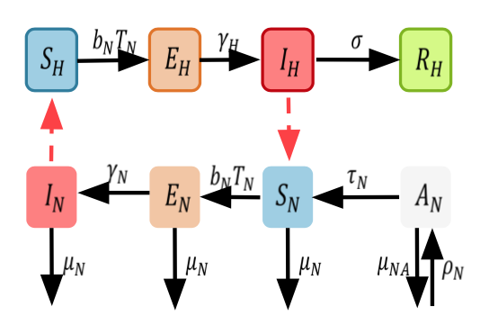

The model works under the assumptions that the populations are well mixed, the mosquitoes seasonally die off, and use only one strain of dengue fever. This model can be represented using the following differential equations.

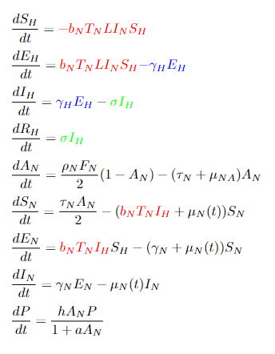

We use the subscript H for human populations and N for the mosquitoes not infected with *Wolbachia*. Since dengue fever is transmitted from mosquito to human and vice versa, we can see that the model shows the rate of infection for both are dependent on the infected population of the other.

Now that we have the model without *Wolbachia,* we can introduce the bacteria to the model to create the Wolbachia model as seen in figure 3.

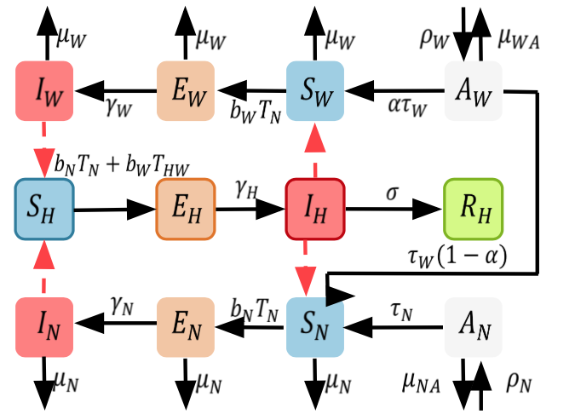

Figure 3

Although the model appears a bit more complicated, we can see that the idea is essentially the same.The main difference with this model is that a bite from a mosquito infected with both *Wolbachia* and dengue has a far lower probability of infecting the human with dengue than a bite from a mosquito infected with dengue alone. Another idea this model uses is vertical transmission. Since *Wolbachia* can be passed from parent to child, it is not necessary to continually reinfect the population. We can see in the model, new mosquitoes will be born already infected with the bacteria.

## Model by adding Predators

Along with the *Wolbachia*, another way to deter the spread of dengue from mosquitoes is to introduce natural predators to the environment. In this case, we looked at the introduction of *Toxorhynchites.* We found an equation which uses searching rate, satiety rate, and conversation factor to describe the hunting pattern of the larva on the current mosquito population. This is shown in the following model in figure 4.

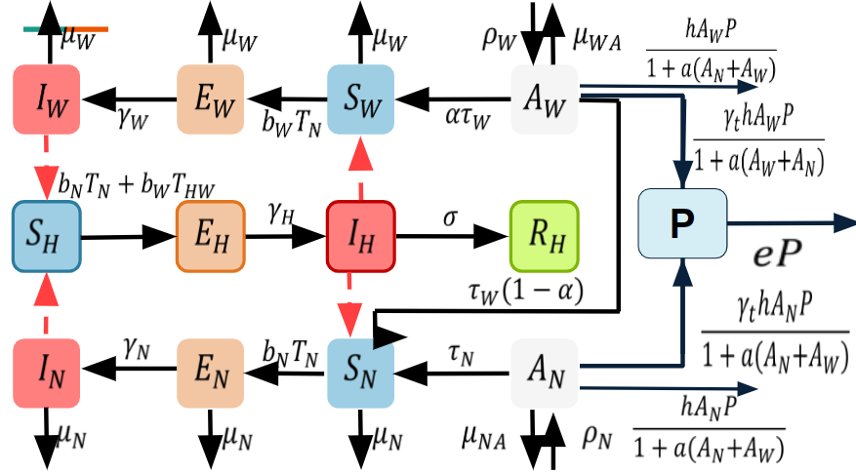

Figure 4

This model shows that rather than preventing the infection of humans by adult mosquitoes, the predators are used to deflate the mosquito population by preying on them while they are still in the larval stage.

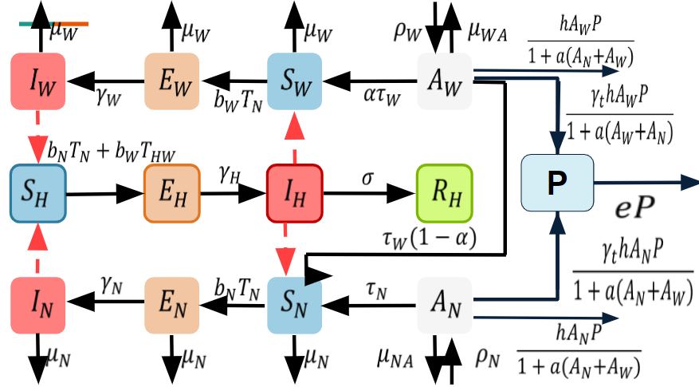

Figure 5

By adding the Toxorhynchites as predators, the rate of change of aquatic (including egg, larval and pulal states) decreased by **[4].** To investigate the effects of the Toxorhynchites for the dengue cases, we modified the code for the original model by adding a new parameter P and changing the parameters like satiety, searching and conversion rate. Also, we are trying to find the best way to release Toxorhynchites, for example, we are modeling the effects of releasing Toxorhynchites at different time intervals based on the average temperature of the previous seven days. By doing so, we will be able to analyze the best release strategy that will utilize our resources efficiently and hopefully work in decreasing the number of mosquitos.

# Results

## Outcome 1:

Exploring the effects of our new model, we wanted to get a baseline of what would occur if we released the new Toxorhynchites population once on the first day using only the original parameters given as seen in figure 6. In this result we noticed that our predator population died off almost immediately, and that the number of infected humans continued to grow over time. However, the initial population of the predator did help push the infection rate back a couple hundred days. Although this release plan was proven to be unsuccessful in eliminating the disease over a long period of time, it gave us useful information. Learning from our first result we understood that to find a successful model, we would need to release them multiple times throughout the duration of our model.

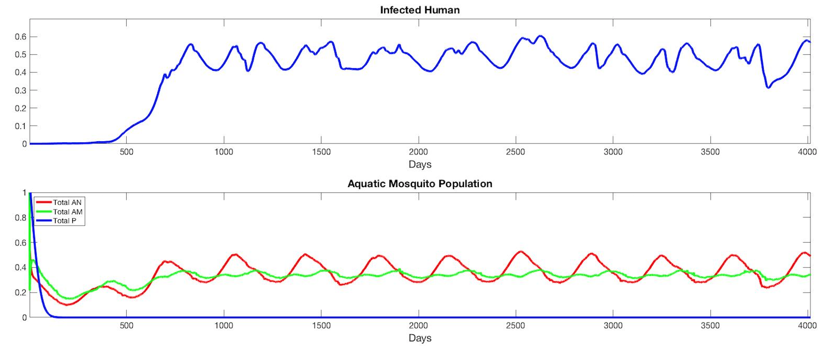

Figure 6

## Outcome 2:

After an unsuccessful first release model, we learned that multiple releases would be needed to successfully manage the number of infected humans contracting dengue fever. Taking this new information into consideration, we adjusted our model to release multiple times. To determine the frequency at which we would model the implementation of Toxorhynchites into the environment, we considered both the cost it would take to release the new Toxorhynchites and how frequent a biologist would have to make a trip into the environment to release the predator. With this in consideration, we determined that releasing the Toxorhynchites once every two weeks would be a reasonable amount that would utilize both time and resources in a reasonable way. With this new simulation, we modeled results in which we released an additional 25% of the original population once every two weeks. We continued to model this same frequency with different proportions of additional Toxorhynchites as seen in figure 7. After modeling these cases we observed that the higher the proportion of Toxorhynchites we introduce, the longer it takes for the amount of infected humans to increase. However, we notice that even with multiple releases of Toxorhynchites, the proportion of infected humans still increases to a worrisome level. Thus we want to continue searching for optimal ways to decrease the infected population.

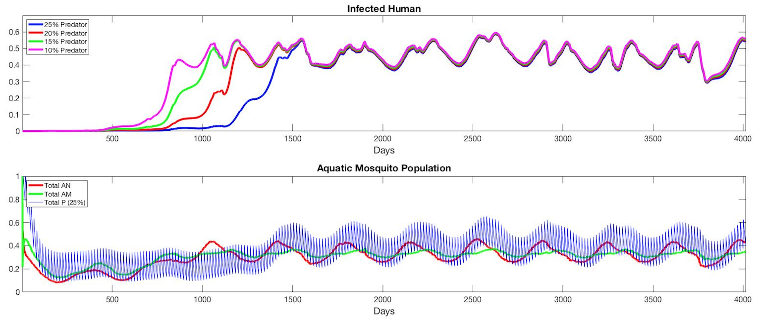

Figure 7

## Outcome 3:

External factors such as the temperature within an environment can have a major impact on the life cycle and population of mosquitoes. Using a temperature dataset from an area where dengue fever is prevalent (Thailand) we have been able to test release schedules dependent on the average temperature of the area over a duration of time. For our model, we wanted to test how releasing different proportions of mosquitos when the average temperature over the previous 7 days was above 30 degrees celsius and its been at most 7 days since the previous release, or if it has been at 10 days since the last release. In doing this we received the model as seen in figure 8. We can notice that once again, the higher proportion of the predator being reintroduced, the lower the proportion of infected humans. A major difference can be viewed in the proportion of infected humans when 25% of the Toxorhynchites population is reintroduced compared to only 20%. This model has provided us with the most promising results.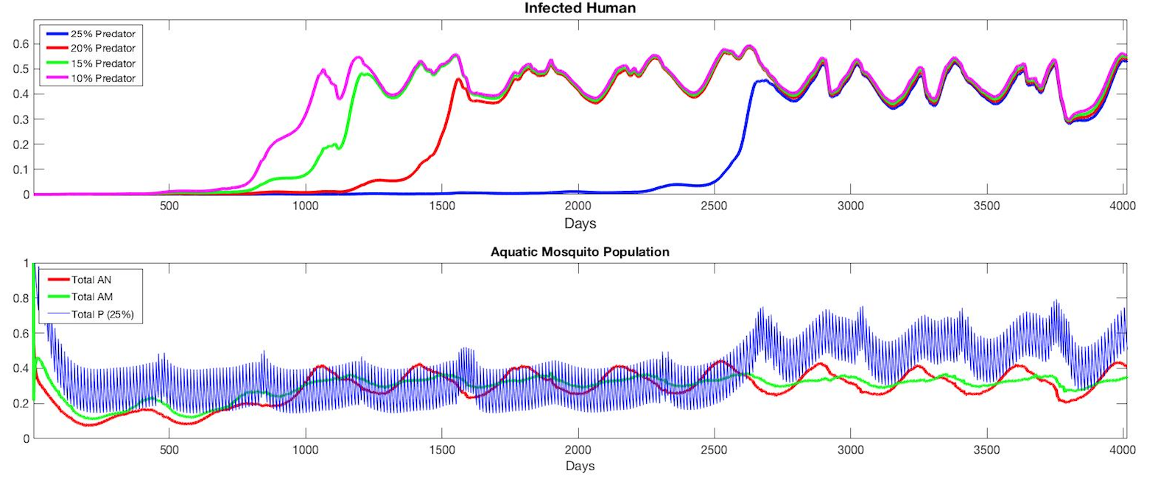

Figure 8

## Outcome 4:

The last model we wanted to experiment with was examining the effects of releasing multiple different proportions of the Toxorhynchites population when the average temperature of the past seven days is less than 24 degrees celsius and its been at least seven days since the last release, or if it has been 10 days since its last release. With these new guidelines in place our new model predicts very promising results in limiting the proportion of infected humans. In figure 9 we can see that reintroducing 25% of the Toxorhynchites population under the previously stated conditions can delay the increase of infected humans for nearly 2800 days. Additionally, the other proportions worked in delaying the infection of dengue fever for around 1000 days, which in comparison to the original model, is a major increase. This model has shown the most success in limiting dengue fever.

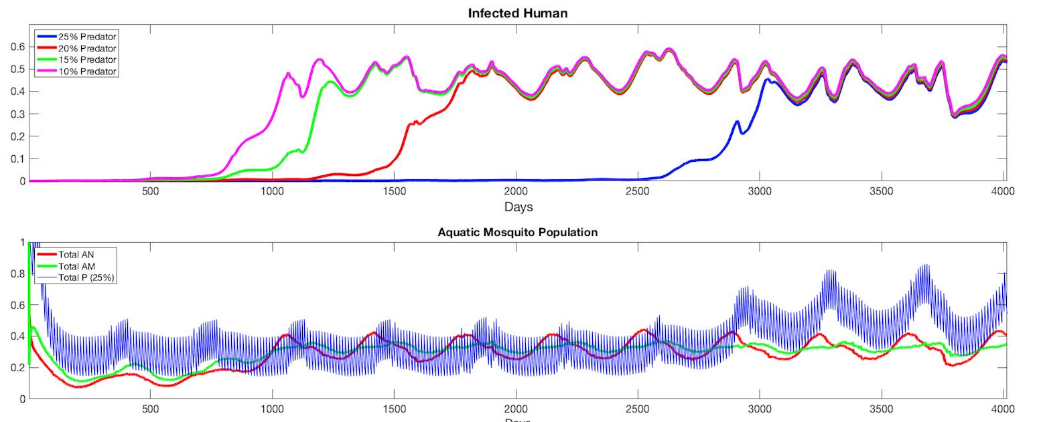

Figure 9

# Discussion

After weeks of working on this project we have learned how valuable differential equations can be in modeling interactions as well as being able to use matlab to code and run through mathematical models and algorithms. We have also learned the valuable skill of teamwork and working through issues as a team by talking through issues and strategizing solutions. These skills are valuable and are useful beyond this project. Focusing on the project itself, we were able to take a model and implement a new tactic in limiting the number of infected humans with dengue fever. After completing our models, new questions arose. One of which was whether there were other sources/research that would suggest different numbers for our parameters or other factors that should be considered to more accurately predict these trends. Additionally, we wanted to explore whether rain and precipitation had any effect on the mosquito population and how that correlates to the proportion of infected humans. This project has allowed us to model and test how different strategies would work in the field and create new plans that might have a higher chance of success in solving our overarching problem.

# 

# 

# References

[1] Centers for Disease Control and Prevention. (2021, November 15). Dengue. Centers for

Disease Control and Prevention. Retrieved April 25, 2022, from [https://www.cdc.gov /dengue/index.html](https://www.cdc.gov/dengue/index.html)

[2] Donald, Claire L, et al. “*Toxorhynchites* Species: A Review of Current Knowledge.”

*Insects*, MDPI, 30 Oct. 2020, <https://www.ncbi.nlm.nih.gov/pmc/articles> /PMC7693308/.

[3] GN;, Ndii MZ;Hickson RI;Allingham D;Mercer. “Modelling the Transmission Dynamics of

Dengue in the Presence of Wolbachia.” *Mathematical Biosciences*, U.S. National Library of Medicine, https://pubmed.ncbi.nlm.nih.gov/25645184/.

[4] Zhou, Fengyan, and Hongxing Yao. “Dynamics and Biocontrol: The Indirect Effects of a

Predator Population on a Host-Vector Disease Model.” *Abstract and Applied Analysis*, Hindawi, 27 Jan. 2014, <https://www.hindawi.com/journals/aaa> /2014/252718/.