Jon Bowen

CS 3210

Exercise 8

Ch 10 – Problem Set #1

* Bigsub’s static parent is Main
* A’s static parent is Bigsub
* B’s static parent is A
* C’s static parent is A

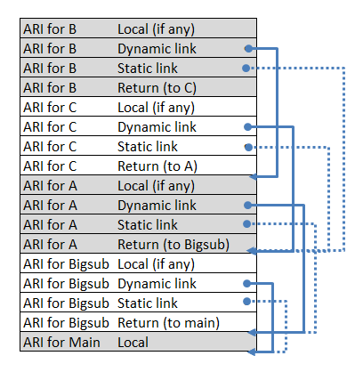

Ch 10 – Problem Set #2

* Bigsub’s static parent is Main
* A’s static parent is Bigsub
* B’s static parent is Bigsub
* C’s static parent is Bigsub

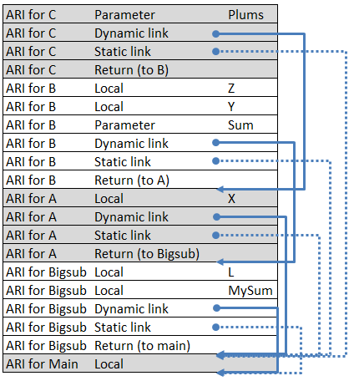

Ch 10 – Problem Set #7

String comparisons are an inefficient way to distinguish distinct variables in digital systems. Integer comparisons are substantially faster because such operations generally only require a single processor instruction. We propose, then, that rather than storing variable names in the activation records, instead store an integer that serves as a pseudonym for the variable. If required, a one-to-one map from integer to variable name may also be stored in a table structure to access the actual name.