**1000 Step Random Walk**

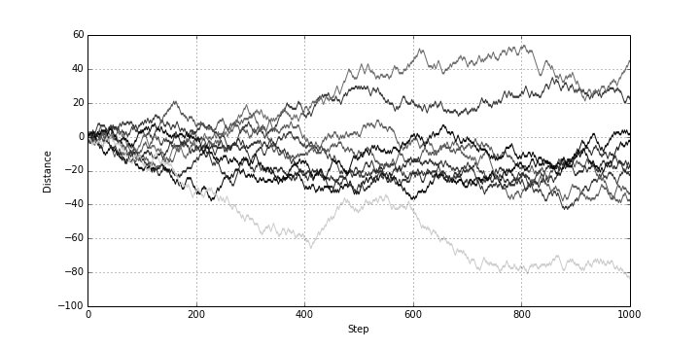

Fig 1: Shows a 1000 step random walk with a 50% chance of going forward or backward 1 step.

Q1: getting zero or close to zero does not seem to be uncommon and may actually be a probable result.

Q2: the average appears to be zero. This is justified by the fact that there is a 50% chance of getting either +1 or -1. Thus the most likely outcome is to have a 50-50 distribution as that macro state is the most likely.

Q3: The spread increases as the number of steps taken by the walkers increases.

Q4: The spread does not increase linearly.

Q5: (python)

def factorial(N):

if N<0 or type(N)!=int:

raise ValueError('N must be a positive integer')

fact=1

for i in range(N+1)[1:]:

fact=i*fact

return fact

print '50!=',factorial(50)

print

print '120!=',factorial(120)

>>>OUT:

50!=

30414093201713378043612608166064768844377641568960512000000000000

120!=

6689502913449127057588118054090372586752746333138029810295671352301633557244962989366874165271984981308157637893214090552534408589408121859898481114389650005964960521256960000000000000000000000000000

Q12:

**Histograms of End Distances Traveled by Random Walkers**

**Given 50, 100, 400, or 1000 Steps**

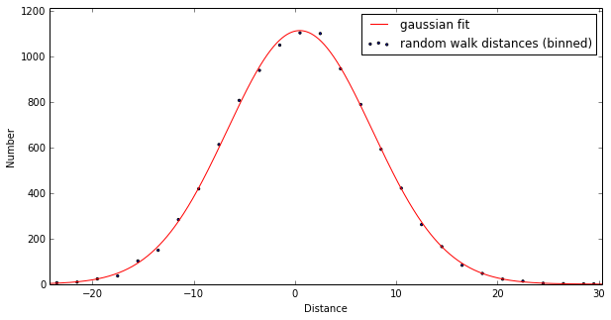 Fig 2: Shows a 50 step random walk with Gaussian fit which is used to determine sigma (or delta x as described in the instructions)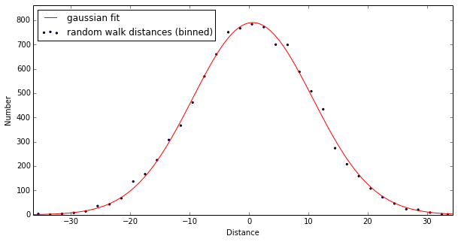 Fig 3: Shows a 100 step random walk with Gaussian fit which is used to determine sigma

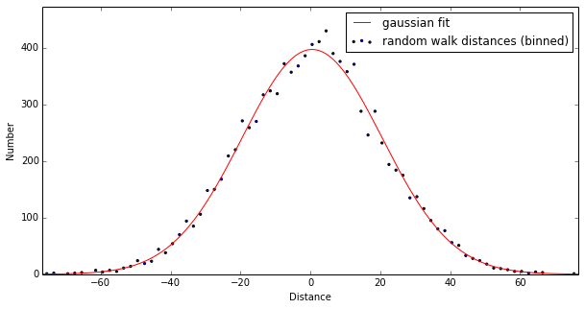 Fig 4: Shows a 400 step random walk with Gaussian fit which is used to determine sigma 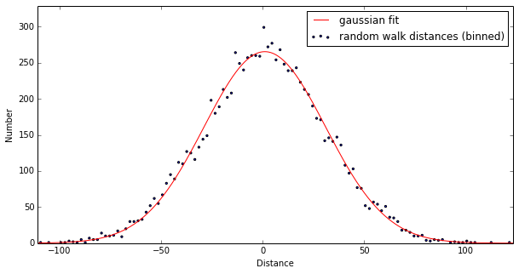 Fig 5: Shows a 400 step random walk with Gaussian fit which is used to determine sigma

|  |  |  |  |  |
| --- | --- | --- | --- | --- |
| ***N*** | **50** | **100** | **400** | **900** |
| **Sigma** | 7.3451819664 | 10.006042799 | 19.890772368 | 29.626867242 |
|  | 7.0943312466 | 10.168577284 | 19.740902531 | 0.2245141243 |
|  | 7.1144867568 | 9.9313577860 | 20.007321181 | 30.612700863 |
|  | 7.1452800267 | 10.332541287 | 19.028850125 | 29.663812144 |
| **Average(Sigma)** | 7.179040 | 10.378473 | 19.887886 | 30.862898 |

Q7:

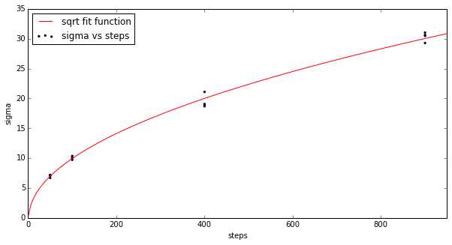

Fig 6: sqrt fit function is of the form, $f\left(N\right)=a\sqrt{N}$, where *a =* 1.0173627826.

Q8:

$$Δx∝\sqrt{t}$$