Ryan Morshead

8.26.A)

T=2.5 : average size of clumps is approx. 50 blocks

T=3.0 : average size of clumps is approx. 30 blocks

T=4.0 : average size of clumps is approx. 15 blocks

T=5.0 : average size of clumps is approx. 10 blocks

T=10 : average size of clumps is approx. 10 blocks

8.26.B)

T=2.5 : average size of clumps is approx. 100 blocks

T=3.0 : average size of clumps is approx. 50 blocks

T=4.0 : average size of clumps is approx. 40 blocks

T=5.0 : average size of clumps is approx. 20 blocks

T=10 : average size of clumps is approx. 10 blocks

8.26.C)

T=1.0: average magnetization is approx. 1.0

T=1.5: average magnetization is approx. 0.5

T=2.0: average magnetization is approx. 0.0

8.26.D)

Since this seems to be fairly close to Tc we would expect that the system would reach a point where the average clump size remains about the same and evenly divided between both up and down magnetizations. This is in fact what was observed.

8.26.E)

The cluster sizes continue to increase. However their size in relation to the lattice remains about the same. This demonstrates the fact mentioned in class; that given a lattice of infinite size you could potentially have an infinitely sized clump.

8.27)

As temperature increases the average energy begins to increase as temperature fluctuations increase the amount of disorder in the lattice. The point at which the energy increases fastest occurs around 2.7 which is to be expected considering the fact that this is a relatively small lattice.

5x5

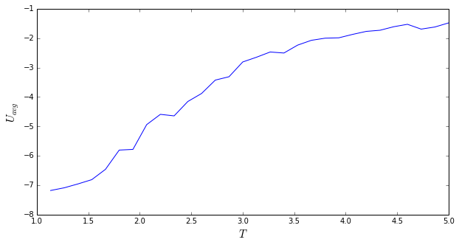

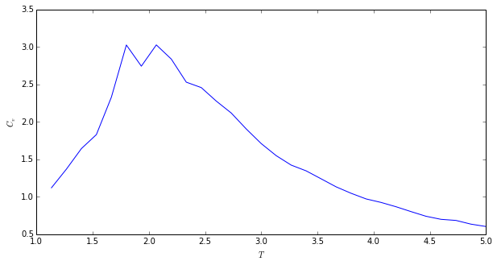

**T=4**

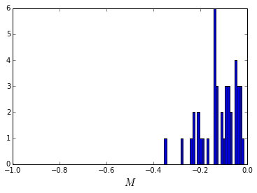

**T=3.5**

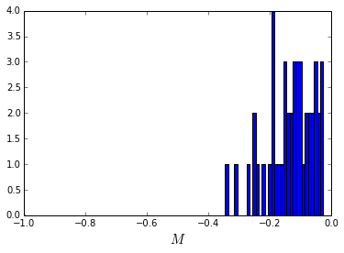

**T=3.0**

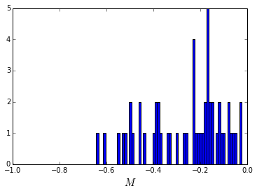

**T=2.5**

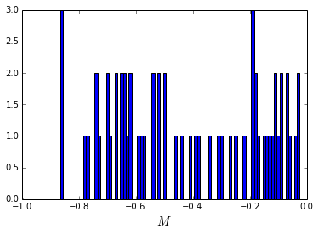

**T=2.0**

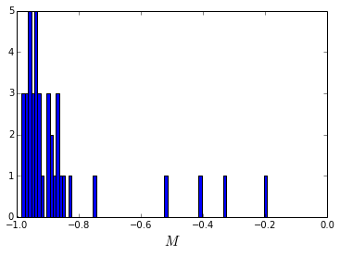

10x10

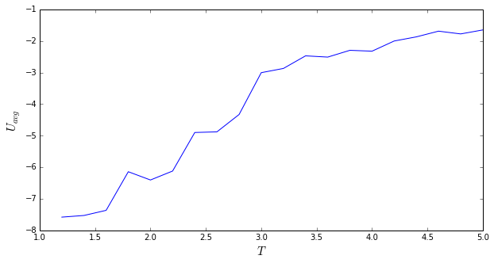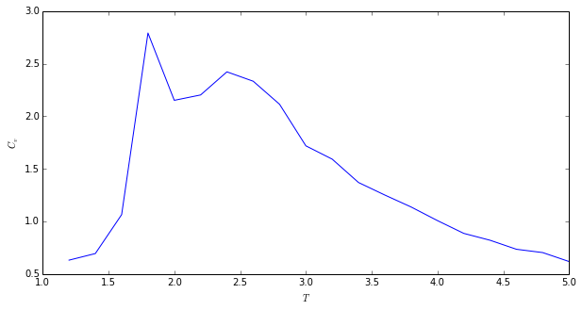

Unfortunately I couldn’t run it for long enough to get the trend showing the development towards an asymptote as Tc for the Cv vs T graph (only calculated 20 points).

20x20

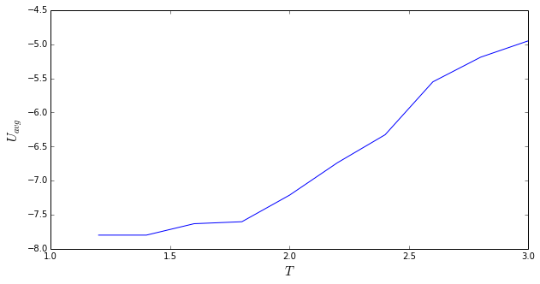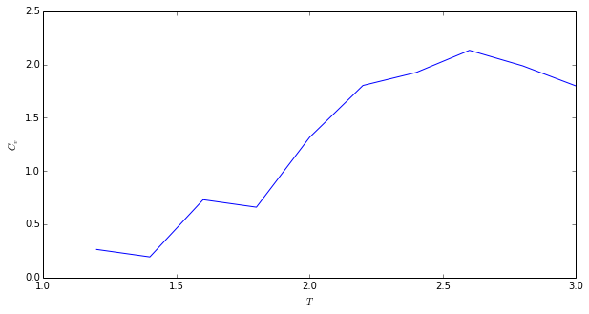

Unfortunately I couldn’t run it for long enough to get the trend showing the development towards an asymptote as Tc for the Cv vs T graph (only calculated 10 points).