截图包括代码和答案

%%%%%%%%%%%%%%%%%%%%%%%%%%%%%%%%%%%%%%%%%%%%%%%%%%%%%%%

1 波士顿房价回归 采用线性回归拟合数据并画出对训练数据的拟合图，建议使用linear_model.LinearRegression()

答：

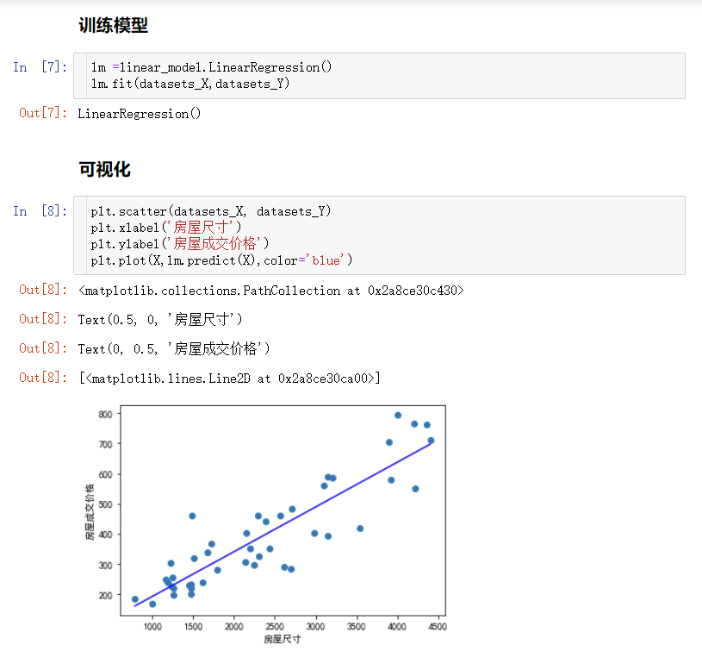

%%%%%%%%%%%%%%%%%%%%%%%%%%%%%%%%%%%%%%%%%%%%%%%%%%%%%%%

2 波士顿房价回归 采用多项式回归拟合数据并画出对测试数据的拟合图，建议使用=PolynomialFeatures(degree=2)

答

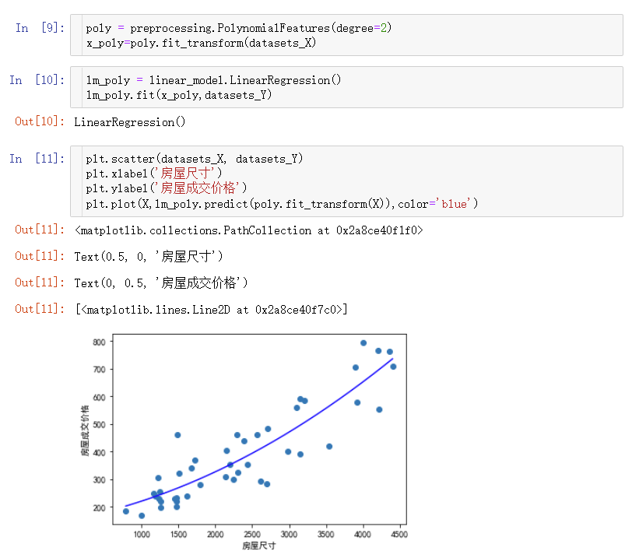

%%%%%%%%%%%%%%%%%%%%%%%%%%%%%%%%%%%%%%%%%%%%%%%%%%%%%%%

3 波士顿房价回归 采用岭回归拟合数据并画出对测试数据的拟合图。

答

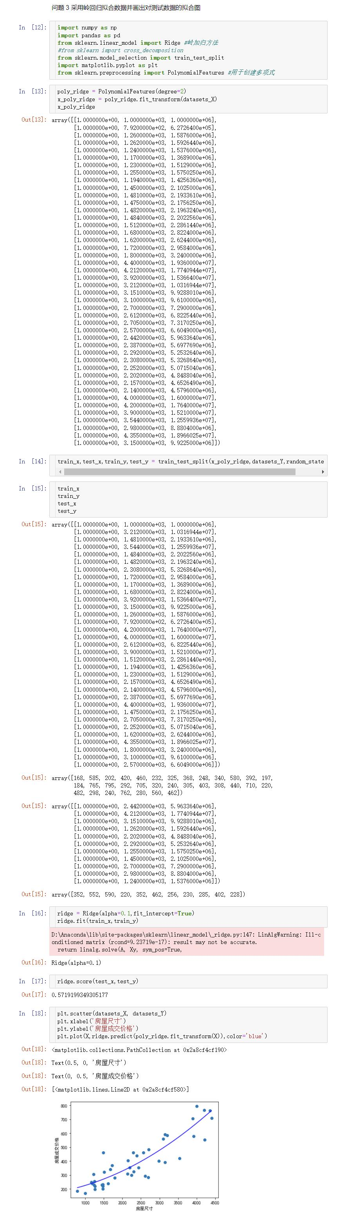

%%%%%%%%%%%%%%%%%%%%%%%%%%%%%%%%%%%%%%%%%%%%%%%%%%%%%%%

4 红酒质量数据回归探索 训练数据和测试数据上的平均绝对误差 MSE 值是多少？

答

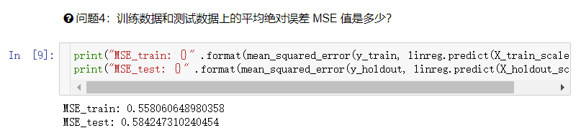

%%%%%%%%%%%%%%%%%%%%%%%%%%%%%%%%%%%%%%%%%%%%%%%%%%%%%%%

5 红酒质量数据回归探索 该线性回归模型中，哪些特征对目标值的影响更大？

答

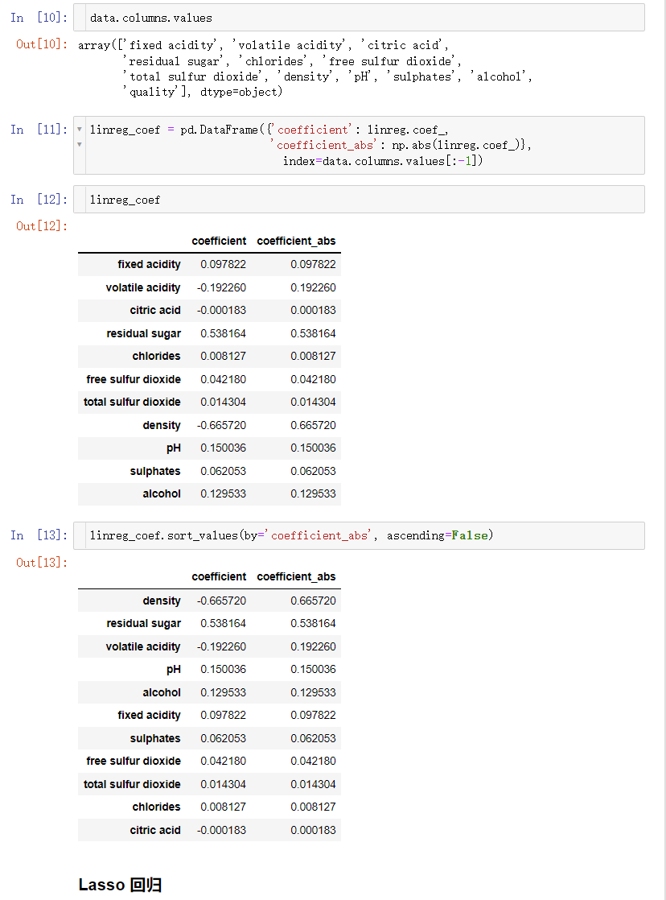

%%%%%%%%%%%%%%%%%%%%%%%%%%%%%%%%%%%%%%%%%%%%%%%%%%%%%%%

6 红酒质量数据回归探索 该 Lasso 回归模型中，哪些特征对目标值的影响最小？

答

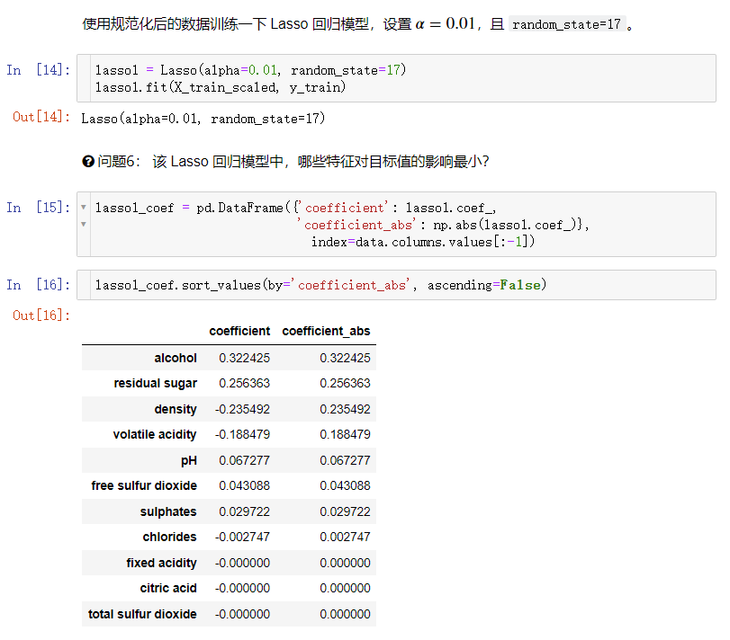

%%%%%%%%%%%%%%%%%%%%%%%%%%%%%%%%%%%%%%%%%%%%%%%%%%%%%%%

7 红酒质量数据回归探索 上面调参得到的 Lasso 回归模型中，哪些特征对目标值的影响最小？。

答

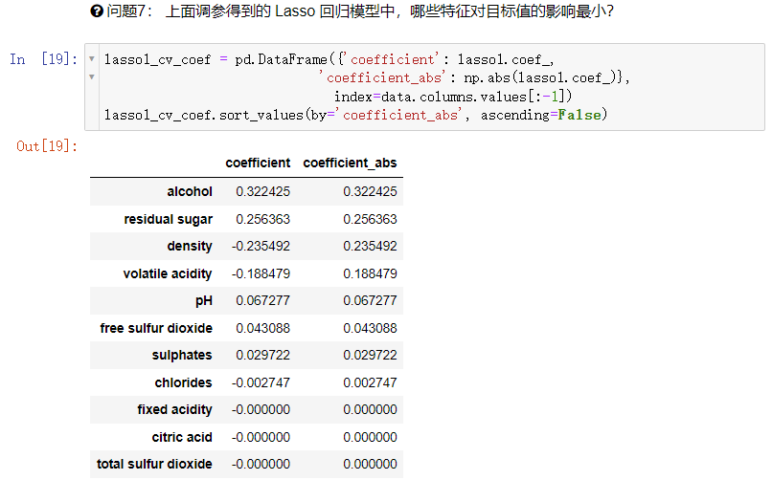

%%%%%%%%%%%%%%%%%%%%%%%%%%%%%%%%%%%%%%%%%%%%%%%%%%%%%%%

8 红酒质量数据回归探索 调参得到的 Lasso 回归模型中，训练数据和测试数据上的平均绝对误差 MSE 值是多少？

答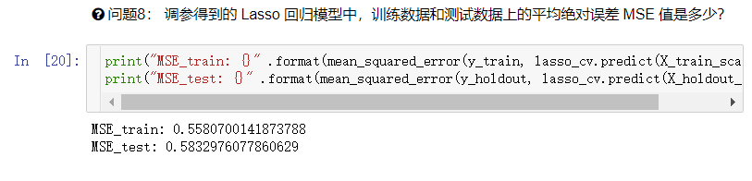

%%%%%%%%%%%%%%%%%%%%%%%%%%%%%%%%%%%%%%%%%%%%%%%%%%%%%%%

9 书3.5 使用带正则项的逻辑回归来完成对瓜的分类，并优化正则化参数。？

答

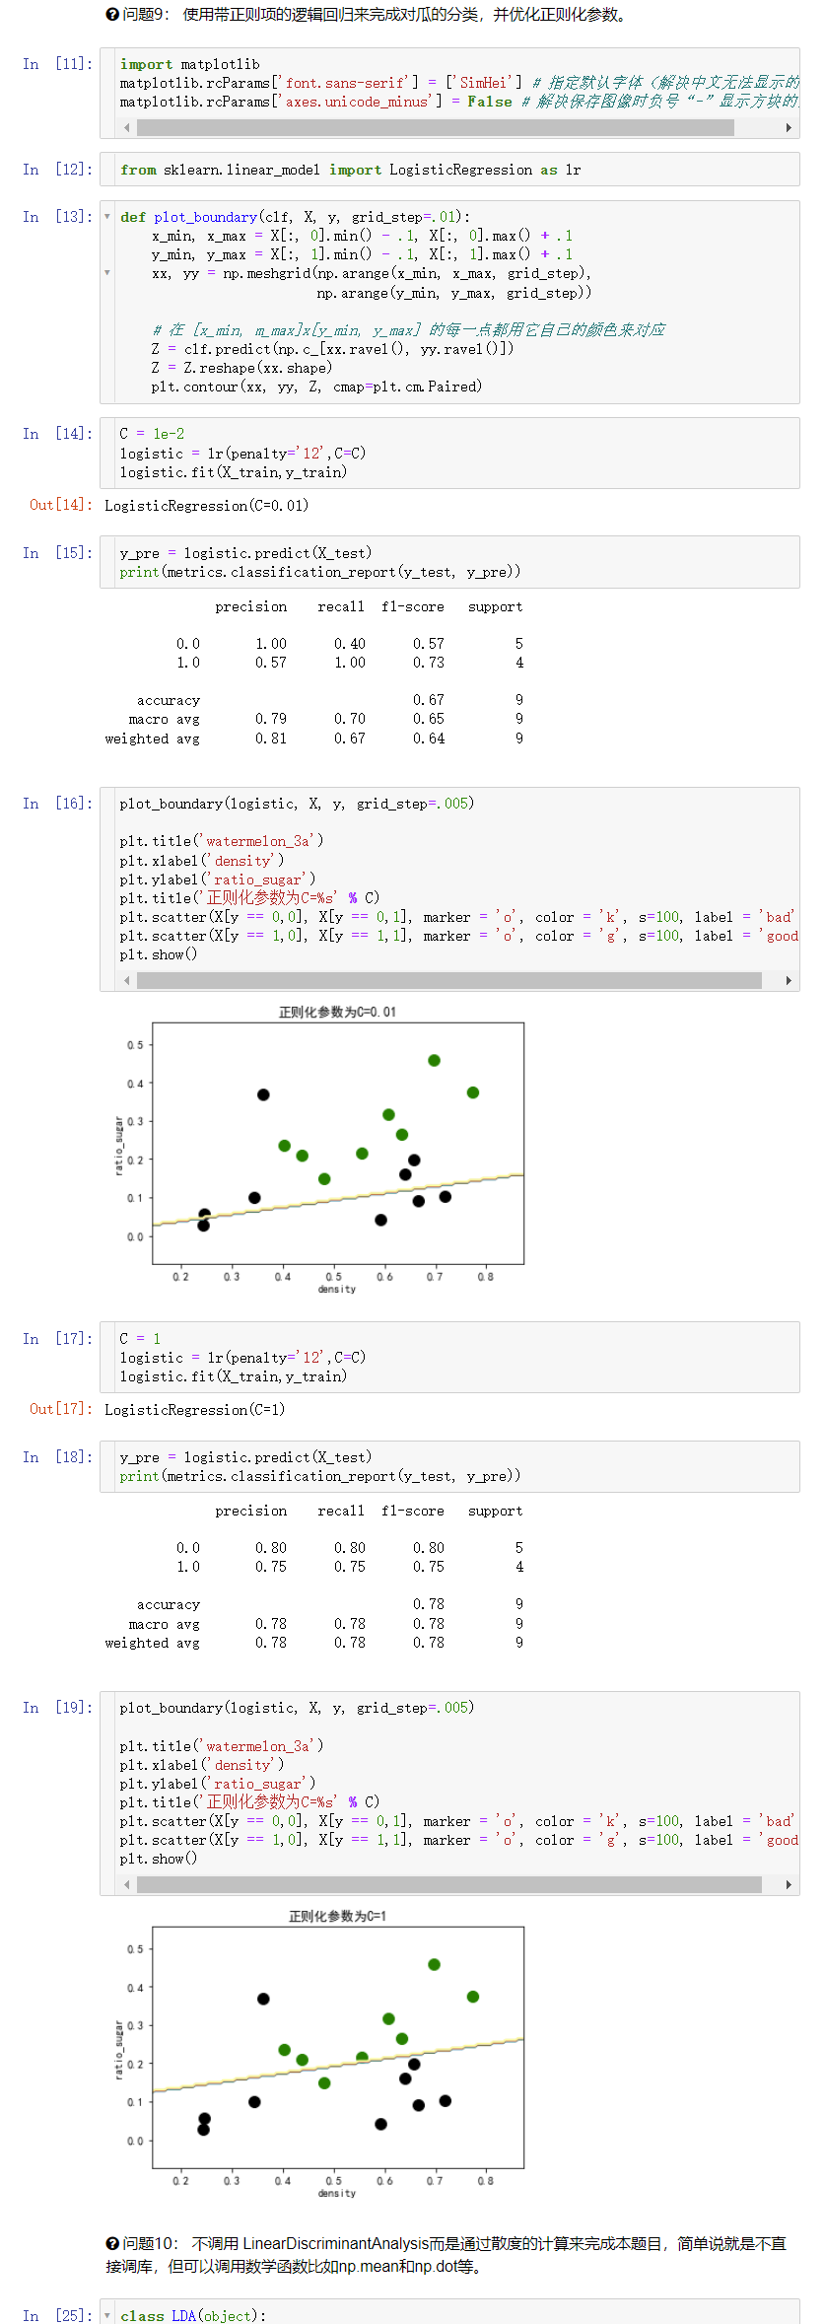

%%%%%%%%%%%%%%%%%%%%%%%%%%%%%%%%%%%%%%%%%%%%%%%%%%%%%%%

10 书3.5 不调用 LinearDiscriminantAnalysis而是通过散度的计算来完成本题目，简单说就是不直接调库，但可以调用数学函数比如np.mean和np.dot等

答

