%%%%%%%%%%%%%%%%%%%%%%%%%%%%%%%%%%%%%%%%%%%%%%%%%%%%%%%

第1题

5.3 对于图5.7中的，试推导出BP算法中的更新公式（5.13）

%%%%%%%%%%%%%%%%%%%%%%%%%%%%%%%%%%%%%%%%%%%%%%%%%%%%%%%

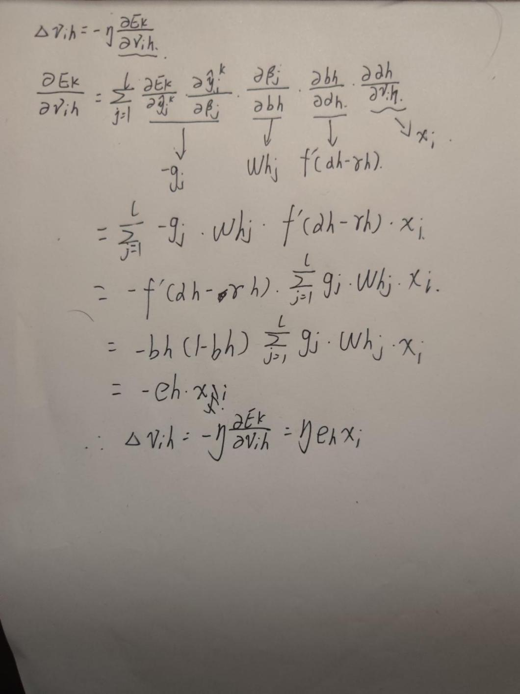

%%%%%%%%%%%%%%%%%%%%%%%%%%%%%%%%%%%%%%%%%%%%%%%%%%%%%%%

第2题自己编程实现一个神经网络中的sigmoid类替代class Tanh(Layer):并完成调用

%%%%%%%%%%%%%%%%%%%%%%%%%%%%%%%%%%%%%%%%%%%%%%%%%%%%%%%

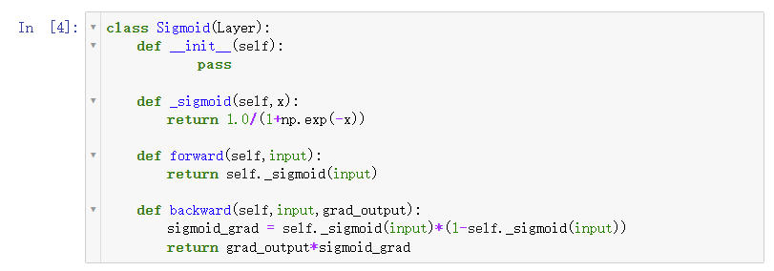

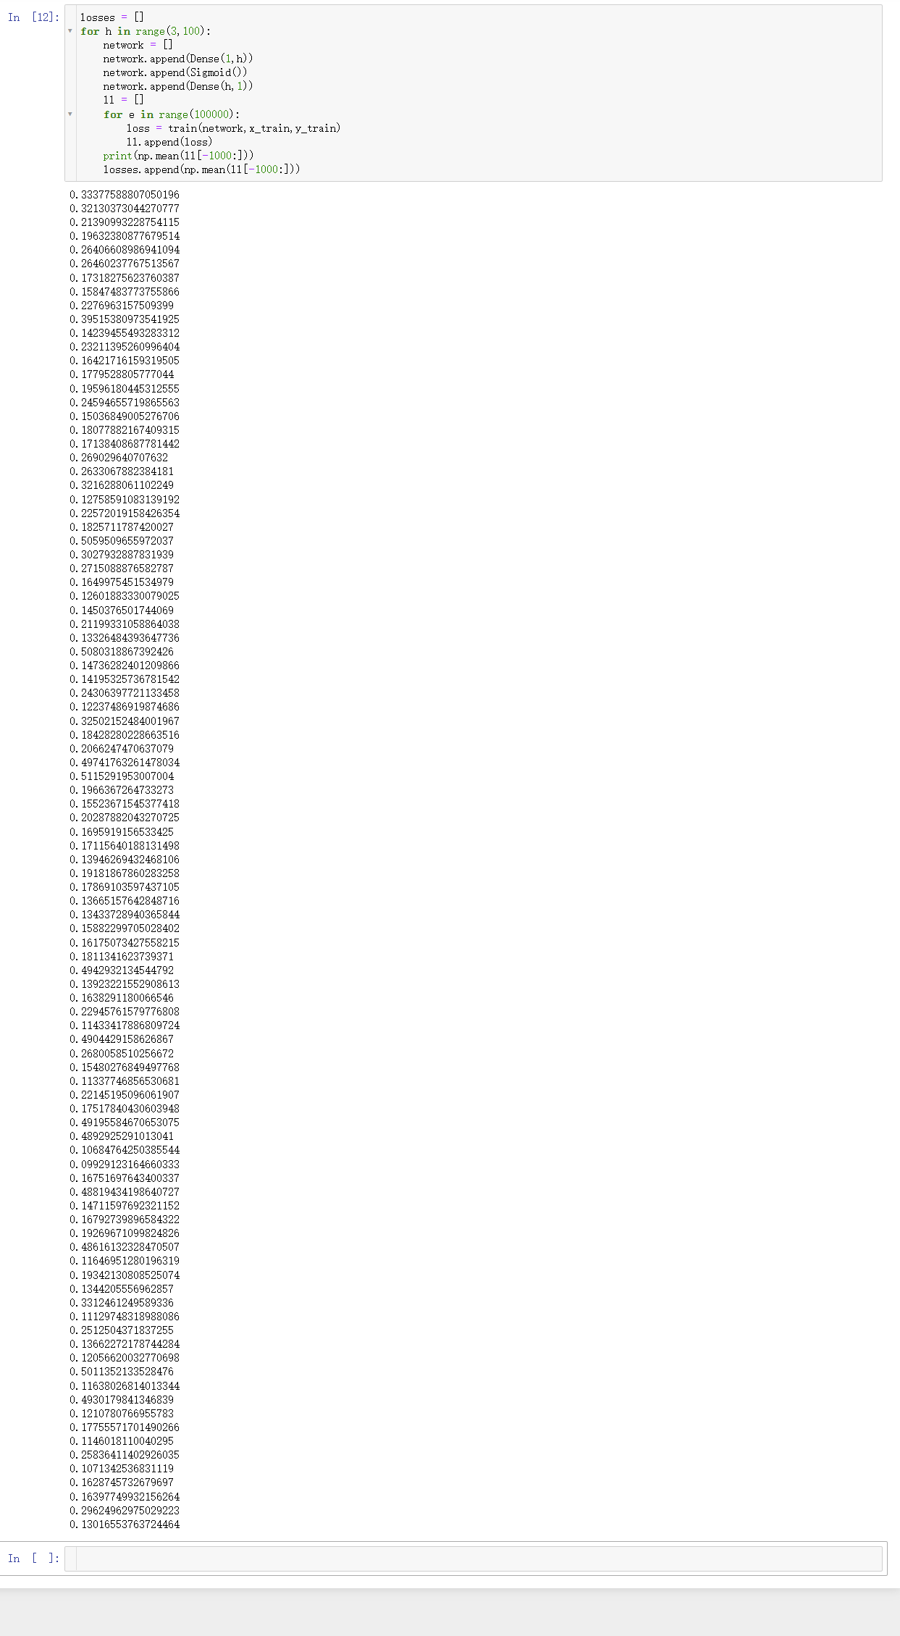

%%%%%%%%%%%%%%%%%%%%%%%%%%%%%%%%%%%%%%%%%%%%%%%%%%%%%%%

第3题

5.10 从网上下载或自己编程实现一个卷积神经网络，并在手写字符识别数据MNIST上进行实验测试。

%%%%%%%%%%%%%%%%%%%%%%%%%%%%%%%%%%%%%%%%%%%%%%%%%%%%%%%

