%%%%%%%%%%%%%%%%%%%%%%%%%%%%%%%%%%%%%%%%%%%%%%%%%%%%%%%

第1题

在西瓜数据集3.0α上分别用线性核和高斯核训练一个SVM，并比较其支持向量的差别

%%%%%%%%%%%%%%%%%%%%%%%%%%%%%%%%%%%%%%%%%%%%%%%%%%%%%%%

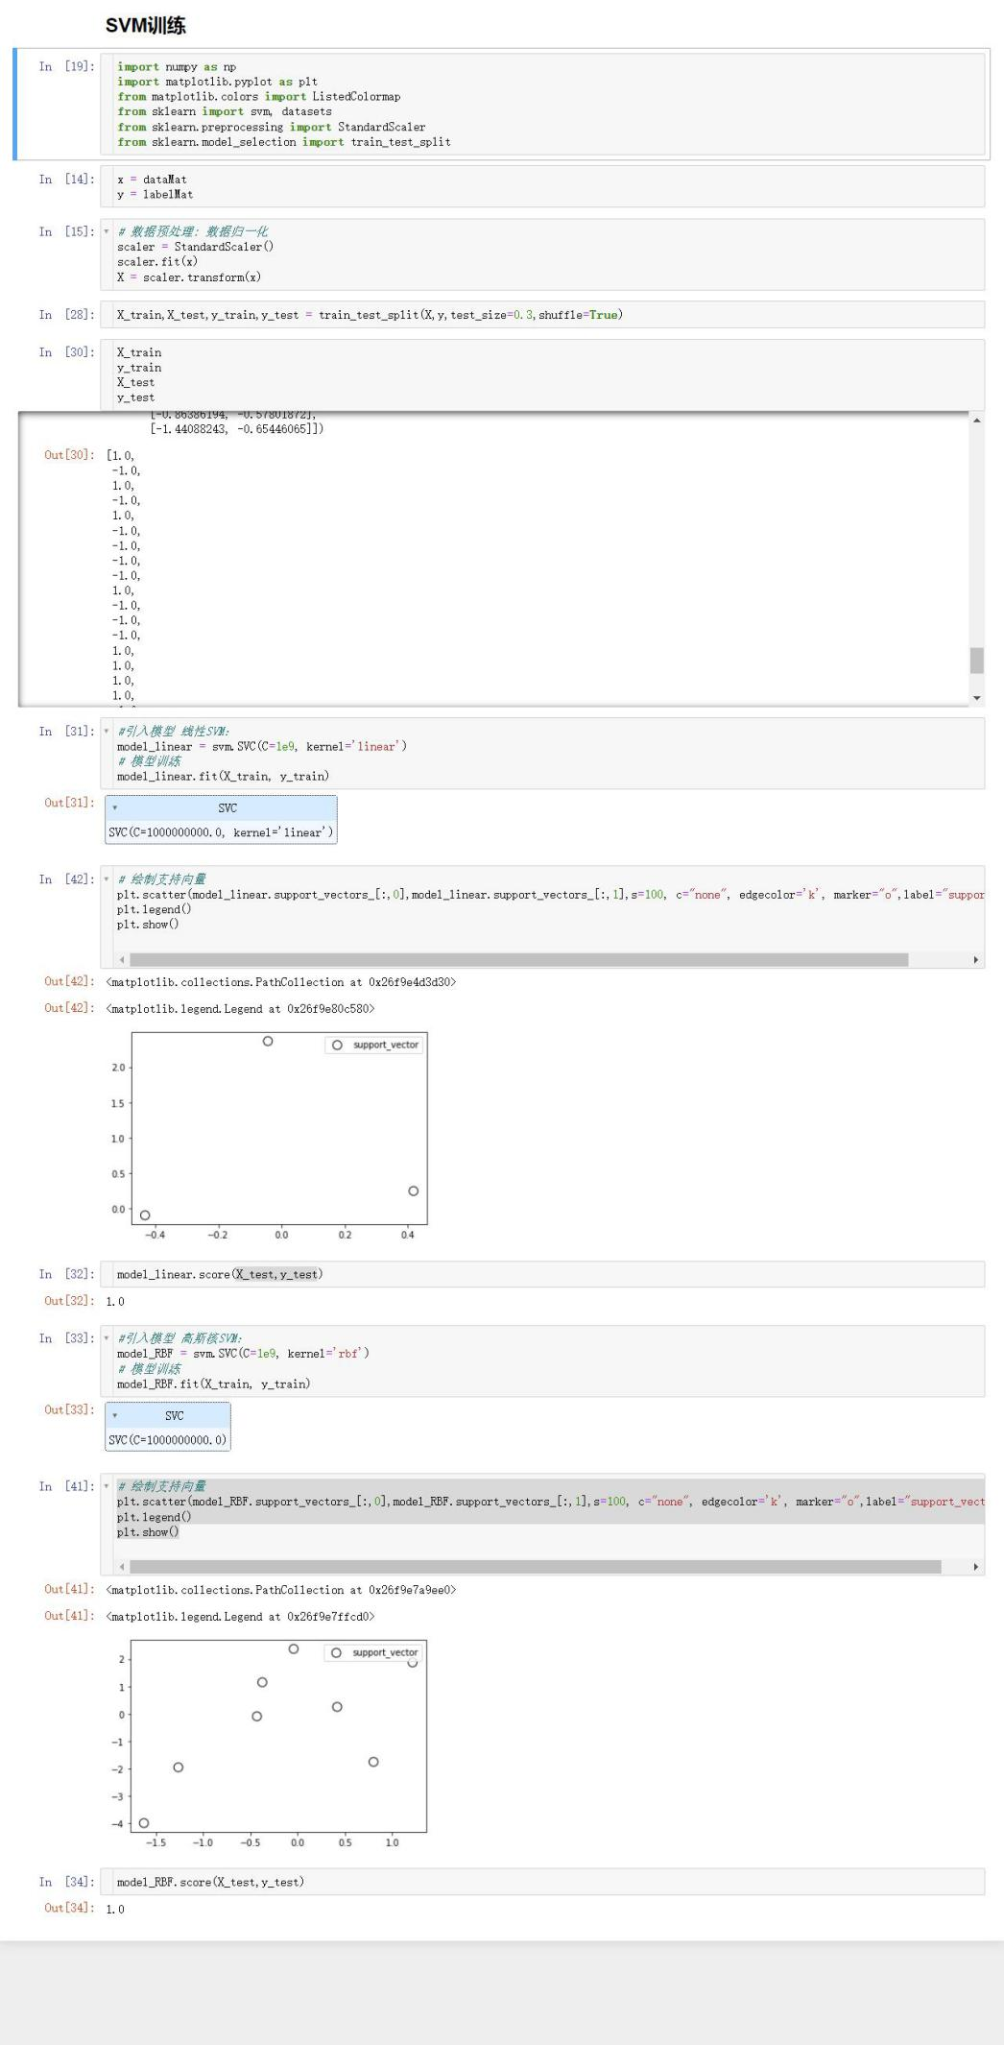

%%%%%%%%%%%%%%%%%%%%%%%%%%%%%%%%%%%%%%%%%%%%%%%%%%%%%%%

第2题 线性判别分析和线性核支持向量机在何种条件下等价。

%%%%%%%%%%%%%%%%%%%%%%%%%%%%%%%%%%%%%%%%%%%%%%%%%%%%%%%

满足以下两个条件：

1. 线性可分
2. 所有的样本都是支持向量。

%%%%%%%%%%%%%%%%%%%%%%%%%%%%%%%%%%%%%%%%%%%%%%%%%%%%%%%

第3题

以西瓜数据集3.0α的“密度”为输入，“含糖率”为输出，试训练一个SVR。

%%%%%%%%%%%%%%%%%%%%%%%%%%%%%%%%%%%%%%%%%%%%%%%%%%%%%%%

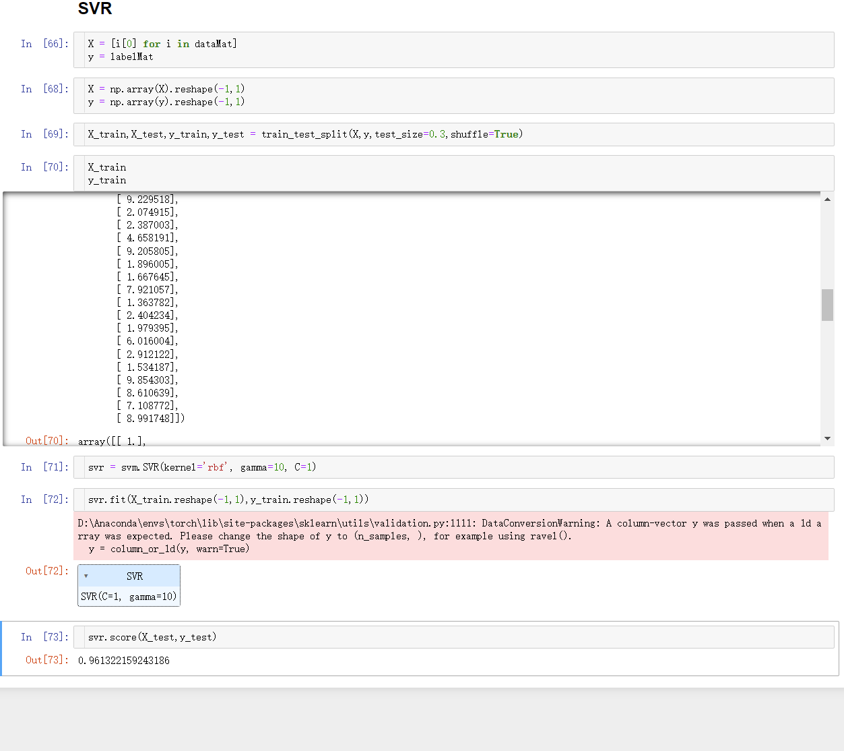

%%%%%%%%%%%%%%%%%%%%%%%%%%%%%%%%%%%%%%%%%%%%%%%%%%%%%%%

第4题

完成基于svm的手写数字识别。

%%%%%%%%%%%%%%%%%%%%%%%%%%%%%%%%%%%%%%%%%%%%%%%%%%%%%%%

