%%%%%%%%%%%%%%%%%%%%%%%%%%%%%%%%%%%%%%%%%%%%%%%%%%%%%%%

第1题

请写出贝叶斯公式，请描述朴素贝叶斯分类方法的原理和步骤。

%%%%%%%%%%%%%%%%%%%%%%%%%%%%%%%%%%%%%%%%%%%%%%%%%%%%%%%

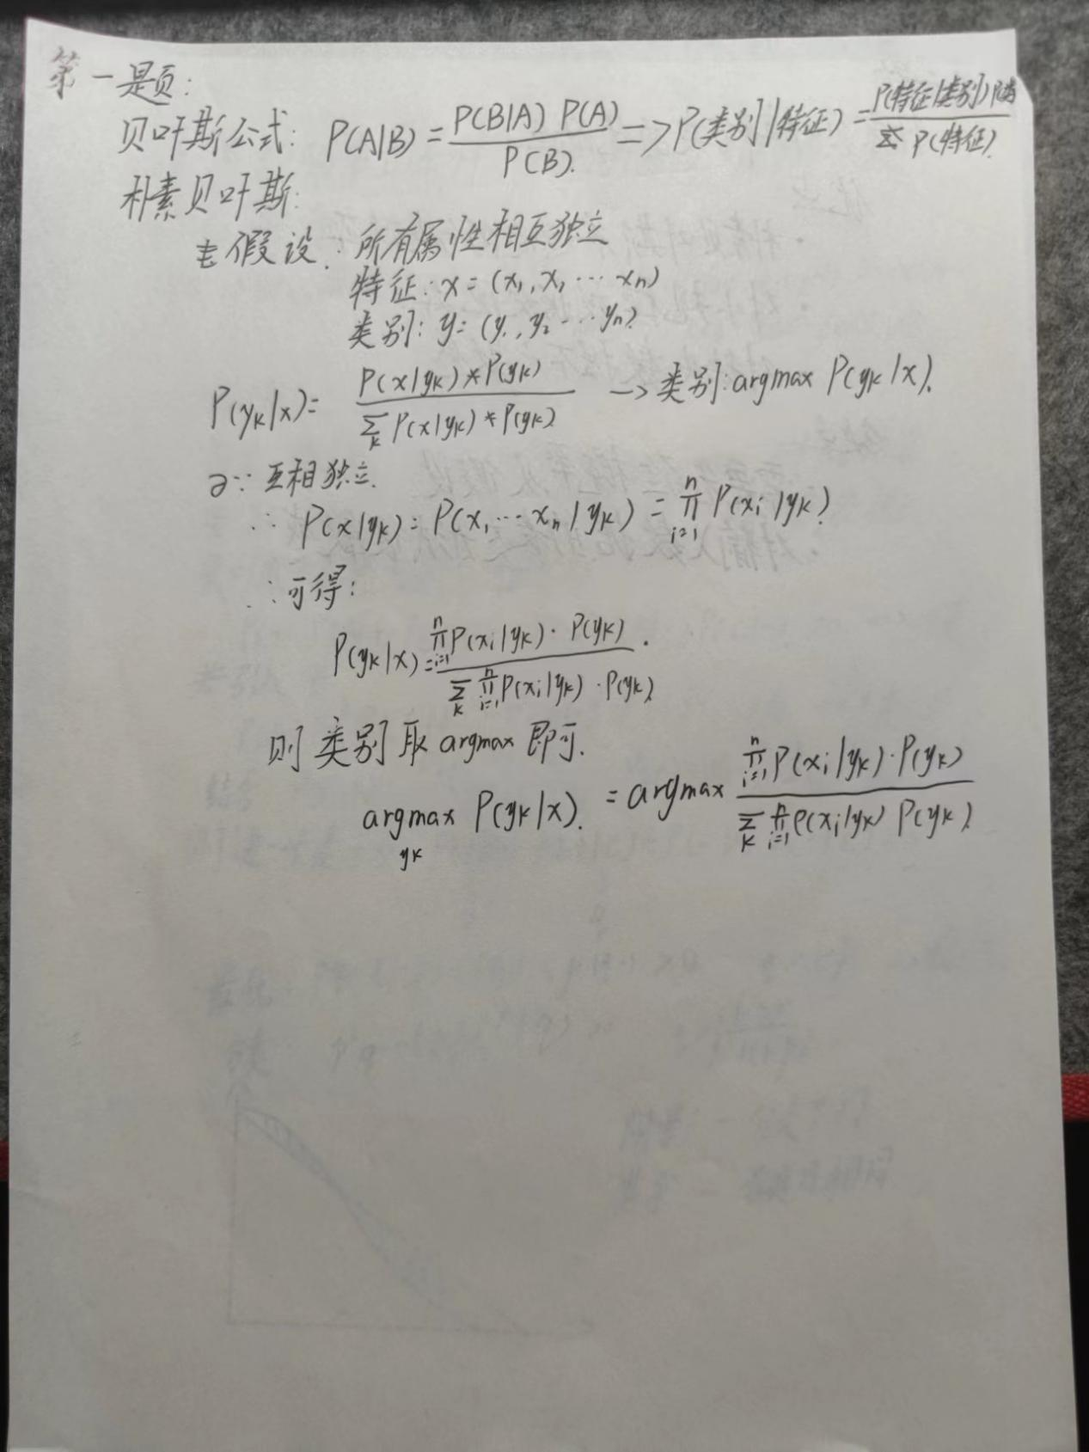

%%%%%%%%%%%%%%%%%%%%%%%%%%%%%%%%%%%%%%%%%%%%%%%%%%%%%%%

第2题 试分析朴素贝叶斯分类的优缺点。。

%%%%%%%%%%%%%%%%%%%%%%%%%%%%%%%%%%%%%%%%%%%%%%%%%%%%%%%

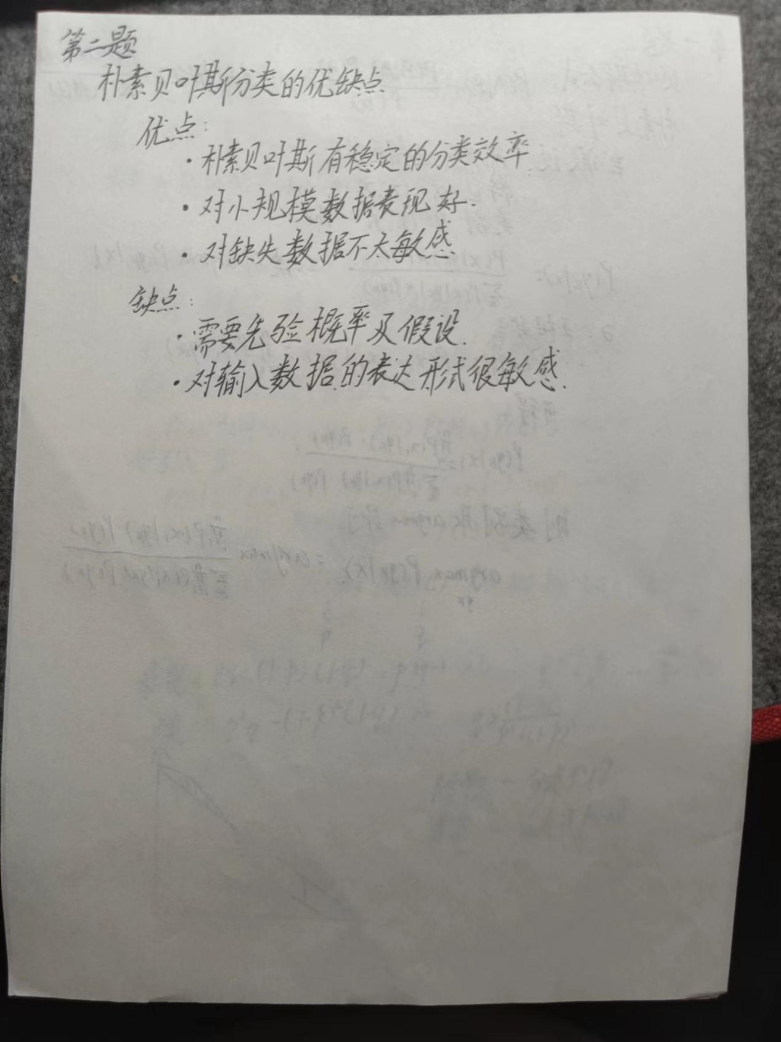

%%%%%%%%%%%%%%%%%%%%%%%%%%%%%%%%%%%%%%%%%%%%%%%%%%%%%%%

第3题

试证明:条件独立性假设不成立时，朴素贝叶斯分类器仍有可能产生最优贝叶斯分类器.。

%%%%%%%%%%%%%%%%%%%%%%%%%%%%%%%%%%%%%%%%%%%%%%%%%%%%%%%

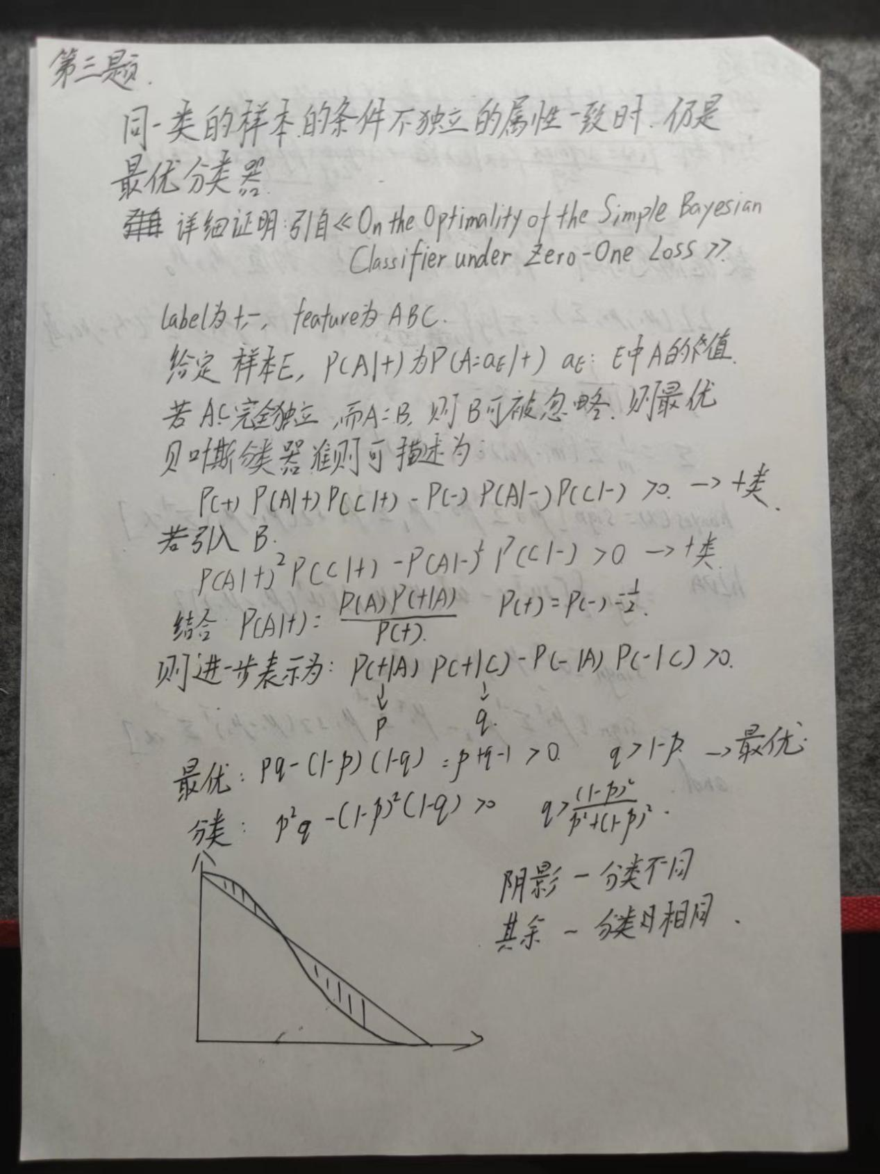

%%%%%%%%%%%%%%%%%%%%%%%%%%%%%%%%%%%%%%%%%%%%%%%%%%%%%%%

第4题

试证明:二分类任务中两类数据满足高斯分布且方差相同时，线性判别分析产生贝叶斯最优分类器。

%%%%%%%%%%%%%%%%%%%%%%%%%%%%%%%%%%%%%%%%%%%%%%%%%%%%%%%

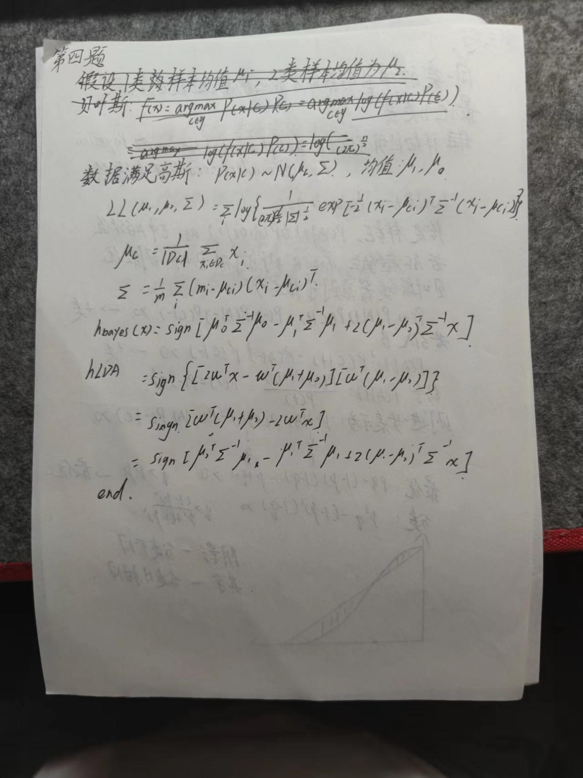

%%%%%%%%%%%%%%%%%%%%%%%%%%%%%%%%%%%%%%%%%%%%%%%%%%%%%%%

第5题

用调库的方式完成处理糖尿病数据集pima-indians-diabetes.data.csv。

%%%%%%%%%%%%%%%%%%%%%%%%%%%%%%%%%%%%%%%%%%%%%%%%%%%%%%%

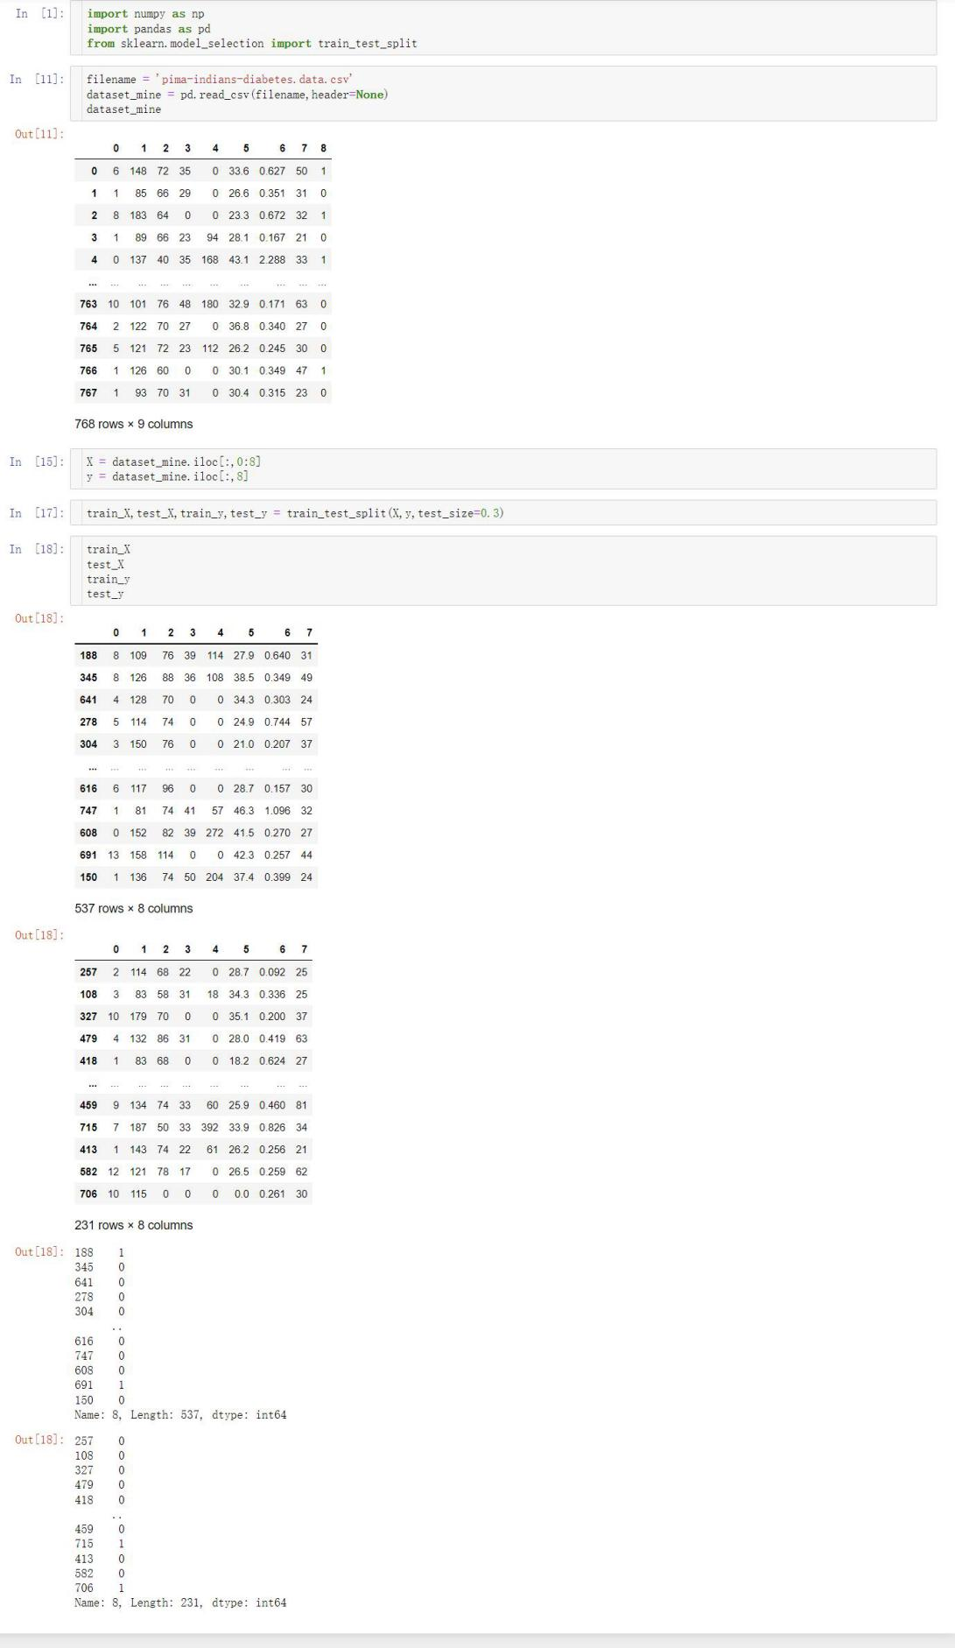

%%%%%%%%%%%%%%%%%%%%%%%%%%%%%%%%%%%%%%%%%%%%%%%%%%%%%%%

第6题

用自己写函数非调库的方式处理iris数据集。

datas = load_iris()

# print(datas)

iris_x = datas.data

iris_y = datas.target

%%%%%%%%%%%%%%%%%%%%%%%%%%%%%%%%%%%%%%%%%%%%%%%%%%%%%%%

