Bihar

Best time to visit : march to octomber

Gaya

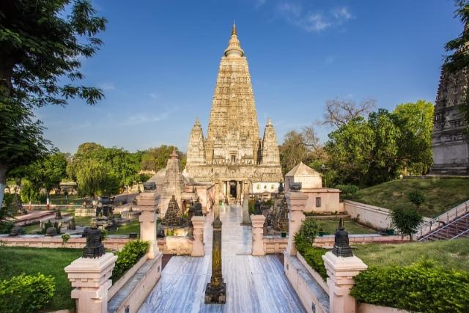

Bihar has several prominent cities in the state. The most famous of these cities must surely be [Gaya](https://www.tripcrafters.com/travel/gaya-tourism-and-travel-guide). Gaya is an important hub for pilgrims who are headed for [Bodhgaya](https://www.tripcrafters.com/travel/bodhgaya-tourism-and-travel-guide) which is of great significance for Buddhists all over the world. It is in Bodhgaya that Buddha is said to have obtained his Mahaparinirvana or eternal enlightenment. Gaya on the bank of River Phalgu has several temples as well as other sites of historic significance that date back to the different eras such as those of the Maurya and Gupta dynasties.

The Mahabodhi Temple Complex is among the four holy sites that are related to the life of Buddha. While the first temple was built in 3rd Century BC by Ashoka, the present temple dates back to the 5th or the 6th centuries. This is one of the earliest Buddhist temples to have been built totally of bricks and still standing in our country.

Nalanda

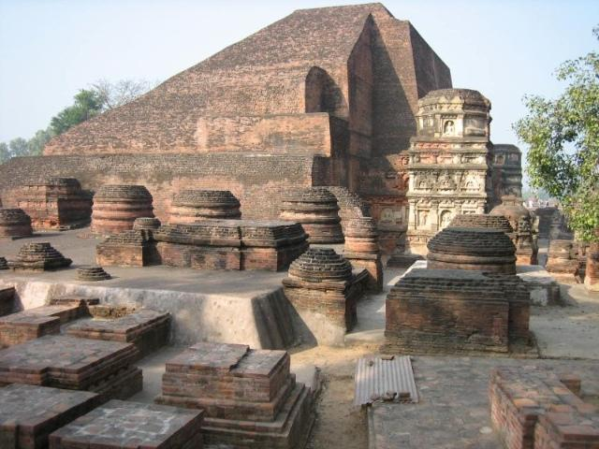

When in Bihar one must visit [India](https://www.tripcrafters.com/travel/india-tourism-and-travel-guide)’s oldest university, [Nalanda](https://www.tripcrafters.com/travel/nalanda-tourism-and-travel-guide). Nalanda will take you back to the great period of India, that of the Guptas and Palas. An acclaimed tourist attraction in Bihar and in India too, Nalanda is where Mahavira, the most famous Jain Tirthankara, spent fourteen monsoons. Buddha too, according to beliefs, is said to have delivered his lectures at the mango grove in Nalanda. It is said that Hiuen Tsang, the well-known traveller from China, visited Nalanda and stayed here for 2 years. The ruins of Nalanda are definitely worth visiting.

Vaishali

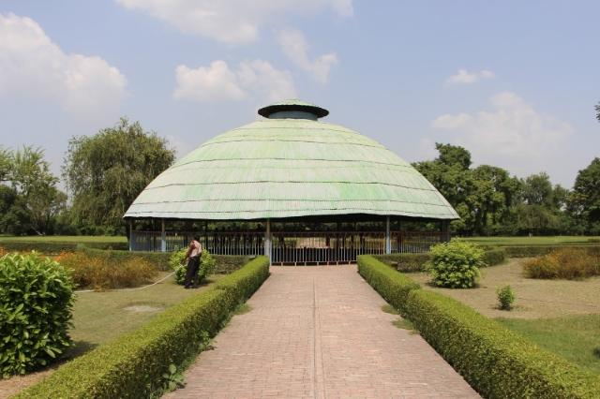

[Vaishali](https://www.tripcrafters.com/travel/vaishali-tourism-and-travel-guide), once known to have been the capital city of the Licchavi rulers, is today an important site in terms of archaeology and history. It is in Vaishali that Lord Mahavira was born and brought up in the 6th century BC. Vaishali is also the place where Buddha delivered his last sermon in 483 BC. A prosperous kingdom in the times of Buddha, Vaishali is also well-known for its most beautiful courtesan, Amrapali. There is an Ashokan Pillar here too that is preserved well. This ancient city has been mentioned in the travelogues of the famous Chinese travellers Fa Hian and Hiuen Tsang.

Patna

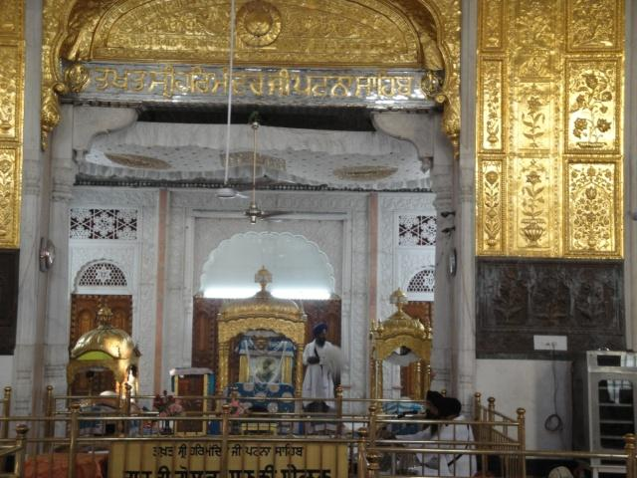

[Patna](https://www.tripcrafters.com/travel/patna-tourism-and-travel-guide) is the capital of modern Bihar but it was as Pataliputra that this city was known in ancient [India](https://www.tripcrafters.com/travel/india-tourism-and-travel-guide). It is also one of the oldest cities to have been continuously inhabited in the world. Patna is famous for being the place of birth of Guru Govind Singh, the last guru of the Sikhs and Takht Sri Patna Sahib is one of the places one must visit while in Patna. Didarganj Yakshi is among the major tourist attractions here.

Rajnagar

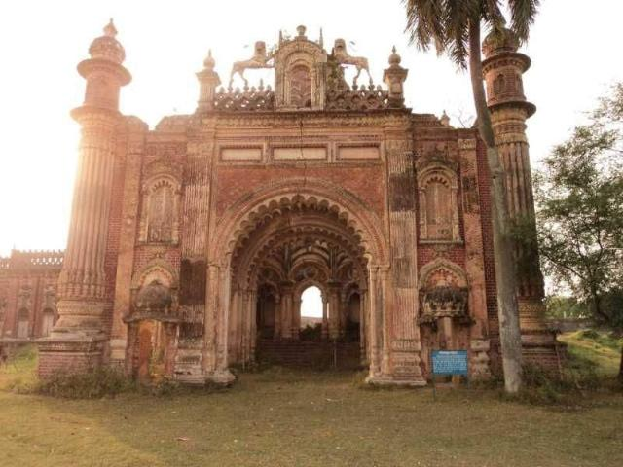

Near [Madhubani](https://www.tripcrafters.com/travel/madhubani-tourism-and-travel-guide" \t "_blank) in Bihar is Rajnagar, a very small town well known for the ruins of Rajnagar Palace, among the various palaces of the Maharaja of Darbhanga. Unfortunately, this palace was destroyed in the [Nepal](https://www.tripcrafters.com/travel/nepal-tourism-and-travel-guide) Bihar earthquake that occurred in 1934. It was during the time of Maharaja Rameshwar Singh that this palace was built and sadly after the palace was destroyed no restoration work was undertaken. The palace therefore remains in the ruined condition it has been for some time. However, one can still marvel at the architectural standard of this palace even in the present condition.

Kundalpur

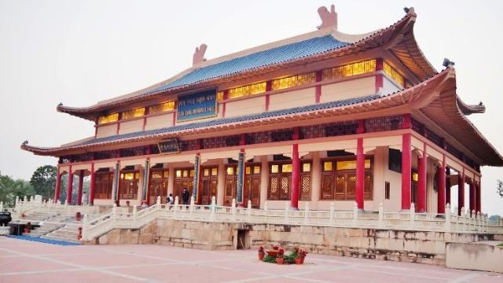

Kundalpur, a village in Bihar’s West Champaran district is the place where a memorial has been built for Hiuen Tsang, the intrepid traveller from China who visited [Nalanda](https://www.tripcrafters.com/travel/nalanda-tourism-and-travel-guide) in the 5th Century AD. Tsang was so impressed by Nalanda and its famous university that he had then decided to stay on for twelve long years for both learning and teaching. The memorial reflects the academic and artistic grandeur of Nalanda University.

Here one will find several writings of Tsang that are preserved in this memorial. The memorial is very informative as well as maintained well. It is a palatial structure that has a large sized courtyard with a beautiful doorway which has been crafted with great skill. A large statue of Tsang is housed at the centre of the courtyard. There is a meditation hall inside which is adorned with a vivid description of what all Tsang had done as well as his travels in [India](https://www.tripcrafters.com/travel/india-tourism-and-travel-guide).

Pawapuri

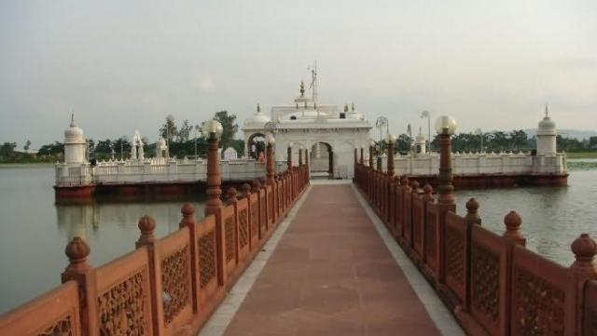

Jalmandir, in [Pawapuri](https://www.tripcrafters.com/travel/pawapuri-tourism-and-travel-guide" \t "_blank), Bihar, is an important pilgrimage for Jains which is highly revered since it is understood that this is the place where Lord Mahavira left the world in 500BC. Local folklore has it that Jalmandir was the spot for Mahavira’s cremation. It is said that the demand for his ash was so great that the soil around the pyre was scooped out and a pond resulted at that spot. You will find a temple in white marble there and this is a place of great significance for Jains all over the world.

Bhagalpur

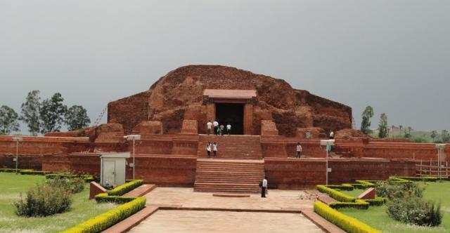

Vikramshila in [Bhagalpur](https://www.tripcrafters.com/travel/bhagalpur-tourism-and-travel-guide), Bihar, and [Nalanda](https://www.tripcrafters.com/travel/nalanda-tourism-and-travel-guide) are two of the important centres of learning for the Buddhists in ancient times. Established by the ruling king Dharampala, Vikramshila, it is understood, was built by the king who was unhappy with the poor quality of Nalanda and created Vikramshila as a replacement. Today Vikramshila, just like Nalanda, lies in ruins although it is now being renovated. During the restoration process excavation has revealed several Buddhist stupas and monasteries besides wall carvings at the site.

Rajgir

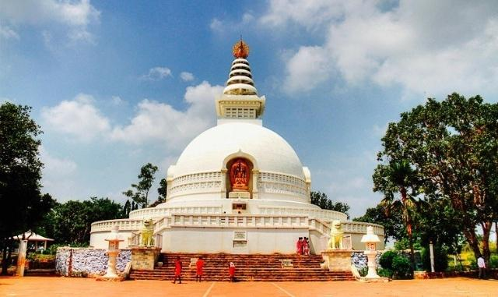

Visitors in Bihar must see the World Peace Pagoda known as Vishwa Shanti Stupa at [Rajgir](https://www.tripcrafters.com/travel/rajgir-tourism-and-travel-guide" \t "_blank), a historic city. This is one among the seven Peace Pagodas that have been built in the country and this one was built in 1969 for promoting the cause for peace and non-violence. The pagoda is marked by 4 statues of Lord Buddha which reflect the four significant phases in Buddha’s life. These are birth, enlightenment, teaching and finally death. The Peace Pagoda represents the finest form of Japanese architecture in [India](https://www.tripcrafters.com/travel/india-tourism-and-travel-guide).

Begusarai

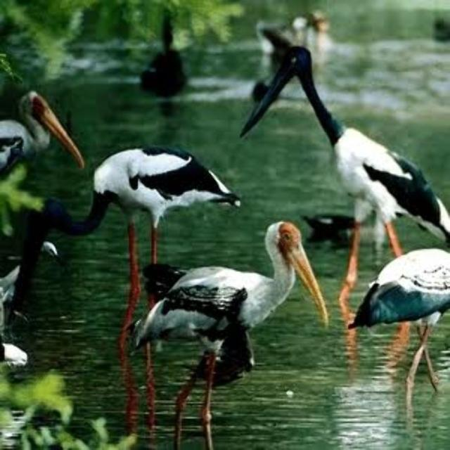

Located in Begusarai, Bihar, the Kanwar Lake is the country’s largest freshwater Oxbow Lake. The Kanwar Lake Bird Sanctuary is the haven for sixty species of migratory birds but unfortunately this sanctuary is perhaps not able to maintain the sanctuary as well as it should. Steps are now being taken to bring about the changes that are necessary to drastically improve the condition of the sanctuary that has so far been a fine home to both migratory and domestic birds.