Steps to follow to set up visual studio IDE

Step 1:

Search visual studio from official microsoft website . An ‘.exe’ file will be downloaded.

Now run the installed file , which will open visual sudio installer.



Step 2:

From visual studio installer select the ‘Desktop development c++’. And select the necessary installations for the IDE, select ‘install and download’ from bottom right corner, after selecting the necessary dependencies for the IDE press install.

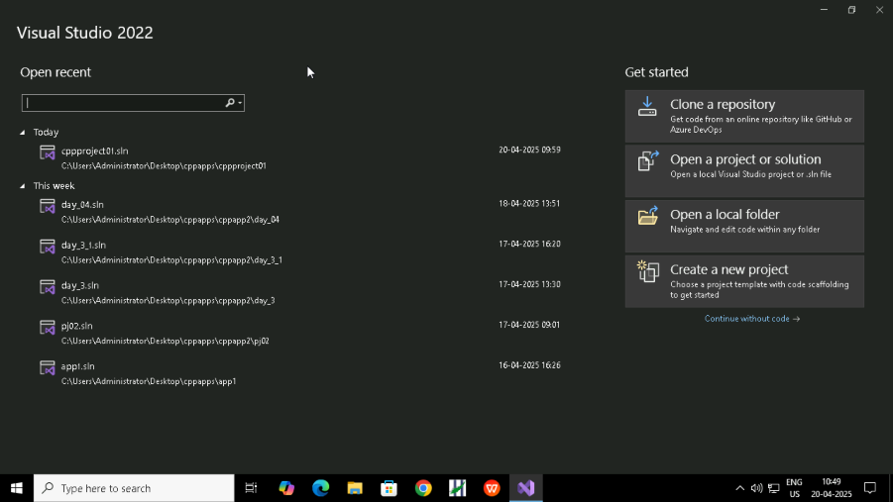

Step 3:

Open visual studio, will be shown multiple templates. Choose create new project for creating new folder. And choose the empty project to create new project.

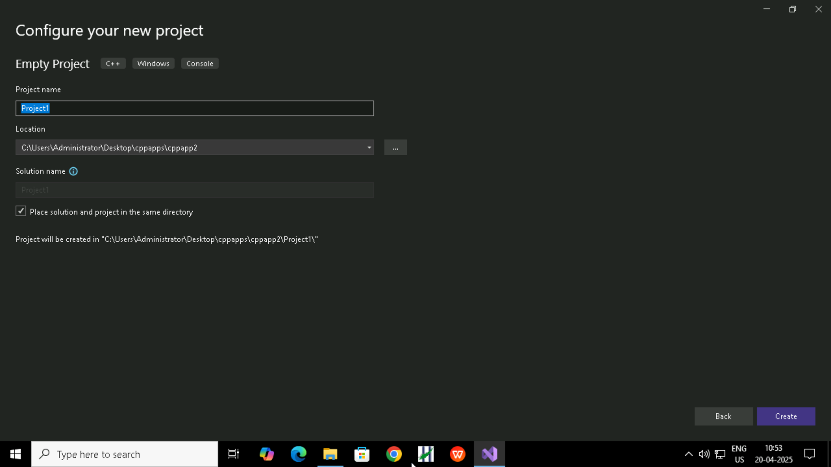

Step 4: Right click on the folder name and create a .cpp file.

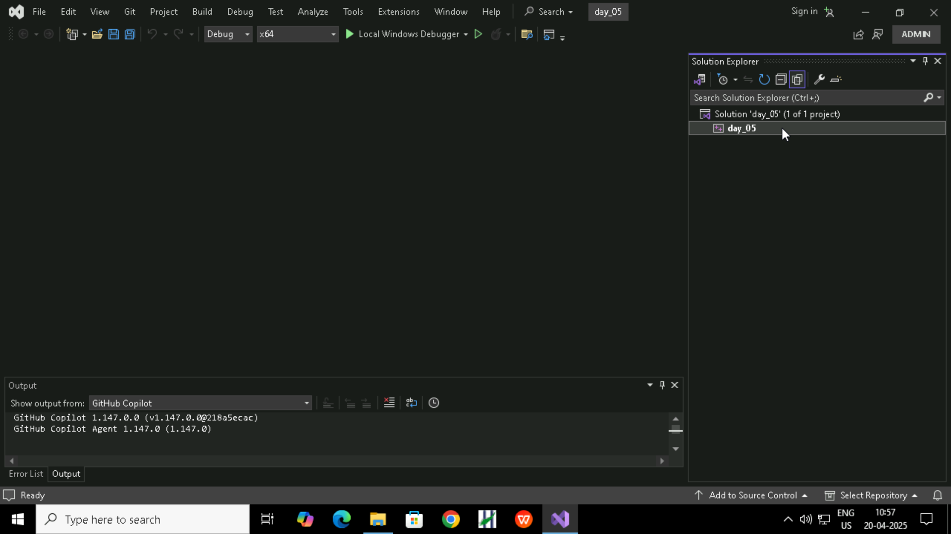

Step 5:

To create the bin directory to store the .exe file of the program select the settings symbol in solution explorer.

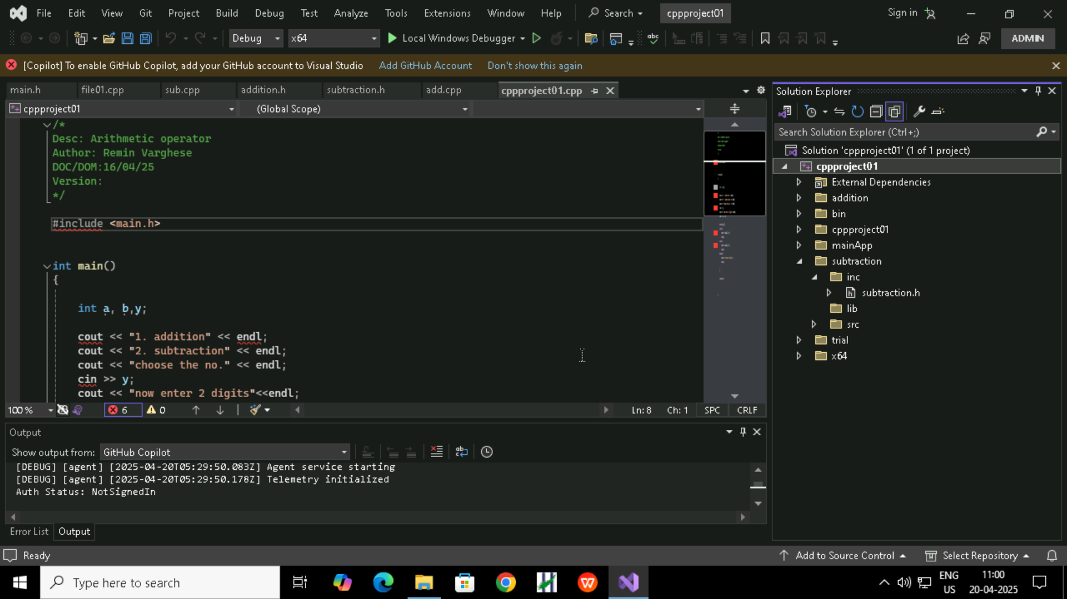

Step 6:

Now in configuration properties select general properties then select output directory and edit our folder as shown which will save our compiled solution in bin directory.

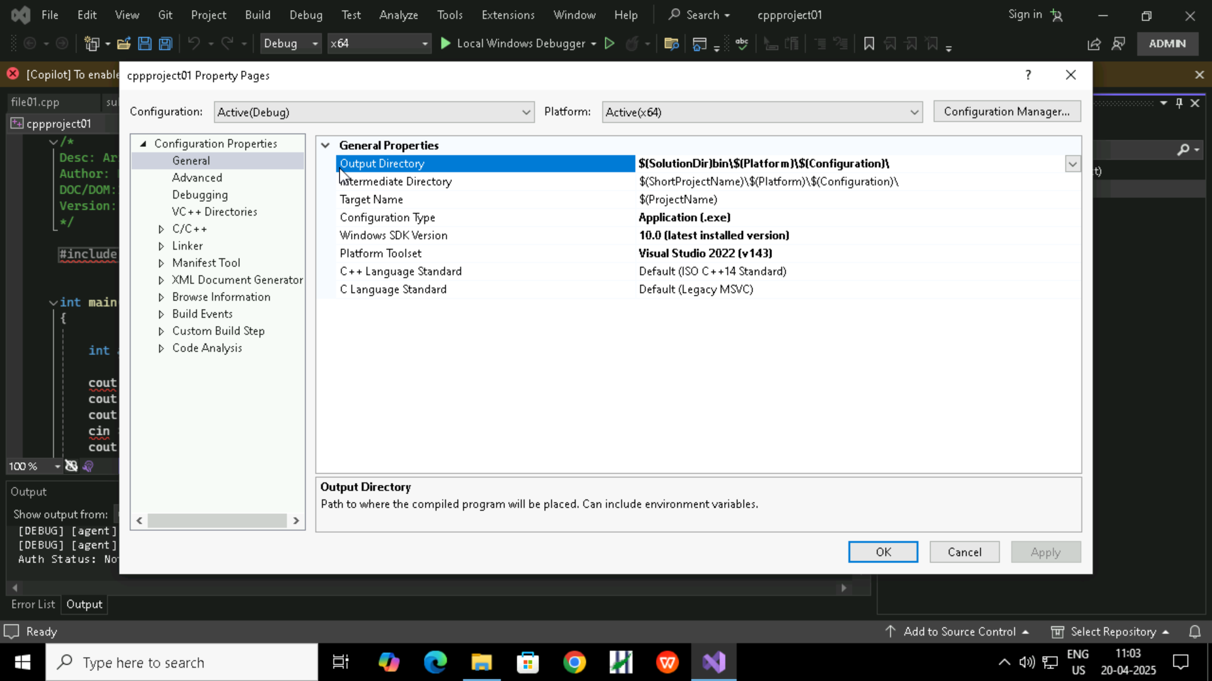

Step 7:

After writing program, to link the header files in inc folder select the settings icon and go to the ‘c/c++’ in configuration properties and edit additional include directory with the location of header file path.

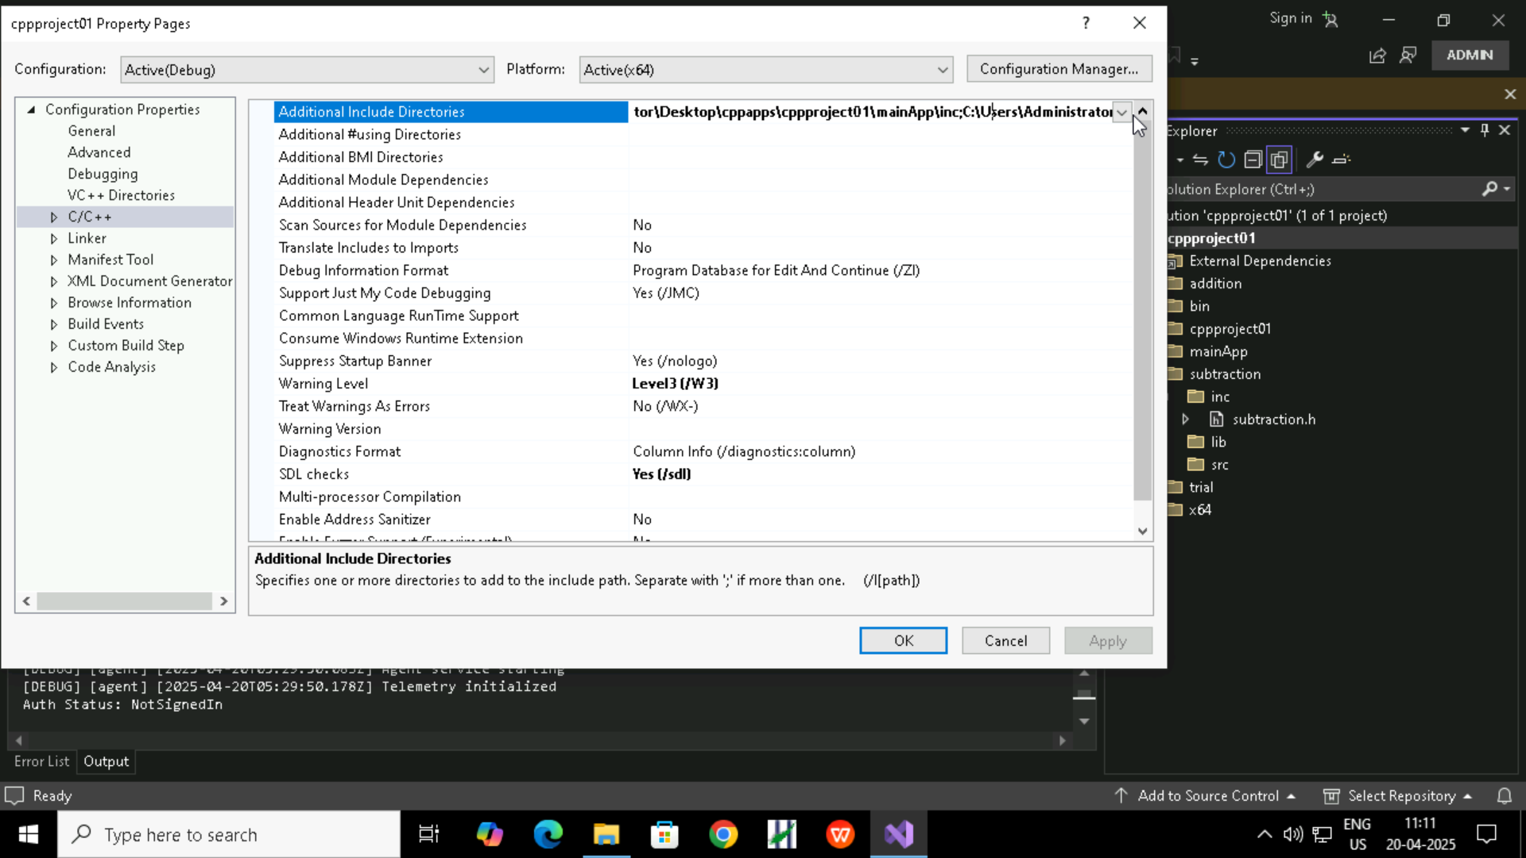

Step 8:

Now the IDE environment has been set for the project created, now compile the code . By using the build button in the IDE or going to the cmd of the working directory and typing the following command “g++ main.cpp”. And press enter.

Step 9:

After the code is compiled run the a.exe executable created, from the cmd run the a.exe executable.