Operating System Exercises 2010-2013
Rahmat M. Samik-Ibrahim et. al.
http://rms46.vLSM.org/2/184.pdf

Contributors: Rahmat M. Samik-Ibrahim (VauLSMorg), Muhammad H. Hilman, Heri Kurniawan, Amril Syalim (Faculty of Computer Science, University of Indonesia), et. al.

Table of Contents
(2011-2) Process State 2
(2013-2) Process State 2
(2011-2) Fork 3
(2013-2) Fork 4
(2012-2) Thread Scheduling 5
(2011-2) Synchronization 10
(2012-2) Synchronization 11
(2013-2) Synchronization 12
(2012-2) Deadlock 13
(2011-2/UCB sp00mt2) Demand Paging 13
(2011-2/UCB fa08mt1) Memory 13
(2013-2) Memory 14
(2011-2/Wikipedia) Disk IBM 350 Storage Unit 16
(2013-2) Disk 16
(2013-2) RAID 17
(2012-2) Performance 17

(2011-2) Process State
There exists four (4) identical processes, with this following CPU utilization table:
 | Multiprogramming Combination (%)
 | A | A+A | A+A+A | A+A+A+A
CPU utilization per proses A | 10 | 9,5 | 9 | 8,6

The CPU time of each processes is 86 seconds
- How long will be the total time to run concurrently all (4) processes together?!
- How long will be the total time to run all (4) processes one by one?!

(2013-2) Process State
Four (4) processes, A(90%), B(80%), C(70%), D(60%); where [W(X); W=process name; X= I/O Wait(%)] with this following CPU utilization table:
 | Multiprogramming Combination (%)
 | A | B | C | D | A+B | A+C | A+D | B+C | B+D | C+D | A+B+C | A+B+D | A+C+D | B+C+D | A+B+C+D
CPU utilization per proses A | 10 | - | - | - | 9.3 | 9.3 | 9.2 | - | - | - | 8.3 | 8.1 | 7.8 | - | 7
CPU utilization per proses B | - | 20 | - | - | 19 | - | - | 18 | 17 | - | 17 | 16 | - | 15 | 14
CPU utilization per proses C | - | - | 30 | - | - | 28 | - | 26 | - | 25 | 25 | - | 23 | 22 | 21
CPU utilization per proses D | - | - | - | 40 | - | - | 37 | - | 35 | 33 | - | 32 | 31 | 30 | 28

The relation between the process and time is as following:
D
A
B
C
100
200
300
400
500
600
700
800

- Calculate the CPU time of process A.
- Calculate the CPU time of process B.
- Calculate the CPU time of process C.
- Calculate the CPU time of process D
- What is the total execution time of process D, if it is executed alone?

(2011-2) Fork
#include <stdio.h>
#include <stdlib.h>
#include <semaphore.h>
#include "myutils.h"

int main(int argc, char * argv[]) {
int ii;
for (ii=0;ii<2;ii++) {
fork();
waitpid(-1,NULL,0);
}
printf("I am %d\n",(int) getpid());
}

Complete the output of that program:

I am 7000

(2013-2) Fork
1 #include <sys/types.h>
2 #include <sys/wait.h>
3 #include <stdio.h>
4 #include <unistd.h>
5
6 int delay1_fork (void) {
7 sleep(1); /* delay 1000 ms */
8 return (int) fork();
9 }
10
11 void main(void) {
12 int i1, i2, i3, i4, i5;
13
14 i1 = i2 = i3 = i4 = i5 = (int) getpid();
15 if (delay1_fork() > 0) {
16 i1 = (int) getpid();
17 if (delay1_fork() == 0) {
18 i2 = (int) getpid();
19 if (delay1_fork() > 0) {
20 i3 = (int) getpid();
21 if (delay1_fork() == 0) {
22 i4 = (int) getpid();
23 if (delay1_fork() > 0) {
24 i5 = (int) getpid();
25 sleep (1);
26 }
27 }
28 }
29 }
30 }
31 printf ("i1=%d - i2=%d - i3=%d - i4=%d - i5=%d \n", i1, i2, i3, i4, i5);
32 fflush(stdout);
33 wait(NULL);
34 wait(NULL);
35 wait(NULL);
36 }
- Convert your right most student ID into column [A-E]: [0 → A], [1 → B], [2-3 → C], [4-5 → D], [>5 → E]!
- Convert your entrance year into row[I-VI]:[<2009→I], [2009→II], [2010→III], [2011→IV], [2012→V], [2013→VI]!
- Fill the value “1000” into the column/row below based on (a) and (b).
- Fill the rest below based on the output of the program above!
 | A [ 0 ] | B [ 1 ] | C [2][3] | D [4][5] | E [ > 5 ]
I (<2009) | i1= | i2= | i3= | i4= | i5=
II (2009) | i1= | i2= | i3= | i4= | i5=
III (2010) | i1= | i2= | i3= | i4= | i5=
IV (2011) | i1= | i2= | i3= | i4= | i5=
V (2012) | i1= | i2= | i3= | i4= | i5=
VI (2013) | i1= | i2= | i3= | i4= | i5=

(2012-2) Thread Scheduling
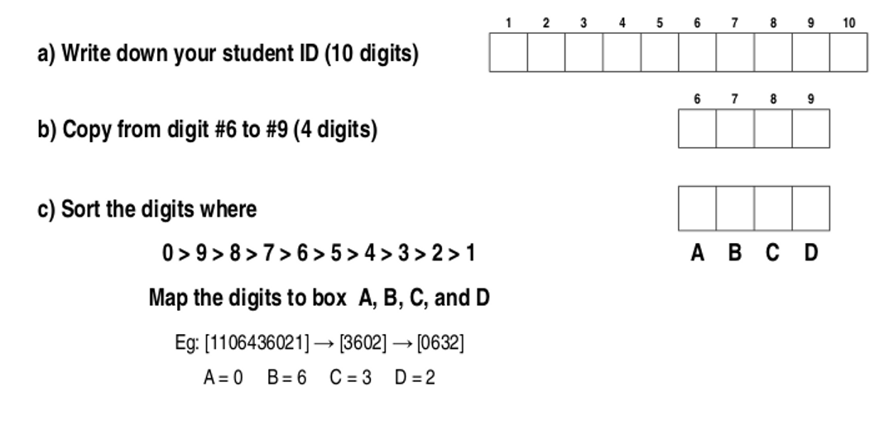
The mapping of function “day_month(X)” is as following:
X | 1 | 2 | 3 | 4 | 5 | 6 | 7 | 8 | 9 | 0
day_month(X) | 0 | 31 | 59 | 90 | 120 | 151 | 181 | 212 | 243 | 273

At the end of executing function “init_n_start_thread(T1,T2,....Tn)”, will appear “n” threads non-preemptive T1, T2, … Tn. Each thread will be put into the “Ready Queue” as “Rd” (Ready). If the CPU is available, the state will be changed to “R” (Run). There will be no new thread be executed before the threads from the previous init_n_start_thread() are done.
This following is the unit time table for the “Pseudo-program” of the following page.
No | Type | Unit | Example (line)
1 | M (Main function) | 1 (R) | 01 M: {
2 | T (Thread) | 1 (R) | 05 T1:{
3 | One Line Executions | 1 (R) / line | 16 day1 = dm1 + D;
4 | Function Executions | 2 (RR) / line | 10 dm1 = day_month(B);  20 init_n_start_thread(T9);

- Calculate:
delta = ________
## This program consists of M: (main) and T1...T9 (threads).
## Fill A, B, C, D according your student ID. See the previous page.

01 M: {
02 A = ________ ;
03 B = ________ ;
04 init_n_start_thread(T1, T2, T3, T4, T5);
}
##
05 T1:{
06 C = ________ ;
}
##
07 T2:{
08 D = ________ ;
}
##
09 T3:{
10 dm1 = day_month(B);
}

##
11 T4:{
12 dm2 = day_month(A);
}

##
13 T5:{
14 init_n_start_thread(T6, T7, T8);
}

##
15 T6:{
16 day1 = dm1 + D;
}

##
17 T7:{
18 day2 = dm2 + C;
}

##
19 T8:{
20 init_n_start_thread(T9);
}

##
21 T9:{
22 delta = day2 – day1;
}

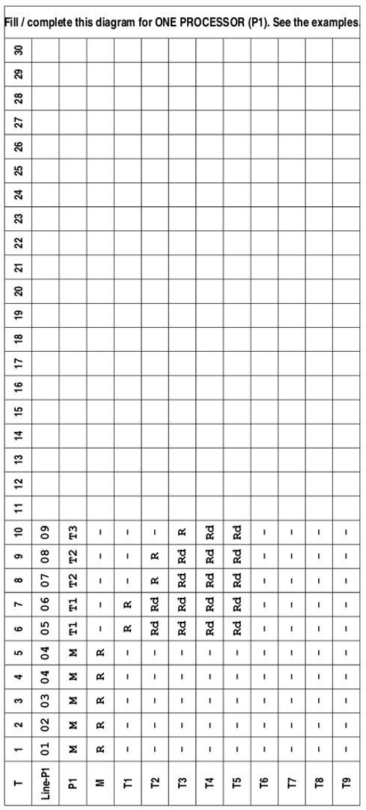

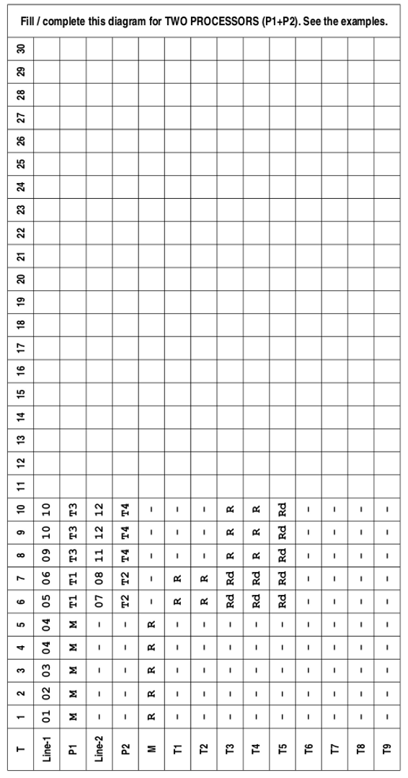

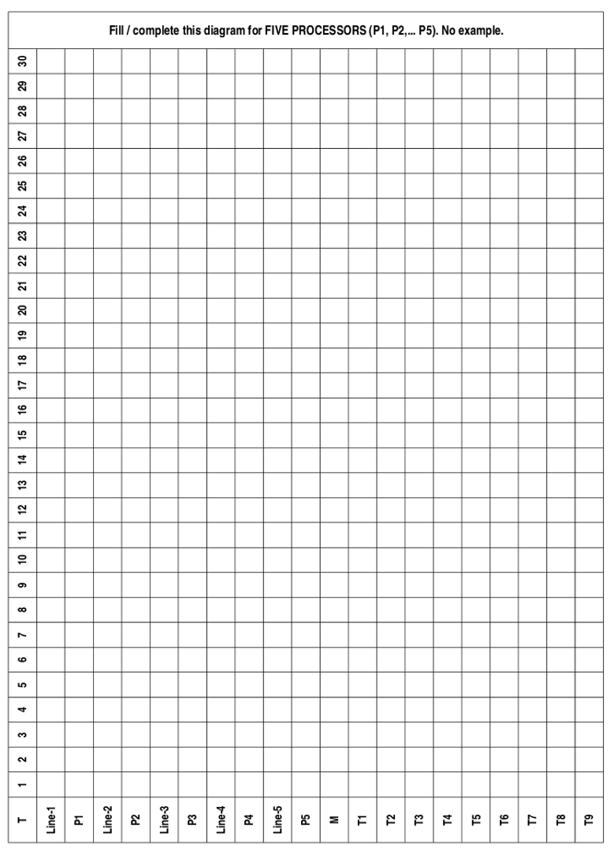

(2011-2) Synchronization
Analyze this following “myutils.h” header program:
#define MAX_THREAD 100
#define BUFFER_SIZE 5
#define TRUE 1
#define FALSE 0
typedef struct {
int buffer[BUFFER_SIZE];
int in;
int out;
int count;
} bbuf_t;
void daftar_trit (void* trit); // mempersiapkan "trit"
void jalankan_trit (void); // menjalankan dan menunggu hasil dari
// "daftar_trit"
void beberes_trit (char* pesan); // beberes menutup "jalankan_trit"
void rehat_acak (long max_mdetik); // istirohat acak "0-max_mdetik" (ms)
void init_buffer (void); // init buffer
void enter_buffer (int entry); // enter an integer item
int remove_buffer (void); // remove the item
void init_rw (void); // init readers writers
int startRead (void); // start reading
int endRead (void); // end reading
void startWrite (void); // start writing
void endWrite (void); // end writing
a) Write down the output of the program:
#include <stdio.h>
#include <stdlib.h> ________________________________________________
#include <semaphore.h>
#include "myutils.h"
sem_t mutex1, mutex2; ________________________________________________

void* THREAD_one (void* a) {
sem_wait (&mutex1); ________________________________________________
printf("This is THREAD one\n");

________________________________________________
}

void* THREAD_two (void* a) { ________________________________________________
sem_wait (&mutex2);
printf("This is THREAD two\n");
sem_post (&mutex1); ________________________________________________
}

void* THREAD_three (void* a) {
printf("This is THREAD three\n"); b) Complete/modify the program by adding
sem_post (&mutex2); “THREAD_four” (thread) which will print
} ”This is THREAD four” after THREAD_one.

int main(int argc, char * argv[]) {
sem_init (&mutex1, 0, 0);
sem_init (&mutex2, 0, 0);

daftar_trit(THREAD_one);
daftar_trit(THREAD_two);
daftar_trit(THREAD_three);

jalankan_trit();
beberes_trit("Good Bye");
}

(2012-2) Synchronization
Add the pseudo-program in “(2012-2) Thread Scheduling” with synchronization semaphores, so that there will be no new thread be executed before the threads from the previous init_n_start_thread() are done.
Add to the pseudo-program, the combination of these following three semaphore functions:
sem_init(X,Y) – initial semaphore “X” with value “Y”
sem_wait(X) – semaphore “X” wait
sem_signal(X) – semaphore “X” signal

(2013-2) Synchronization
The program (next page) is using function like “daftar_trit()” for registering a “threat” and “jalankan_trit()” for starting the “threats”. The “sem_init()” function will initiate a semaphore, “sem_post()” to signal a semaphore, and “sem_wait()” to wait for a semaphore.
- Write down one posibility of the program output.
- From the output above, which lines might be in different sequences. Explain!
- What is the role of semaphore “mutex”?
- What is the role of semaphore “switch1”?
- What is the role of semaphore “switch2”?

1 /*  2 * $Revision: 140 $  3 * (c) 2013 Rahmat M. Samik-Ibrahim  4 * This is FREE SOFTWARE.  5 */  6  7 #include <stdio.h>  8 #include <stdlib.h>  9 #include <semaphore.h>  10 #include "myutils.h"  11  12 #define NThreads 4  13  14 sem_t mutex, switch1, switch2;  15 int addvar1, addvar2, addresult;  16 int subvar1, subvar2, subresult;  17 int mulvar1, mulvar2, mulresult;  18 int divvar1, divvar2, divresult;  19  20 void* manager (void* a) {  21 printf("Manager starts \n");  22  23 for (int ii=0; ii< NThreads;ii++)  24 sem_wait (&switch1);  25 sem_wait (&mutex);  26 addvar1 = 5;  27 addvar2 = 2;  28 subvar1 = 7;  29 subvar2 = 2;  30 mulvar1 = 2;  31 mulvar2 = 3;  32 divvar1 = 4;  33 divvar2 = 2;  34 sem_post (&mutex);  35  36 for (int ii=0; ii< NThreads;ii++)  37 sem_post (&switch2);  38 for (int ii=0; ii< NThreads;ii++)  39 sem_wait (&switch1);  40 printf("Result add:%d; sub:%d; mul:%d;  div:%d;\n",  41 addresult, subresult, mulresult,  divresult);  42 }  43 | 44 void* add (void* a) {  45 sem_post (&switch1);  46 sem_wait (&switch2);  47  48 sem_wait (&mutex);  49 printf("Add starts \n");  50 addresult = addvar1 + addvar2;  51 sem_post (&mutex);  52 sem_post (&switch1);  53 }  54  55 void* subtract (void* a) {  56 sem_post (&switch1);  57 sem_wait (&switch2);  58  59 sem_wait (&mutex);  60 printf("Subtract starts \n");  61 subresult = subvar1 - subvar2;  62 sem_post (&mutex);  63 sem_post (&switch1);  64 }  65  66 void* multiply (void* a) {  67 sem_post (&switch1);  68 sem_wait (&switch2);  69 sem_wait (&mutex);  70 printf("Multiply starts \n");  71 mulresult = mulvar1 * mulvar2;  72 sem_post (&mutex);  73 sem_post (&switch1);  74 }  75  76 void* divide (void* a) {  77 printf("Divide starts \n");  78 sem_post (&switch1);  79 sem_wait (&switch2);  80 sem_wait (&mutex);  81 divresult = divvar1 / divvar2;  82 sem_post (&mutex);  83 sem_post (&switch1);  84 }  85  86 void main(void) {  87 sem_init (&mutex, 0, 1);  88 sem_init (&switch1, 0, 0);  89 sem_init (&switch2, 0, 0);  90 daftar_trit (manager);  91 daftar_trit (add);  92 daftar_trit (subtract);  93 daftar_trit (multiply);  94 daftar_trit (divide);  95 jalankan_trit ();  96 beberes_trit ("Done...");  97 }

(2012-2) Deadlock
- What are the four conditions that can arise a deadlock situation. Explain each condition in 1-2 sentences.
- What are the three ways that are generally used to handle deadlock? Explain each way in 1-2 sentences.
- Which solution is the most used way to handle deadlock? Explain it in 1-2 sentences.

(2011-2/UCB sp00mt2) Demand Paging
Consider a demand paging system with four physical memory frames and the following reference string over seven pages:
1, 2, 3, 4, 2, 1, 5, 6, 2, 1, 2, 3, 7, 6
Assuming that memory starts empty, how many page faults will occur and what pages will be the final contents of memory under:
- the FIFO page replacement policy?
- the LRU page replacement policy?
- the OPTIMAL page replacement policy?

(2011-2/UCB fa08mt1) Memory
Suppose we have a 32-bit virtual addresses system with 2 TB physical addresses. The page size is 8 kB. The Page Table Entry (PTE) will consist of:
- some bits for all frames of the physical address;
- one Valid/Invalid bit; and
- some unused bits.

- What will be the frame size (1 TB = 1024 GB = 1024 x 1024 MB)?
- In how many frames will the physical address be divided?
- How many bits are needed in the PTE for the frame part?
- Draw a complete PTE scheme with the “frame numbers” bits, “valid/invalid” bit, and “unused” bits. How many bytes (rounded) are needed?

- How many PTEs can be fit into one virtual page?
- Draw a complete virtual address scheme with “page numbers” bits and “offset” bits.

- How many PTEs are needed to map the whole the virtual address space?
- How many virtual pages are needed for those all PTEs above?

(2013-2) Memory
Consider a system with a 16 bits Virtual Address space and a 24 bits Physical Address space. The offset/ displacement ialah 12 bits. The Page Table starts at Physical Address 001000 (HEX).
Address (HEX) | +0 | +1 | +2 | +3 | +4 | +5 | +6 | +7 | +8 | +9 | +A | +B | +C | +D | +E | +F
001000 | 10 | 24 | 10 | 23 | 10 | 22 | 10 | 21 | 10 | 20 | 10 | 1F | 10 | 1E | 10 | 1D
001010 | 10 | 34 | 10 | 33 | 10 | 32 | 10 | 31 | 10 | 30 | 10 | 2F | 10 | 2E | 10 | 2D
…...
01F000 | A0 | A1 | A2 | A3 | A4 | A5 | A6 | A7 | A8 | A9 | AA | AB | AC | AD | AE | AF
…...
020000 | B0 | B1 | B2 | B3 | B4 | B5 | B6 | B7 | B8 | B9 | BA | BB | BC | BD | BE | BF
…...
023000 | C0 | C1 | C2 | C3 | C4 | C5 | C6 | C7 | C8 | C9 | CA | CB | CC | CD | CE | CF
…...
031000 | D0 | D1 | D2 | D3 | D4 | D5 | D6 | D7 | D8 | D9 | DA | DB | DC | DD | DE | DF
…...

The TLB entry is (in HEX): “[Page Number][Flag 4 bits][Frame Number]”. The “Frame Number” is INVALID unless the FLAGS value is “1 (HEX)” or “0001 (BIN)”.
[Page#] | [Flags] | [Frame#]
0 | 1 | 0 | 2 | 4
1 | 1 | 0 | 2 | 3
2 | 1 | 0 | 2 | 2
3 | 1 | 0 | 2 | 1
4 | 1 | 0 | 2 | 0

- Write down your student ID (NPM):

- Write down the most right digit of your student ID: _________
- VA1 is 1000 (HEX) plus the value of point “b”: VA1 = ____ + 1000 (HEX) = ______
- VA2 is 5000 (HEX) plus the value of point “b”: VA2 = ____ + 5000 (HEX) = ______

- Draw the 16 bit Virtual Address diagram:
Page Number (?? bit) | Offset (12 bit)

How many bits are there in the “Page Number” space? ____________ bit
- Based on the Page Number space, how many pages are there? _________ pages
- Draw the 24 bit Physical Address diagram:
Frame Number ( ?? bit) | Offset (12 bit)

How many bits are there in the “Frame Number” space? ____________ bit
- Based on the Frame Number space, how many frames are there? _________ frames
- What is the Page Number of VA1 (see point “c”): _____________________
- Is VA1's Frame Number in TLB ? Yes / No (circle the correct one)
- Is VA1's Frame Number in PT (Page Table) ? Yes / No
- The Frame Number for VA1 is Valid / Not Valid / Not Found
- If valid, what is the Frame Number value for VA1? _____________________

- (If applicable) What is the Physical Address (PA1) value of VA1? __________________________
- (If applicable) What number is inside VA1 __________________________
- What is the Page Number of VA2 (see point “d”): _____________________
- Is VA2's Frame Number in TLB ? Yes / No (circle the correct one)
- Is VA2's Frame Number in PT (Page Table) ? Yes / No
- The Frame Number for VA2 is Valid / Not Valid / Not Found
- If valid, what is the Frame Number value for VA2? _____________________

- (If applicable) What is the Physical Address (PA2) value of VA2? __________________________
- (If applicable) What number is inside VA2 __________________________

(2011-2/Wikipedia) Disk IBM 350 Storage Unit
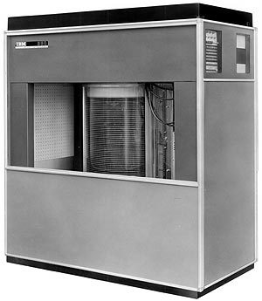 | The IBM 350 disk storage unit model 1 (151 cm x 171 cm x 50.2 cm) was announced on September 4, 1956. IBM 350 had 100 surfaces @ 100 tracks. Each track had 5 sectors @ 600 bits. The disk spun at 1200 RPM. The seek time was about (10 + 10 Tr) mS where “Tr” was the Track differences. Switching time between surfaces was assumed 0 mS. At that time, the main purpose of IBM 350 was to store “6 bits” characters.
- How many "6 bits” characters can be stored into one sector?
- How many "6 bits” characters can be stored into one track?
- How many "6 bits” characters can be stored into one cylinder?
- How many "6 bits” characters can be stored into the whole disk?
- Calculate the maximum theoretical data transfer rate in “characters per seconds”.
- How long (mS) will it take to write in sequence (sector by sector), 50100 characters starting from (Track 0, Surface 0, Sector 0) or (0, 0, 0) to (0, 0, 4) to (0, 1, 0) to (0, 1, 4) to (0, 2, 0) and so on.
- Which one (Track, Surface, Sector) will be the last to be written?

(2013-2) Disk
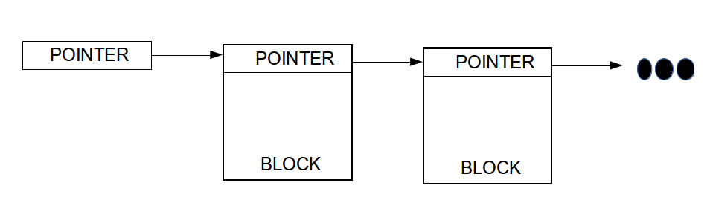
Consider a disk with 256 M sectors. Design a File System with linked-list blocks. There will be a pointer to the next block inside each block. The pointer size should be bytes (1, 2, 3, or more). The size of one block is equal to the size of a sector is equal to 8 kBytes. Use 1k=1024; 1M=1024k; 1G=1024M; 1T=1024G.
- What is the size of the disk (in Tbytes)?
- What is the size of the pointer (in bits)?
- Explain, why the maximum size of a file will be always less than the size of the disk!

(2013-2) RAID
Consider a collections of 1 Tbytes disks. Design a disk array with performance at least six times better compared to an individual disk. The amount of disks should be as few as possible.
- Draw a diagram of a disk array without any fault tolerance. How many disks will be used?
- Draw a diagram of a RAID 6 + 0. How many disks will be used?

(2012-2) Performance
Consider an application with total execution time of 100 hours. Based on an analysis, 24% of execution time is the CPU time and the rest is mostly the time of handling the HDD. Suppose you would like to make the application execution time less than 50 hours. First, the CPU is replaced with a one that has got 2 (two) cores where each core is twice faster. Second, a new RAID 6+0 configuration will be deployed, however using the same HDD type as before.

- Draw a diagram of the RAID 6+0 disks that fulfill the requirements!
- How much will be the minimum disk capacity of the new HDD configuration?

