Jawaban Soal Ujian Sistem Operasi 2010-2015
(2010-1) Fork dan (2011-1) Fork
Rahmat M. Samik-Ibrahim
https://rms46.vLSM.org/2/232.pdf

Table of Contents
(2010-1) Fork 1
(2011-1) Fork 3

(2010-1) Fork
Lengkapi kotak serta pohon (tree) hasil kompilasi program ''fork2010.c'' (PID=301) berikut ini:
001 #include <sys/types.h>  002 #include <sys/wait.h>  003 #include <stdio.h>  004 #include <unistd.h>  026 int my_fork(void) {  027 int ii;  028 sleep(1);  029 ii=(int) fork();  030 sleep(1);  031 return ii;  032 } | 008 main(void)  009 {  010 int ii, jj, kk;  011  012 my_fork();  013 ii = (int) getpid();  014 my_fork();  015 jj = (int) getpid();  016 if (my_fork() > 0)  017 my_fork();  018 kk = (int) getpid();  019 printf ("ii = %3.3d -- jj = %3.3d -- kk = %3.3d\n",ii,jj,kk);  020 wait(NULL);  021 wait(NULL);  022 wait(NULL);  023 wait(NULL);  024 }
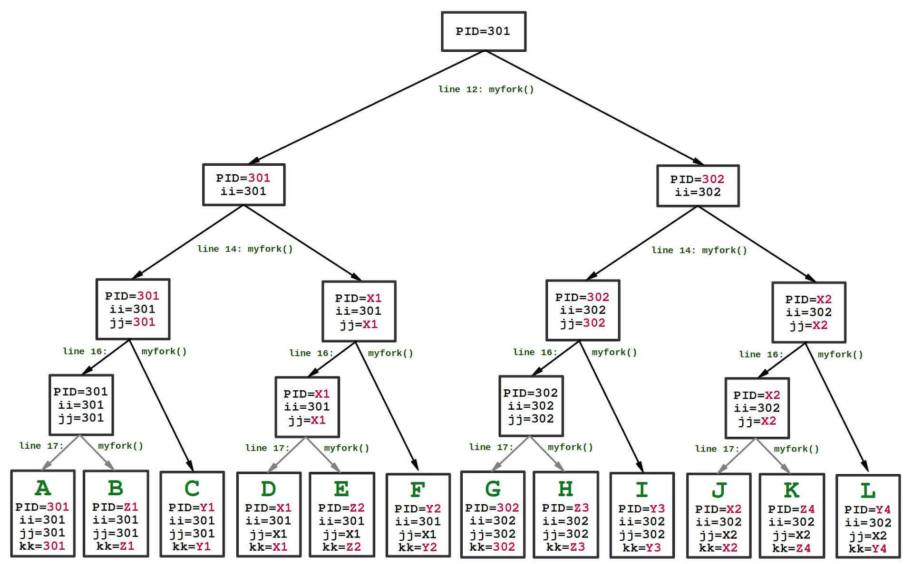

 | ii | jj | kk
A | 301 | 301 | 301
B | 301 | 301 | Z1
C | 301 | 301 | Y1
D | 301 | X1 | X1
E | 301 | X1 | Z2
F | 301 | X1 | Y2
G | 302 | 302 | 302
H | 302 | 302 | Z3
I | 302 | 302 | y3
J | 302 | X2 | X2
K | 302 | X2 | Z4
L | 302 | X2 | Y4

{X1, X2} = {303, 304}
{Y1, Y2, Y3, Y4} = {305, 306, 307, 308}
{Z1, Z2, Z3, Z3} = {309, 310, 311, 312}

 | ii | jj | kk
A | 301 | 301 | 301
G | 302 | 302 | 302
J | 302 | 303 | 303
D | 301 | 304 | 304
F | 301 | 304 | 305
L | 302 | 303 | 306
I | 302 | 302 | 307
C | 301 | 301 | 308
B | 301 | 301 | 309
E | 301 | 304 | 310
K | 302 | 303 | 311
H | 302 | 302 | 312

Berapakah kisaran dari ii, jj, dan kk?
301
≤ ii ≤
302
301
≤ kk ≤
312
301
≤ jj ≤
304
<=
<=
kk
jj
ii

(2011-1) Fork
Perhatikan program C di bawah ini. Isilah kotak-kotak kosong berikut ini.
001 #include <stdio.h>  002 #include <sys/types.h>  003 #include <unistd.h>  004  005 pid_t fork_2sec() {  006 pid_t tmp;  007 sleep(1);  008 tmp = fork();  009 sleep(1);  010 return tmp;  011 }  012 | 013 main(){  014 int ii, jj, kk, ll;  015 ii = jj = kk = ll = (int) getpid();  016 printf(" ii jj kk ll\n");  017 printf("============================\n");  018 fork_2sec();  019 jj = (int) getpid();  020 fork_2sec();  021 kk = (int) getpid();  022 fork_2sec();  023 ll = (int) getpid();  024 printf("[%3.3d] [%3.3d] [%3.3d] [%3.3d]\n", ii,jj,kk,ll);  025 wait(NULL); wait(NULL); wait(NULL);  028 }
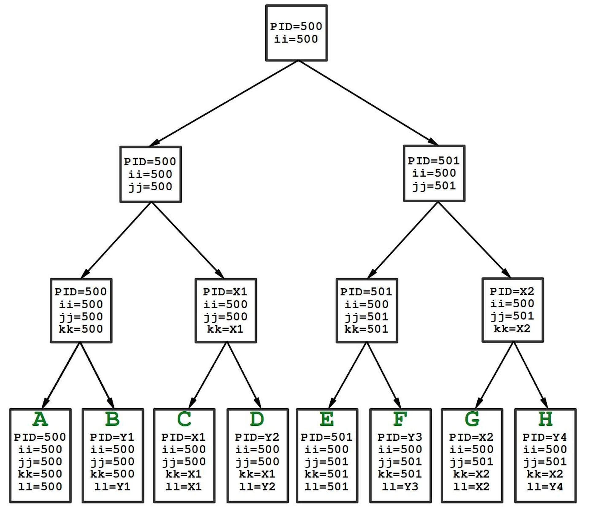

 | ii | jj | kk | ll
A | 500 | 500 | 500 | 500
B | 500 | 500 | 500 | Y1
C | 500 | 500 | X1 | X1
D | 500 | 500 | X1 | Y2
E | 500 | 501 | 501 | 501
F | 500 | 501 | 501 | Y3
G | 500 | 501 | X2 | X2
H | 500 | 501 | X2 | Y4

{X1, X2} = {502, 503}
{Y1, Y2, Y3, Y4} = {504, 505, 506, 507}

 | ii | jj | kk | ll
A | 500 | 500 | 500 | 500
E | 500 | 501 | 501 | 501
G | 500 | 501 | 502 | 502
C | 500 | 500 | 503 | 503
D | 500 | 500 | 503 | 504
H | 500 | 501 | 502 | 505
F | 500 | 501 | 501 | 506
B | 500 | 500 | 500 | 507

