plumbline
TRUE BY MEASURE
Architecture & Design
A layered re-architecture of Plumbline Studio — a thin HTML front-end with no math, an encapsulated proof-carrying engine, and dedicated database and LLM interaction layers.
Prepared for Robert Samuel · Confidential working note

Contents
Right-click and choose “Update Field” to populate page numbers.

1. Overview and design principles
Plumbline models a business process as a finite-state machine (FSM), runs six structural improvement tools over it, and — crucially — certifies every finding: it returns a machine-checkable certificate, or the counterexample that is itself the finding. This document specifies the layered architecture that turns the single-file demo into a maintainable product without losing its defining property: findings are computed and proven, not asserted.
The re-architecture is organised around four requirements, stated by the brief and preserved throughout:
- The HTML is mostly front-end and contains no math — the presentation layer only calls facades.
- The math is encapsulated behind a single engine facade (the FSM analysers, the cost model, and the Lemma proof kernel).
- A dedicated database interaction layer is the only channel to persistent state (users, saved workflows, history).
- A dedicated LLM interaction layer provides advisory language (stage names, plain-English explanations) without ever certifying a result.

Design principles
- Propose, then dispose. Analysers are fast and heuristic; they propose a result and a witness. Lemma is small and conservative; it certifies the witness or refutes it.
- Certificate or counterexample. Every structural finding surfaces only once Lemma has produced an independently checkable certificate — or the counterexample the client is paying to discover.
- One boundary per concern. Each cross-layer contract is a single global facade: PlumblineEngine, PlumblineData, PlumblineLLM. Nothing reaches around a facade.
- Offline-first. The built app is one self-contained HTML file that runs with no server; the data and LLM layers swap to remote adapters when a backend is present.
- Provenance is load-bearing. Structural findings are labelled lemma-certified; cost figures assumption-based; LLM output narrative-only.

2. System architecture
Five layers stack from the front-end down to the backend. The presentation layer calls three facades; the engine encapsulates all math with the Lemma kernel at its trusted core; the data and LLM layers each expose one interface over two interchangeable adapters (offline and remote); and the server backs the remote adapters and holds the LLM API key.
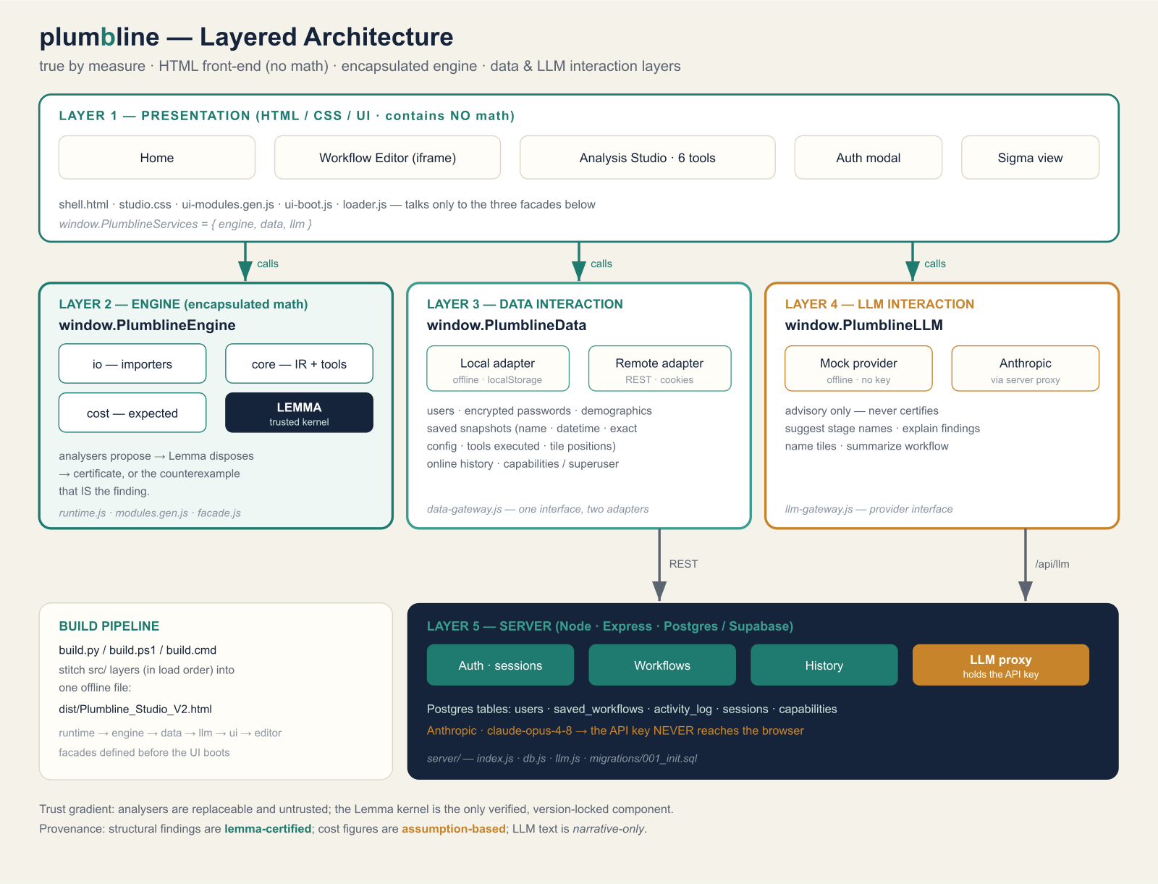
Figure 1 — The five layers, their facades, and the trust gradient. The Lemma kernel is the only verified, version-locked component.

3. The five layers in detail

Layer 1 — Presentation (HTML / CSS / UI)
Files: src/presentation/shell.html, studio.css, src/app/ui-modules.gen.js, ui-boot.js, loader.js.
The three pages (Home, Workflow Editor, Analysis Studio), the six-tool toolbar, the canvas/sigma views, and the auth modal. This layer performs no FSM, cost, or proof arithmetic. It renders state and forwards user intent to the facades, reachable as window.PlumblineServices = { engine, data, llm }. The Workflow Editor is embedded as a base64 blob decoded to an iframe at runtime and exchanges snapshots with the Studio over postMessage.

Layer 2 — Engine (encapsulated math)
Files: src/engine/runtime.js (shared module registry), modules.gen.js (the math packages), facade.js (window.PlumblineEngine).
The sole math boundary. Behind the facade sit four packages: io (importers that turn untrusted JSON / FSM tables into the canonical IR), core (the IR plus the analysers and redesign bisimulation), cost (expected-cost arithmetic), and lemma (the trusted kernel). The facade exposes a clean API — parseWorkflow, analyze, compareRedesign, certify, expectedCost, and a one-call run(json) — so the caller never touches an analyser or the kernel directly. analyze() wires the pattern together: it runs every analyser and passes each witness to lemma.check, attaching a certified/refuted verdict to every finding before it returns.

Layer 3 — Data interaction layer
File: src/data/data-gateway.js (window.PlumblineData).
The only channel to persistent state. One promise-based interface over two interchangeable adapters: a Local adapter (offline, browser localStorage, salted-SHA-256 passwords) and a Remote adapter (REST to the server with an httpOnly session cookie). The domain follows the DB-interaction specification exactly: users with encrypted passwords, demographics, saved workflow snapshots capturing the name, datetime, the exact configuration, which tools were executed, and the tile positions, plus per-user online history and capabilities/superuser. autodetect() prefers the server when reachable and silently falls back to offline.

Layer 4 — LLM interaction layer
File: src/llm/llm-gateway.js (window.PlumblineLLM).
The only channel to a language model, and strictly advisory: it never certifies a finding and never computes a number. Task-shaped intents — suggestStageNames (naming the buckets from Zoom out), explainFinding (a plain-business paragraph), suggestTileName, and summarizeWorkflow — run through one of two providers: a Mock provider (offline, deterministic, no key) and an Anthropic provider that posts to the server proxy. The API key is never present in the browser.

Layer 5 — Server (DB API + LLM proxy)
Files: server/src/index.js, db.js, llm.js, migrations/001_init.sql.
Express over Postgres/Supabase. It backs the Remote data adapter (auth with bcrypt and a signed session cookie, workflow snapshots, history, capabilities) and hosts the LLM proxy at /api/llm, which holds the Anthropic key and calls Claude (claude-opus-4-8) with output_config.format so each intent returns schema-valid JSON. The browser app runs fully without this server; it is stood up only for real multi-user persistence and live language features.

Responsibilities at a glance
Layer | Facade / entry | Responsibility | Trusted?
Presentation | PlumblineServices | Render + forward intent; no math | n/a
Engine | PlumblineEngine | IR, analysers, cost, Lemma certification | Lemma only
Data | PlumblineData | Users, snapshots, history (Local/Remote) | no
LLM | PlumblineLLM | Advisory language (Mock/Anthropic) | no
Server | REST + /api/llm | Postgres persistence + key custody | no

4. Representative request flows

Certifying an analysis (no server needed)
- The UI reads the current workflow and calls PlumblineEngine.analyze(workflow).
- The engine runs each analyser; every proposed witness is passed to the Lemma kernel, which returns a certificate or a counterexample.
- The facade returns findings already labelled certified or refuted; the UI renders them. No math ran in the front-end.

Saving a workflow
- The UI calls PlumblineData.saveWorkflow({name, workflow, config, toolsExecuted, layout}).
- Offline, the Local adapter writes to localStorage; online, the Remote adapter POSTs to /api/workflows and the server persists the exact snapshot to Postgres.

Suggesting zoom-out stage names
- After Zoom out produces stage buckets, the UI calls PlumblineLLM.suggestStageNames(stages).
- The Mock provider answers offline; the Anthropic provider POSTs {intent, payload} to /api/llm, which calls Claude with the key held server-side and returns schema-valid names.

5. Build pipeline
Three entry points produce one result: build.py (Python), build.ps1 (pure PowerShell, no Python needed), and build.cmd (chooses one). The Python and PowerShell builders emit a byte-identical file.
The builder fills ordered markers in shell.html with each layer's code and base64-encodes the editor. The script order is load-bearing: each facade must exist as a global before the next layer and the UI run.
Order | Marker | Source | Publishes
1 | @@RUNTIME_JS@@ | engine/runtime.js | window.__PL registry
2 | @@ENGINE_MODULES_JS@@ | engine/modules.gen.js | math modules
3 | @@ENGINE_FACADE_JS@@ | engine/facade.js | window.PlumblineEngine
4 | @@DATA_GATEWAY_JS@@ | data/data-gateway.js | window.PlumblineData
5 | @@LLM_GATEWAY_JS@@ | llm/llm-gateway.js | window.PlumblineLLM
6 | @@UI_MODULES_JS@@ | app/ui-modules.gen.js | presentation modules
7 | @@UI_BOOT_JS@@ | app/ui-boot.js | starts the Studio
Output: dist/Plumbline_Studio_V2.html — one offline file. For development without a build step, src/plumbline-dev.html loads every layer from its relative source.

6. Mapping to the certifying-algorithm plan
Each of the six tools maps to a known algorithm whose result the Lemma kernel checks. The analyser proposes; Lemma discharges the obligation or returns the counterexample, which becomes the finding.
Tool | Obligation Lemma discharges | The counterexample (the finding)
Zoom out | Partition has the substitution property | An input that lets work escape a stage
Spot duplicates | Two states are language-equivalent; a branch is unreachable | A trace distinguishing two look-alikes
Plan vs. reality | A logged trace is/ isn't in the model's language | The exact step where reality diverges
Move the decision | Two designs are bisimilar | The trace where a decision point moved
Run in parallel | Components are independent and recompose | A hidden dependency blocking parallelism
Find the loops | Cycles are bounded; a loop terminates | An unbounded loop with no progress measure
The cost model is deliberately not certified by Lemma: its outputs are conditional on supplied costs and probabilities, and the product labels them assumption-based. Lemma certifies structure; the cost model quantifies it under stated inputs; the LLM layer describes it in words.

7. Source map
build.py / build.ps1 / build.cmd the build (three entry points, one result)
dist/Plumbline_Studio_V2.html the built, single-file app
src/presentation/ shell.html · studio.css (Layer 1)
src/app/ ui-modules.gen.js · ui-boot.js · loader.js · dev-loader.js
src/engine/ runtime.js · modules.gen.js · facade.js (Layer 2)
src/data/ data-gateway.js (Layer 3)
src/llm/ llm-gateway.js (Layer 4)
src/editor/ workflow-editor.html (embedded)
server/ index.js · db.js · llm.js · migrations/001_init.sql (Layer 5)
plumbline · true by measure

