PLUMBLINE
System Architecture
The three-module client, the Express API, and the database
github.com/rmsamuel2/Plumbline2 · master · commit fc271d6
Describes the system AS BUILT after Phase 1. Where the intended end state differs from what exists today, the difference is stated explicitly rather than glossed.

Contents
Contents 2
1 What Plumbline is, structurally 3
1.1 The three tiers 3
2 System overview 3
The same diagram as text 4
3 The client in detail 5
3.1 Module structure 5
The same diagram as text 5
3.2 The screen contract 6
3.3 State ownership and the hooks 6
3.4 The editor iframe 7
The same diagram as text 7
4 The client–server relationship 8
4.1 What actually crosses the wire 8
4.2 A request, end to end 8
The same diagram as text 9
4.3 Two deployment shapes 9
5 The server and the database 10
5.1 API surface 10
5.2 Defence in depth 10
6 Where the architecture is not yet finished 11
The same diagram as text 11
6.1 The rule that keeps it honest 12
7 Reference 12
7.1 Where things live 12
7.2 Build and run 12
7.3 Invariants worth not breaking 13

1 What Plumbline is, structurally
Plumbline models business processes as finite state machines and analyses them with a certifying engine: analysers propose findings, and a small trusted kernel (Lemma) re-verifies each one and returns a certificate or a counterexample. Around that core sits an ordinary three-tier web application.
Three facts define the shape of the system, and everything else follows from them:
- The database is the system of record. Nothing of value lives only in the browser. Workflows are stored as immutable versions, and each version's snapshot is decomposed into normalized FSM tables server-side.
- The browser is a client, not a peer. It holds no credentials, no connection string, and no API key. Every durable operation is an HTTP request to the Plumbline API.
- The user interface is one compiled file. build.py inlines every presentation source into a single dist/Plumbline_Studio_V2.html. There is no bundler, no module server, and no build step at run time.

1.1 The three tiers
Tier | What it is | Responsibility
Client | dist/Plumbline_Studio_V2.html — one file, opened locally or served | Rendering, routing, editing, and (today) analysis computation. Holds no secrets.
Application | Node/Express, server/src/index.js, port 8080 | Authentication, sessions, authorization, all SQL, the LLM proxy, and snapshot normalization.
Data | Supabase PostgreSQL — migrations 001, 002, 003 | Storage, referential integrity, integrity triggers, row-level security, append-only audit.

A note on honesty in this document. The engine — the mathematics — is still compiled into the browser file today. The architecture is designed to move it behind the API (Phase 3), and section 6 covers that specifically. Everywhere else, this document describes what is actually built.

2 System overview
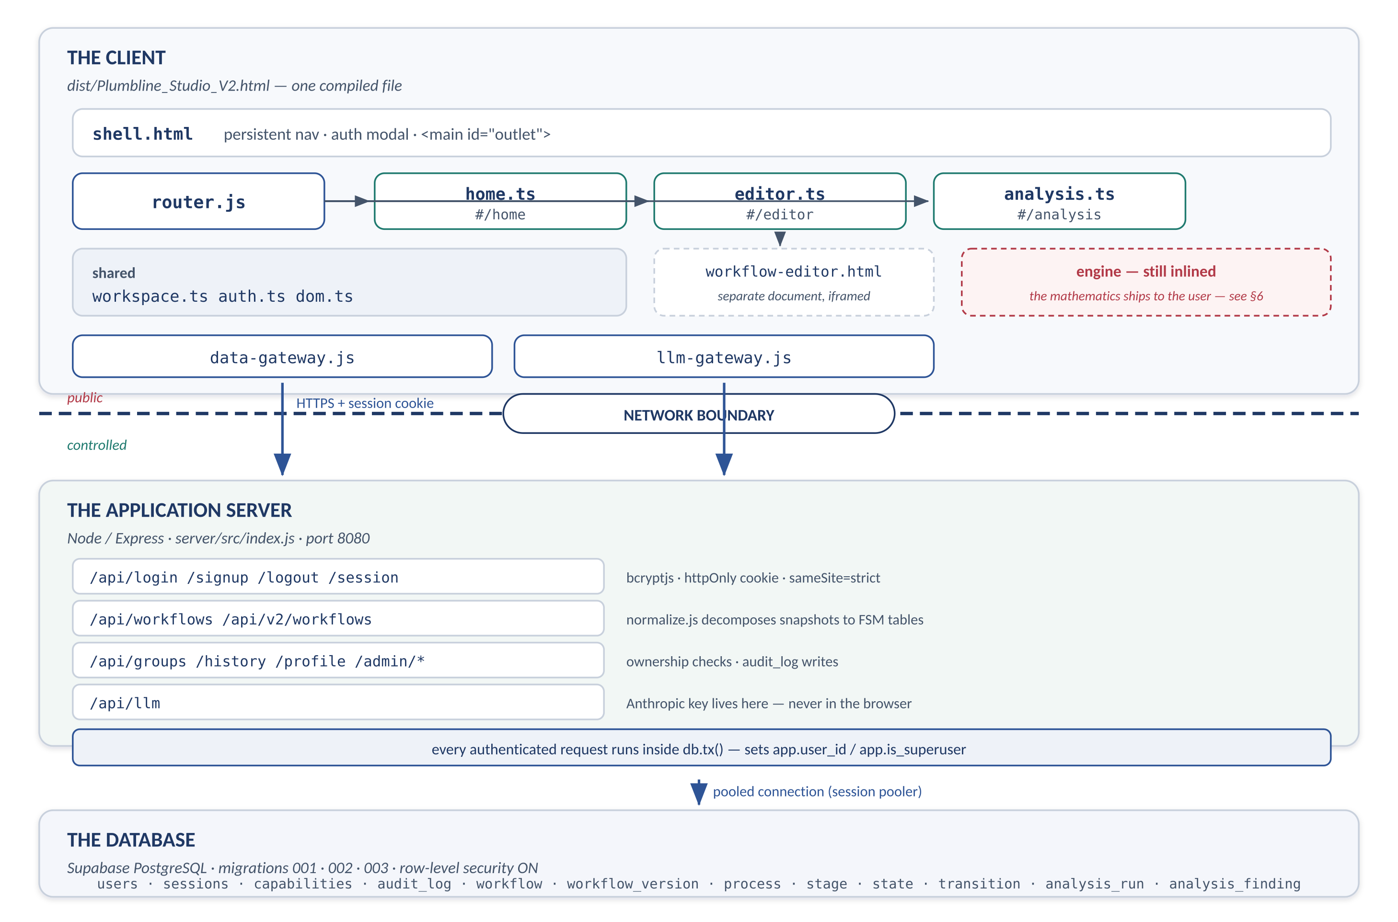
Figure 1 — The three tiers. The double line is the network boundary: everything above it is public, everything below it is controlled.

The same diagram as text
Reproduced for copy-paste, diffing, and plain-text contexts.
THE CLIENT one compiled HTML file
+--------------------------------------------------------------------+
| shell.html nav bar | auth modal | <main id="outlet"> |
| |
| router.js -- #/home -------------------> home.ts |
| -- #/editor -----------------> editor.ts --> [iframe] |
| -- #/analysis ---------------> analysis.ts | |
| | |
| shared: workspace.ts (docs, hooks) | |
| auth.ts (modal, session) workflow-editor.html
| dom.ts (helpers) (separate document) |
| |
| gateways: data-gateway.js llm-gateway.js |
| engine (still inlined - see section 6) |
+-----------------|--------------------------|-----------------------+
| HTTP + session cookie |
==================|==========================|======================
v v
+--------------------------------------------------------------------+
| THE APPLICATION SERVER Express, server/src/index.js:8080 |
| |
| /api/login /signup /logout /session bcryptjs, httpOnly |
| /api/workflows /api/v2/workflows cookie, sameSite=strict |
| /api/groups /history /profile |
| /api/admin/* normalize.js decomposes |
| /api/llm <- API key lives here, never in the browser |
| |
| every authenticated request runs inside db.tx(), which sets |
| app.user_id and app.is_superuser for the duration |
+-----------------------------|--------------------------------------+
| pooled connection (session pooler)
v
+--------------------------------------------------------------------+
| THE DATABASE Supabase PostgreSQL, RLS on |
| users · sessions · remember_tokens · capabilities · audit_log |
| workflow · workflow_version (immutable) · workflow_group |
| process · stage · state · transition · cost_item · dependencies |
| analysis_run · analysis_finding |
+--------------------------------------------------------------------+
Read three things off Figure 1.
- The client reaches the server through exactly two gateways today — data-gateway.js and llm-gateway.js. Both are thin fetch wrappers. Neither contains business logic, and neither holds a credential.
- The API is the only thing that speaks SQL. The browser never sees a connection string; the browser cannot address the database at all.
- Authorization is enforced twice, deliberately. The route checks ownership, and the database independently enforces row-level security using a context the route sets. A bug in one does not open the other.

3 The client in detail

3.1 Module structure
Before Phase 1 the entire UI was one 2,571-line module. It is now three screens over a shared core, with a hash router owning which screen is mounted. The engine, data and LLM layers were already separate and did not change.
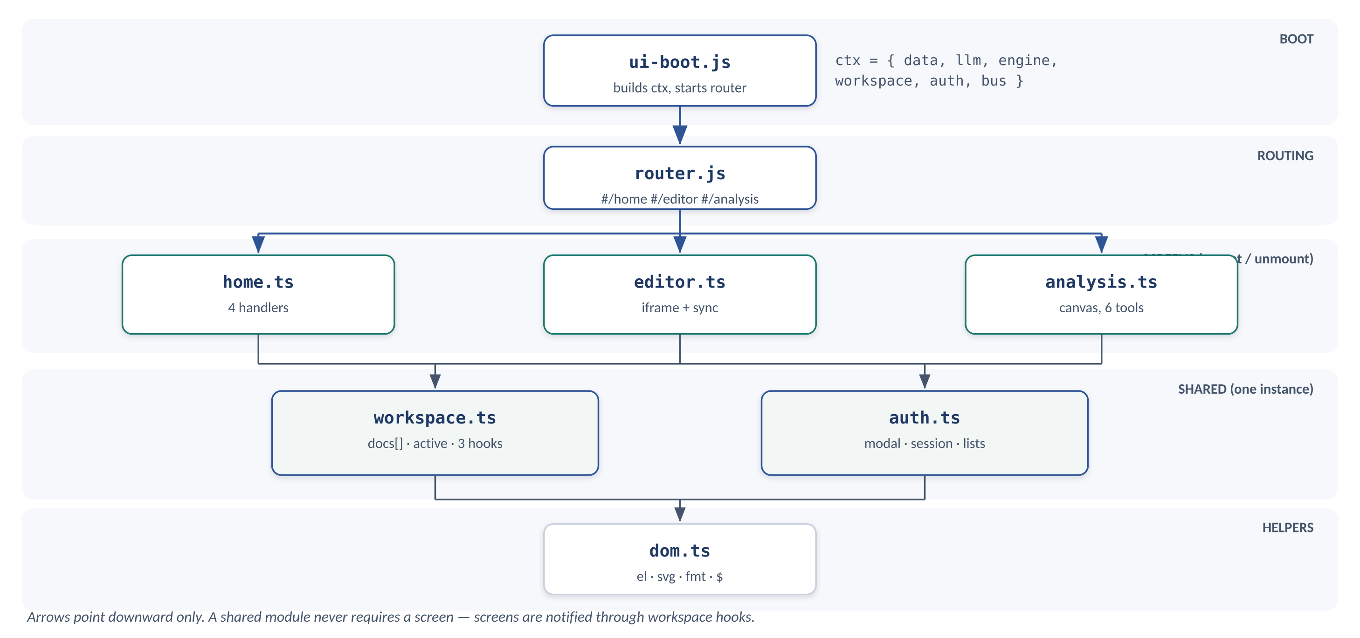
Figure 2 — Client module graph. 207 declarations were distributed across these six files; each carries its original line range as a provenance comment.

The same diagram as text
Reproduced for copy-paste, diffing, and plain-text contexts.
ui-boot.js
| builds ctx { data, llm, engine,
| workspace, auth, bus }
v
router.js #/home #/editor #/analysis
+----------------+----------------+
v v v
home.ts editor.ts analysis.ts SCREENS
| | | (mount/unmount)
+--------+-------+-------+--------+
v v
workspace.ts auth.ts SHARED
docs[] active modal, session (single instance)
3 hooks
| |
+-------+-------+
v
dom.ts HELPERS

Arrows point downward only. A shared module never requires a screen;
screens are notified through workspace hooks instead.
Module | Decls | Owns
shared/dom.ts | 17 | Element builders and formatting. Depends on nothing.
shared/workspace.ts | 61 | The document model: docs[], active, layout, serialization, import. Sole owner of that state; notifies screens through hooks.
shared/auth.ts | 25 | The account modal, sign-in/out, profile, saved-workflow and history lists. A service, not a screen — its markup sits outside the router outlet.
modules/home.ts | 0 | Four handlers over static markup. No moved code.
modules/editor.ts | 10 | Hosts the editor iframe and owns the two-way sync protocol.
modules/analysis.ts | 94 | Canvas, six tools, tables, inspector, findings, savings.
router.js | — | Hash routes, mount/unmount lifecycle, overlapping-navigation guard.

3.2 The screen contract
exports.default = {
async mount(outlet, params, ctx) { }, // build/show; register hooks
async unmount() { } // deregister; hide; abort
};
// ctx = { data, llm, engine, workspace, auth, bus, navigate }
Four rules make this hold, each present because its absence is a known failure:
- Dependencies arrive through ctx. Screens do not read window.PlumblineData and friends, so they can be mounted against a stub in a test.
- Whatever a screen registers outside itself, it deregisters on unmount. Workspace hooks are the main case.
- Cross-screen communication is the URL: ctx.navigate("/analysis"). That makes every screen deep-linkable and refresh-safe for free.
- The router guards overlapping navigation with a token checked after each await. Without it, two fast clicks leave the outlet owned by a screen that believes it was unmounted.

3.3 State ownership and the hooks
The hardest part of the split was that docs[] and active were read and written by both the editor sync path and the analysis canvas. Duplicating them would have meant the editor's edits silently never reaching Analysis. They now have exactly one owner, and the flow of control is strictly downward: workspace never calls a screen, it fires a hook.
Hook | Meaning and who listens
onChange | State changed; re-render. analysis.ts registers renderAll(). When no screen is mounted the hook set is empty, commit() still persists, and nothing renders — which is exactly right.
onRecomputeTools | Recompute one tool's suggestions for a document. analysis.ts listens.
onPushToEditor | The Studio's model changed; push it to the editor iframe. editor.ts listens.

3.4 The editor iframe
The Workflow Editor is a separate HTML document, shipped base64-encoded inside the same file and mounted as an iframe from a blob URL. It has its own state, its own undo history, and its own rendering. It is same-origin, so the parent can call into it directly.
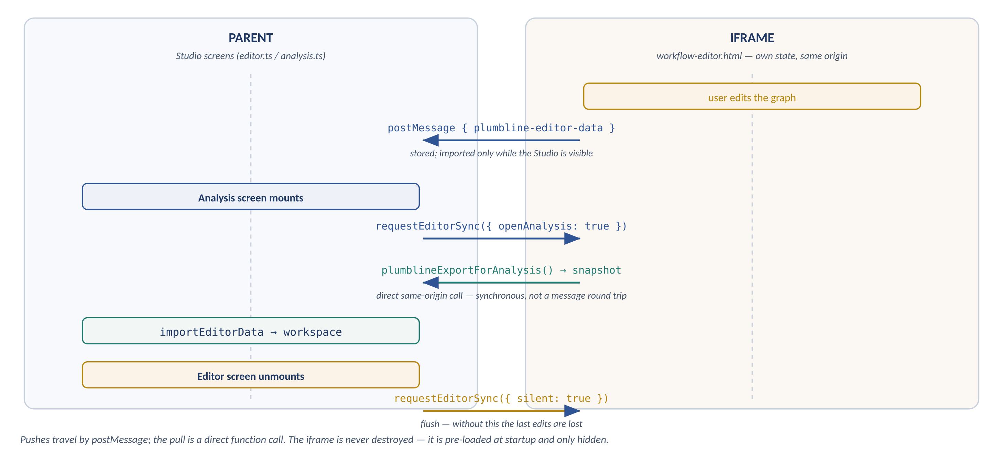
Figure 3 — Parent/iframe protocol. The pull is a direct same-origin function call; postMessage carries the pushes.

The same diagram as text
Reproduced for copy-paste, diffing, and plain-text contexts.
parent (analysis/editor screens) iframe (workflow-editor.html)
-------------------------------- ----------------------------
user edits the graph
|
setupEditorSync listener <---- postMessage -----+
{ type: plumbline-editor-data }
stored; imported only when
the Studio is visible

Analysis screen mounts
requestEditorSync({openAnalysis:true})
-> frame.contentWindow
.plumblineExportForAnalysis() [ direct call, synchronous ]
<- snapshot
importEditorData -> workspace

Studio model changes
workspace.persist() -> onPushToEditor
-> postMessage { plumbline-studio-data } --> editor replaces model

Editor screen unmounts
requestEditorSync({silent:true}) [ flush, so edits are not lost ]
Why the pre-load matters. loader.js loads the editor at startup even if the user never opens the Editor screen, so the Analysis screen always has a graph to analyse. The cost is that the editor lays itself out while hidden and computes its viewport from a zero-width pane; editor.ts corrects this by triggering the editor's own Recenter the first time the screen is actually shown.

4 The client–server relationship
This is the part most worth being precise about, because the application can be run in two configurations that look similar and behave differently.

4.1 What actually crosses the wire
Concern | Where it happens
Password verification | Server. bcryptjs compares against a stored hash. The browser sends a password once, over the session, and never stores one.
Session identity | Server. An httpOnly, sameSite=strict cookie the browser cannot read from JavaScript.
Authorization | Server, twice: the route checks ownership, and Postgres RLS independently enforces it.
All persistence | Server. Every workflow, version, group, history entry and audit row is written by the API.
Snapshot decomposition | Server. normalize.js turns a saved snapshot into process/stage/state/transition rows so the database, not the browser, is the system of record.
LLM calls | Server. /api/llm proxies to Anthropic; the API key is in server/.env and never reaches the browser.
Rendering, routing, editing | Client.
Analysis computation | Client TODAY — see section 6. Intended to move to the server.

4.2 A request, end to end
Saving a workflow, which exercises nearly every layer:
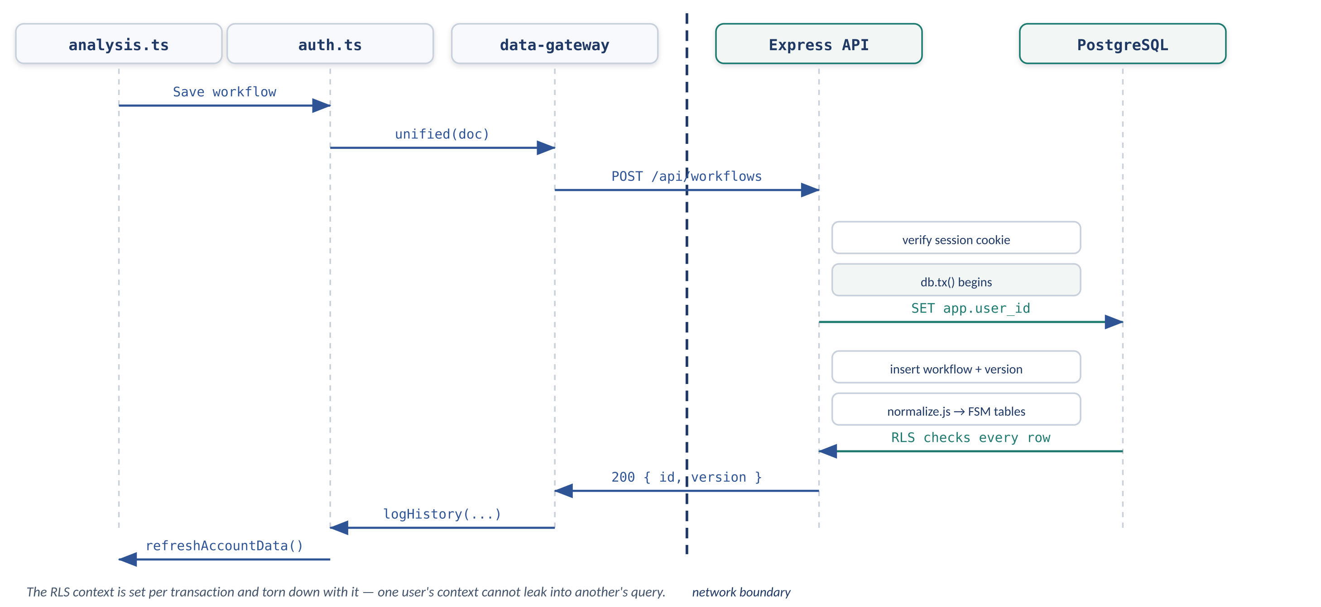
Figure 4 — Saving a workflow. Note the transaction: the RLS context is set per request and torn down with it, so one user's context can never leak into another's query.

The same diagram as text
Reproduced for copy-paste, diffing, and plain-text contexts.
analysis.ts auth.ts data-gateway Express Postgres
| | | | |
Save workflow --> saveCurrentWorkflow | | |
| | unified(doc) | | |
| |----------------->| | |
| | | POST /api/workflows |
| | | credentials: include |
| | |-------------->| |
| | | | verify session cookie
| | | | db.tx() begins:
| | | | SET app.user_id
| | | | SET app.is_superuser
| | | |------------->|
| | | | insert workflow /
| | | | next workflow_version
| | | | normalize.js -> stage,
| | | | state, transition ...
| | | | RLS checks every row
| | | |<-------------|
| | |<--------------| 200 { id, version }
| |<-----------------| | |
| | logHistory(...) | | |
|<----------------| refreshAccountData() | |

4.3 Two deployment shapes
The compiled file can be opened directly from disk or served by the API. window.PLUMBLINE_API in shell.html tells the client where the API is; the data gateway auto-detects reachability at boot and warns in the console if it fails.
Configuration | Behaviour
File opened locally (today's dev loop) | Browser loads file://…/dist/Plumbline_Studio_V2.html; the API runs at http://localhost:8080. Cross-origin, so the cookie configuration and CORS matter. This is what start-plumbline.bat produces.
Served by the API (production shape) | Express serves dist/ from the same origin as /api/*. No CORS, cookies behave naturally, and one URL is the whole product. This is the intended shape for plumblinetech.com.

There is no offline mode. Without a reachable API the client shows "Plumbline database is unreachable" and cannot sign in, load, or save. The single-file build is a packaging convenience, not an offline capability. Any promise made to a customer about running the HTML standalone would be a promise about a mode that does not exist.

5 The server and the database

5.1 API surface
Group | Endpoints
Session | POST /api/login /signup /logout /password /profile · GET /api/session /profile
Workflows (v1) | GET/POST /api/workflows · GET/DELETE /api/workflows/:id
Workflows (v2, versioned) | GET/POST /api/v2/workflows · GET/PATCH/DELETE /api/v2/workflows/:id · POST /api/v2/workflows/:id/versions · GET /api/v2/versions/:versionId
Analysis lineage | GET /api/v2/versions/:versionId/analyses · POST … /analyses · PATCH /api/v2/analyses/:runId
Groups and history | GET/POST /api/groups · PATCH/DELETE /api/groups/:id · GET/POST /api/history
Administration | GET /api/admin/users /audit · POST /api/admin/users/:id/password /active /revoke-sessions · POST /api/admin/purge-expired-auth
Services | POST /api/llm · GET /api/health

The v2 endpoints already exist for the versioned model, and analysis_run / analysis_finding are already wired. That is the surface a server-side engine will write into — the schema was designed for it.

5.2 Defence in depth
Authorization is enforced at two independent layers, and the second does not trust the first.
- Route level: the handler checks that the caller owns the resource, or is a superuser.
- Database level: every authenticated request runs inside db.tx(), which sets app.user_id and app.is_superuser. RLS policies on workflow, workflow_version, process, stage, state, transition, cost_item, analysis_run and analysis_finding read that context. A route that forgot its ownership check still returns nothing.
Supporting properties enforced by the schema rather than by application code:
- Versions are immutable — a trigger rejects UPDATE on workflow_version, and the ORIGINAL version cannot be deleted while its workflow exists.
- audit_log is append-only against every role including the owner, by trigger.
- Integrity that would be tedious and unreliable in JavaScript lives in triggers: folder cycles, dependency cycles, stage/process consistency, state-type validity.
- Passwords are bcrypt only. admin_reset_password() re-hashes, revokes sessions, deletes remember tokens and writes an audit row in one transaction.

6 Where the architecture is not yet finished
One deliberate gap remains, and it is the most consequential thing in this document. The certifying engine is still compiled into the browser file. build.py inlines runtime.js, modules.gen.js, facade.js and monoid.js into dist/Plumbline_Studio_V2.html, so anyone who opens that file in a text editor has the analysers, the Lemma kernel and the cost model in front of them.
There is a second copy of the same problem: computeTool() inside analysis.ts re-implements the six tools' suggestion logic — depth maps, reachability, duplicate detection, the cost arithmetic — independently of the engine bundle. Moving the engine without excising that would protect nothing.
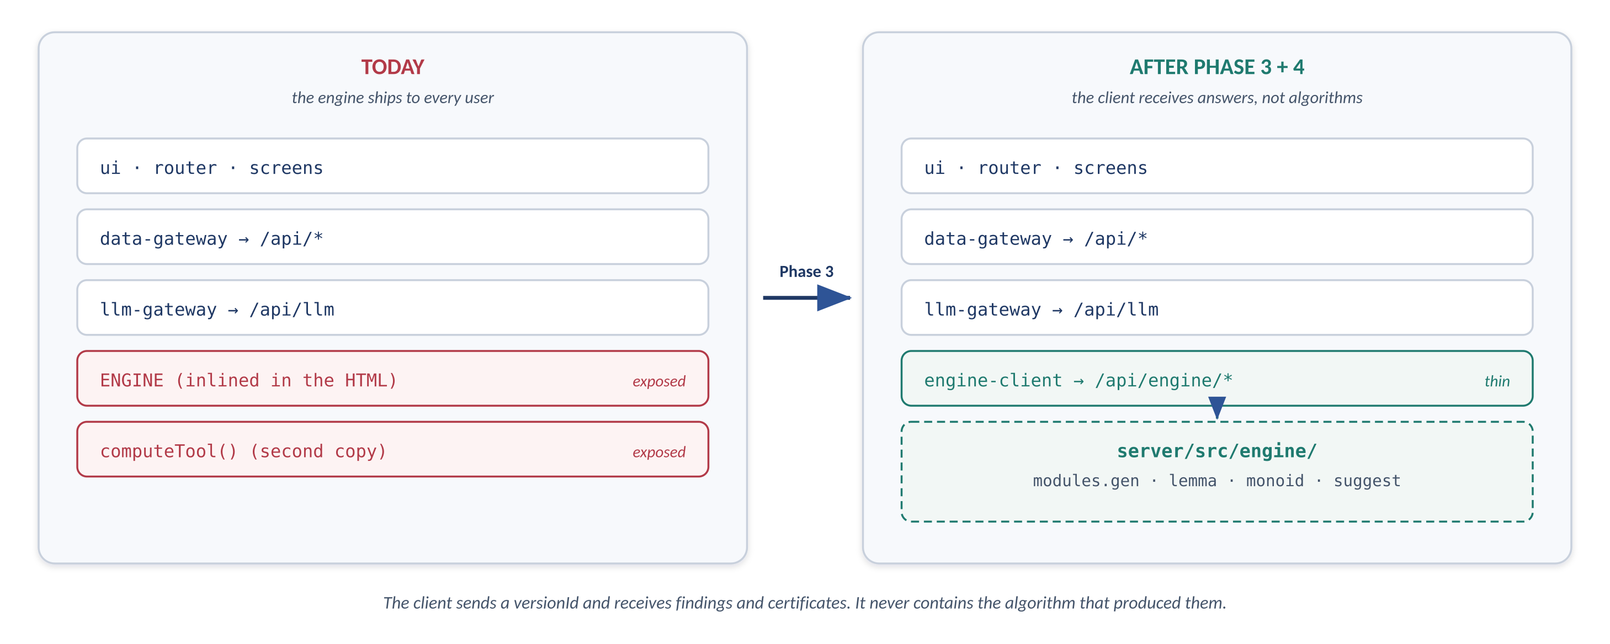
Figure 5 — The remaining move. Phases 1 and 2 make it a transport change rather than a refactor.

The same diagram as text
Reproduced for copy-paste, diffing, and plain-text contexts.
TODAY INTENDED (Phase 3 + 4)
----- ----------------------
browser browser
ui + router + screens ui + router + screens
data-gateway --> /api/* data-gateway --> /api/*
llm-gateway --> /api/llm llm-gateway --> /api/llm
ENGINE (inlined) engine-client --> /api/engine/*
computeTool (inlined) |
server |
engine-api.js
engine/ modules.gen, lemma,
monoid, suggest

The client sends a versionId and receives findings and certificates.
It never contains the algorithm that produced them.
The four-phase plan, and where it stands:
Phase | Work | Status
1 | Split the UI into three routed modules over a shared core | DONE — commit fc271d6
2 | Route every engine call through one async client, still executing locally | Entry points marked // PHASE2 in analysis.ts
3 | Move the engine to server/src/engine/; add /api/engine/*; harden build.py against re-inlining | Not started
4 | Relocate computeTool() to the server; return suggestions as declarative ops | Marked // PHASE4 in analysis.ts

The decision that gates Phase 3. After the engine moves, the compiled file only works against a reachable API. Since there is no offline mode today (4.3), that costs nothing — but it must be confirmed rather than assumed before the move, because it is irreversible in the sense that customers notice.

6.1 The rule that keeps it honest
Once the engine moves, build.py should fail the build if engine identifiers reappear in the output. Protection that depends on a file list staying correct is one bad merge from not existing; protection that fails a build is visible. build.py already does this for the module split — it aborts if any of the seven presentation modules is missing, or if studio/main.ts reappears — so the pattern is established.

7 Reference

7.1 Where things live
src/
presentation/ shell.html studio.css
app/ runtime.js router.js ui-boot.js loader.js
ui-modules.gen.js (render/app packages, presets)
modules/shared/ dom.ts workspace.ts auth.ts
modules/home/home.ts modules/editor/editor.ts
modules/analysis/analysis.ts
data/ data-gateway.js REST client
llm/ llm-gateway.js proxy client
engine/ runtime.js modules.gen.js facade.js monoid.js <- moves in Phase 3
editor/ workflow-editor.html separate document, iframed

server/
src/index.js routes, auth, sessions, RLS context
src/normalize.js snapshot -> normalized FSM tables
migrations/ 001_init 002_production_schema 003_security_patch

build.py inlines everything into dist/Plumbline_Studio_V2.html
tools/phase1-undef-check.js reports identifiers a module never declares

7.2 Build and run
Task | Command
Full setup (install, migrate, build, run) | powershell -ExecutionPolicy Bypass -File .\setup-plumbline.ps1
Start the app | start-plumbline.bat
Rebuild after editing src/ | python build.py --check
Check module references after moving code | node tools/phase1-undef-check.js <files>
Edit without building | open src/plumbline-dev.html

7.3 Invariants worth not breaking
- No secret ever reaches the browser. The connection string, session secret and API key live only in server/.env.
- The database is the system of record; the browser holds a working copy.
- Shared modules never require screen modules — screens are notified through workspace hooks.
- Screens toggle the "active" class, never style.display: studio.css defines .plPage{display:none} and .plPage.active{display:flex;flex-direction:column}.
- ui-boot.js is inlined mid-document, so anything touching DOM below that point must wait for DOMContentLoaded.
- Moving code between modules is done with the AST rewriter and verified with the undefined-reference checker — regex fails on ===, on bare callback references, and on locally shadowed names.

