PLUMBLINE
Workflow Navigation Sidebar
Development plan — overview, file-by-file changes, build changes
github.com/rmsamuel2/Plumbline2 · master · written against commit fc271d6
Every file path, function name, endpoint and line reference below was verified against the repository at that commit.

Contents
Contents 2
1 Big picture 4
1.1 What is being built 4
1.2 The single most important fact 4
1.3 The one server-side gap 4
1.4 Shape of the work 5
1.5 Why a shared module and not a screen module 5
1.6 Sequence 6
2 Files that need to be modified 7
2.1 server/src/index.js 7
2.2 src/editor/workflow-editor.html 7
2.3 src/presentation/shell.html 8
2.3.1 The sidebar container 8
2.3.2 The Analysis Read/Save button 8
2.3.3 The script marker 8
2.4 src/presentation/studio.css 8
2.5 src/app/ui-boot.js 9
2.6 src/app/modules/editor/editor.ts 9
2.7 src/app/modules/analysis/analysis.ts 10
3 New files that need to be created 11
3.1 Public surface 11
3.2 Internal structure 11
3.3 The three behaviours that need care 12
3.3.1 Saving 12
3.3.2 Loading 12
3.3.3 Folder operations 13
3.4 Two states that must be handled 13
4 How the build needs to change 14
4.1 build.py — PARTS 14
4.2 build.py — REQUIRED_MODULES 14
4.3 shell.html — the marker 14
4.4 src/plumbline-dev.html 14
4.5 Expected build output 15
4.6 Verification 15
5 Order of work and acceptance 16
5.1 Suggested commits 16
5.2 Acceptance checklist 16
5.3 Effort 16
5.4 Deliberately out of scope 17

1 Big picture

1.1 What is being built
A pop-up sidebar that lists the signed-in user's saved workflows organised into folders, and that both reads and writes. It opens from the Editor's existing Read/Save button, and from a new Read/Save button in the Analysis Studio. From it the user can:
- Save the active workflow as a standalone item, or into a folder.
- Open a saved workflow into whichever screen they opened the sidebar from.
- Create, rename, move and delete folders.
- Move a workflow between folders, or out of one entirely.
This document treats that as a first slice. The panel is expected to grow — version history, search, sharing — so the plan is organised so that later features are additions to one module rather than changes spread across the codebase.

1.2 The single most important fact
Almost all of this already exists. Folders are not a new feature that needs designing from the database up. The schema, the API and the client data gateway were all built for this and are sitting unused. What is missing is the user interface and the two buttons that open it.

Verified at commit fc271d6:
Layer | State today
Database | workflow_group exists with recursive parent_group_id, an owner-scoped unique sibling-name index, a cycle-rejecting trigger, and RLS. workflow.group_id exists and is nullable. The v_workflow_tree recursive view exists. No migration is required.
Express API | GET /api/groups returns the whole tree for the caller. POST /api/groups creates. PATCH /api/groups/:id renames and re-parents. DELETE /api/groups/:id removes. POST /api/workflows already accepts groupId. One gap only — see 1.3.
data-gateway.js | listGroups, createGroup, updateGroup, deleteGroup all exist. saveWorkflow already forwards groupId. updateWorkflow can PATCH a workflow's groupId. No new gateway methods are needed.
Client UI | Nothing. Saved workflows appear as a flat list inside the account modal (paintAccountLists in shared/auth.ts). Folders are invisible to the user.
Editor button | workflow-editor.html line 1512 has <button id="btnReadSave"> with the tooltip "Read/Save is coming soon" and no click handler at all.
Analysis button | Does not exist. The toolbar has Download, Save workflow, Saved workflows, Apply all improvements.

1.3 The one server-side gap
GET /api/workflows returns id, name, savedAt, tools and versionNumber — but not group_id. Without it the sidebar cannot know which folder a workflow belongs to, so it cannot place it in the tree. That is a one-column addition to one SELECT. It is the only server change in this plan.

1.4 Shape of the work
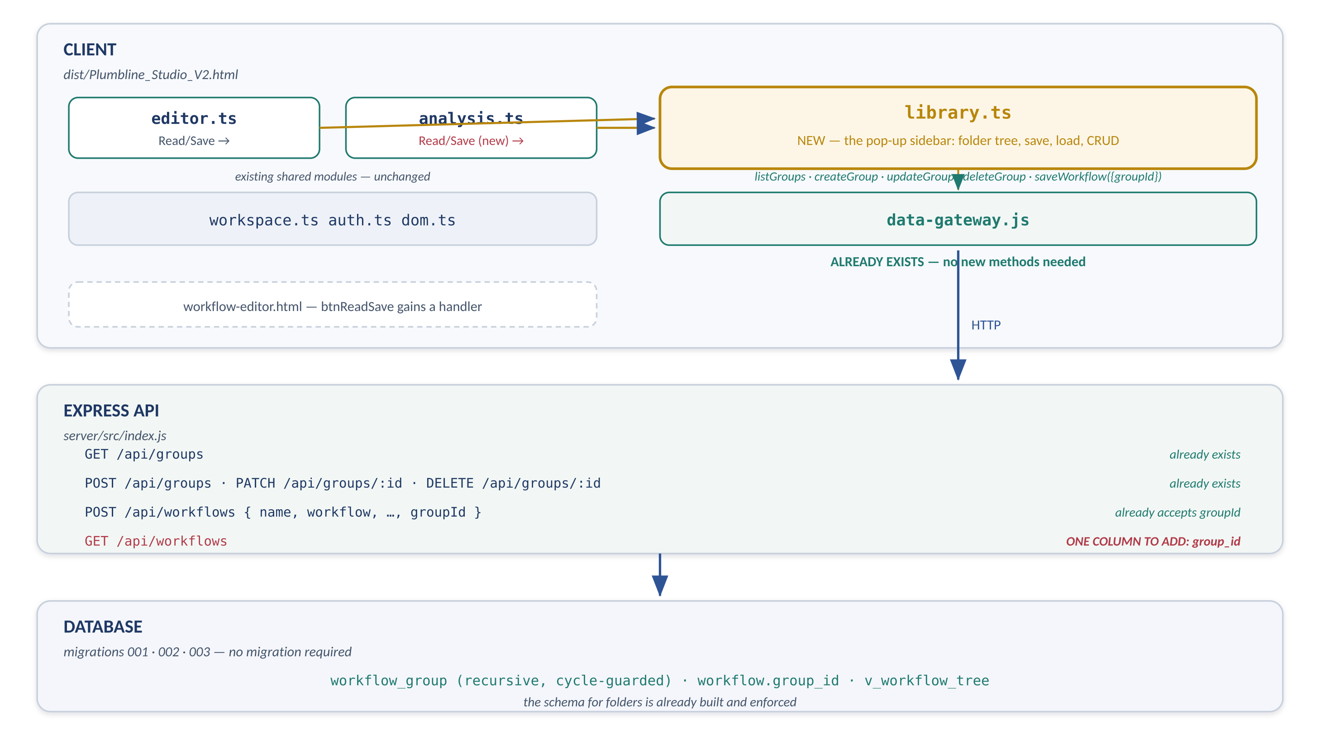
Figure 1 — Where the sidebar sits. Amber is new, green is existing and reused. The data and database layers need no work; the API needs one column.
The work divides into four pieces, in the order they should be done:
# | Piece | Why this order
1 | Server: add group_id to the workflow list | Everything downstream needs it, and it is a five-minute change that can ship on its own without any UI.
2 | New client module: shared/library.ts | The whole sidebar — tree rendering, folder CRUD, save and load. Testable on its own before anything opens it.
3 | Wire the two entry points | Editor: give btnReadSave a handler that messages the parent. Analysis: add a Read/Save button. Both call the same library.open().
4 | Build and verification | Two lines in build.py, one script tag in shell.html, and the undefined-reference check.

1.5 Why a shared module and not a screen module
The sidebar is opened from two different screens and overlays whichever one is showing. That makes it a service, like shared/auth.ts — not a screen. It therefore lives in src/app/modules/shared/, its markup sits in shell.html outside the router outlet, and it is initialised once at boot rather than mounted and unmounted. Putting it in a screen module would mean duplicating it, or having one screen reach into another — which the Phase 1 dependency rule forbids.

1.6 Sequence
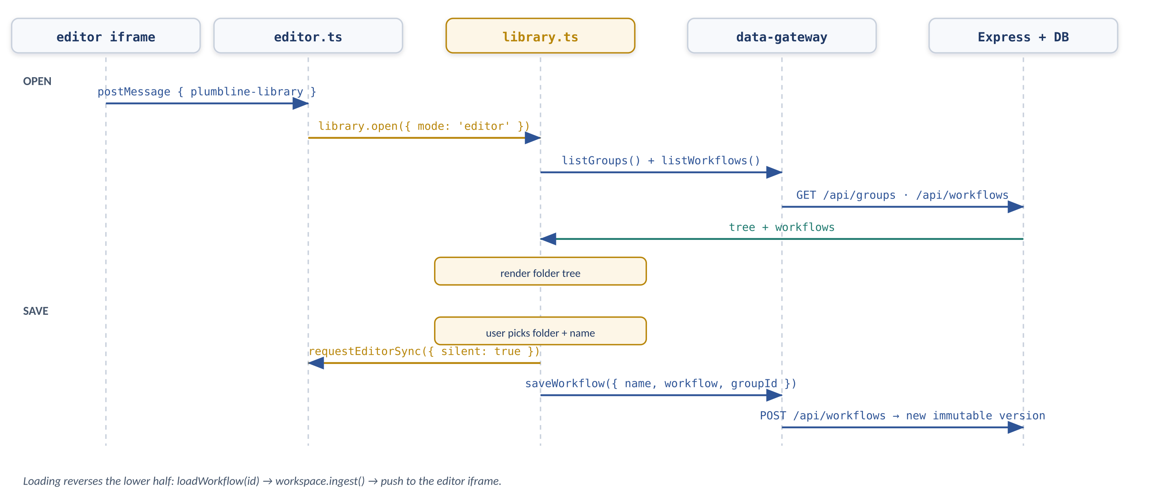
Figure 2 — Opening the sidebar from the Editor, then saving into a folder. Loading reverses the lower half.

2 Files that need to be modified
Seven files. Each section gives the exact change.
File | Size of change | What
server/src/index.js | 1 line | Add group_id to the workflow list query
src/editor/workflow-editor.html | ~8 lines | Give btnReadSave a click handler that messages the parent
src/presentation/shell.html | ~12 lines | Sidebar container markup, an Analysis Read/Save button, one script marker
src/presentation/studio.css | ~40 lines | Sidebar panel, overlay, tree rows
src/app/ui-boot.js | 3 lines | Load and initialise the library module, add it to ctx
src/app/modules/editor/editor.ts | ~6 lines | Handle the message from the iframe
src/app/modules/analysis/analysis.ts | ~4 lines | Bind the new Read/Save button
build.py | 2 lines | PARTS entry and REQUIRED_MODULES entry — see section 4

2.1 server/src/index.js
In the GET /api/workflows handler (around line 200), add the group id to the projection:
// BEFORE
q("select w.workflow_id as id, w.name, w.updated_at as \"savedAt\", " +
" coalesce(v.tools_executed, '[]'::jsonb) as tools, " +
" v.version_number as \"versionNumber\" " +
"from workflow w left join workflow_version v on v.version_id = w.current_version_id " +
"where w.owner_user_id = $1 order by w.updated_at desc", [req.session.userid])

// AFTER — one added column
q("select w.workflow_id as id, w.name, w.updated_at as \"savedAt\", " +
" w.group_id as \"groupId\", " +
" coalesce(v.tools_executed, '[]'::jsonb) as tools, " +
" v.version_number as \"versionNumber\" " +
"from workflow w left join workflow_version v on v.version_id = w.current_version_id " +
"where w.owner_user_id = $1 order by w.updated_at desc", [req.session.userid])
Nothing else on the server changes. The group endpoints, the save path and RLS are already correct.

2.2 src/editor/workflow-editor.html
Line 1512 defines the button; no handler exists anywhere in the file. Add one next to the other toolbar bindings (near line 6016, where addStage and addState are bound):
document.getElementById("btnReadSave").addEventListener("click", function () {
try {
if (window.parent && window.parent !== window) {
window.parent.postMessage({ type: "plumbline-library", mode: "editor" }, "*");
return;
}
} catch (e) { }
setStatus("Read/Save is only available inside Plumbline Studio.");
});
Also remove the "coming soon" tooltip on line 1512. This mirrors requestAuth() at line 5966, which is how the editor's Login button already reaches the parent — the same pattern, a new message type.
Do not build the sidebar inside the editor document. The editor is a separate document with its own state. Putting the panel there would mean a second copy of the folder logic, and it would have no access to the Studio's data gateway or session. The editor's only job is to say "the user pressed Read/Save".

2.3 src/presentation/shell.html
Three separate edits.

2.3.1 The sidebar container
Add immediately after the #authModal block — outside <main id="outlet">, because the sidebar overlays whichever screen is mounted and must not be torn down by the router:
<div id="libraryOverlay" class="libOverlay" style="display:none">
<aside id="librarySidebar" class="libPanel" role="dialog" aria-label="Workflow library">
<div class="libHead">
<span class="libTitle">Workflows</span>
<button class="btn ghost" id="libNewFolder" title="New folder">New folder</button>
<button class="btn ghost" id="libClose" aria-label="Close">&times;</button>
</div>
<input id="libSearch" type="text" placeholder="Find a workflow" autocomplete="off">
<div id="libTree" class="libTree"></div>
<div class="libFoot">
<input id="libSaveName" type="text" placeholder="Name this workflow">
<button class="btn primary" id="libSave">Save here</button>
</div>
<div id="libStatus" class="libStatus"></div>
</aside>
</div>

2.3.2 The Analysis Read/Save button
The Studio toolbar is at lines 76-79. Add one button before btnDownload:
<button class="btn ghost" id="btnReadSaveStudio">Read/Save</button>
Leave the existing Save workflow and Saved workflows buttons in place for now. Removing them is a separate decision — once the sidebar works, both become redundant and should go, but keeping them means the change is reversible without losing the ability to save.

2.3.3 The script marker
In the script block at the foot, add one line after @@SHARED_AUTH_JS@@:
<script>@@SHARED_LIBRARY_JS@@</script>

2.4 src/presentation/studio.css
Add near the other overlay rules. Values chosen to match the existing modal and panel styling:
.libOverlay{position:fixed;inset:0;background:rgba(22,36,59,.28);z-index:120;
display:flex;justify-content:flex-start}
.libPanel{width:320px;max-width:86vw;height:100%;background:#fff;
border-right:1px solid var(--line);display:flex;flex-direction:column;
box-shadow:2px 0 18px rgba(22,36,59,.12)}
.libHead{display:flex;align-items:center;gap:8px;padding:12px 14px;
border-bottom:1px solid var(--line)}
.libTitle{font-weight:600;flex:1}
.libPanel>input{margin:10px 14px;padding:7px 10px;border:1px solid var(--line);
border-radius:8px;font:inherit}
.libTree{flex:1 1 auto;min-height:0;overflow:auto;padding:4px 8px 10px}
.libRow{display:flex;align-items:center;gap:6px;padding:5px 6px;border-radius:8px;
cursor:pointer;font-size:13px}
.libRow:hover{background:var(--paper)}
.libRow.sel{background:var(--plumb);color:#fff}
.libRow .twist{width:14px;text-align:center;color:#6f7886}
.libRow .ver{margin-left:auto;font-size:11px;color:#6f7886}
.libKids{margin-left:14px;border-left:1px solid var(--line);padding-left:8px}
.libFoot{border-top:1px solid var(--line);padding:10px 14px;display:flex;gap:8px}
.libFoot input{flex:1;padding:7px 10px;border:1px solid var(--line);
border-radius:8px;font:inherit}
.libStatus{padding:0 14px 10px;font-size:12px;color:#6f7886;min-height:16px}
position: fixed is correct here. The sidebar overlays the whole viewport, so unlike the page containers it is not part of the flex chain that #outlet participates in. It is deliberately not inside #outlet and therefore is not affected by the .plPage display rules.

2.5 src/app/ui-boot.js
Load the module and add it to ctx, next to the existing auth.init(ctx) / ed.init(ctx) calls:
var auth = window.__PL.load("studio/shared/auth.ts");
var ws = window.__PL.load("studio/shared/workspace.ts");
var ed = window.__PL.load("studio/modules/editor.ts");
var lib = window.__PL.load("studio/shared/library.ts"); // ADD

var ctx = {
data: window.PlumblineData, llm: window.PlumblineLLM,
engine: window.PlumblineEngine,
workspace: ws, auth: auth,
library: lib, // ADD
bus: bus
};

auth.init(ctx);
ed.init(ctx);
lib.init(ctx); // ADD
auth.restoreSession();
window.__PL.load("studio/router.ts").start(ctx);
The lib.init(ctx) call must come after auth.init (the library needs a session to list anything) and before router.start (a screen may open it during its own mount). It is inside the existing DOMContentLoaded guard, which matters: the sidebar markup sits below this script tag in the document.

2.6 src/app/modules/editor/editor.ts
The iframe's new message needs handling. Add a branch to the listener installed by setupEditorSync(), alongside the existing plumbline-editor-data branch:
if (d && d.type === "plumbline-library") {
/* Flush first: the sidebar saves whatever the workspace holds, and the
user's most recent edits live inside the iframe until asked for. */
try { requestEditorSync({ silent: true }); } catch (e) { }
var lib = CTX && CTX.library;
if (lib) lib.open({ mode: "editor" });
return;
}
This requires editor.ts to keep the ctx it is given. Its init(ctx) currently discards the argument — store it in a module-level CTX variable, exactly as auth.ts already does.
The flush is not optional. Without requestEditorSync the sidebar would save the last state the Studio happened to import, silently discarding whatever the user typed since. This is the same failure the Editor screen's unmount guards against.

2.7 src/app/modules/analysis/analysis.ts
Bind the new button inside init(), with the other toolbar bindings:
var rs = dom_1.$("btnReadSaveStudio");
if (rs) rs.addEventListener("click", function () {
if (CTX && CTX.library) CTX.library.open({ mode: "analysis" });
});
As with editor.ts, analysis.ts must retain its ctx. Its mount already receives one and assigns this.ctx; promote that to a module-level variable so init(), which runs once, can reach it.

3 New files that need to be created
One file. Everything the feature needs that does not already exist lives in it.
Path | Purpose
src/app/modules/shared/library.ts | The pop-up sidebar: folder tree, folder CRUD, save into a folder, load from a folder. Registered as studio/shared/library.ts.

3.1 Public surface
Deliberately small. Screens do not reach inside it; they open it and let it finish.
Export | Contract
init(ctx) | Called once from ui-boot. Stores ctx, binds the panel's own controls (close, new folder, save, search). Binds once because the markup is permanent, matching the pattern in auth.ts.
open(opts) | opts.mode is "editor" or "analysis" and records where a loaded workflow should be delivered. Shows the overlay, then refreshes tree data. Returns a promise that resolves when the tree has rendered.
close() | Hides the overlay. Does not clear state, so reopening is instant.
refresh() | Re-fetches groups and workflows and re-renders. Called after any mutation and by open().

3.2 Internal structure
__PL.define("studio/shared/library.ts", function (require, exports, module) {
"use strict";
Object.defineProperty(exports, "__esModule", { value: true });

var dom_1 = require("studio/shared/dom.ts");
var ws_1 = require("studio/shared/workspace.ts");

var CTX = null; // injected by init()
var MODE = "editor"; // where a loaded workflow is delivered
var groups = []; // flat rows from GET /api/groups (v_workflow_tree)
var items = []; // rows from GET /api/workflows, now with groupId
var expanded = {}; // groupId -> bool
var selection = null; // { kind: 'group'|'workflow', id }
var filter = "";

/* ---- data ---------------------------------------------------------- */
async function refresh() { ... } // Promise.all of listGroups + listWorkflows

/* ---- tree shaping --------------------------------------------------- */
function buildTree() { ... } // flat rows -> nested nodes by parentGroupId
function matches(node) { ... } // search filter, keeps ancestors of hits

/* ---- rendering ------------------------------------------------------ */
function render() { ... } // rebuild #libTree from the model
function rowFor(node, depth) { ... } // one .libRow, folder or workflow

/* ---- actions -------------------------------------------------------- */
async function saveHere() { ... } // name + selected folder -> saveWorkflow
async function loadItem(id) { ... } // loadWorkflow -> workspace -> deliver
async function newFolder() { ... } // prompt -> createGroup -> refresh
async function renameFolder(id) { ... } // prompt -> updateGroup({name})
async function moveTo(id, groupId) { ...}// updateGroup or updateWorkflow
async function removeFolder(id) { ... } // confirm -> deleteGroup

exports.init = function (ctx) { ... };
exports.open = function (opts) { ... };
exports.close = function () { ... };
exports.refresh = refresh;
});

3.3 The three behaviours that need care

3.3.1 Saving
The save path is already correct — ctx.data.saveWorkflow forwards groupId, and the server appends a new immutable version when the name already exists. The sidebar therefore only decides two things: the name, and the selected folder (or null for a standalone workflow).
async function saveHere() {
var doc = ws_1.D();
if (!doc) return status("Open a workflow first.");
var name = (dom_1.$("libSaveName").value || "").trim() || doc.name || "Workflow";
var groupId = (selection && selection.kind === "group") ? selection.id : null;
try {
await CTX.data.saveWorkflow({
name: name,
workflow: doc.wf,
config: doc.config || {},
toolsExecuted: ws_1.activeToolIndexes(doc),
layout: doc.layout || {},
groupId: groupId
});
await refresh();
status(groupId ? "Saved into the selected folder." : "Saved.");
} catch (e) { status("Could not save: " + (e && e.message || e)); }
}
Workflow names are unique per user, not per folder. The schema has unique (owner_user_id, name) on workflow. Two workflows called "Returns" in two different folders is therefore rejected by the database. The panel must say so plainly rather than surfacing a constraint-violation error — and "save into this folder" cannot resolve a clash by moving it.

3.3.2 Loading
Where a loaded workflow goes depends on which screen opened the panel. In both cases it enters the workspace the same way; only the delivery differs, and MODE records which.
async function loadItem(id) {
var snap = await CTX.data.loadWorkflow(id);
ws_1.ingest(snap, "library"); // creates/selects the document
if (MODE === "editor") {
/* persist() fires the pushToEditor hook, which editor.ts listens to */
ws_1.persist();
}
ws_1.emitChange(); // analysis re-renders if mounted
close();
}
Note that neither branch calls into a screen module. The library talks to workspace, and the workspace hooks deliver the result to whichever screen is listening. That keeps the Phase 1 dependency rule intact: shared modules never require screens.

3.3.3 Folder operations
Operation | Implementation and the constraint behind it
Create | ctx.data.createGroup(name, parentGroupId). The database enforces unique sibling names per owner, so a duplicate returns an error the panel should show inline rather than as a raw failure.
Rename | ctx.data.updateGroup(id, { name }). Same uniqueness constraint.
Move | ctx.data.updateGroup(id, { parentGroupId }). trg_group_no_cycle rejects making a folder its own descendant, so drag-and-drop cannot corrupt the tree — but the panel should also grey out invalid drop targets rather than relying on the error.
Delete | ctx.data.deleteGroup(id). workflow.group_id is ON DELETE RESTRICT, so deleting a non-empty folder fails. Either block it in the UI when the folder has children, or offer to move the contents out first. Do not silently cascade.
Move a workflow | ctx.data.updateWorkflow(workflowId, { groupId }). Passing null takes it out of every folder.

3.4 Two states that must be handled
- Workflows with no folder. workflow.group_id is nullable, and the migration that imported the old saved_workflows rows left every one of them ungrouped. If the tree only renders folder contents, all pre-existing workflows become invisible. Render an explicit "Not in a folder" section.
- Empty folders. A newly created folder has nothing in it and must still be visible and selectable, otherwise the user cannot save into the folder they just made.

4 How the build needs to change
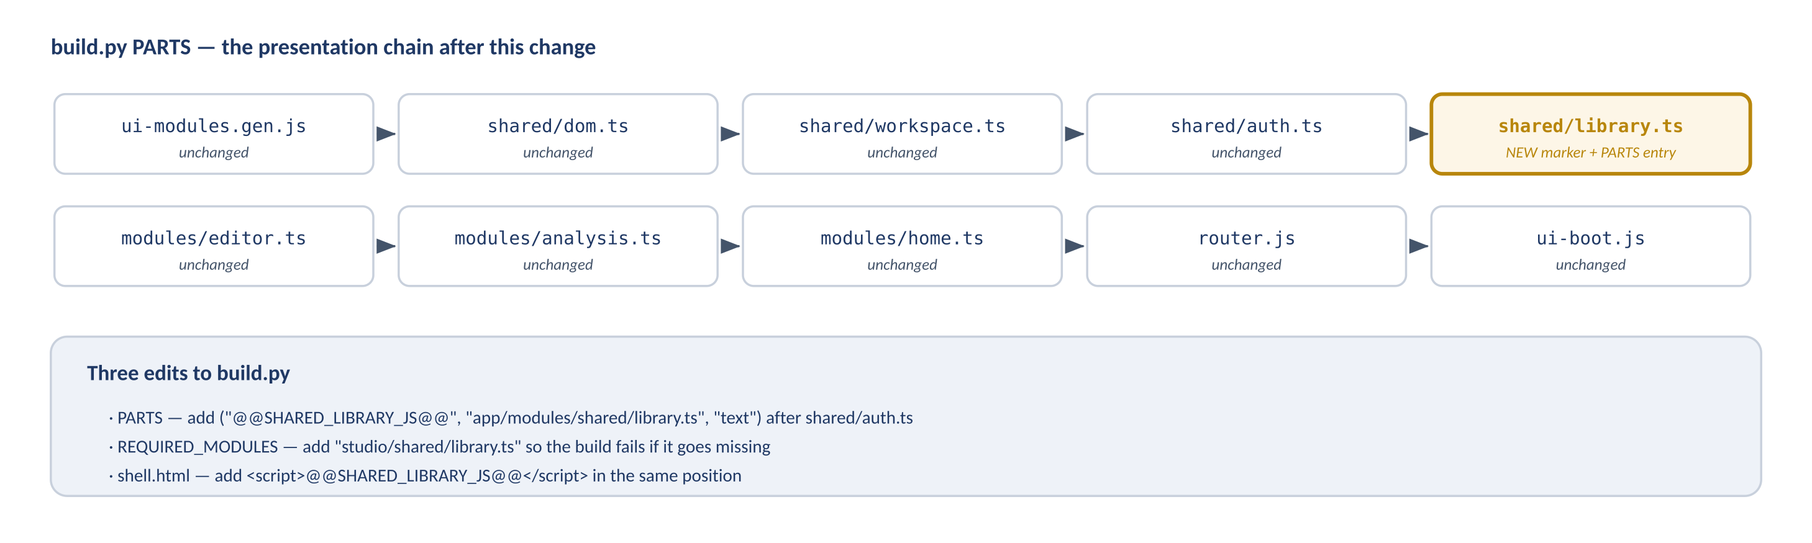
Figure 3 — The presentation chain in build.py. One new entry, one new marker, one new required module.

4.1 build.py — PARTS
Add one entry to the PARTS list, positioned after shared/auth.ts and before the screen modules. The __PL registry resolves lazily, so ordering among modules is not strictly load-bearing — but keeping the file order matching the dependency order makes the build output readable.
("@@SHARED_DOM_JS@@", "app/modules/shared/dom.ts", "text"),
("@@SHARED_WORKSPACE_JS@@", "app/modules/shared/workspace.ts", "text"),
("@@SHARED_AUTH_JS@@", "app/modules/shared/auth.ts", "text"),
("@@SHARED_LIBRARY_JS@@", "app/modules/shared/library.ts", "text"), # ADD
("@@MODULE_EDITOR_JS@@", "app/modules/editor/editor.ts", "text"),
("@@MODULE_ANALYSIS_JS@@", "app/modules/analysis/analysis.ts", "text"),
("@@MODULE_HOME_JS@@", "app/modules/home/home.ts", "text"),
("@@ROUTER_JS@@", "app/router.js", "text"),
("@@UI_BOOT_JS@@", "app/ui-boot.js", "text"),

4.2 build.py — REQUIRED_MODULES
Phase 1 added a self-check that fails the build if any presentation module is missing from the output. Extend it so the same protection covers the new module — otherwise a mis-typed path produces a build that succeeds and an app whose Read/Save button does nothing:
REQUIRED_MODULES = (
"studio/shared/dom.ts",
"studio/shared/workspace.ts",
"studio/shared/auth.ts",
"studio/shared/library.ts", # ADD
"studio/modules/editor.ts",
"studio/modules/analysis.ts",
"studio/modules/home.ts",
"studio/router.ts",
)

4.3 shell.html — the marker
Covered in 2.3.3. The marker name in shell.html must match the PARTS entry exactly; a mismatch leaves a literal @@SHARED_LIBRARY_JS@@ string in the output, which the existing stray-marker check already catches.

4.4 src/plumbline-dev.html
The no-build development shell script-loads each source file directly. Add modules/shared/library.ts to its list in the same position, or the dev shell will diverge from the built artifact and nobody will notice until they need it.

4.5 Expected build output
python build.py --check

built C:\dev\Plumbline2\dist\Plumbline_Studio_V2.html
size: ~772,000 bytes (up from 759,325 — the new module plus CSS)
sha256: ...
check: OK — all layers inlined, facades present,
8 presentation modules registered, no stray markers
The count in that message is derived from REQUIRED_MODULES, so it moves from 7 to 8 on its own once 4.2 is done.

4.6 Verification
- Run the undefined-reference checker over every module, including the new one. It reports identifiers a module uses but never declares or imports — the failure mode that produced a dead editor in Phase 1.
cd tools
node phase1-undef-check.js ..\src\app\router.js `
(Get-ChildItem ..\src\app\modules -Recurse -Filter *.ts).FullName

# every line must read: clean
- Build with --check and confirm 8 modules are reported.
- Manual pass — the list in 5.2.

5 Order of work and acceptance

5.1 Suggested commits
# | Commit | Verifiable by
1 | server: return group_id from the workflow list | curl /api/workflows with a session cookie; groupId appears (null for existing rows)
2 | shell + css: sidebar markup and styling, hidden | Build passes; nothing visible changes
3 | library.ts + build.py + ui-boot wiring | Build reports 8 modules; window.__PL can load studio/shared/library.ts; open it from the console
4 | editor + analysis entry points | Both Read/Save buttons open the panel
5 | folder CRUD and move | Create, rename, move, delete all round-trip after a page reload

Commits 1 and 2 are independently safe: neither changes any behaviour a user can see, so both can land before the module is finished.

5.2 Acceptance checklist
# | Check
1 | Read/Save in the Editor opens the panel. Read/Save in Analysis opens the same panel.
2 | Editing in the Editor, then Read/Save → Save, stores the edits just made — not a stale snapshot. (This is the flush in 2.6.)
3 | Saving with no folder selected creates a standalone workflow, and it appears under "Not in a folder".
4 | Saving with a folder selected places the workflow in that folder; it survives a page reload.
5 | Saving an existing name appends a version rather than creating a second workflow — the version badge increments.
6 | A second workflow with a name already in use is refused with a readable message, not a raw database error.
7 | Create, rename, move and delete a folder; each survives a reload.
8 | Deleting a folder that still contains workflows is refused or offers to move the contents — never silently deletes them.
9 | A folder cannot be dragged into its own descendant.
10 | Loading a workflow from the Editor puts it in the editor canvas; loading from Analysis puts it on the analysis canvas.
11 | Pre-existing workflows created before this feature are all visible under "Not in a folder".
12 | Opening the panel while signed out prompts for sign-in rather than showing an empty tree.
13 | A second user account sees none of the first account's folders or workflows.
14 | Escape closes the panel; clicking the overlay closes it; neither loses unsaved editor work.

5.3 Effort
Piece | Rough size | Note
Server column | minutes | One line
shell.html + studio.css | 1–2 hours | Markup and styling only
library.ts | 1–2 days | The whole feature; tree rendering and folder CRUD are most of it
Entry points and ctx plumbing | 2–3 hours | Small, but touches four files
Build and verification | under an hour | Two lines plus the checks

5.4 Deliberately out of scope
- Version history in the panel. listVersions and loadVersion already exist, so it is a later addition to library.ts and nothing else.
- Removing the old Save workflow and Saved workflows buttons, and the saved-workflow list in the account modal. All three become redundant, but retiring them is its own change once the sidebar has proven itself.
- Drag-and-drop. Move via a context menu first; drag-and-drop is a rendering refinement over the same updateGroup and updateWorkflow calls.
- Sharing folders between users. workflow_group is owner-scoped and RLS enforces it; sharing would need a schema change and is a much larger piece of work.
One thing to decide before starting. Whether the sidebar replaces the account modal's saved-workflow list or sits alongside it. Two places to load a workflow from, behaving slightly differently, is the kind of duplication that becomes permanent. The plan above keeps both so the change is reversible — but the intent should be to retire the old one.

