**RMS**

Login Page:

RMS

Forget Password

Login

Sign On

Password

User Id

Business Logic:

1. Both internal and external user need to get authenticated using there either window credential or web (form).
2. Login button business logic first validates against active directory and if user present then it will allow success full authentication else it will check for form authentication. If user is validated successfully against form authentication then it will allow user to login to application else show message of invalid user.
3. We can use workflow to validate user.

Dashboard:

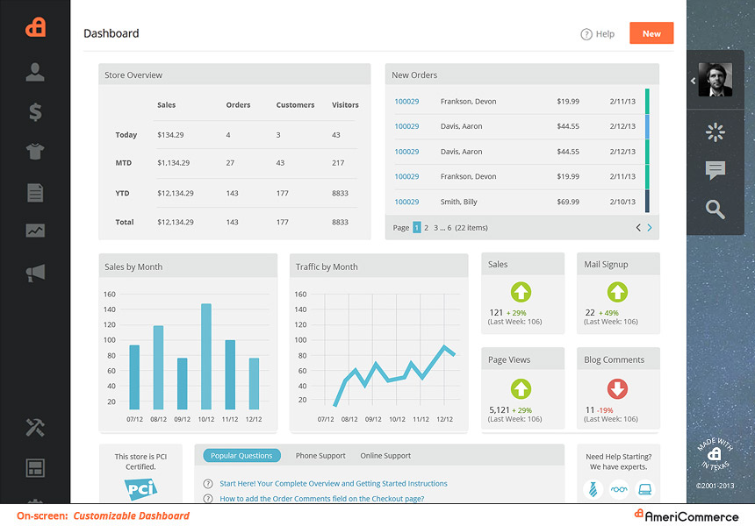

This is sample dashboard image. User can design his dashboard by using predefined component and availability of component will depend on user rights.

We need to find all component and rights as per Role.

Add Candidate Info:

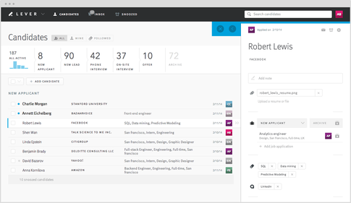

Panel Creation:

