System Design Document Template
Version 1.0

Approved By:
____________________________ ___________________________

Program Manager Quality Assurance

REVISION HISTORY
Revision | Version | Description of Change | Changed By | Effective Date
1 | 1.0 | Template | LCS, LLC
2
3

Note: Some areas of this template suggest including the requirement ID with the design element. This could create additional work in updating the design document if there are subsequent requirements changes. If you are using an automated requirements repository, it is better to include only the design element ID in the document. The requirement can be located using traceability from the design element to the requirement if the repository is well-maintained. The compliance matrix can be printed with requirement and design IDs as well as the requirements text to assist the reader.

There may be more sections in this template than desired in your SDD. Some may be removed, changed, or merged depending on your system or organizational requirements.

Ludwig Consulting Services, LLC
TABLE OF CONTENTS
1 INTRODUCTION 6
1.1 Overview 6
1.2 Scope 6
1.3 Background 6
1.4 References 6
1.5 Assumptions and Constraints 6
1.6 Document Overview 7
2 METHODOLOGY 7
2.1 System Design Framework 7
2.2 System Design Alternatives 8
2.3 Risks 8
2.4 Updated Requirements Compliance Matrix 8
3 ROLES AND RESPONSIBILITIES MATRIX 8
4 SYSTEM DESCRIPTION 8
4.1 System Software Architecture 8
4.2 System Technical Architecture 9
4.3 System Hardware Architecture 9
4.4 External Interfaces 9
5 SUBSYSTEM SPECIFICATIONS 10
5.1 Subsystems 10
6 TECHNICAL SPECIFICATIONS 13
6.1 Module 13
7 DATA ARCHITECTURE 13
7.1 Database and File Architecture 13
7.2 Data Dictionary 14
7.3 Data Conversion 14
8 SECURITY 15
8.1 User Level Permissions 15
8.2 Control Points 15
8.3 Vulnerabilities 15
9 OPERATIONAL CONSIDERATIONS 15
9.1 Audit Trail 15
9.2 Recoverability 16
9.3 Failure Contingencies 16
9.4 System Availability 16
9.5 Capacity 16
9.6 Performance and Timing 16
9.7 Data Retention 17
9.8 Error Handling 17
9.9 Validation Rules 17
9.10 Conventions/Standards 17
9.11 Adaptability 17
APPENDIX A - ACRONYM LIST 18
APPENDIX B – GLOSSARY 19
APPENDIX C – REQUIREMENTS COMPLIANCE MATRIX 20

List of Exhibits
Exhibit 3: Sample Subsystem Diagram 10
Exhibit 4: Sample Module Diagram 11
Exhibit 5: Sample Sub Module Diagram 11
Exhibit 6: Sample Sub Module Diagram with Web Page Template 12
Exhibit 7: Sample User Interface Page 12
Exhibit 8: Data Element Matrix 12

INTRODUCTION
Provide a high-level overview of the system and include additional information that may be appropriate. The SDD is the system development blueprint that describes the system in detail. The details of the SDD are developed to the requirements and show traceability back to those requirements.

Overview
Describe briefly the structure of the document. Describe the system to be implemented. Since the SDD is a statement of how the system will perform, the SDD commits developers to the design.

Scope
Discuss what the document does and does not address.

Background
Discuss the organization for which the system is being developed, including its major responsibilities. Provide additional information to give the reader some context for the system, for example the capabilities gap the new or revised system will overcome or the strategic goals the system is intended to fulfill.

References
List key documents that support the SDD. Include meeting summaries, white paper analyses, standards, and related deliverables, as well as preceding documentation that provides information for its development. Keep it brief, details or a long list can go in an appendix. Pointing to documents that are frequently updated rather than including the information here (such as the risk register) will ensure this document remains current.

Assumptions and Constraints
Contractual or task level assumptions and/or constraints that are preconditions to preparation of the design should be spelled out here.

Assumptions
State assumptions associated with the system development. Assumptions are future situations beyond the control of the project, whose outcomes influence the success of a project.

Constraints
State constraints associated with development of the system. Constraints are conditions outside the control of the project that limit design alternatives. Constraints exist because of real business conditions. For example, a delivery date is a constraint if there are real consequences that will happen as a result of not meeting the date. Preferences are arbitrary. For example, a date chosen arbitrarily is a preference. Preferences, if included in the SDD, should be noted as such. Constraints can be broadly categorized as technical and non-technical. The following are examples of both types of constraints:
- Government regulations
- Technical standards imposed on the solution (for example, specific technology required by the enterprise architecture)
- Strategic decisions

Document Overview
Provide a guide to the document organization, the sections and their titles.

METHODOLOGY
Describe the approach used to develop the components of the SDD. If a particular methodology was followed, name it. This section is often omitted from an SDD.

System Design Framework
The design effort transforms the detailed, defined requirements into complete, detailed specifications that direct development and testing. Design decisions detail how the system will meet the defined functional, physical, interface, security, and data requirements. At the end of the design process the design is baselined.
The general system characteristics are defined during design. The operating system is established and the automated system packaged into major design subsystems. Inputs and outputs of each subsystem are defined, interfaces to external systems are designed, and administrative activities are established. Security and auditing needs are also addressed.
A more detailed structure of the system is then created based on the subsystems identified by the general characteristics. Each subsystem is partitioned into one or more design units, or modules. The process is described in a structure chart, flowchart, action diagram, pseudo code, or other acceptable format for each design unit, or module. Detailed logic specifications are written for each module described and data usage is physically defined to the elemental level. Functions requiring user input and approval are completed in this activity.
Throughout the design phase there are a series of check point and review processes. The design is reviewed to verify that it has the following characteristics:
- Is directly traceable to the requirements.
- Describes how the capabilities defined by the requirements will be implemented.
- Describes design considerations such as computer hardware, operating system, and database design.
The SDD includes:
- User, human/computer interface design
- System architecture
- Detailed system design
- Data base design including a physical data model and data dictionary
- External interface design

System Design Alternatives
Discuss viable design alternatives that were considered. If the status quo (current system, no changes) is not viable, state why. This is a concise, high level discussion that points out the major viable alternatives that were discussed during the design process. Discuss the risks and benefits of each, including the assessment of the design review of each alternative achieving the goals discussed in the background.

Risks
Discuss risks in the design of the system that affect future work and the contingency plans if the risk occurs. Risks should be in the risk register, and this document included in the reference list.

Updated Requirements Compliance Matrix
Functional requirements are baselined after the approval of the Functional Requirements Document (FRD). If requirements must be changed (which can occur at any time during the system life cycle), they must go through the configuration management process. After approval of the change, a minor baseline is created (this is the modified baseline, for example, from version 1.0 to 1.1).
The compliance matrix is updated to add the SDD elements. After the design is approved, it is baselined and any changes to it must also go through the configuration management process. The compliance matrix, updated with design elements, would be attached to the SDD for review and its version identified. As there are possible changes after SDD approval, the reference document section should state the location of the requirements repository (if there is one) so that future system developers can locate the current version. Ideally, the SDD will be updated to reflect changes.

ROLES AND RESPONSIBILITIES MATRIX
The roles and responsibilities of the team are sometimes included in the SDD.

SYSTEM DESCRIPTION
Describe the system in narrative form using non-technical terms.

System Software Architecture
Provide an overview of system software architecture and organization and a high-level diagram illustrating the subsystems and show interfaces to external systems and relationships between the system and user organizations.

System Technical Architecture
Describe and diagram the technical platform(s) that will be used to build the. If different subsystems use different technical platforms, describe each platform and relate it to the appropriate subsystem.

System Hardware Architecture
Describe the overall system hardware/communications and its organization. Include a list of hardware components, a brief description of each item, and diagrams showing connectivity.
Provide a description of the equipment required to operate the system. Include descriptions of the equipment presently available, as well as a more detailed description of the characteristics and impact of new equipment necessary for system operation. If the equipment documentation is extensive, put the information in an appendix or referenced as a separate document. Add diagrams and information to describe each component and its functions. Follow industry-standard component specification practices. Include the following information in the detailed equipment component designs:
- Memory and/or storage space requirements
- Processor requirements (speed and functionality)
- Graphical representation depicting the number of hardware items (for example, monitors, printers, servers, input/output devices), and the relative positioning of the components to each other

External Interfaces
Describe interfaces with other application software units, including those of other operational capabilities internal and external. For each interface, specify the following information:
- Name of application
- Owner of application, if external
- Details of interface
- Type of interface, such as interfaces to other software units
- Description of operational implications of data transfer, including security considerations
- Data transfer requirements to and from the software unit, including data content, format, and sequence
- Formats of data for both the sending and receiving systems, including the data item names, codes, or abbreviations that are to be interchanged
- Interface procedures
- Interface equipment
- Data conversion requirements

SUBSYSTEM SPECIFICATIONS
List and describe subsystems to establish a reference within the document. For web based systems, different web pages can be categorized as a subsystem. Provide a diagram, such as a hierarchical structure chart, that depicts the flow and mapping of the entire system. Include graphics of relationships of user organizations to major system components. To aid in identifying the set of requirements represented by those diagrams, it is recommended that the requirement number(s) be provided.

Subsystems

Subsystem Description #1
Provide a description of the subsystem and present the logical flow of the subsystem through the use of charts and diagrams such as structure charts, information architecture diagrams, interaction design diagrams, and wireframes. When feasible, the charts and diagrams should include a reference to their high level requirement(s). The charts and diagrams must provide an integrated presentation of the subsystem dynamics, entrances and exits, and interfaces with other software units. Supplement the representation with a program design language presentation, a narrative presentation, or a combination of the two.
Exhibit 3: Sample Subsystem Diagram
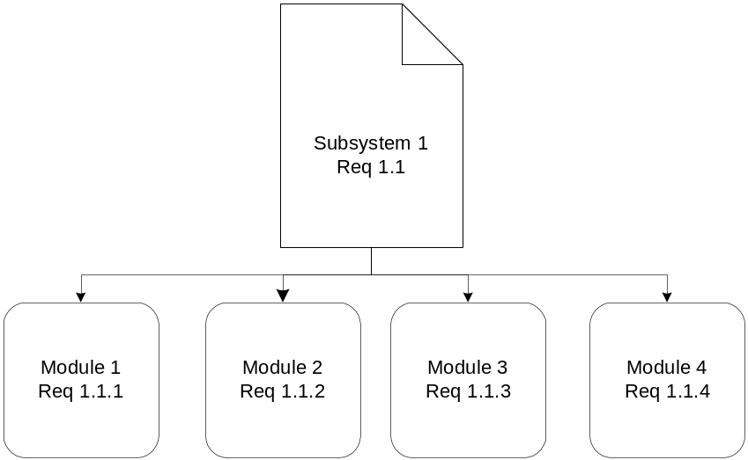

Master List of Modules
List modules in the subsystem and provide a brief description of each module. If there are no modules within the subsystem, this section may be omitted.

Modules
Repeat module sections and subsections as needed to describe the system.

Module Description
Provide a description for each module within the subsystem and explain its function. Use a chart or diagram to show the breakdown of any sub modules that exist within the module. If possible, provide the number for the requirement the module represents.
Exhibit 4: Sample Module Diagram
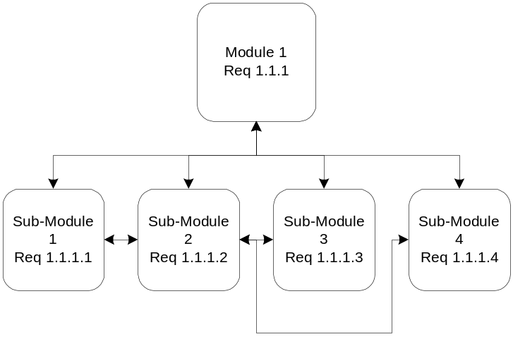

Master List of Sub-Modules
Provide a diagram or narrative list of all sub-modules for each module. If the module includes user interfaces (i.e., web pages), provide the interaction architecture (IA) diagram or an interaction design diagram showing the navigation or flow of screens (sub-modules) within the module and if applicable, the requirement numbers they represent.
Exhibit 5: Sample Sub Module Diagram
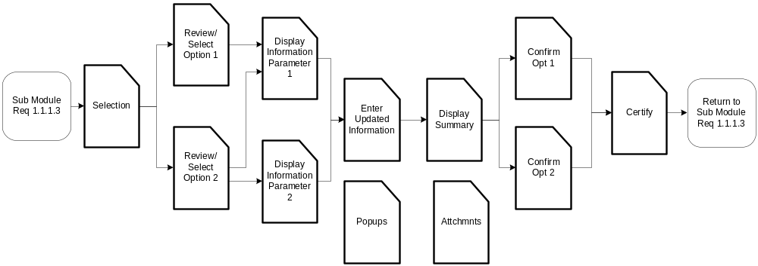
Exhibit 6: Sample Sub Module Diagram with Web Page Template

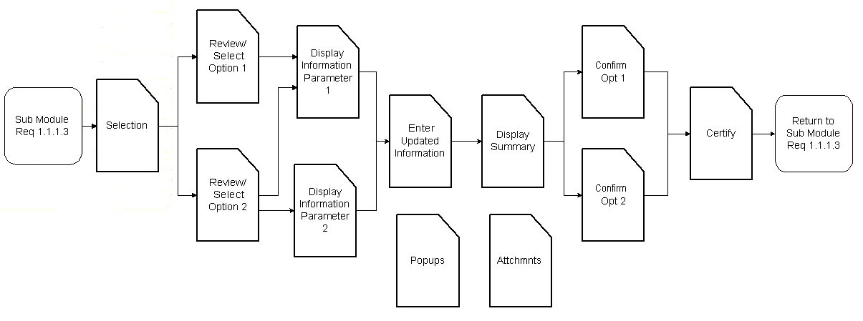

Sub-Module

Sub-Module Description
Provide a brief description of the sub-module. Repeat this section for multiple sub-modules.

User Interface
Provide the detailed design of the user interface of a sub-module (e.g., screen/page design or report) and if possible, the requirement number that the interface represents. For each field or label on the screen or report, define all data elements using the following table format.
Exhibit 7: Sample User Interface Page
Include a screen print of the user interface.
Exhibit 8: Data Element Matrix
Label | Table Name | Data Element Name | Edits/Comments
For screens, describe surface edits for data entry fields (e.g., Required, Must be ‘1’ or ‘2’, etc.). For screens and reports, include comments such as “Derived”, “Display Only”, etc.

Sub-Module Logic
Describe the logic of each software unit or module in the subsystem in narrative. This section is intended for end-users to understand. Do not use technical terms or reference software objects (e.g., stored procedures, Java beans, servlets, etc.

TECHNICAL SPECIFICATIONS
The intended audience of this section is the developer. Provide detailed technical design specifications that permit the developer to code. The section will be organized by sub-module within its parent module. The detailed design specifications are provided in each component section for each component of a sub-module. Provide the detailed design of shared, common sub-modules in a “Module “1 – N”” section labeled “Common Sub-Modules”. NOTE: The format of this section is flexible since it is dependent upon the technical platform environment, tool(s) used for the technical design, and the methodology. Use outputs from tools where appropriate.

Module

Provide a brief description of the module. Repeat section and sub-sections as needed. A more detailed description will be provided in Section 5.1.3.1. The purpose of the section is mainly to provide a framework to logically describe and list the sub-modules.

Sub-Module
Provide a technical overview of the sub-module using a narrative description accompanied by a diagram showing the relationships between all components within the sub-module.

Component

Provide a technical description of the component. Repeat this section as needed. Items included in the description are dependent upon the type of component (e.g., stored procedure, template, etc.). For all component types, provide the name, type, definition, location, constraints, and logic (either narrative or pseudo code). Include items such as input parameters, output parameters/result sets, and tables/files accessed as appropriate.

DATA ARCHITECTURE

Database and File Architecture
Describe the final design of the system database management system (DBMS) and the non-DBMS files. This can be included as an appendix.

Database Management System Architecture
Describe the final design of the database and include the following information (refer to the data dictionary):
- The physical data model including normalized table layouts and an entity relationship diagram (ERD).
- A description of the DBMS schemas, sub-schemas, records, sets, tables storage page sizes, etc.
- Describe database connectivity method (e.g., ODBC).
- Estimate of the database size or volume of data within the file and data pages, including overhead resulting from access methods and free space.
- Definition of the update frequency of the database tables, views, files, areas, records, sets, and data pages. Estimate the number of database transactions.
- Describe how permissions will be accommodated (e.g., user groups).
- List and reference the documentation of the DBMS utility software available to support the use or maintenance of the database.

Non-Database Management System Files
Provide a detailed description of non-DBMS files and include a narrative description of the usage of each file, include if the file is used for input, output, or both. If this file is a temporary file, an indication of which modules read and write the file, etc., and file structures (refer to the data dictionary).
- The file structure should:
- Identify record structures, record keys or indexes, and reference data elements within the records.
- Define record length (fixed or maximum variable length).
- Estimate the file size or volume of data within the file including overhead resulting from file access methods.
- Define the update frequency of the file. If the file is part of an online transaction-based system, provide the estimated number of transactions per unit time, and the statistical mean, mode, and distribution of those transactions.

Data Dictionary
Provide a comprehensive data dictionary detailing data element name, type, length, source, validation rules, maintenance (i.e., create, read, update, and delete capability), data stores, outputs, aliases, null/not null status, and description. This can be included as an appendix.

Data Conversion
Describe the data conversion process from the old to the new system. If there is a separate Data Conversion Plan, provide a brief description of the data conversion approach in this document and refer to the Data Conversion Plan.

SECURITY
Security is often an ignored area of a system, being added on rather than built in. In today’s environment, security must be addressed early in the system life cycle. Describe the use and management of integrity and access controls that apply to the physical components such as schema, sub-schema, partitions or physical files, records or tables, sets or relations, and data elements. Provide the security standard the system must meet, e.g., NIST or other standard or point to the security requirements ID numbers based on these standards.

User Level Permissions
Identify user roles and permissions. Describe use of permissions for that particular module, including the user levels that are available, and the authority that grants those permissions. Discuss differences between internal and external use of the module if applicable. List the data that is classified as private and unavailable to the public user.

Control Points
Identify the control points in the system. A control point is an application or a physical device that regulates which users have access to specific information and resources. A firewall is an excellent example of a control point. Additionally, show the relationship of security control points to each other in the system. For example, a proxy or web server may communicate to another server (domain controller) to validate the authentication of users accessing web content on a third server.

Vulnerabilities
Describe potential vulnerabilities that exist in the system. Vulnerability is a design, implementation, or operational condition inherent in the application or system that causes error, loss, or compromise of information or denial of service. Vulnerability may include, but not limited to dialup access, file uploads/downloads, logon screens or public web sites.

OPERATIONAL CONSIDERATIONS
Provide design-related information for operational considerations of the system. If the operational considerations have already been provided or addressed in another section or separate document, give a reference to that section or document rather than replicate the information.

Audit Trail
Describe audit trails to be built into the system. Audit trails enable the system to track and maintain a history of certain actions or behaviors by the users. This includes tracking mechanisms built into the system, including logs that keep track of submissions made by the users, changes or edits made by the user and any errors generated by the system.

Recoverability
Describe the system recovery design, for example, database mirroring, switchover, automatic system re-boot, graceful shutdown/start up, etc. Do not include recovery process steps performed manually by operators or system administrators

Failure Contingencies
Discuss alternative courses of action to be taken to satisfy requirements if the proposed system fails or refer to the business continuity and contingency Plan. Include:
- Backup, alternative requirements for ensuring the continued success of system functions.
- Fallback techniques for ensuring the continued satisfaction of the specific system requirements. Fallback indicates the use of another system or manual methods to satisfy the system requirements. For example: the fallback techniques for an automated system might be manual manipulation and recording of data.
- Degraded modes of operation, and if applicable, state the priorities for restoring the essential functional processing steps in the event that full processing capability is not available.

System Availability
Describe how system design reflects requirements for system availability. Identify and describe the major factors related to application availability, such as hardware, communications, other. If applicable, specify the design for systems with limited availability, and restricted hours of operation. For example, describe how the design addresses user attempts to access the system during the period of downtime. Also describe the design that would accommodate temporary shutdowns for enhancements or routine maintenance.

Capacity
Describe capacities and expected volumes of data that will reside on the host hardware. Then describe the design decisions that were made and/or strategies that were identified to satisfy the expected capacity requirements. Examples include, system memory requirements, hard drive space.

Performance and Timing
Describe the design decisions and/or strategies that were identified to satisfy the expected performance and timing requirements; include the reasoning employed for the design decisions made. The design should reflect performance and timing requirements for the following:
- Throughput time
- Response time to queries and to updates of the data files
- Sequential relationship of system functions
- Priorities imposed by types of input and changes in modes of operation
- Timing requirements for the range of traffic load under varying operating conditions

Data Retention
Describe how data retention requirements are addressed. Describe storage requirements for retained data. Include auxiliary storage medium such as tape, external hard drives, or DVD R/RW etc. and an estimate of the size of permanent or temporary storage that is required. This section should also outline the process for cataloging and storing the data.

Error Handling
Describe general error handling routines and procedures. This may include, but is not limited to standard screen and database errors. Also, describe how the system will process application errors and any subsequent interaction with users. Include or reference any standards or conventions that will be used.

Validation Rules
If applicable, describe additional system validation design not addressed in Section 7.2 Data Dictionary or elsewhere.

Conventions/Standards
Describe the system conventions and standards followed in the design. For example: If Microsoft standards are followed for Windows, IEEE for data formats, Section 508 compliance for accessibility, etc.

Adaptability
Describe the design decisions and/or strategies that were identified to meet the capabilities that will be incorporated into the system, giving it the flexibility to adapt to changing requirements, such as anticipated operational changes, interaction with new or improved systems, and planned periodic upgrades. Components and procedures designed for the system that are most likely to change must be identified.
APPENDICES

APPENDIX A - ACRONYM LIST
Provide the expanded name or title for the acronyms and abbreviations used in the document.

APPENDIX B – GLOSSARY
Provide a glossary of unique or special terms used in the SDD.

APPENDIX C – REQUIREMENTS COMPLIANCE MATRIX
Attached the compliance matrix. Requirements and their unique identifiers appearing in the body of the SDD must appear verbatim in the RCM. If the requirement is deleted or changed, these sections must also be reviewed and possibly updated.

