Names:
Raghad Shatnawi
Shatha Balaw
Mais Al-Qudah

The main function code:
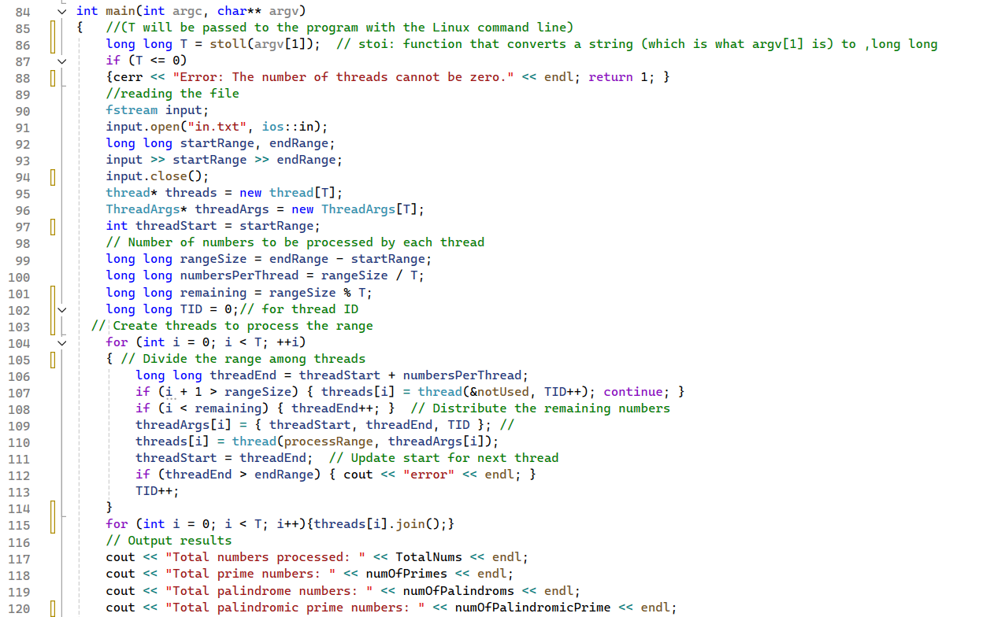
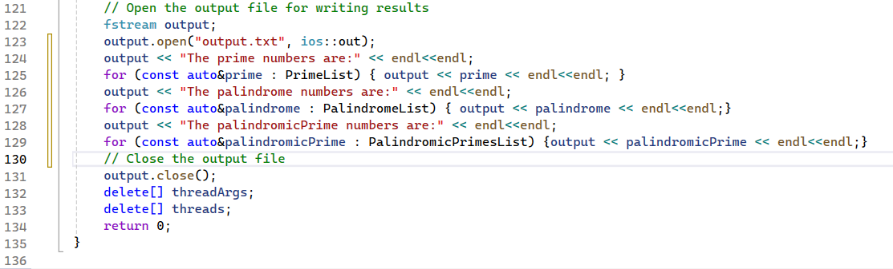

Thread Struct Code:
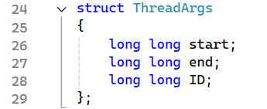

Thread Functions:
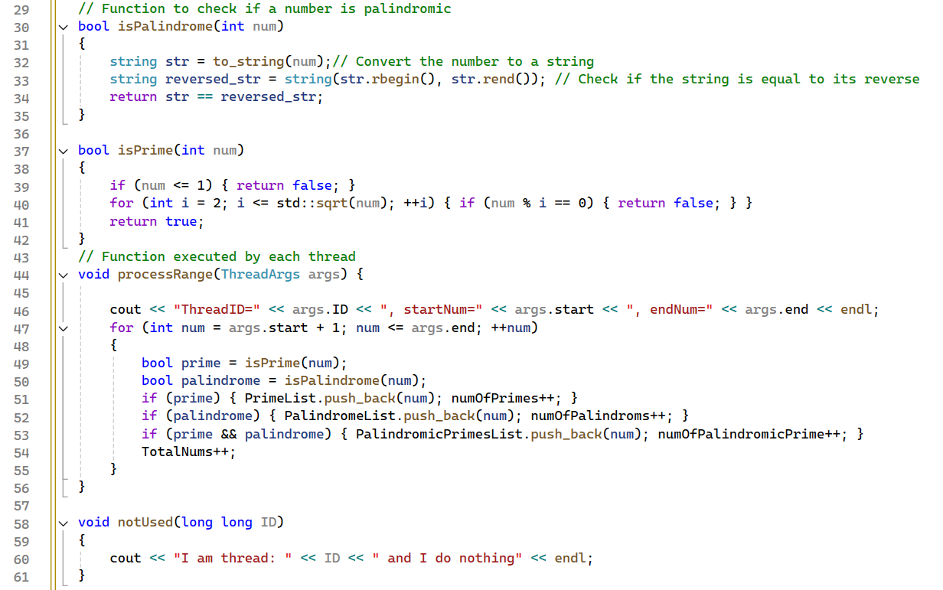

The part added to make the code safe:

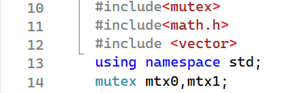
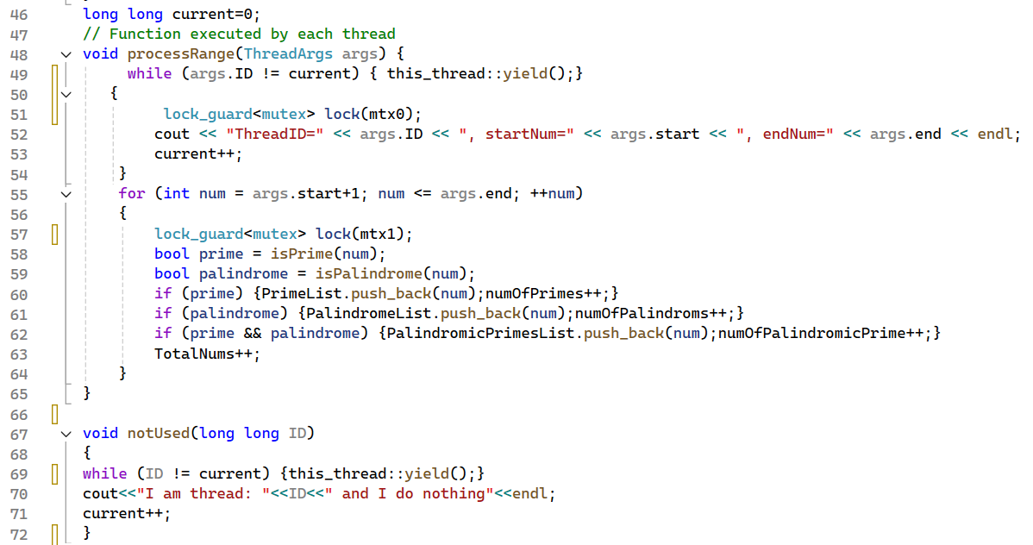
Race conditions occurred in the previous code because multiple threads accessed shared resources simultaneously, causing unpredictable results. So we implemented locks to control access to shared resources, ensuring only one thread can modify them at a time, thus fixing the issue.

the mutex library is used to ensure thread safety when multiple threads access shared resources concurrently
Added mutexes mtx0 and mtx1:
- mtx0 is used to lock the printing of the thread details.
- mtx1 is used to protect access to shared resources: the global variables (numOfPrimes, numOfPalindroms, numOfPalindromicPrime, and the lists PrimeList, PalindromeList, PalindromicPrimesList).
lock_guard<mutex> is used to lock and unlock the mutexes automatically when entering and exiting a block of code. This prevents other threads from accessing the critical section of the code where shared variables are modified.
current:
- New global variable current was added to ensure that threads start processing only after their turn, preserving the order of execution. Each thread checks if its ID matches current before proceeding, and if it doesn't, it yields (gives up its CPU time slice) until the condition is met.

ScreenShots:

- Screenshot of the output (unsafe version), when running the code with the following number of threads (T): 1, 4, 16, 64, 256, 1024:
T=1
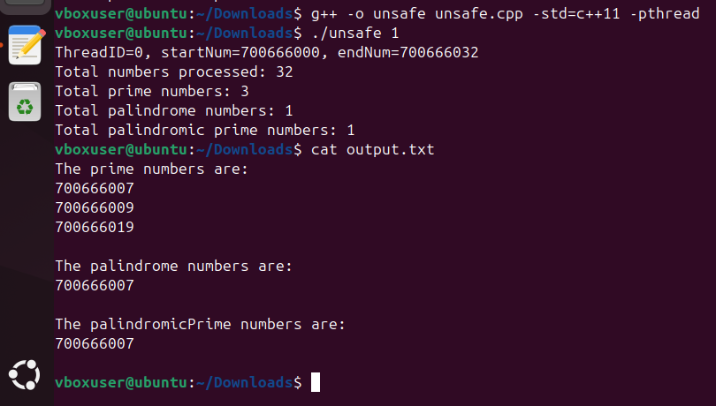
T=4
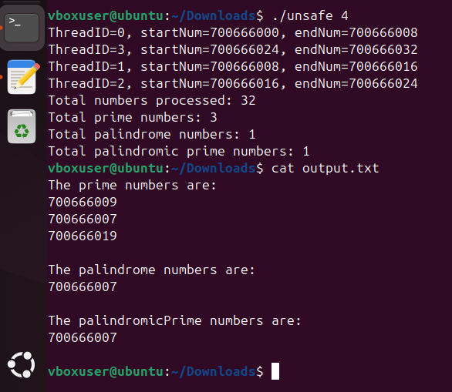

T=16
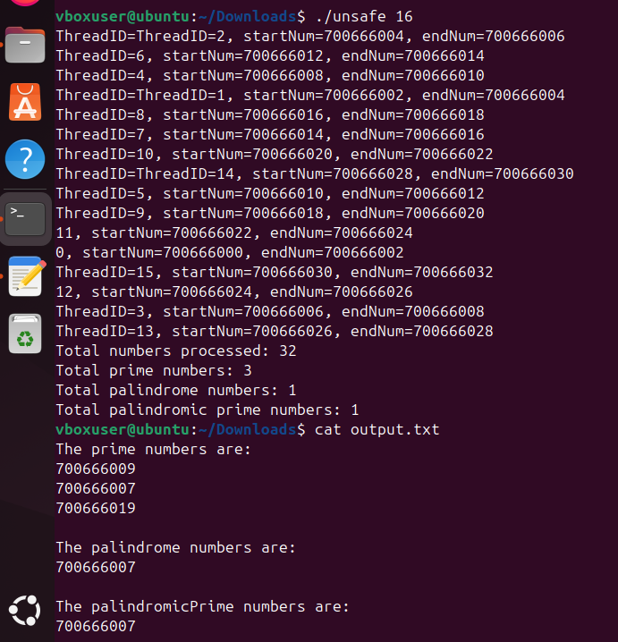

T=64
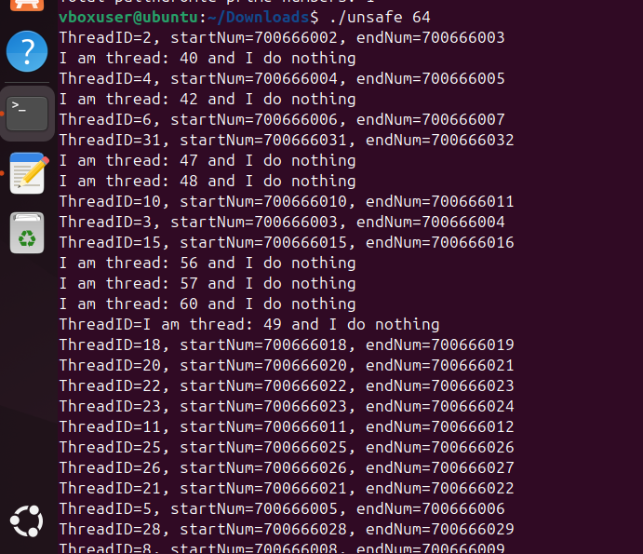
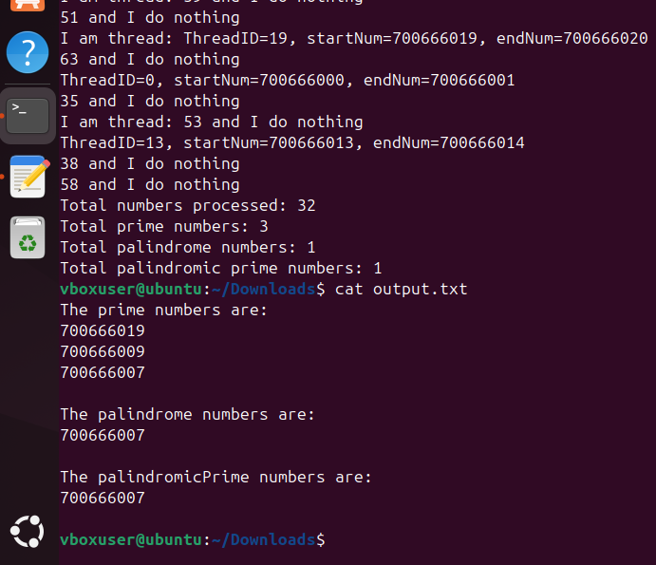

T=256
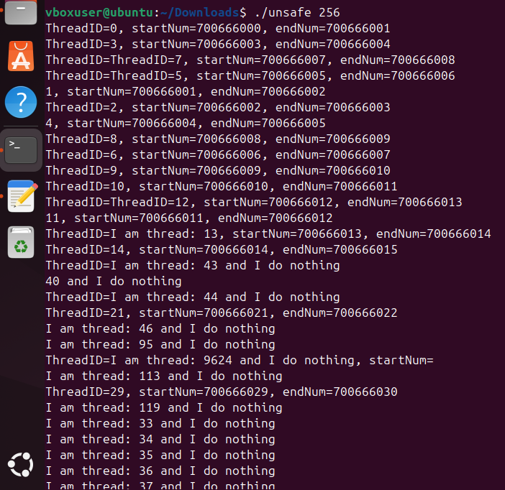
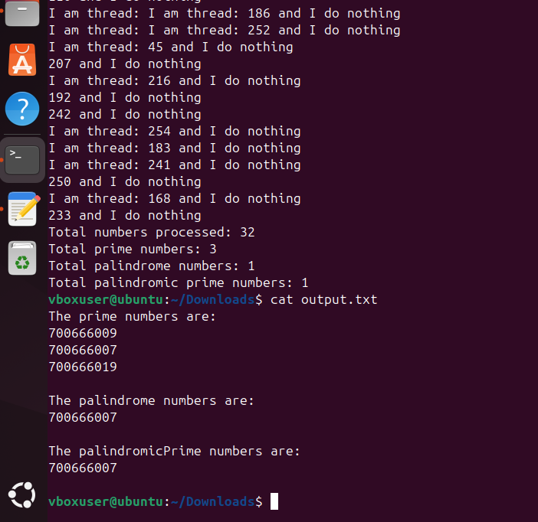

T=1024
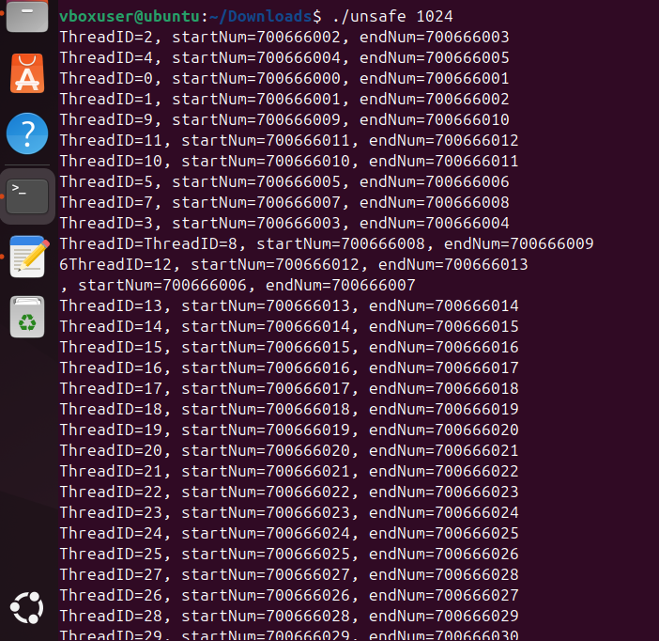
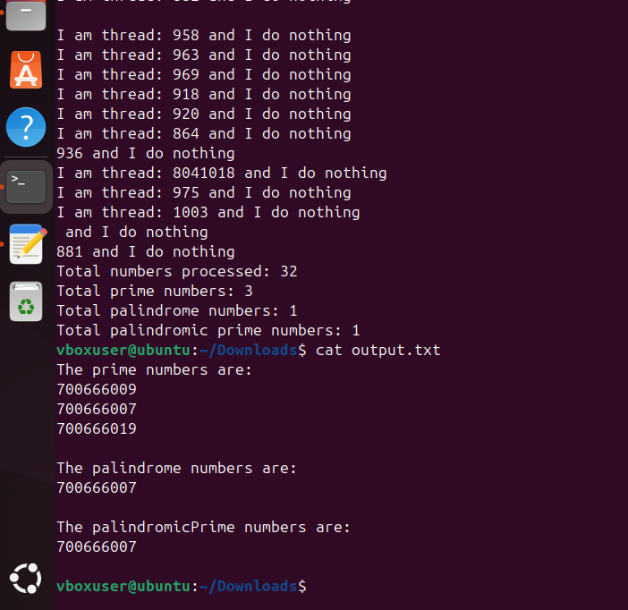

- Screenshot of the output (safe version), when running the code with the following number of threads (T): 1, 4, 16, 64, 256, 1024:
T=1
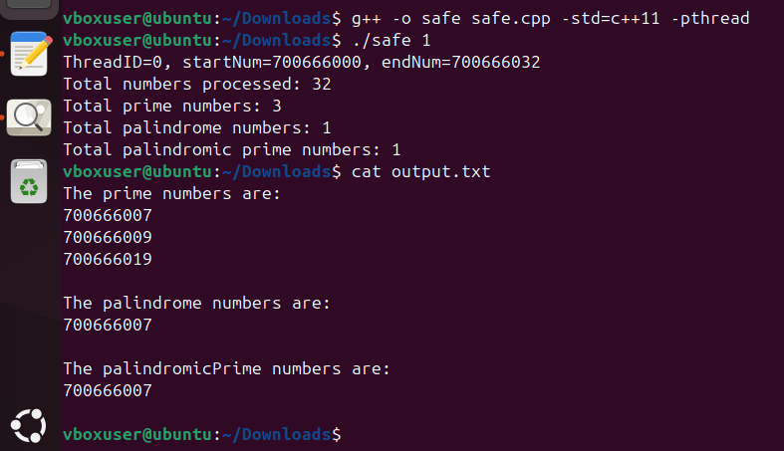
T=4
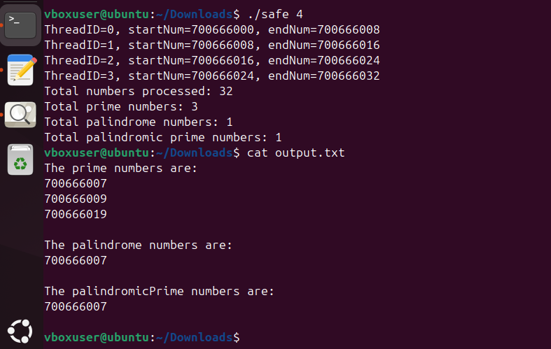
T=16
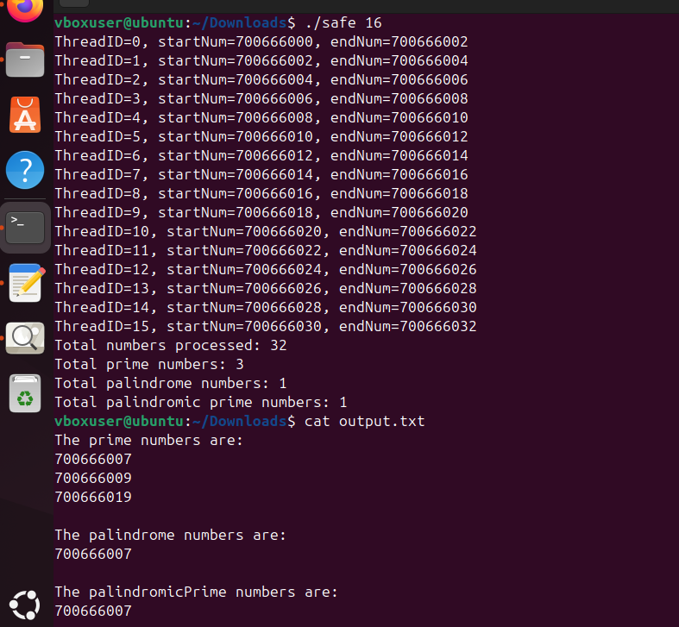

T=64
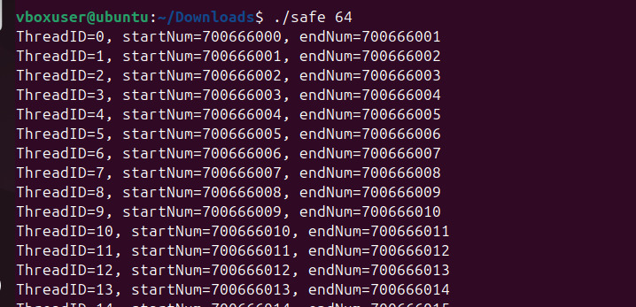
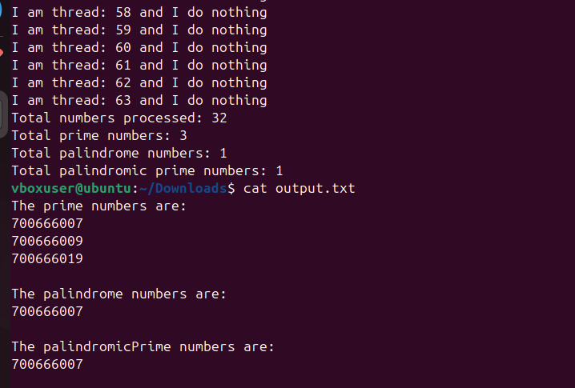

T=256
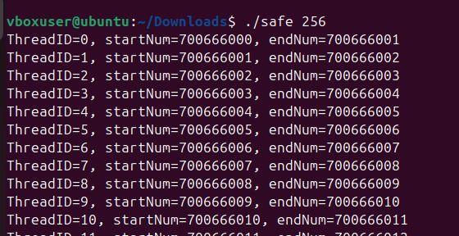
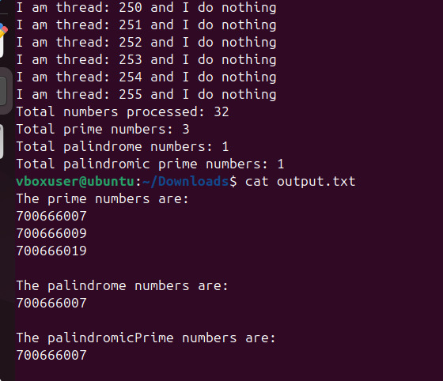

T=1024
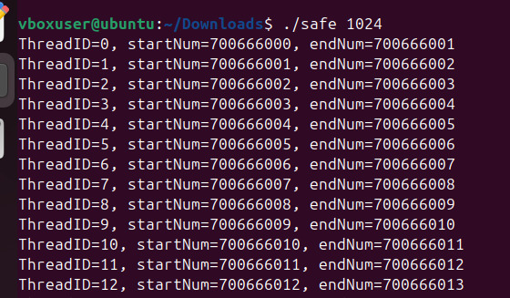
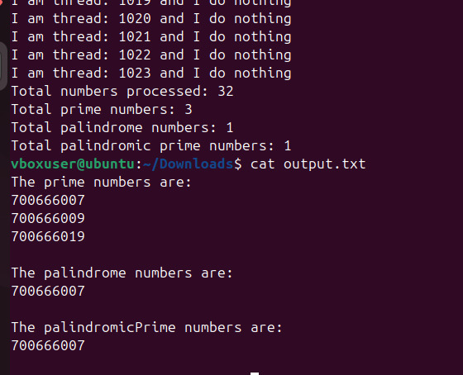

PC properties:
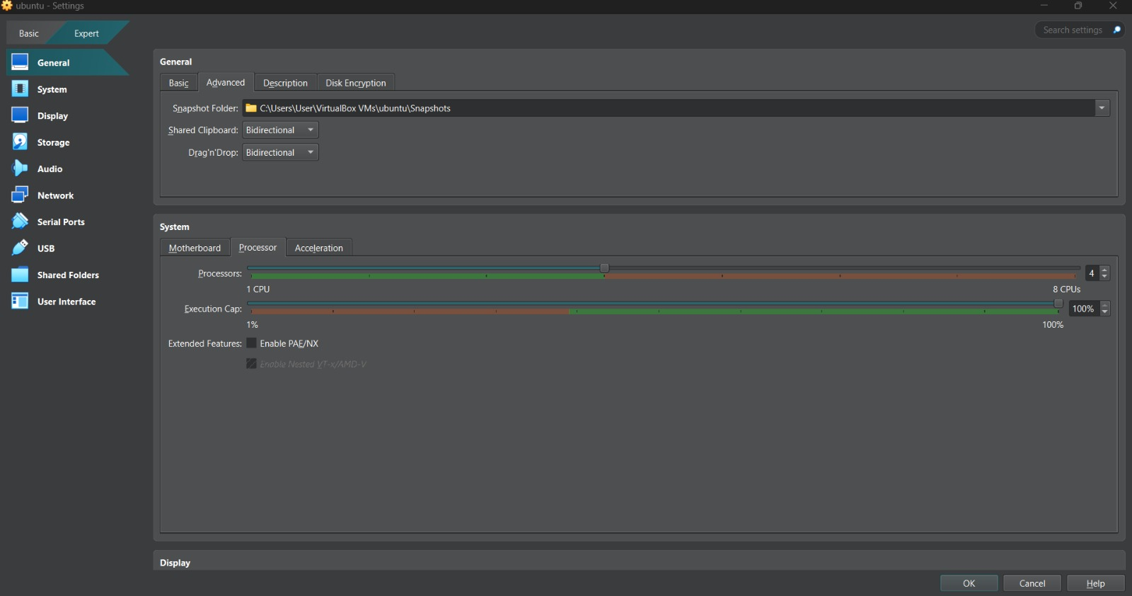
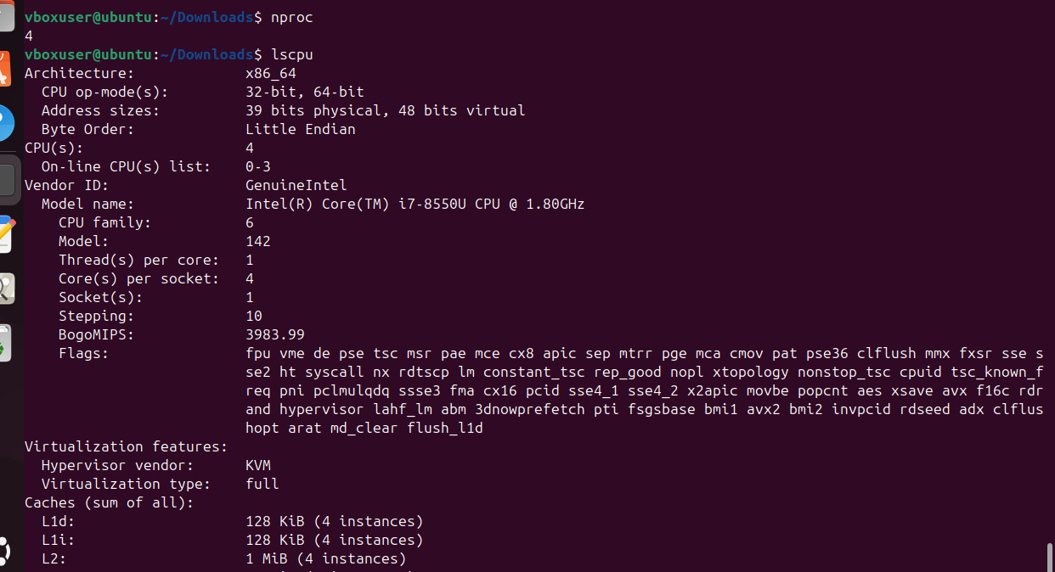
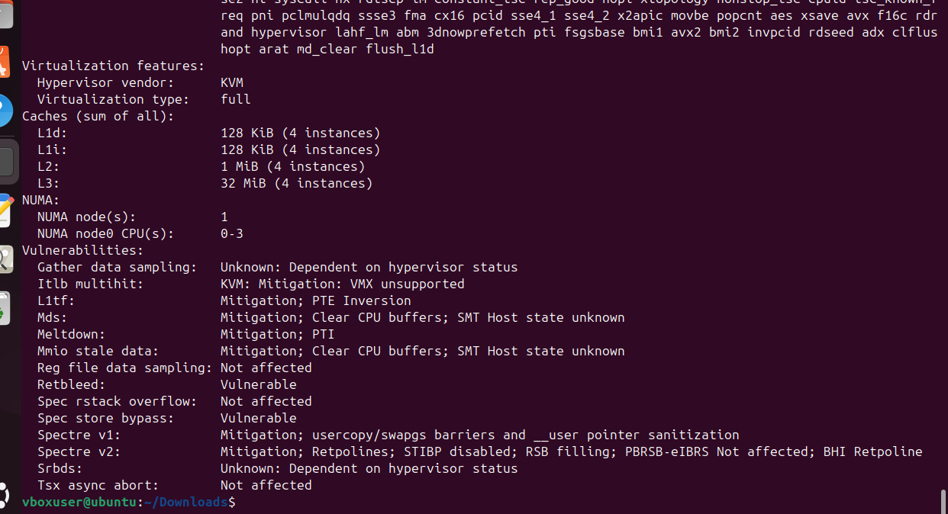
Conclusion:
We developed a multi-threaded program to identify and count prime numbers, palindrome numbers, and numbers that are both prime and palindrome in a specified range. We created two versions: one without handling race conditions and another with locks.
The unsafe version had potential issues with race conditions, where multiple threads could access shared data simultaneously, leading to unpredictable results. To solve this, we used locks in the safe version, ensuring that only one thread could update shared data at a time, preventing conflicts.
We observed that when the number of processors was set to 1, the compilation was relatively slow. However, as we increased the number of processors to 4, the speed improved significantly. We also tested several cases with large ranges (10,000, 1 million, and 10 million), using different numbers of threads in each case. As the number of threads increased, the speed improved, but beyond a certain point, further increasing the number of threads resulted in a decrease in performance.
In terms of performance, multi-threading significantly improved the speed of the program by dividing the workload among several threads. However, despite the parallel processing, managing thread synchronization still introduced some overhead, which impacted the program's execution time. While the safe version was slower due to this overhead, it ensured correct and consistent results. The unsafe version ran faster but could produce unpredictable results due to race conditions.

