CS23633 – Cloud Computing Laboratory
Experiment 6:
CDN Service Selection and CDN Configuration
Aim:
To select a Content Delivery Network (CDN) provider, deploy a simple web application using Cloudflare, access the application through Cloudflare's edge network, and verify the HTTP response and Cloudflare-specific headers using browser Developer Tools.
Software Used:
• Cloudflare Workers
• Google Chrome Web Browser
• Internet Connection
CDN Provider Selection:
Cloudflare was selected as the CDN/edge provider for this experiment. The working guide considered Cloudflare, Amazon CloudFront, and Akamai, and selected Cloudflare because it was the easiest option for the practical experiment.
Procedure:
1. Created/logged into a Cloudflare account and opened the Cloudflare dashboard without changing any DNS or nameserver settings.
2. Selected Create app from the Cloudflare dashboard.
3. Selected Start with Hello World! as the application option.
4. Kept the automatically generated Worker name and the default Worker code unchanged.
5. Clicked Deploy and successfully deployed the Worker, obtaining a public workers.dev URL.
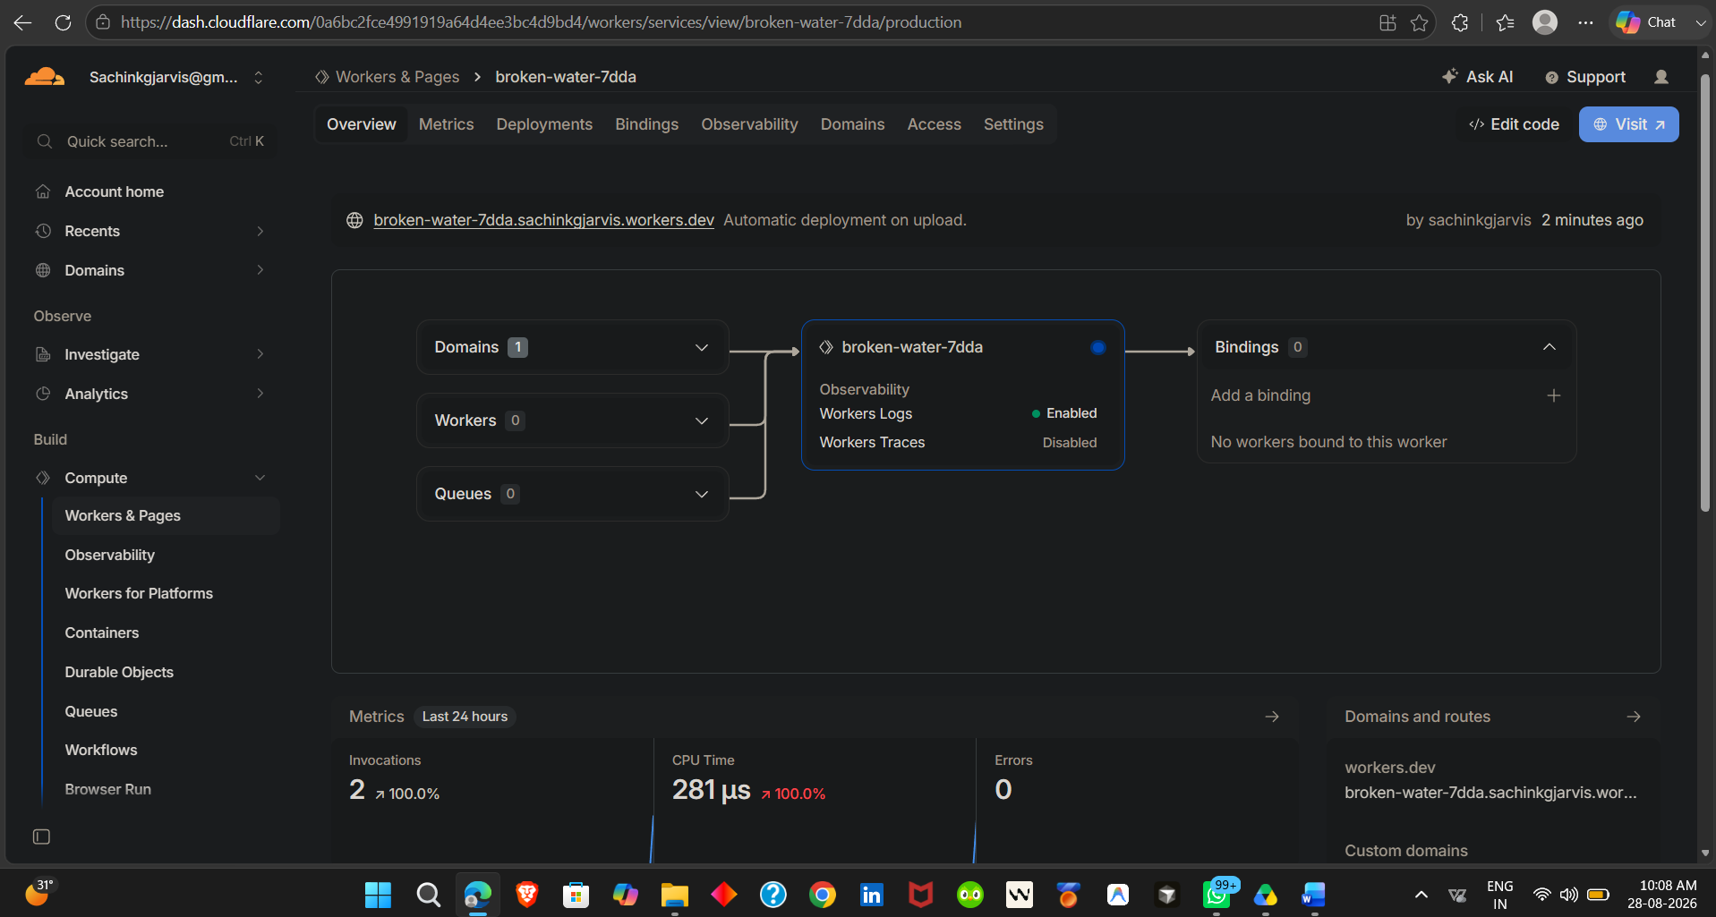
Cloudflare Worker successfully deployed with a workers.dev URL.
6. Clicked Visit to open the deployed Worker and verified that the page displayed Hello World!.
7. Returned to the Cloudflare dashboard and checked the Worker metrics. After the visit, the invocation count increased to 1 while the error count remained 0.
8. Opened Edit code and replaced the Hello World response with an HTML page titled CDN Service Experiment containing Cloudflare content-delivery information.
9. Deployed the updated Worker successfully.
10. Clicked Visit again and verified the CDN demonstration webpage with the messages CDN Service Experiment, Cloudflare Content Delivery, This webpage is being delivered through Cloudflare, CDN reduces the distance between users and content, and Status: Successfully Deployed.
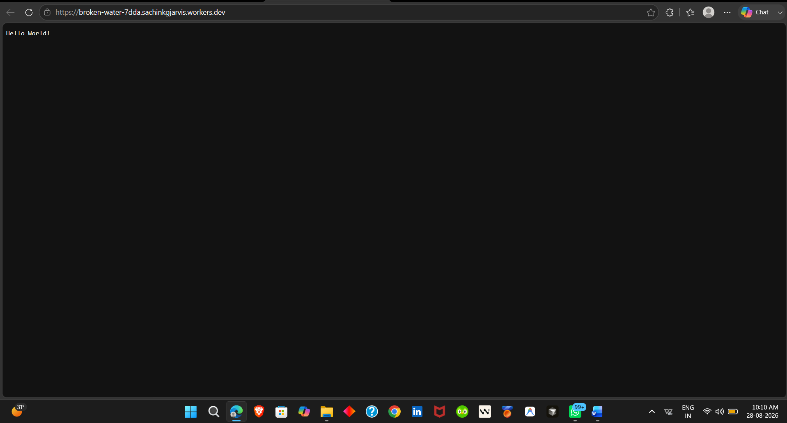
Worker output displaying Hello World!
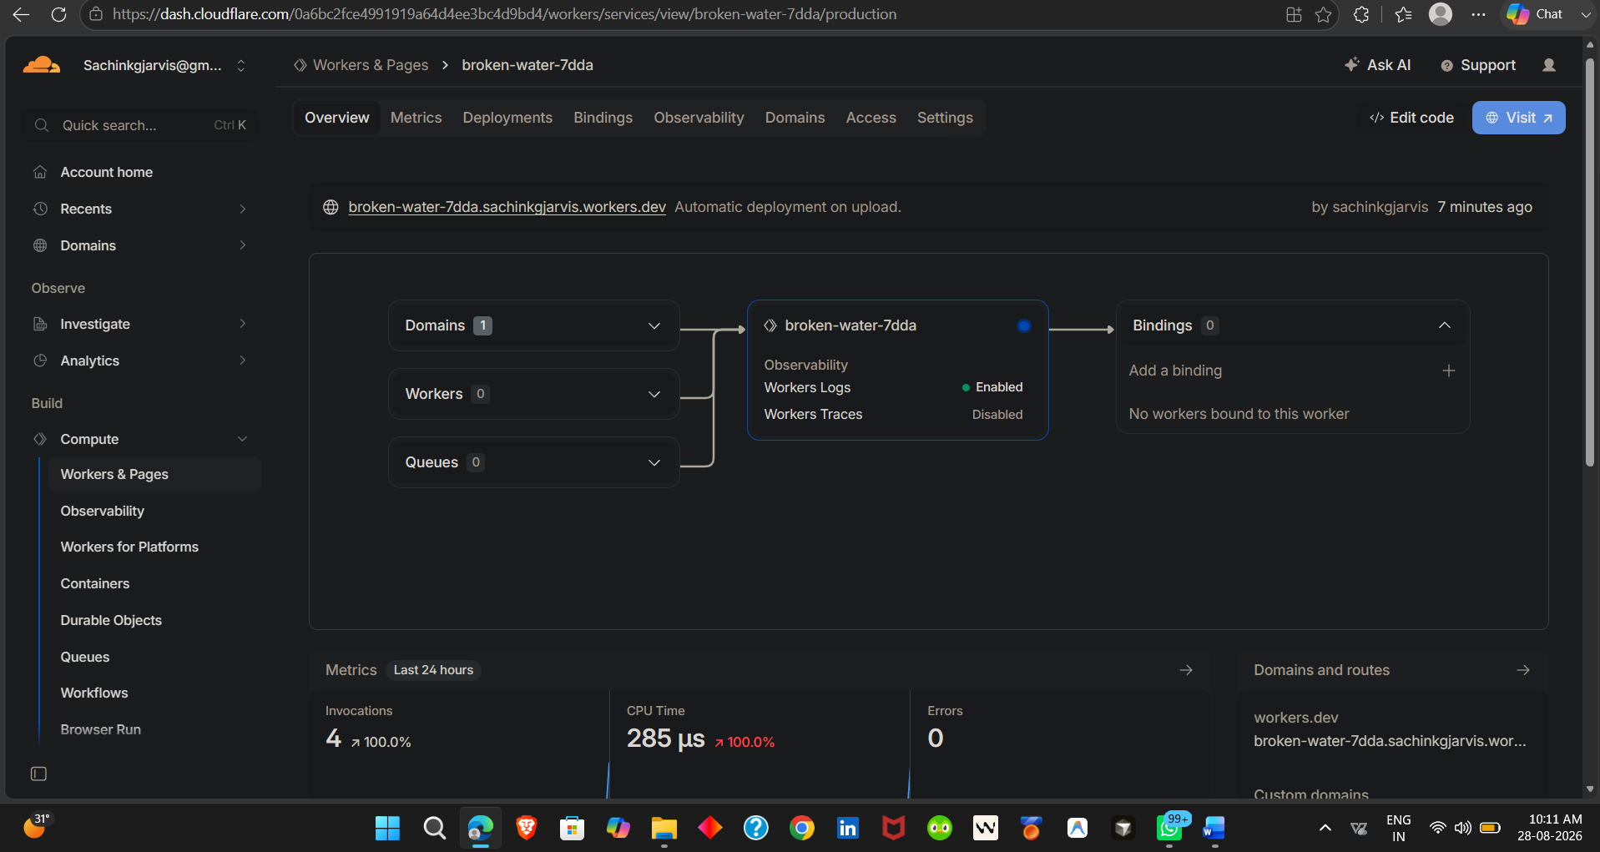
Cloudflare Metrics showing 4 invocation and 0 errors.
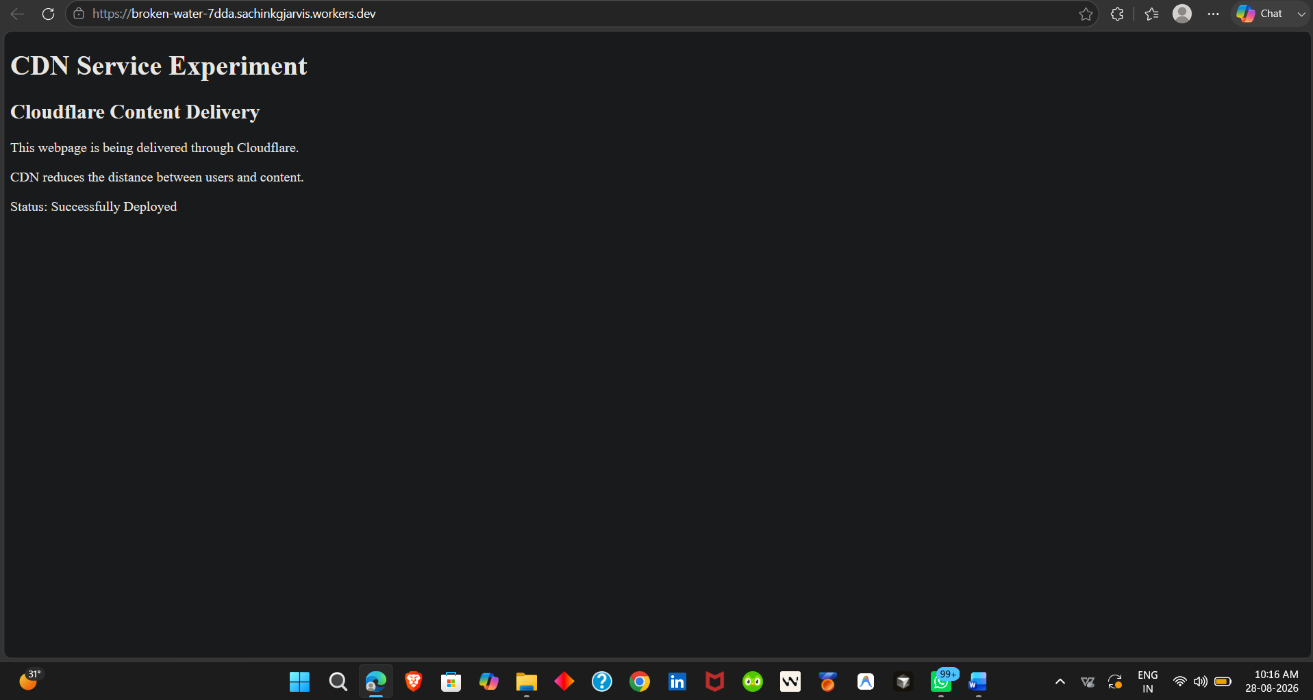
CDN Service Experiment webpage delivered through Cloudflare.
11. Opened Chrome Developer Tools using F12 and selected the Network tab.
12. Reloaded the CDN demonstration webpage and selected the request to the workers.dev address.
13. Verified the request method as GET and the HTTP status code as 200 OK.
14. Checked the response headers and verified Content-Type: text/html and the Cloudflare-specific CF-Ray header.
15. Scrolled further in the Response Headers section and verified Server: cloudflare, confirming that the response was handled by Cloudflare.
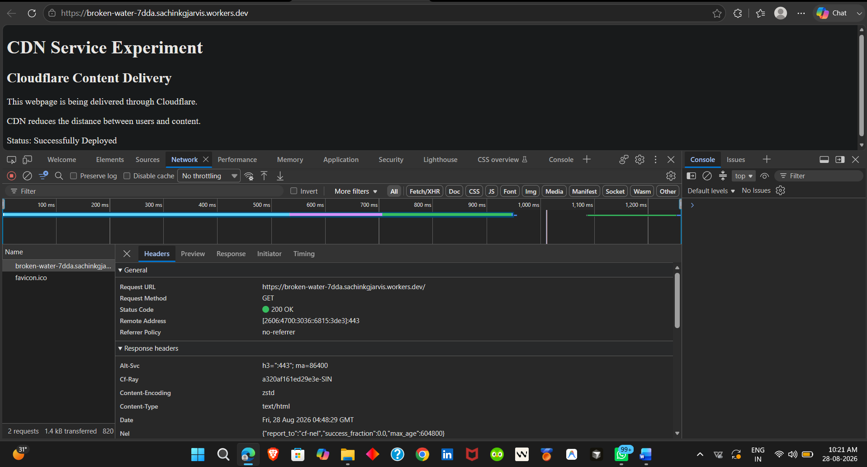
Developer Tools Network Headers showing GET, 200 OK, CF-Ray and Content-Type.
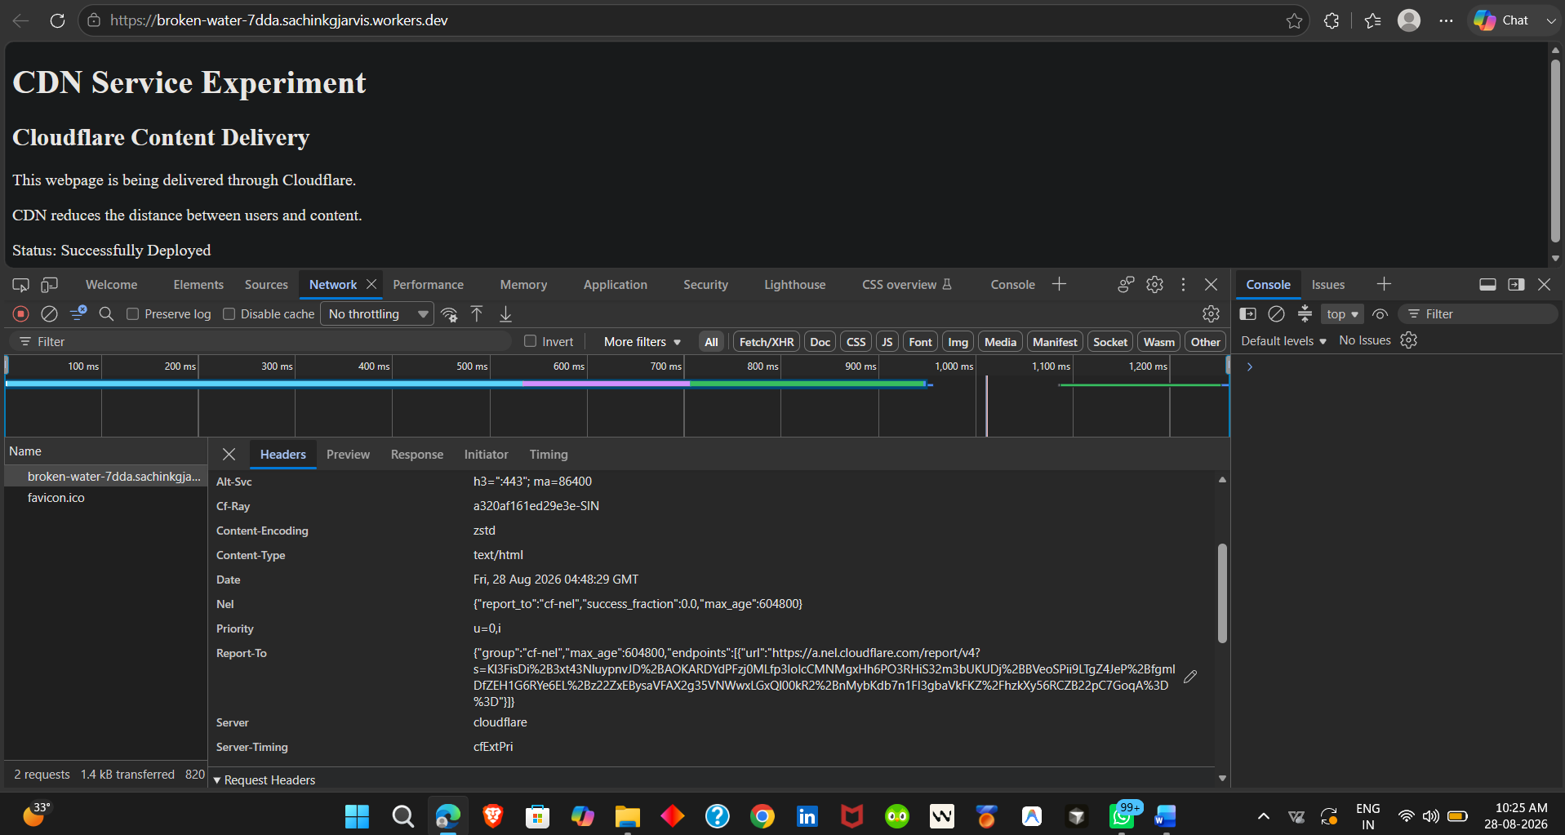
Response Headers showing Server: cloudflare and CF-Ray.
Result:
A Cloudflare-based edge content delivery experiment was successfully implemented. A Cloudflare Worker was deployed and accessed through a public workers.dev URL. The browser successfully received the CDN demonstration webpage with HTTP status 200 OK. The response headers included Cloudflare-specific information such as Server: cloudflare and CF-Ray, confirming that the request was processed through Cloudflare's network.

