**With Historical Data**

**Logistic Regression**

**Accuracy**: 0.644489572253

**The confusion matrix is**:

No Delay [[15749 3228]

Delay [ 7801 4245]]

**The classification report is**:

precision recall f1-score support

No Delay 0.67 0.83 0.74 18977

Delay 0.57 0.35 0.43 12046

avg / total 0.63 0.64 0.62 31023

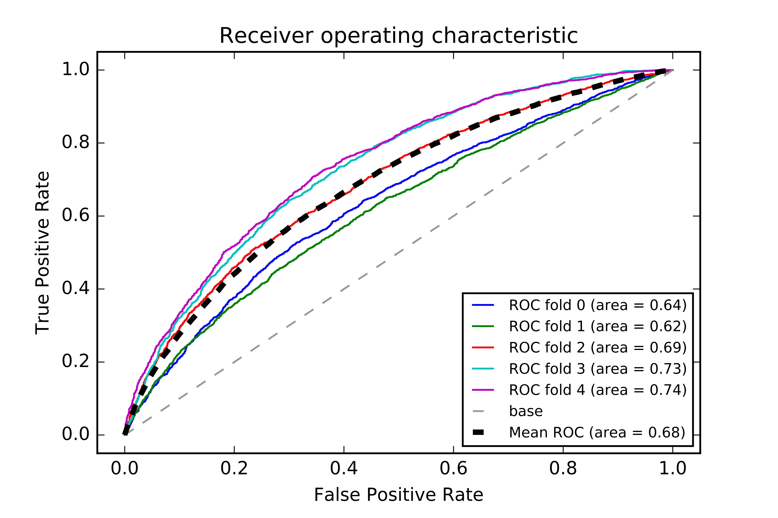

**Random forest**

**Accuracy**: 0.723624407698

**The confusion matrix is**:

[[15525 3452]

[ 5122 6924]]

**The classification report is**:

precision recall f1-score support

No Delay 0.75 0.82 0.78 18977

Delay 0.67 0.57 0.62 12046

avg / total 0.72 0.72 0.72 31023

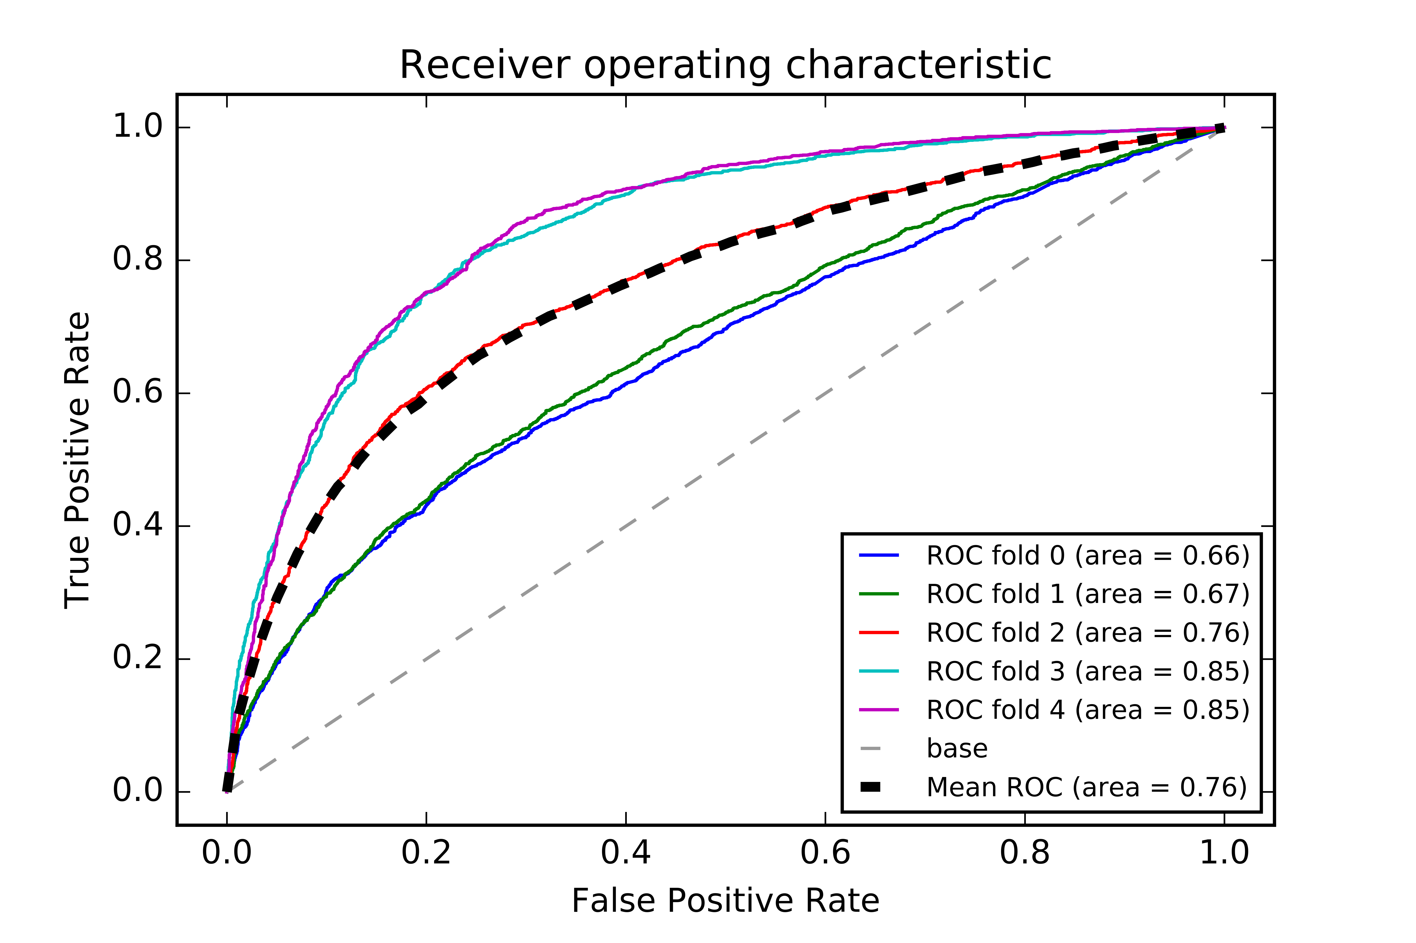

**With Historical and weather data**

**Logistic Regression**

**Accuracy**: 0.66

**The confusion matrix is**:

No Delay [[15655 3316]

Delay [ 7196 4862]]

**The classification report is**:

precision recall f1-score support

No Delay 0.69 0.83 0.75 18971

Delay 0.59 0.40 0.48 12058

avg / total 0.65 0.66 0.64 31029

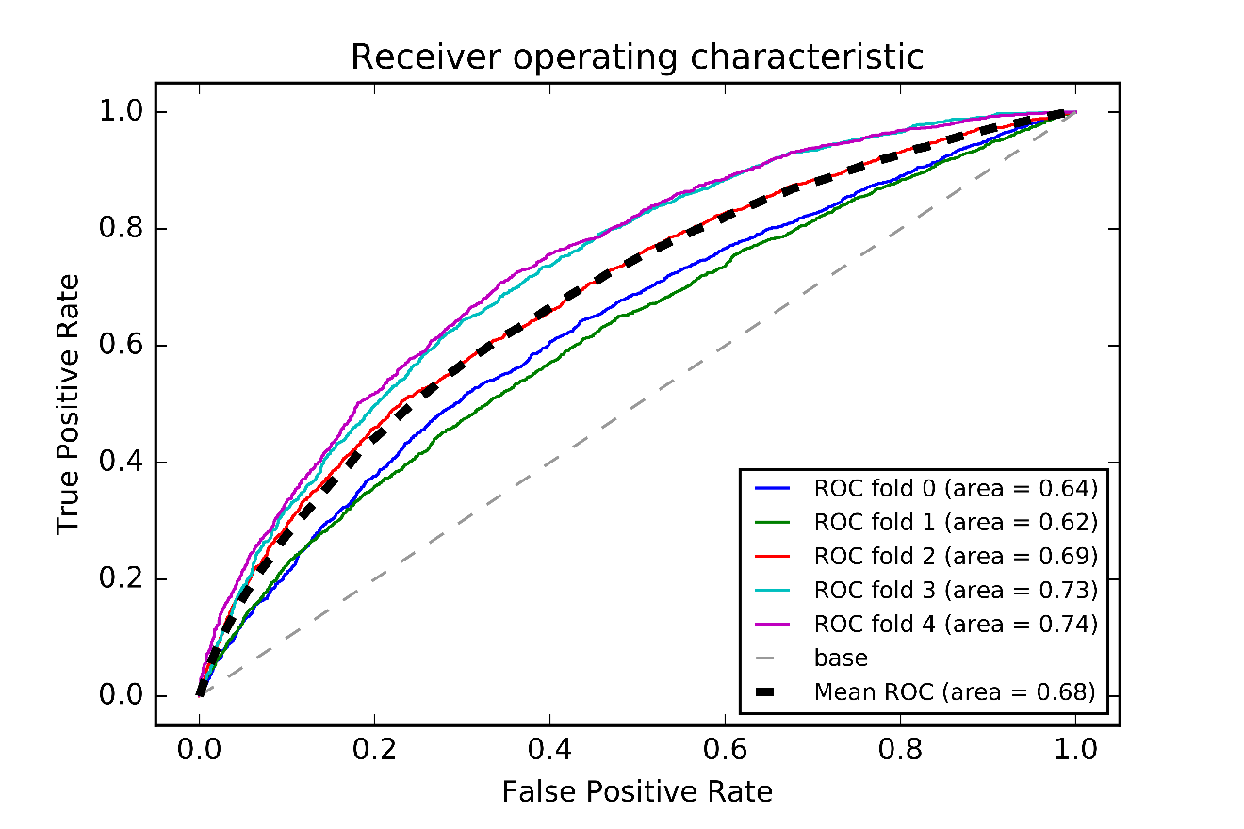

**Decision Tree**

**Accuracy**: 0.705372393567

**The confusion matrix is**:

No Delay [[15300 3671]

Delay [ 5471 6587]]

**The classification report is:**

precision recall f1-score support

No Delay 0.74 0.81 0.77 18971

Delay 0.64 0.55 0.59 12058

avg / total 0.70 0.71 0.70 31029

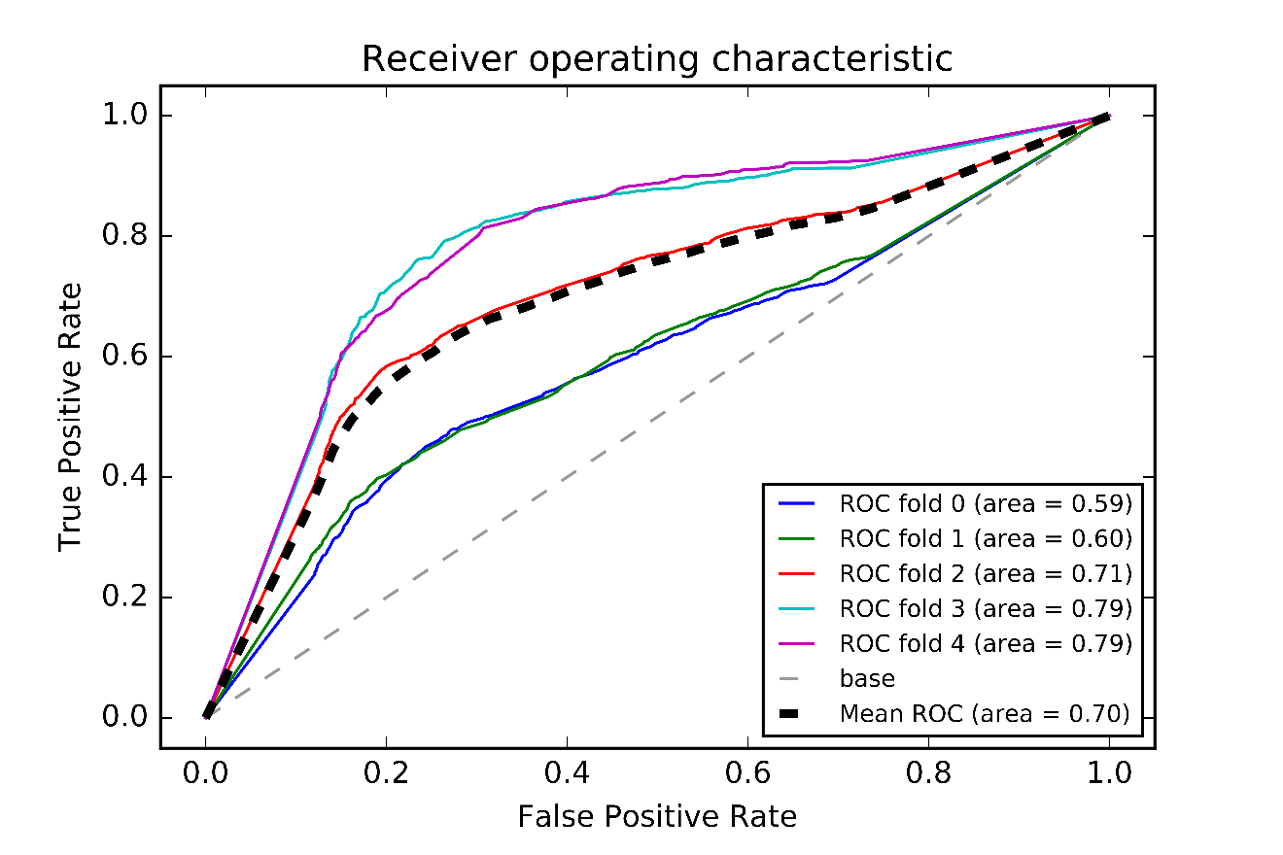

**Depth Analysis with Weather**

**Decision Tree**

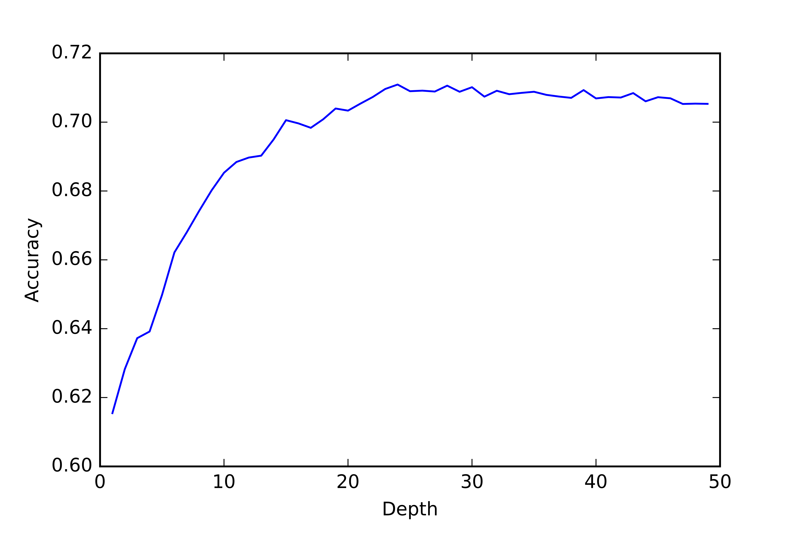

**Random forest**

